Indian Currency Detection
Prof. N. Y. Chaoudhary^{1,} Minal Mahajan², Punam Patil³, Manish Mali⁴,
Aakib Khatik⁵, Tazim Shaikh⁶.
¹Asst Prof, ^{2,34,5,6} BE Students
¹²³⁴⁵⁶Department of Computer Engineering GF’s Godavari College of Engineering, Jalgaon-425003, India
² minalmahajan251@gmail.com, ³ paribpatil24@gmaill.com

Abstract – There are around 200+ different currencies used in different countries around the world. Currency Recognition and conversion system is implemented to reduce human power to automatically recognize the amount monetary value of currency and convert it into the other currencies without human supervision.
Modernization in the financial system is a milestone in protecting the economic development. As the highest value note there is a chance that corrupt people will try to make it as a counterfeit. So main objective of this paper is to study different key features of new genuine currency and use such techniques to detect and verify new currency circulated by Reserve Bank Of India.
The software interface that we are proposing here could be used for various currencies. Many a times, currency notes are blurry or damaged; many of them have complex designs to enhance security.
This makes the task of currency recognition very difficult. So it becomes very important to select the right features and proper algorithm for this purpose. Our main aim is to design an easy but efficient algorithm that would be useful for maximum number of currencies, because all currencies have different security features, making it a tough job to design one algorithm that could be used for recognition of all available currencies.

Keywords- Segmenting feature of currency, canny, genuine note.
- INTRODUCTION

An economic development of every nation is mostly dependent on its currency and every person is the part of Economy but some of the unsocial group of people damage this process and unbalances the social harmony of the nation. For ex. Now days, in process of demonetization, there are long queues in front of banks and ATM Machines of those common people who contribute to our economy by paying taxes but on the other hand many corrupted people are issuing the money directly by evil sources and it is directly effecting on economic status of India.
As we know, in India, Ministry Of Finance and RBI are authorized to issue currency notes and coins. But corrupt people take the advantage of high printing and scanning technologies to print fake notes by using latest hardware tools and techniques. Fake currency detection means finding the fake currency from the original one. Generally, currency recognition system is mostly used in banks, business firms, shopping malls, railway stations, government sector, organizations etc. But common people do not have any source of currency detection and they are unable to identify the real original currency.
The aim of our system is to help people who need to recognize different currencies, and work with convenience and efficiency. It is very difficult to count different denomination notes in a bunch. This project proposes an image processing technique for paper currency recognition and conversion. The extracted region of interest (ROI) can be used with Pattern Recognition and Neural Networks matching technique. Image Processing involves changing the nature of an image in order to improve its pictorial information for human interpretation. [1]

- LITERATURE SURVEY
The Detection of fake currency manually is very default or time-consuming. This process is check by using some technique it is batter to human life that is done by using feature extraction with HSV is nice technique to detect fake currency with his opinion. In this article, recognition of paper currency with the help of digital image processing techniques is described. Here, the characteristics of Indian paper currency are selected for counterfeit detection. The characteristic feature extraction is performed on the image of the currency and it is compared with the characteristic features of the genuine currency. The decision making is done by calculating the black pixels. This article is aimed to design a low cost system and quick decision making system. This research paper presents a new feature about counting the random notes as well as fake notes and display the total amount of real notes & fake notes also.

Texture Based Recognition Techniques
Texture is a very useful feature for Currency recognition. Textural features corresponding to human visual perception are very useful for optimum feature selection and texture analyzer design. There are some set of texture features that have been used quite frequently for image retrieval. Tamura features Tamura coarseness is defined as the average of coarseness measures at each pixel location inside a texture region. This type of features can compute directly from the entire image without any homogeneity constraint. As a result, an improved version of this feature by representing the coarseness information using a histogram should be considered.[2]

Pattern Based Recognition Techniques
The Pattern recognition is conclusions based on prior knowledge. A form of this is the classification of objects based on a set of images. There are number of techniques exist in the literature which Indian Currency Note Denomination Recognition in Color Images make use of pattern recognition as a feature to some of the good problems. These techniques are broadly focused on Vector quantization based histogram modeling. After these determining the RGB value, then a Segmentation program was applied to these images. After the data collection next step is image Segmentation and Cropping. In this step note image were segmented from their backgrounds using some modification. After completion of segmentation cropping program was implemented to locate the edges of image. After this Features were extracted from the images by convolving texture templates with each image, with edge detection templates.

Color Based Recognition Technique
Color histogram (CH) method for an image is constructed by counting the number of pixels of each color. Histogram describes the global color distribution in an image. It is easy to compute and is insensitive to small changes in (VP) viewing position. The computation of color histogram just involves counting the number of pixels of specified color. Color histograms also have some limitations. Color histograms describe which colors are present in the image and in what quantities; color histograms provide no spatial information. Color coherence vector is a refined approach of coherence histogram. In this approach, the local properties of images are taken into consideration

2.1 Problem Statement
The currency recognition techniques that were implemented before were using some texture, or pattern or any other feature to recognize currency notes.
The recognition technique discussed in this paper does not require the image to have the exact size as that of the currency note for these we use the edge detector
In this Technique we gives the folder of random notes that we have to detect, and as the result it displays total number of real notes as well as fake notes with their total amount etc.[3]
It also takes a single image to determine the currency
2.2 Proposed Method/System
The proposed system of this article is divided into two parts such as:
1) Currency Recognition
2) Currency Verification
In Currency Recognition, Feature such as Identity Mark And optical variable link are used. Pixel value for each feature is calculated. Based on that pixel value histogram is plotted. Currency feature such as Id mark and Optical variable link will be using for recognition. Currency features such as watermark, security thread, Fluorescence and latent image will be using for currency verification. Figure 3.1 given
below describes flowchart for currency Recognition. In Currency Verification, Character from each segmented part is extracted. Pixel value for that extracted part can be calculated.[4]

2.2.1 Image Acquisition:
Performing image acquisition in image processing is always the first step in the workflow sequence because, without an image, no processing is possible. After the image has been obtained, various methods of processing can be applied to the image to perform the many different vision tasks. There are various
ways to acquire image such as with the help of camera or scanner. Acquired image should retain all the features.

2.2.2 Pre-processing:
The main goal of the pre-processing to enhance the visual appearance of images and improve the manipulation of data sets. Image preprocessing, also called image restoration, involves the correction of distortion, degradation, and noise introduced during the imaging process. Interpolation is the technique mostly used for tasks such as zooming, rotating, shrinking, and for geometric corrections. Removing the noise is an important step when processing is being performed. However noise affects segmentation and pattern matching [6].

2.23 Binarization :
The image acquired is in RGB color. It is converted into gray scale because it carries only the intensity information which is easy to process instead of processing three components R (Red), G (Green), B (Blue). To take the RGB values for each pixel and make as output a single value reflecting the brightness of that pixel.

2.2.4 Edge Detection:
Edge detection is the name for a set of mathematical methods which aim at identifying points in a digital image at which the image brightness changes sharply or, more formally, has these continuities. The points at which image brightness changes sharply are typically organized into a set of curved line segments termed edges. Edge detection is an image processing technique for finding the boundaries of objects within images. It works by detecting discontinuities in brightness. Edge detection is used for image segmentation and data extraction in areas such as image processing, computer vision, and machine vision [7].

2.2.5 Image Segmentation:
Image segmentation is the process of partitioning a digital image into multiple. The goal of segmentation is to simplify and/or change the representation of an image into something that is more meaningful and easier to analyze.[5]
Image segmentation is typically used to locate objects and boundaries (lines, curves, etc.) in images Segmentation algorithm for images generally are based on one of the two basic properties of image intensity values-

1) Discontinuity:
Based on abrupt changes in intensity such as edges in an image.

2) Similarity:
Based on partitioning an image into regions that are similar according to a set of predefined criteria [7].

2.2.6 Feature Extraction:
Feature extraction is a special form of dimensional reduction. When the input data to an algorithm is too large to be processed and it is suspected to be very redundant then the input data will be transformed into a reduced representation set of features. Transforming the input data into the set of features is called feature extraction. If the features extracted are carefully chosen it is expected that the features set will extract the relevant information from the input data in order to perform the desired task using this reduced representation instead of the full size input [8].

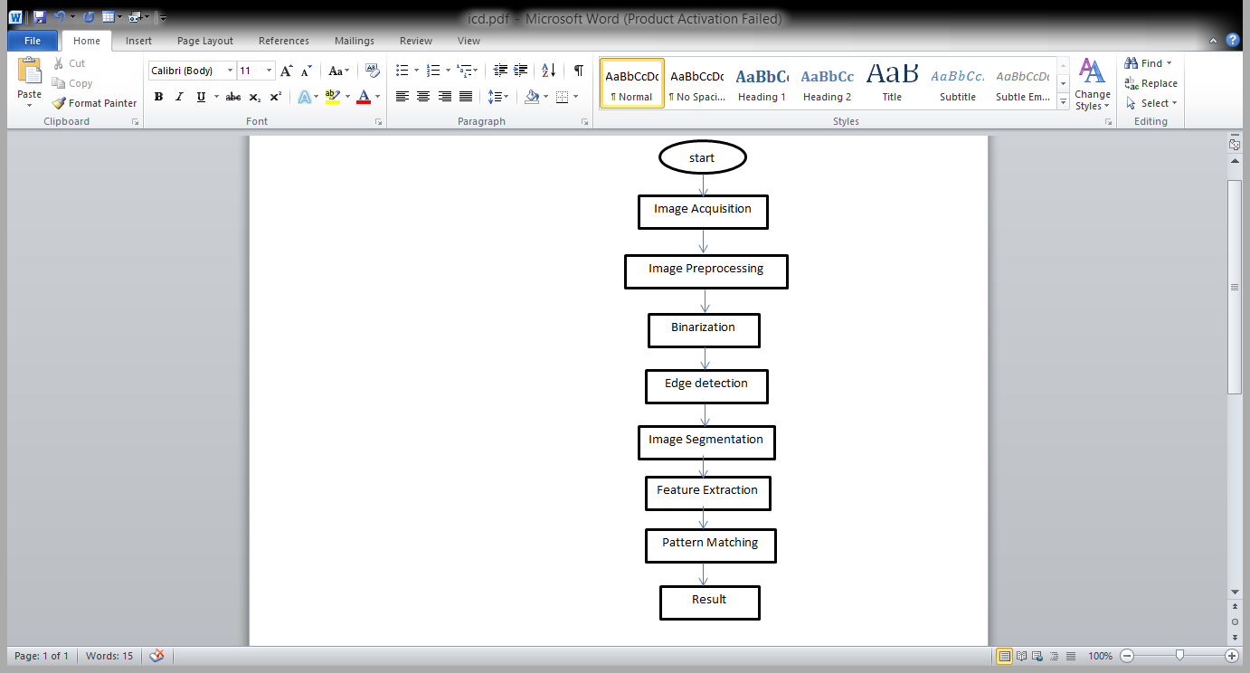
Fig 2.1 flowchart

- METHODOLOGY
A. Input images
In this first stage of any vision system is the input image stage. After the image has been obtained, various methods of processing can be applied to the image to perform the many different tasks. Performing input images in image processing is always the first step in the workflow sequence because, without an image, no processing is possible. There are various techniques to acquire image such as with the help of camera or scanner. Input image should retain all the features.
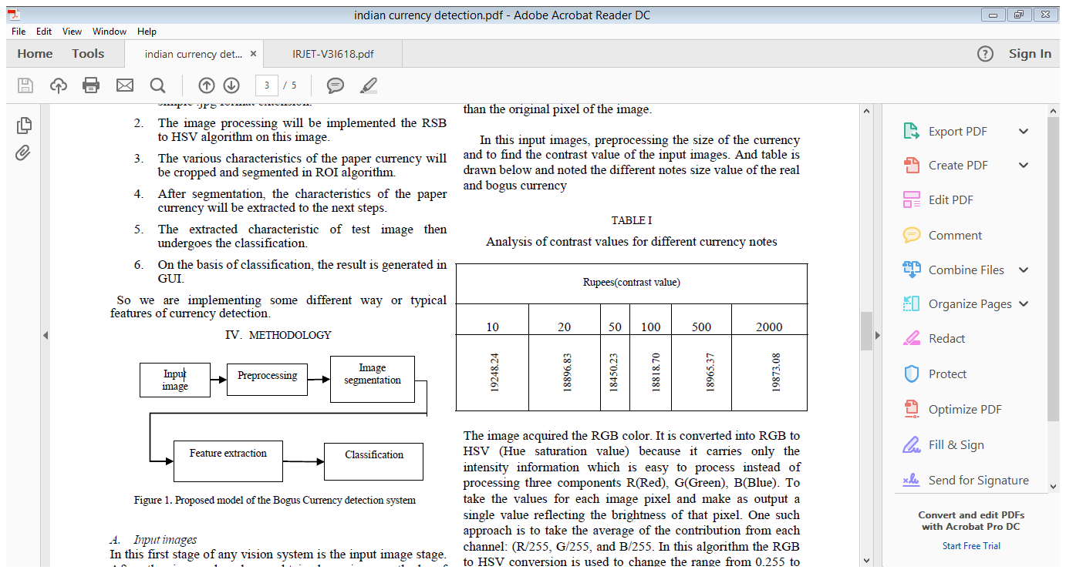
Fig: 3.1 Proposed moel of the Bogus Currency detection system
B. Image preprocessing

The main part of this step is to pre-processing the image to enhance the visual appearance of images and improve the manipulation of datasets. Pre-processing of image are those operations that are normally required to the main data analysis and extraction of information. Image preprocessing, also called image restoration, involves the correction of distortion, degradation, and noise introduced during the imaging process.
It can significantly increase the reliability of an optical
inspection. Several filter operations are used, which intensify or reduce certain image details enable an easier or faster evaluation.[9]
Image Adjusting is part of preprocessing with the help of
image interpolation. Interpolation is the method mostly
applicable for tasks such as zooming, rotating, shrinking, and for geometric corrections. Then removing the noise is an important step when image processing is being performed. However noise may affect to the image segmentation and pattern matching. When performing smoothing process, better than the original pixel of the image.

C. Image segmentation
Image segmentation is the process used to partitioning a digital image into multiple segmentations (sets of pixels, threshold saturation and value). It mainly used to threshold the saturation and value of the images. The application of segmentation is to simplify and/or change the representation of an image into something that is more than meaningful and easier to analyze. It is typically used to locate objects and boundaries (lines, curves, etc.) of the given images.

D. Feature extraction

In the extraction, the mainly some feature are used in security to identify the bogus currency. We are used watermarking, latent image, security thread, strips, and an identification mark.
In the feature extraction ROI is used in the image. It is a
special form of dimensional reduction. In the input data to an algorithm is very large to be processed, the input data will be transformed into a reduced representation part of features. In the feature extraction set the database to the one folder the give to input image to compare the database and find the currency real or bogus.[10]

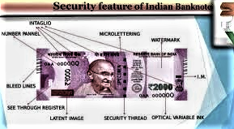
Fig 3.2 Feature Extraction

3.1 System Hardware
A Windows OS
Processor P4
At least 512 megabytes (MB) RAM
A Pentium 600 MHz PC (or faster)

3.2 System Software
Operating system
Jdk1.6
J Creator
Netbeans
Adobe Dream viewer

- RESULT AND DISCUSSION
1.Image Sending Module:
In this system we use folder with image as a input or give the single image as a input. Once the image of the currency note is received, it has to be processed using waterrmark, security thread detection checking currency number.
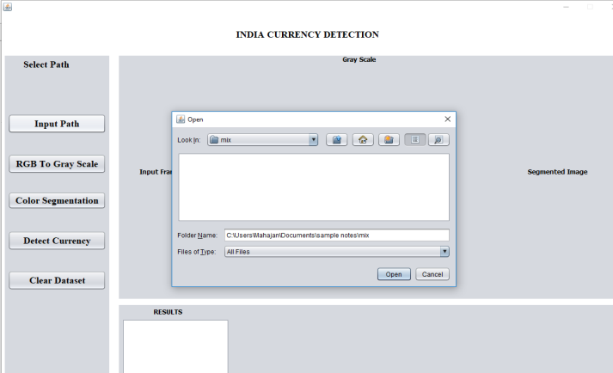
Fig. 4.1 Selection Path for input

2. Image Processing Module:
Give the input image( 768*432 pixels,24bit color depth),we first convert it to grayscale & convolve with 3*3 Gaussian low-pass filter to eliminate high frequency noise.
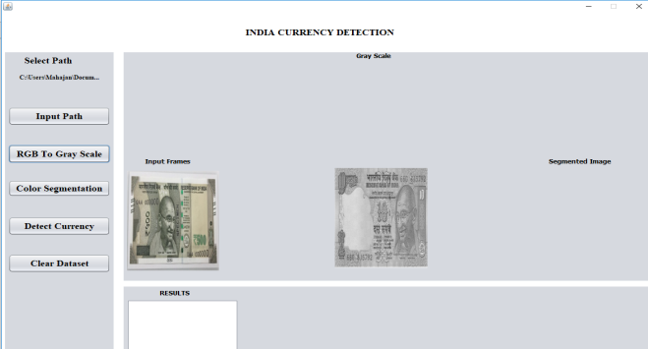
Fig. 4.2 Gray Scale Conversion

3. Image Comparison Module:
Find Matching interest points from reference images of banknotes.
For given point from reference image we calculate the distance from it to the closest point from test image.

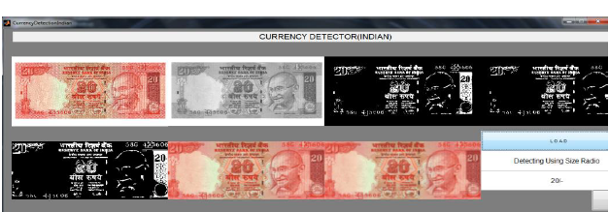
Fig 4.3 Preprocessing of the real and bogus currency.

- CONCLUSION
According to our project we can conclude that with above proposed algorithm, we can recognize currencies, which have good differentiation in color and size related to feature.
The main conclude the point that the note will detect, and as the result it displays total number of real notes as well as fake notes with their total amount.
This system could be a very useful tool in order to prevent high order counterfeiting by taking advantage of cheaper and high quality equipment.

6. REFERENCES
[1] G Chinmay Bhurke, Meghana Sirdeshmukh, Prof. Mrs. M.S.Kanitkar “Currency Recognition Using Image Processing s,” International Journal of Innovative Research in Computer and Communication Engineering,, vol.III,May 2015.

[2] Sagar S. Lawade , Gayatri S. Hedau, Apurva C. Ramgirwar, Fake Currency detection using image processing,” International Journal of Research in Computer and Communication Technology, vol III, may 2014

[3] Shital Mahajan, K.P.Rane, “A Survey on Counterfeit Paper Currency Recognition and Detection, International Journal of Engineering Research and Applications (IJERA), vol.III,13 April 2014..

[4] PM.Deborah., PC.Soniya Prathap, “Detection of Fake currency using Image processing,” IJISET - International Journal of Innovative Science, Engineering & Technology, vol I, 10 December 2014.

[5] Mohammad H Alshayeji1, Mohammad Al-Rousan, Dunya T. Hassoun,“Detection Method for Counterfeit Currency Based on Bit-Plane SlicingTechnique, ” International Journal of Multimedia and Ubiquitous Engineering Vol.10, No.11 (2015)

[6] Kamesh Santhanam; Sairam Sekaran; Sriram Vaikundam; Anbu Mani Kumarasamy,“Counterfeit Currency Detection Technique Using Image Processing, Polarization Principle and Holographic Technique”, International Conference on Computational Intelligence, Modelling and Simulation, 14
November 2013

[7] Neeru Rathee; Arun Kadian ; Rajat Sachdeva ; Vijul Dalel ; Yatin Jaie Feature fusion for fake Indian currency detection.” International Conference on Computing for Sustainable Global Development (INDIACom), 31 October
2016.

[8] K. Kang ;C. Lee], Fake banknote detection using multispectral images,’ International Conference on Information, Intelligence, Systems & Applications (IISA), 19 December 2016.

[9] Mohammad Shorif Uddi ; Pronaya Prosun Das ; Md. Shamim Ahmed Roney, Image-based approach for the detection of counterfeit banknotes ofBangladesh,” International Conference on Informatics, Electronics and Vision (ICIEV)1 December 2016.

[10]D.Alekhya,G.DeviSuryaPrabha , G.VenkataDurgaRao, Fake Currency Detection Using Image Processing and Other Standard Methods”, International

