Climate Change Intimation and Seed Sowing Accordance

Vedant Arun Sonar ^{1*}, Tejas Nitin Supr², Hritika Desale³, V. D. Chaudhari⁴, H.T. Ingle⁵

^{1,2,3} UG Student, ⁴Professor, ⁵H.O.D. Of & E&TC
^{1,2,3,4}E&TC Engg dept, GF’S Godavari College of Engineering, Jalgaon-425001

vedantsonar.999@gmail.com, vinuda.chaudhari@gmail.com⁴

Received on: 04 May,2024 Revised on: 04 June,2024, Published on: 06 June ,2024

Abstract- Farmers faces many problems during farming there were many problems like climate change, heavy rain fall or uneven conditions for farming this makes farming a difficult task for farmers. Seed is the basic and most vital input of agriculture and food security. The seed industry is the cornerstone of global food security; food security depends on seed security but seed industries are facing a basket of emerging problem shares narrowed down the smooth pursuance of enhanced productivity and quality. Among these, the burning issue of climate change and its possible consequences on agricultural production has received importance late, but the problem is very real. So, Climate change presents a profound challenge to food security and development. Climate change will alter pest, plant disease and weed distributions, with potential to reduce crop yields, including of staple crops like wheat, soybeans, and corn. Warmer temperatures can increase the metabolic rate and number of breeding cycles of insect populations. Odd security depends on seed security and the international seed industry must be able to continue to deliver the quantities of quality seed required for this purpose. Abiotic stress resulting from climate change, particularly elevated temperature and water stress, will reduce seed yield and quality. Options for the seed industry to adapt to climate change include moving sites for seed production, changing sowing date, and the development of cultivars with traits which allow them to adapt to climate change conditions. However, the ability of seed growers to make these changes is directly linked to these ecosystem. In the formal seed system operating in developed countries, implementation will be reasonably straight forward. In the informal system operating in developing countries, the current seed production challenges including supply failing to meet demand and for seed quality will increase with changing climates.

Keywords: Climate change, Seed Sowing, food, weather

1. INTRODUCTION
In this project we will deal with the live problem that how the climate change affects the plant seed germination so how do we overcome this problem? by using weather sensing technology and raspberry pi module we will be able to find the right seed which will be suitable for the uneven climate conditions. The past fifty years have seen seed yield increases for the world’s major crops of 1%–3%
per year, due largely to genetic gains obtained with plant breeding, but also to improved agronomic inputs and specialized management systems. Can these seed yield increases continue given that climate change will have direct impacts on land, water, temperature, atmospheric CO2, and weather patterns? These changes must impact agricultural activities, although there is debate as to whether the impacts will be negative or positive. Some authors concluded that the overall impact of climate change on agriculture is expected to be negative, threatening global food security, whereas others considered that global crop production could increase by approximately 50% by 2050 without extra land. However,
the latter authors did stress that a large proportion of these yield increases will need to be delivered via plant breeders through the release of new cultivars adapted to cope with a changing environment we examine the effects of climate change on seed production and explore options for adaptation of seed production in response to climate change and deal this problem with raspberry pi module

2. LITERATURE SURVEY
Engineering ideas in farming industries have an huge scope for market and we all moving towards urbanization and modernization but still farmers takes huge efforts and hard work for farming but still they fails on un-suitable conditions and after a huge efforts they don’t have much revenue as compared to hard work they done. So if we consolidates their problem that which seed is much profitable according weather conditions hence this deals with the live problem if we’ll able to know the which seed is more profitable, easy in fertilization, needs less time to grow then we can definitely done a good job in farming hence this project will have a huge scope. The agriculture sector forms only about 18 percent of India’s GDP despite employing almost 65 percent of the total workforce. Despite significant improvement in food grain production, there are several challenges to tack leas the government aims to increase agricultural production as a share of GDP. Agriculture in India is largely dependent on nature, but climate and global warming issues make farming unpredictable. The need of the hour is to educate farmers in the use of modern technology and innovative approaches to increase productivity and raise profitability.
Agricultural development practices over a while have been perceived to exploit natural resources faster than they could be renewed. Exponential growth in the human pop0ulation has resulted in
Demand for food and shelter, which the “natural” carrying capacity of the land is under pressure to provide.

2.1 Problem Statement
Natural imbalance is visible in climate, soil Humidity, soil cons, and human-created alterations of flora and fauna. It is reasonable to assume that human population growth will continue and place greater demands on the Agri-ecosystem. Thus, technology has and will continue to play a major role in agriculture and sustainable development going forward.

2.2 Proposed Method/System
Technology has a major role in farming and agriculture practices; and with the advent of digital technology, the scope has widened. Innovation in agriculture is leading an evolution in agricultural practices, thereby reducing losses and increasing efficiency. This is positively impacting farmers. The use of digital and analytic tools is driving continuous improvement in agriculture, and the trend is here to stay, resulting in improving crop yields and helping to increase the income of the farming community. Climate/ weather prediction – A major advance in agriculture is the use of artificial intelligence (AI). Modern equipment and tools based on AI enable data gathering and assist in precision farming and in formed decision-making. Drones, remote sensors, and satellites gather 24/7 data on weather patterns in and around the fields, providing farmers with vital information on temperature, rainfall, soil, humidity, etc.

The evidence of changing climate from observations has grown significantly during recent years. At the same time improved ways of characterizing and quantifying uncertainty have highlighted the challenges that remain silent for developing long-term global and regional climate quality data records. The globally averaged combined land and ocean surface temperature data as calculated by a linear trend, show a warming of 0.85 [0.65 to 1.06] °C, over the period 1880–2012, when multiple independently produced datasets exist and about 0.72°C [0.49°C to 0.89°C] over the period 1951–2012. The total increase between the average of the 1850–1900 period and the 2003– 2012 period is 0.78 [0.72 to 0.85] °C and the total increase between the average of the 1850–1900 period and the reference period for projection 1986”2005 is 0.61 [0.55 to 0.67] °C. This is based on the single longest dataset available. Averaged over the mid-latitude land areas of the Northern hemisphere, precipitation has likely to be increased since 1901 (medium confidence before and high confidence after 1951). For other latitudinal zones area-averaged long-term positive or negative trends have low confidence due to data quality, data completeness or disagreement amongst available estimates. It is very likely that the numbers of cold days and nights have decreased and the numbers of warm days and nights have increased globally since about 1950. However, it is likely that heat wave frequency has increased during this period in large parts of Europe, Asia and Australia. It is likely that since about 1950, the number of heavy precipitation events over land has increased in more regions than it has decreased.
The projected change in global mean surface air temperature is likely be in the range from 0.3 to 0.7°C (medium confidence). It is more likely that the global mean surface air temperature for the period 2016–2035 will be around 1°C above the mean temperature of 1850–1900. Zonal mean precipitation is likely to increase in high and some of the mid latitudes, and is more likely than not decrease in the subtropics. At more regional scales precipitation changes may be influenced by anthropogenic aerosol emissions and will be strongly influenced by natural internal variability. Models project near-term increases in the duration, intensity and spatial extent of heat waves and warm spells. These changes may proceed at a different rate than the mean warming. The frequency and intensity of heavy precipitation events over land are likely to increase on average in the near term. However, this trend will not be apparent in all the regions because of natural vari-ability and possible influences of anthropogenic aerosols.In the last 100 years the mean annual surface air temperature of India has increased by 0.4-0.6°C (Rupakumar 2002). Annamalai et al. (2010) reported decreasing rainfall tendency in both southwest and northeast monsoon seasons in most parts of central and northern India. In contrast, peninsular parts of India particularly over the region from 9-16oN encompassing the rice growing areas showed an increasing rainfall tendency. This increase was particularly strong during the northeast monsoon season.
.3. METHODOLOGY
3.1System Hardware
Here the block diagram of the system where all the sensors and raspberry pi pico.
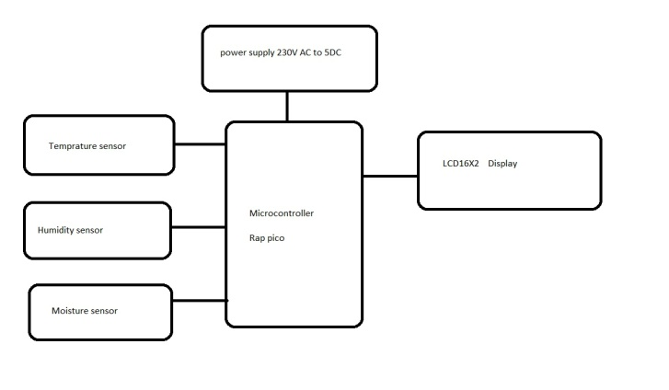
Figure1- SYSTEM’S Block Diagram.
No one expected that Raspberry Pi, the most popular single-board computer maker inthe world, would suddenly release a microcontroller of its own. What's more surprising is that Raspberry Pi Pico does not base its design on the common ESP32 or SAMD21, but instead a brand new microcontroller chip: the RP2040 microcontroller. The RP2040 microcontroller is a microcontroller chip independently designed by Raspberry Pi, and is powered by a dual-core ARM Cortex-M0+ processor that runs.
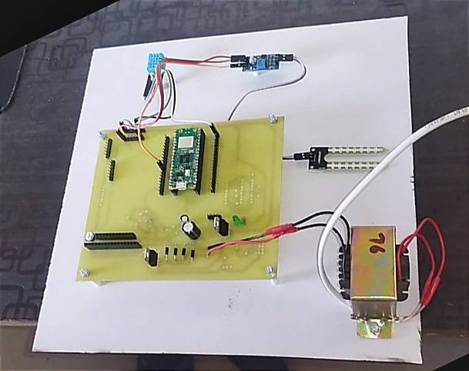
Figure2- SYSTEM’S On Board
Figure3- SYSTEM’S Humidity Sensors
Table 1 Derived results after implementation.
By keeping the weather station in the environment for monitoring enables self-protection to the environment. To implement this need to use the sensor devices in the environment for collecting the data and analysis. By using sensor devices in the environment, we can bring the environment into real life. Then the collected data and analysis results will be available to the user through the Wi-Fi. The smart way to monitor the environment an efficient, low-cost embedded system is presented in this paper. It also sent the sensor parameters to the cloud. This data will be helpful for future analysis and it can be easily shared to other users also. This model can be expanded to monitor the developing cities and industrial zones for pollution monitoring. To protect the public health from pollution, this model provides an efficient and low-cost solution for continuous monitoring of environment.
3.2 System Software
Raspberry Pi Pico is an open-source hardware and software. user can designs and manufactures single-board microcontrollers and microcontroller kits for building digital devices. The open-source Arduino Software (IDE) wirte a code as per user design system it makes it easy to write code and upload it to the board. And This software. System is critical element of measure of assurance and represents the review of specification ultimate review of specification and design. The system is tested during above methods as a theoretical and practical verification of the results. An effort is made to compare the system with traditional one.

4. DISCUSSION
Before applying method to the design test, must understand the basic principle that guide testing. The testing principle include.

The entire test should be traceable to the operator requirement. The most serve defect is those that the program fails to meet its requirement.
Test definition be planed long testing begins, test planning can be begin as soon as requirement model is complete.
Detailed definition of the test has been solidified. Exhaustive testing is not possible. The path permutation for even or moderately sized programs exceptionally large. For this reason it is possible, however to adequately cover. The program logic and to ensure that all condition to complete level has been exercised.

Testing Objectives:
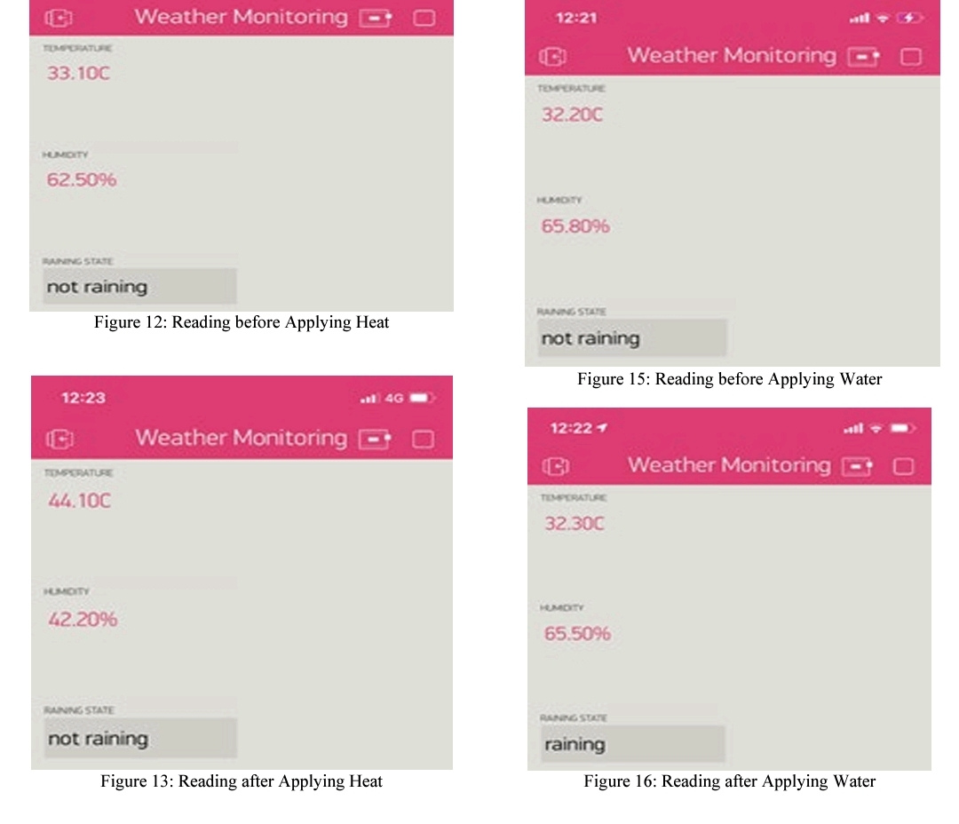
There are various testing objective. Testing is process of executing hardware with intend of finding an error. We can find out an undiscovered error with minimum amount of time and effort. If testing is conducted successfully it will uncover error in hardware. As a secondary benefit, testing demonstrate that hardware function appear to the working specification that behaved and performance requirement appears to have been met. In addition data collected as testing cannot show absence of error and defect. It can show accuracy and deviation in the measured value. A good is one that of the has probability of finding an un discovered error. The objective is to design the test is that of systematically uncover different types of error and to do with minimum time and effort.

Faults and their Possible Remedies:

- Checking all the connections.
- Checking all the Power Supply Sections.
Checking all the connections:
By using the DMM check all the connection made by the wire. Also check the connections that the any wire is break or disconnected. If found so then connect it using the soldering Gun.

Checking the Power Supply Output:
By using the DMM test all the Power Supply output voltage available at the series voltage regulator and Transformer bridge rectifier output. 3
Figure4- SYSTEM’S Experimental Real Time Results

Continuity Test:
In electronics, a continuity test is the checking of an electric circuit to see if current flows (that it is in fact a complete circuit). A continuity test is performed by placing a small voltage (wired in series with an LED or noise-producing component such as a piezoelectric speaker) across the chosen path. If electron flow is inhibited by broken conductors, damaged components, or excessive resistance, the circuit is "open".
Devices that can be used to perform continuity tests include multi meters which measure current and specialized continuity testers which are cheaper, more basic devices, generally with a simple light bulb that lights up when current flows.An important application is the continuity test of a bundle of wires so as to find the two ends belonging to a particular one of these wires; there will be a negligible resistance between the "right" ends, and only between the "right" ends.
Figure5- SYSTEM’S Experimental Real Time Results
This test is the performed just after the hardware soldering and configuration has been completed. This test aims at finding any electrical open paths in the circuit after the soldering. Many a times, the electrical continuity in the circuit is lost due to improper soldering, wrong and rough handling of the PCB, improper usage of the soldering iron, component failures and presence of bugs in the circuit diagram. We use a multi meter to perform this test. We keep the multi meter in buzzer mode and connect the ground terminal of the multi meter to the ground. We connect both the terminals across the path that needs to be checked. If there is continuation then you will hear the beep sound.
Figure4- SYSTEM’S Experimental Real Time Results

- Implementation
Climate change affecting the crops this project first we sense the current weather conditions and according with the current weather status we will create an chart that will predict the next few days or months weather, on the basis of this information acooring with the souce information device will tell us the seeds that will be suitable for this type of weather so we will deal with the live problem that how the climate change affects the plant seed germination so how do we overcome this problem? By using weather sensing technology and raspberry pi module we will be able to find the right seed which
will be suitable for the uneven climate conditions.

Engineering ideas in farming industries have an huge scope for market and we all moving towards urbanization and modernization but still farmers takes huge efforts and hard work for farming but still they fails on un-suitable conditions and after a huge efforts they don’t have much revenue as compared to hard work they done. So if we consolidates their problem that which seed is much profitable according weather conditions hence this deals with the live problem if we’ll able to know the which seed is more profitable, easy in fertilization, needs less time to grow then we can definitely done a good job in farming hence this project will have a huge scope. The agriculture sector forms only about 18 percent of India’s GDP despite employing almost 65 percent of the total workforce. Despite significant improvement in food grain production, there are several challenges to tackle as the government aims to increase agricultural production as a share of GDP. Agriculture in India is largely dependent on nature, but climate and global warming issues make farming unpredictable. The need of the hour is to educate farmers in the use of modern technology and innovative approaches to increase productivity and raise profitability.
Agricultural development practices over a while have been perceived to exploit natural resources faster than they could be renewed. Exponential growth in the human population has resulted in demand for food and shelter, which the “natural” carrying capacity of the land is under pressure to provide.

Natural imbalance is visible in climate, soil Humidity, soil cons, and human-created alterations of
flora and fauna. It is reasonable to assume that human population growth will continue and place greater demands on the Agri-ecosystem. Thus, technology has and will continue to play a major role in agriculture and sustainable development going forward.Technology has a major role in farming and agriculture practices; and with the advent of digital technology, the scope has widened. Innovation in agriculture is leading an evolution in agricultural practices, thereby reducing losses and increasing efficiency. This is positively impacting farmers. The use of digital and analytic tools is driving continuous improvement in agriculture, and the trend is here to stay, resulting in improving crop yields and helping to increase the income of the farming community.

Climate/ weather prediction – A major advance in agriculture is the use of artificial intelligence (AI). Modern equipment and tools based on AI enable data gathering and assist in precision farming and informed decision-making. Drones, remote sensors, and satellites gather 24/7 data on weather patterns in and around the fields, providing farmers with vital information on temperature, rainfall, soil, humidity, etc.

However, finds slow acceptance in a country like India where marginal farming, fragmented landholdings, and other reasons act as impediments. But there is no doubt that technologies based on AI can bring precision to large-scale farming and lead to an exponential rise in productivity. Communications technology has evolved rapidly in India and made smart farming a possibility
.
Sensors are now being used in agriculture to provide data to farmers to monitor and optimize crops given the environmental conditions and challenges. These sensors are based on wireless connectivity and find application in many areas such as determining soil composition and moisture content, nutrient detection, location for precision, airflow, etc. Sensors help farmers save on pesticides, and labor, and result in efficient fertilizer application. They allow farmers to maximize yields using minimal natural resources.

6. CONCLUSION
This System monitors the changes happening over the climate and provides enough ways for the users to access the information and display the readings. The temperature and humidity and moisture sensor will monitor and gives the details about the changes happening over the climate. All this climate conditions are shown and system able to predict the right seed for farmers to get used for farming according the data of present environmental conditions. The Monitored condition will be updated time to time.
This Device first sense the environment climate conditions like temperature, rain, humidity and this information is displayed on the screen after that on the basis of this information it will show the prediction of weather of next few months and creates a chart this chart delivers to the User and then according to the prediction of weather and climate condition the device will show the chart of perfect seeds which can be sow for harvest and this all done with the above information of seed wise chart harvest and after that user can easily decide that which seeds will be suitable during the season or climate. By keeping the weather station in the environment for monitoring enables self protection (i.e., smart environment) to the environment. To implement this need to use the sensor devices in the environment for collecting the data and analysis. By using sensor devices in the environment, we can bring the environment into real life. Then the collected data and analysis results will be available to the user through the Wi-Fi. The smart way to monitor environment an efficient, low cost embedded system is presented in this paper. It also sent the sensor parameters to the cloud. This data will be help ful for future analysis and it can be easily shared too the users also. This model can be expanded to monitor the developing cities and industrial zones for pollution monitoring. To protect the public health from pollution, this model provides an efficient and low cost solution for continuous monitoring of environment.

.REFERENCES
- Mary Nsabagwaa, Maximus Byamukamab, Emmanuel Kondelaa, “Towards a robust and
- affordable Automatic Weather Station “, journal homepage: www.elsevier.com/locate/deveng.
- Ravi Kishore Kodali and Snehashish Mandal “IoT Based Weather Station” 2016
- International Conference on Control, Instrumentation, Communication and Computational
- Technologies (ICCICCT) 978-1-5090- 5240-0/16/$31.00, IEEE, (2016).
- Ravi Kishore Kodali and Archana Sahu “An IoT based Weather Information Prototype
- Using WeMos” 2016 2nd International Conference on Contemporary Computing and
- Informatics (ic3i), 978-1-5090-5256- 1/16/$31.00, IEEE, (2016)
- Zi-Qi Huang, Ying-Chih Chen and Chih-Yu Wen, “Real-Time Weather Monitoring and
- Prediction Using City Buses and Machine Learning”, Vols. 3 to 21 Published 10 September (2020)
- Kavya Ladi, A V S N Manoj, G V N Deepak, “IOT Based Weather Reporting System to
- Find Dynamic Climatic Parameters”, International Conference on Energy, Communication, Data Analytics and Soft Computing (ICECDS-2017)
- P. Susmitha, G. Sowmyabala “Design and Implementation of Weather Monitoring and
- Controlling System”, International Journal of Computer Applications (0975 – 8887) Volume 97– No.3, (July 2014)
- Tanmay Parashar1, Shobhit Gahlot2, Akash Godbole3, Y.B. Thakare4 “Weather
- Monitoring System Using Wi-Fi”, (IJSR) ISSN (Online): 2319-7064 Index Copernicus Value (2015): 78.96, 2015
- Nutant Sabharwal, Rajesh Kumar, Abhishek Thakur, Jitender Sharma “A LOW-COST
- ZIGBEE BASED AUTOMATIC WIRELESS WEATHER STATION WITH GUI AND
- WEB HOSTING FACILITY” e-ISSN: 1694-2310 | p-ISSN: 1694-2426, Vol. 1, Spl. Issue 2(May 2014)
- M. Prasanna, M. Iyapparaja, M. Vinothkumar, B Ramamurthy, S.S. Manivannan,” An
- Intelligent Weather Monitoring System using Internet of Things”, International Journal of
- Recent Technology and Engineering (IJRTE) ISSN: 2277-3878, Volume-8 Issue4, November (2019)
- Mircea Popa and Catalin Iapa “Embedded Weather Station with Remote Wireless
- Control”, 19th Telecommunications forum TELFOR 2011 Serbia, Belgrade, November 22-
- Padmadevi, S., and K. SanthaSheela. "Survey on street lighting system based on vehicle movements." Int. J. Innov.Res. Sci., Eng., Tech 3, no. 2 (2012).
- Steve Chadwick,“Street Light Monitoring – a Practical Solution magazine” November/December 2002.
- “Wireless internet lighting control system”,Budike, E.S. Lothar (Power web Technologies), US patent 7,167,777,Jan 23, 2007.
- http://www.hobbytronics.co.uk/arduino-uno-r3.

