Case Study: Solar Power Monitor Using IoT

Tushar Dhake¹, Vijay D. Chaudhari². Dr. Ishwar S. Jadhav³, Hemraj V. Dhande ⁴, Hemant T. Ingale⁵
¹PG student, ² Assistant Professor
^{1,2,3,4,5} E&TC dept, MTech (VLSI & ES), GF’s Godavari College of Engg, Jalgaon - 425003, Maharashtra, India.

tushardhake@gmail.com ¹, vinuda.chaudhari@gmail.com², hemrajd99@gmail.com4

Received on: 04 May,2024 Revised on: 04 June,2024, Published on: 06 June ,2024

Abstract- Using the Internet of Things Technology for supervising solar power generation can greatly enhance the performance, monitoring and maintenance of the plant. With advancement of technologies the cost of renewable energy equipment is going down globally encouraging large scale solar plant installations. This massive scale of solar system deployment requires sophisticated systems for automation of the plant monitoring remotely using web based interfaces as majority of them are installed in inaccessible location as and thus unable to be monitored from a dedicated location. The Project is based on implementation of new cost effective methodology based on IoT to remotely monitoring a solar plant for performance monitoring.
Keywords: Internet of Things (IoT), NODE MCU, GSMA, PV, Solar panel, LCD, Things Speak.

- INTRODUCTION

The Internet of Things (IoT) is now playing a major role in improving the daily life of humans by enabling the connectivity of many devices to the Internet to exchange data for monitoring and control devices from a remote location. This is what makes devices intelligent [1]. This technology can connect a wide variety of things like sensors on animals, sensors for humans or smart devices, smart transport, smart grid, power grid, smart

city infrastructure, vehicles, health monitoring systems, environmental parameter sensing, shopping systems, smart homes. , energy management systems, smart assistance for disabled and elderly persons, cochlear implants, object tracking, equipment manufacturing, agriculture, emergency monitoring systems, electronics tool collection systems, vehicle control, etc. 8.4 billion internet connected devices by 2016-2017. Connected devices could grow to 30 billion by 2020, making the business market around $7.1 trillion by 2020 [2]. Using IoT we can enable machine to machine communication (M2M) or device to device (D2D) communication without human intervention.
Electricity has become an important and necessary part of life in modern life. Nowadays we need electricity for most things like lighting, heating, refrigeration, cooling, transportation system. Not all home appliances run on electricity. Electricity consumption is increasing today and will not decrease in the future. To compete with the increasing demand for electricity, more and more electricity has to be generated and supplied to end users such as individuals, industries, institutions, offices, essential services etc. As population and economic growth increases, so does consumption.

Power is generated in three ways: generator, electro chemistry, photovoltaic effect.
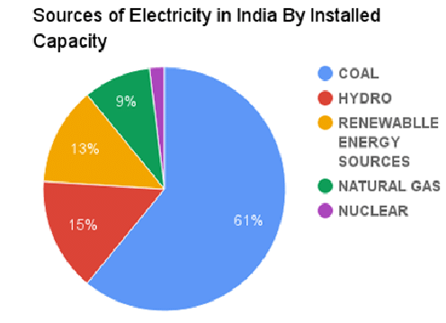

Fig. 1: The percentage of power sources installed

An electric generator is the most widely used method of generating electricity which is based on Faraday's law of electromagnetic induction by converting mechanical energy into electrical energy. Storing electricity in batteries is called electrochemistry which converts chemical energy into electrical energy. Another source of electricity is renewable energy which converts sunlight energy into electrical energy known as photovoltaic effect which we know as solar energy. Electricity in this is generated from a free and abundant source which is sunlight.

Mechanically generated power is cheaper than solar energy to produce in large quantities due to the land requirement for photovoltaic solar panels and setup. In remote places where there is no commercial power, solar energy becomes a source of electricity for homes and other things. In recent times solar panels have been dramatically deployed and subsidized for their rapid adoption. Due to environmental conditions such as global warming, all countries around the world are reducing electricity generation by burning fossil fuels.
A typical solar module consists of 6x10 photovoltaic solar cells that can generate power for residential applications.
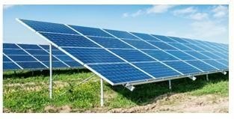
Fig. 2: Solar panels

If we need more electricity, then more panels are required. The panel produces a DC output power of 100 to 365Watts.

A large number of panels are placed in an arrangement called Solar Plants to generate electricity for commercial and industrial purposes.
The output power of solar panels always depends on the radiation that reaches the solar cells, which is converted into electrical energy. If there is more dust on the panels, less electricity is produced where the efficiency of the solar panels decreases. In order to increase the efficiency of solar panels, some optimization process should be done. In this paper, we propose a system to control the dust collected in the panels. The system consists of a Node MCU, a controller coupled with an LDR sensor. The monitor checks the programmed preset conditions and detects dust accumulation on the panels by reducing the output voltage and alerting the user or service personnel. It also uses Thinkspeak's IOT application to display data from sensors [9].

- Literature of the Existing Method

Many researchers have done a lot of research on this important issue and have proven that the performance of PV solar panels decreases up to 50% due to the accumulation of dust on the panels.
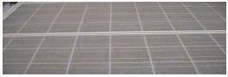
Fig. 3: Solar module covered by heavy layer of dust accumulated before cleaning

A study conducted by a world-renowned organization on the effects of dust accumulation on solar panels. A 1.6 MW solar facility [3] is located at Google's headquarters in California. An average loss of 4.7% was recorded in the pioneer Hotel e.l. [4]. Author Salim et al conducted a study on dust accumulation and reported a 32% reduction in solar energy over eight months in a solar village near Riyadh [5]. The test was carried out by the author Dirk Goosen and others. Al [6] on the deposition of dust particles, which affects the performance of PV cells and analyzed airborne concentration and wind speed caused by the accumulation of dust. Author Garg of Roorkee made an experiment and discovered that panel would reduce 8% average transmittance by the accumulation of dirt on 45-degree tilted glass plate after a 10-day period [7]. Due to accumulation of dust on the panels it is observed that useful energy is reduced by 30%. The common methods used to clean the dust is by spraying water on the panels with cleaning agent. Vibrating the panels with motors as the cell phone vibrates so that the dust goes off from the panels. The dust jumps off from the panels by creating a positive charge. By using a manual brush method too we can clean the PV panels. Hence Solar panel monitoring is important. It is vital that solar panels are monitored regularly in one way or another. You need to make sure they are operating correctly, and the system is generating as much as predicted. If you have solar panels installed, you should at the very least check the generation meter once a week and take a note of the reading [8]. And should go to the place of the panels arranged and note the readings at regular predefined time. It is a manual checking procedure, which mandates going to the place of solar panel system arrangement to note down the readings. It is not possible to take readings all the time, as it is required to go to the place of system arrangement. And optimum power cannot be obtained unless there is proper alignment of solar power.

- Proposed Method

The main objective of this project is to get an optimum power output from the solar panels during normal operation when dust is accumulated on it. Also, if there is any malfunctioning of the solar panels then we should get this information, also whether the solar output or battery is connected to the loads. The system detects and alerts the user or the administrator when is fall below the pre- define conditions, and display on the GUI. A solar panel is used that keeps monitoring the sunlight. Here different parameters like voltage, current and temperature are displayed on the LCD by using IOT technology.

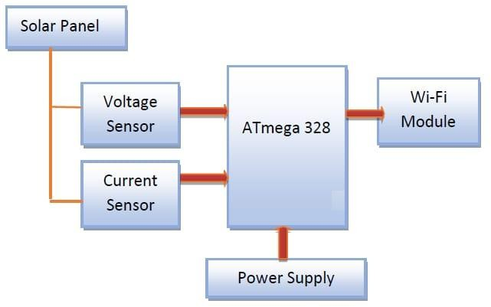

Fig. 4: Block diagram of proposed method

The above shown is the block diagram in figure 4 is the block diagram of the proposed method
- Hardware Implementation of the Proposed Method

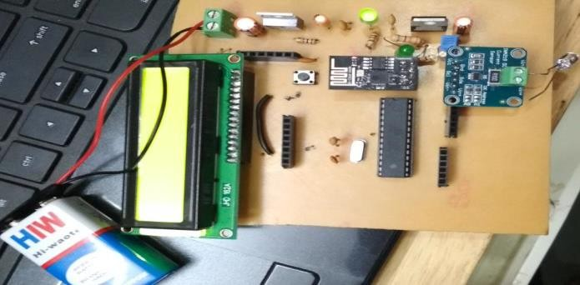

Fig. 5: Hardware implementation of the proposed method

The most visible part of a residential solar energy system is the solar panels. Thin film semiconductors or crystalline silicon are used to produce PV solar cells for most residential applications. Photovoltaic (PV) devices contain semiconductors that generate electricity directly from sunlight.
Electricity is produced when electrons are made free by solar energy in these materials. It is used to run electrical equipment or send to the grid. One of the most important aspects of getting your solar panels to produce electricity at optimal efficiency is keeping them out of direct sunlight. When a photovoltaic solar panel is exposed to direct sunlight, voltage is generated. Solar panels produce DC, where home appliances run on AC power, so the output of the panels is provided as input to the inverter. All of these devices are powered by an inverter. The inverter consists of a battery. The battery charges when the device is not in use and recharges when power is needed.
A solar monitoring system will track the amount of electricity your solar panels have produced and contributed. We use a light-sensitive resistor to sense the light. This component changes its resistance with the intensity of light falling on it and can vary from day to day. There are many potential ways to monitor solar panel performance. There are high-tech solutions that continuously upload data to web portals that allow you to monitor your system's performance from anywhere in the world.
This proposed system uses Thinkspeak, an open source [10] cloud platform. It receives and stores data from sensors or connects to systems on the Internet using Hypertext Transfer Protocol (HTTP) from local systems to the cloud. Updates all data logs received from sensors, tracking location apps and location apps sent and received from users. To use this, the user must create an account that allows access to multiple channels to monitor various parameters in the system or monitor parameters on a remote device. This cloud application allows administrators or users to visualize data graphically. With Internet-based monitoring, energy output data is sent to the router and made available through an online interface. The main advantage of a system like this is that the solar panel output data is readily available wherever an Internet connection is available.

The MCU point acts as the main processing element for the proposed system as shown in Figure 4 and Figure 5. ESP8266 on a single board can be programmed using Arduino IDE with 128Kbytes of RAM, developed by the open source microcontroller community. and program storage capacity of 4 Megabytes. The operating voltage is 3.3-5 volts and can be powered by a USB cable and the SoC's built-in Wi-Fi architecture. Figure 6 shows the MCU node.

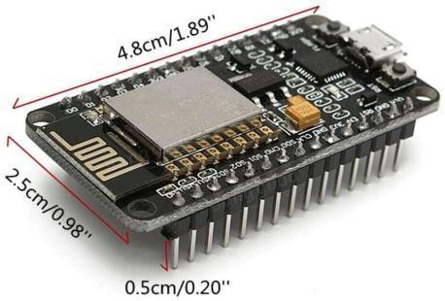

Fig. 6: Node MCU

Solar Panel
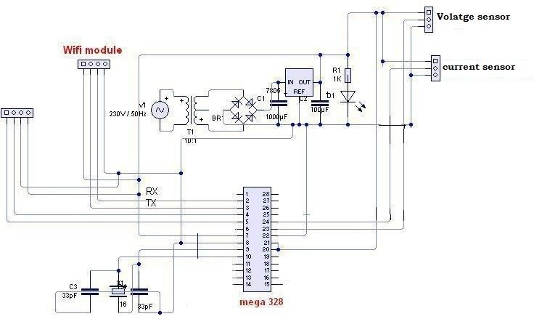
The electrical energy produced by capturing sunlight is called Solar Energy, which is used for business and home purposes. Natural nuclear reactors emit energy in tiny packets called photons. When a photon hits a solar cell, the atom loses an electron. A solar panel consists of several panels wired together, and by placing more panels, electricity can be produced. Silicon is used as a conductor
Fabrication of PV photovoltaic solar panels is shown in Figure 7. Direct current is produced by solar panels. Most electrical appliances operate on an AC supply. AC current can be cheaper to transmit.

Things Speak Cloud setup

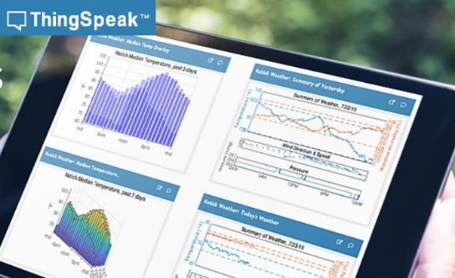

Fig. 9: ThinkSpeak GUI

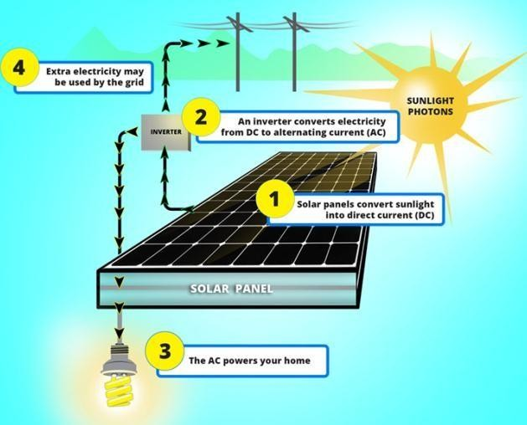
Fig. 7: Solar Energy Conversion
LDR
Photoconductivity is the basic working principle of LDR or light emitting resistor. All electrons in the semiconductor valence band are excited when light or photons fall on the resistor. When the LDR is exposed to light, its resistance decreases and in the dark the resistance increases, called dark resistance. Based on the material of LDRs, they are divided into two types, intrinsic photoresistor and extrinsic photoresistor.

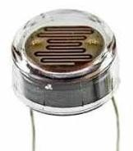
Fig. 8: LDR
It uses the Thinkspeak open source cloud platform. It receives and stores data from sensors or connects to systems on the Internet using Hypertext Transfer Protocol (HTTP) from local systems to the cloud. Update the application location received from sensors, trackers and location applications to the user and received from the user. To use this, the user has created an account that includes several channels to monitor various parameters in the system or monitor parameters on a remote device. This cloud allows administrators or users to visualize data in graphical form anywhere in the world with internet access. With Internet-based monitoring, energy output data is sent to the router and made available through an online interface. The main advantage of such a system is that the solar panel output data is available in GUI format wherever there is an Internet connection.

RESULTS & CONCLUSION

In this project, an IoT-based system is designed to receive alerts when dust accumulates on solar panels for optimal power output. Also, a monitoring system has been developed that will indicate the failure of the solar panels and we can get information about the failure of the solar or battery connected to the load. Now display these parameters to the user using an intuitive GUI as shown in Figure 10 and alert the user if the output exceeds certain thresholds. Solar panels are used which continuously monitor the sunlight. Here various parameters such as voltage, current and temperature are displayed on the LCD through IOT technology. Currently we only receive data that we can see in the cloud, but in the future we can control the entire system through IoT remotely.

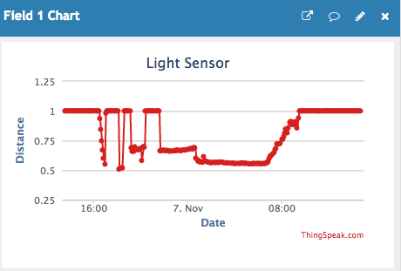

Fig. 10: LDR values transmitted from the working location to the cloud

REFERENCES

  - P. Gopi Krishna et. al. “Design and development of bi-directional smart IoT gateway with interoperability for heterogeneous devices” International Journal of Engineering & Technology, 7 (2.8) (2018) 109-114
  - Nordrum, Amy (18 August 2016). "Popular Internet of Things Forecast of 50 Billion Devices by 2020 Is Outdated".IEEE
  - M. Moon. (2009) Google Studies How Dirt Affects Solar Panel Efficiency. PC Magazine: Good Clean Tech. Available:www.goodcleantech.com/2009/08/google_studies_how_dirt_affect.php
[4] M. C. Hottel and B. B. Woertz, "Performance of flat plate solar heat collectors," ASME Trans., vol. 64, pp. 91-104,1942.
  - Salim, F. Huraib, and N. Eugenio, " PV power-study of system options and optimization," in Proceedings of the 8th European PV Solar Energy Conference, Florence, Italy,1988.
  - H. P. Garg, "Effect of dirt on transparent covers in flat-plate solar energycollectors,"SolarEnergy,vol.15,pp.299-302,1973
  - P. Gopi Krishna et. al. “Design and development of smart energy meter for effective use of electricity in IoT applications” International Journal of Engineering & Technology, 7 (2.8) (2018) 115-119
  - P. Gopi Krishna et. al “Design and development of bi-directional IoT gateway using ZigBee and Wi-Fi technologies with MQTT protocol” International Journal of Engineering & Technology, 7 (2.8) (2018)125-129
  - Agora Energiewende (2016), “Agorameter”, website, www.agora- energiewende.de/en/topics/- agothem-/Produkt/produkt/76/Agorameter/ (accessed 23 May 2016).
  - BNEF (Bloomberg New Energy Finance) (2016), Renewable Energy Projects dataset, Bloomberg New Energy Finance website, (accessed on 15 April2016).
  - CENACE (2016), “Subastas Largo Plazo” [Long Term Auctions],

