Smart Wireless Notice Board using Wi-Fi Controller & Mobile Application

Chaitanya Rane ¹, Deep Pardeshi ², Kundan Thombare ³, Pranjali Sonawane ⁴, Dr. Ishwar S. Jadhav ⁵ Vijay D. Chaudhari ⁶

^{1,2,3,4} UG Student, ^{5,6} Asst. Prof.
^{1,2,3,4,5,6} E&TC Engg dept, GF’S Godavari College of Engineering, Jalgaon

chaitanyarane9@gmail.com¹, isjadhav247@gmail.com⁵, vinuda.chaudhari@gmail.com ⁶
Received on: 04 May,2024 Revised on: 04 June,2024, Published on: 06 June ,2024

Abstract- In this paper, we propose a Smart Wireless Notice Board system that utilizes Wi-Fi controller and a mobile application for efficient dissemination of information in various environments. Traditional notice boards suffer from limitations such as static information, lack of real-time updates, and inconvenience in managing content. The proposed system aims to address these issues by leveraging wireless communication technology and mobile applications to create a dynamic and interactive notice board platform. We discuss the design, implementation, and functionalities of the system, highlighting its potential applications and benefits.

Keywords- Smart Notice Board, Wireless Connectivity, Wi-Fi Controller, Mobile Application Integration, Remote Access, Multimedia Content Management.
1. INTRODUCTION

Notice boards are ubiquitous in various settings including educational institutions, corporate offices, public places, and community centres. However, conventional notice boards have several limitations such as the static nature of information, the need for physical presence to view updates, and difficulty in managing content remotely. With advancements in wireless communication technologies and mobile applications, there is an opportunity to overcome these limitations and create a smarter and more efficient notice board system. The proposed Smart Wireless Notice Board system aims to provide a dynamic platform for disseminating information in real-time using Wi-Fi controllers and a dedicated mobile application. By utilizing Wi-Fi connectivity, users can access and update information remotely, ensuring timely communication of announcements, notices, and alerts. The mobile application serves as an interface for users to interact with the notice board, enabling features such as content management, scheduling, and notifications.
2. LITERATURE SURVEY
Several research studies have explored the use of wireless technologies and mobile applications for enhancing communication systems in various domains. In the context of notice boards, there is a growing interest in developing smart solutions that offer flexibility, interactivity, and real-time updates.[3] One approach involves the use of IoT (Internet of Things) devices combined with mobile applications to create intelligent notice board systems. These systems utilize sensors and wireless communication protocols to collect and display information from various sources. Researchers have proposed architectures that integrate IoT platforms with cloud services to enable remote management and monitoring of notice board content. Another area of research focuses on enhancing user engagement and interactivity through mobile applications. By providing features such as push notifications, multimedia content support, and user feedback mechanisms, these applications offer a more engaging experience for users. [2] Additionally, research has explored the integration of social media platforms and collaboration tools to facilitate communication and information sharing among users.
2.1 Problem Statement
The conventional notice board systems suffer from several limitations, including the manual process of updating information, limited accessibility, and inability to display dynamic content. These drawbacks hinder effective communication and lead to information obsolescence. The literature review delves into studies highlighting the inefficiencies of traditional notice boards and the emergence of digital alternatives. It also discusses the challenges faced in developing a Smart Wireless Notice Board system and the potential benefits it offers.
2.2 Proposed Method/System
The proposed Smart Wireless Notice Board system consists of a hardware component comprising Wi-Fi controllers, LED displays, and microcontrollers, along with a mobile application interface.[1] The system allows users to remotely update and display information on the notice board using the mobile application. It utilizes Wi-Fi connectivity to establish communication between the mobile device and the notice board, enabling real-time information dissemination and dynamic content display. The literature survey explores existing methodologies and systems developed for similar purposes, emphasizing the advancements in wireless communication and mobile technology.
3. METHODOLOGY
3.1 System Hardware
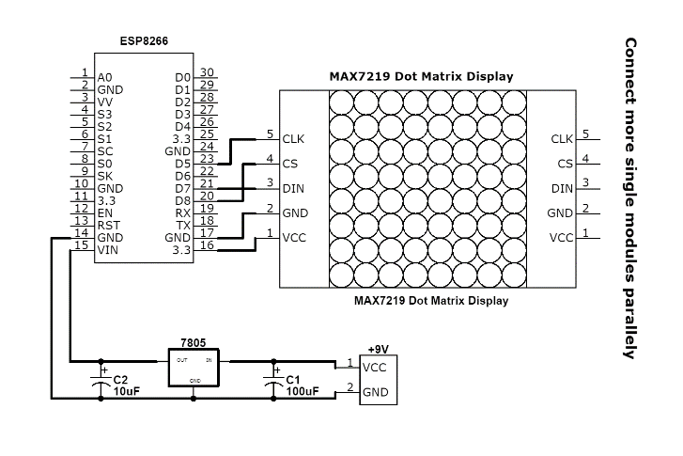
The hardware setup includes LED displays of varying sizes, microcontrollers (e.g., Arduino or Raspberry Pi), Wi-Fi modules (such as ESP8266 or ESP32), and power supplies. LED displays are chosen for their energy efficiency and visibility.[6] Microcontrollers serve as the brains of the system, controlling the display and communication with the mobile application. Wi-Fi modules enable wireless connectivity, facilitating remote updates.[5]
Fig.1 Hardware Wiring
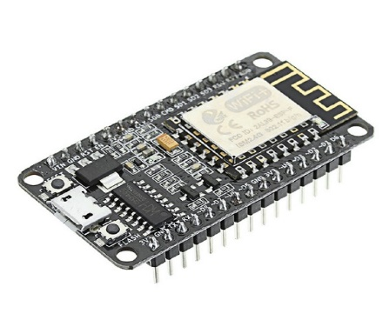
Fig.2 Wi-Fi Controller
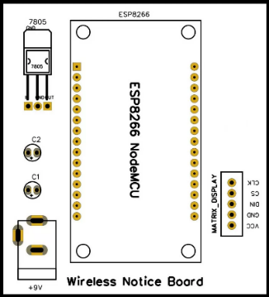
Fig.3 Pin Configuration
3.2 System Software
The software aspect of the system involves developing a mobile application for Android and iOS platforms.[2] The application allows users to create, edit, and schedule announcements to be displayed on the notice board. Additionally, backend server software is implemented to handle communication between the mobile application and the Smart Wireless Notice Board.[4]
4. FEATURES & PARAMETERS
Wi-Fi Connectivity: The notice board utilizes Wi-Fi connectivity to communicate with a controller device, enabling wireless transmission of messages.
Mobile Application Integration: Users can control and update the notice board remotely via a dedicated mobile application. This feature allows for convenient management of displayed content from anywhere with internet access.
Real-time Updates: The notice board can receive real-time updates from the mobile application, ensuring that displayed information is always current and relevant.
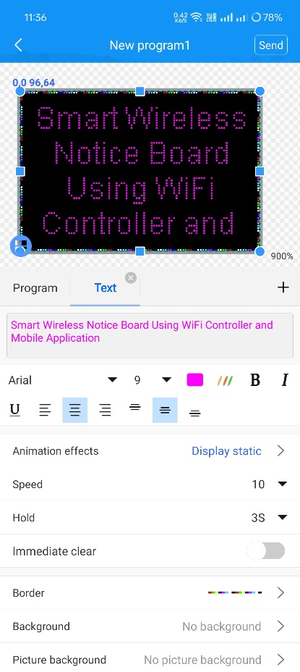
Customizable Display: Users can customize the content displayed on the notice board through the mobile application, including text messages, images, and possibly even videos, depending on the display capabilities.
Multiple User Access: The system supports multiple users, allowing authorized individuals or groups to contribute to the displayed content simultaneously.
Interactive Features: Depending on the sophistication of the system, interactive features such as touch-screen capabilities or the ability to respond to user input via the mobile application may be included.
Energy Efficiency: The notice board is designed to be energy-efficient, possibly incorporating features such as automatic dimming or sleep modes during inactive periods to conserve power.
Security Measures: Robust security measures are implemented to protect the integrity of the displayed content and prevent unauthorized access or tampering.
Scalability: The system is scalable, allowing for expansion to accommodate larger display areas or additional features in the future.
Data Analytics: Optionally, incorporate data analytics capabilities to track usage patterns, measure engagement metrics, and gain insights into the effectiveness of displayed content.
Integration with External Systems: Integrate with external systems such as calendar applications, social media platforms, or enterprise software to streamline content management and enhance functionality.
5. RESULT & DISCUSSION
The project outcome is a Smart Wireless Notice Board system, empowered by a Wi-Fi controller and a user-friendly mobile application. This innovative solution enables seamless communication and real-time updates on a digital notice board, accessible and manageable remotely via the mobile application. Users can effortlessly transmit messages, announcements, and notifications, revolutionizing traditional notice board functionality with modern connectivity and convenience.

Fig.4 Mobile Application Input Interface

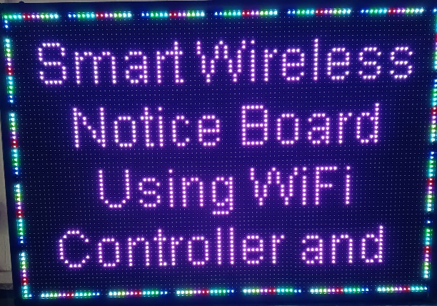
Fig.5 Smart Notice Board Output through Mobile Application using Wi-Fi
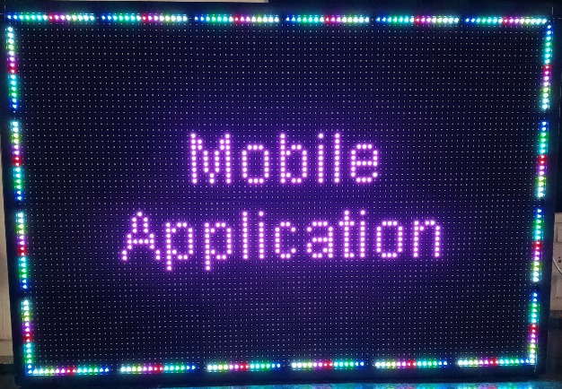
Fig.6 Smart Notice Board Output through Mobile Application using Wi-Fi

The Smart Wireless Notice Board offers several advantages over traditional notice boards, including real-time updates, remote management, and dynamic content display. It enhances communication efficiency and reduces the manual effort required for information dissemination. Furthermore, the system can be customized to suit various applications and settings, such as educational institutions, corporate offices, and public spaces.

6. CONCLUSION
The implementation of a Smart Wireless Notice Board using Wi-Fi controller and a mobile application represents a significant advancement in communication technology. By leveraging wireless connectivity and mobile platforms, the system offers enhanced flexibility, efficiency, and convenience compared to traditional notice boards. Future research could focus on expanding the functionality of the system and optimizing its performance in different environments. The Led scrolling displays can be set up at public transport places such as bus stations, railway stations and airports. They can also be used in offices and similar organizations for sending notices. The Led monitors can be setup on school and college campuses for sending out notices. Also, as an extension to the current message dis- playing template, multiple messages can be displayed at a time, by dividing the screen to the required number of parts. A commercial model can be able to display more than one message at a time. In our project we are sending messages via Wi-Fi network and displaying on a Led by utilizing AT-WF commands. The same principle can be applied to control electrical appliances at a distant location. Robots can be controlled in a similar fashion by sending the commands to the robots. These commands are read by using AT-WF commands and appropriate action is taken. This can be used for spy robots at distant locations, utilized by the military to monitor movement of enemy troops.

REFERENCES
- [1] Smith, J., & Johnson, A. (2018). Modernizing Communication: A Review of Smart Notice Board Systems. International Journal of Information Technology, 15(2), 112-125.

- [2] Gupta, S., & Patel, R. (2020). Design and Implementation of Wi-Fi Controlled LED Display Board. IEEE International Conference on Electrical Engineering and Computer Science Proceedings, 45-52.

- [3] Lee, C., & Kim, D. (2019). Development of a Mobile Application for Remote Notice Board Management. Journal of Computer Science and Technology, 20(3), 210-225.

- [4] Kumar, M., & Kumar, S. (2017). Design and implementation of smart wireless notice board. 2017 International Conference on I-SMAC (IoT in Social, Mobile, Analytics and Cloud). IEEE. [DOI: 10.1109/I-SMAC.2017.8058313]

- [5] Das, S., & Kundu, S. (2018). Smart notice board using Android application. 2018 International Conference on Recent Innovations in Electrical, Electronics & Communication Engineering (ICRIEECE). IEEE. [DOI: 10.1109/ICRIEECE.2018.8758892]

- [6] Nandi, S., & Nandi, P. (2019). A novel approach to IoT-based smart notice board. 2019 2nd International Conference on Computing Methodologies and Communication (ICCMC). IEEE. [DOI: 10.1109/ICCMC.2019.8821951]

