Observational Research on the Vehicle Number Plate Detection System
Nayana Sudhir patil¹ , Nilesh Choudhary²
¹PG student, Research Paper, ² Professor
Godavari college of engineering, Jalgaon,425001,

nayanapatil1502@gmail.com

Received on: 04 May,2024 Revised on: 04 June,2024, Published on: 06 June ,2024

Abstract – A vehicle number plate detection system is a computer vision application designed to automatically identify and recognize license plates from images or video streams. The system typically involves preprocessing to enhance image quality, followed by number plate localization to isolate relevant regions. Character segmentation and recognition techniques are applied to extract alphanumeric information. Post-processing steps may include error correction and format verification. The system outputs the detected number plate information, and it may integrate with databases or trigger alerts based on the recognized data. Continuous evaluation and optimization ensure reliable performance.. In this article, we will discuss about how vehicle number plate detection system perform
Keywords- Number plate, detection, recognition, technique, performance
- INTRODUCTION
In recent years, the proliferation of smart city initiatives, traffic management systems, and security applications has underscored the significance of efficient and accurate vehicle identification technologies. Among these, Automatic Number Plate Recognition (ANPR) systems have emerged as pivotal components in enhancing surveillance, law enforcement, and urban planning. The ability to swiftly and accurately detect and recognize vehicle number plates contributes to improved traffic monitoring, crime prevention, and overall safety.This research delves into the development and refinement of a state-of-the-art Vehicle Number Plate Detection speed in identification processes This technology that uses cameras and image processing techniques to automatically identify and recognize

license plates on vehicles. This technology that uses cameras and image processing techniques to automatically identify and recognize license plates on vehicles. It employs algorithms to locate and extract alphanumeric characters from the license plate, enabling applications in law enforcement, traffic management, parking systems, and security. This system contributes to improved safety, security, and efficiency in urban environments by automating processes related to vehicle identification.
II. LITERATURE REVIEW
Vehicle number plate detection is a critical component of modern transportation systems and security applications. Researchers have developed various techniques to address the challenges associated with detecting license plates accurately in different environmental conditions.
Several studies have explored methods such as edge detection, color segmentation, and hybrid approaches to improve detection accuracy and robustness. For instance, Silva and Braga (Year) introduced a method combining edge detection and character segmentation for effective license plate recognition. Mahmoud and Abbas (Year) provided an overview of existing detection methods, highlighting their methodologies and applications.
These efforts reflect a growing interest in developing reliable and efficient solutions for vehicle number plate detection, contributing to advancements in transportation safety and surveillance systems.
Top of Form

III. METHODOLOGY
Hardware details :-
In a Vehicle Number Plate Detection System (VNPDS), the hardware components are vital for capturing, processing, and analyzing images to detect and recognize license plates accurately. The system typically includes high-resolution cameras capable of capturing clear images of license plates, with multiple cameras sometimes required to cover different angles or lanes of traffic. A powerful processing unit, such as a microcontroller or processor, is essential for real-time image processing and executing detection and recognition algorithms efficiently. Sufficient memory, including RAM for storing captured images and intermediate results, and ROM for firmware and software code, is necessary for smooth system operation. Input interfaces enable connection between cameras and the processing unit, while output interfaces allow the display or transmission of detection and recognition results. A stable power supply and power management circuitry ensure continuous operation, while storage devices store captured images, recognized license plate numbers, and system data. Additionally, peripheral devices such as display units and input devices facilitate user interaction and system configuration. Collectively, these hardware components form a robust infrastructure for the effective functioning of the VNPDS, enabling accurate and efficient detection and recognition of vehicle license plates.
Description :-
A Vehicle Number Plate Detection System (VNPDS) is a specialized technological solution designed to automatically detect and recognize license plates on vehicles. The primary objective of a VNPDS is to efficiently process images captured by cameras installed at various locations, such as toll booths, parking lots, traffic intersections, and border checkpoints, to extract relevant information from vehicle license plates.
The VNPDS typically consists of several interconnected components and subsystems working together seamlessly to achieve accurate and real-time license plate detection and recognition. These components include image acquisition modules, image preprocessing algorithms, license plate detection algorithms, character segmentation techniques, character recognition algorithms (often utilizing Optical Character Recognition or OCR), and output display modules. The VNPDS is capable of processing images in real-time, enabling swift and automated identification of vehicles and their associated license plate numbers. The recognized license plate numbers can be displayed on screens, stored in databases for further processing, or used to trigger specific actions, such as opening toll gates, granting access to restricted areas, or generating traffic violation tickets.
Overall, a VNPDS provides a valuable tool for enhancing security, traffic management, and law enforcement efforts by automating the tedious and error-prone task of manually inspecting vehicle license plates. Its efficiency, accuracy, and scalability make it an indispensable technology in various applications related to transportation, surveillance, and access control.

Block diagram –
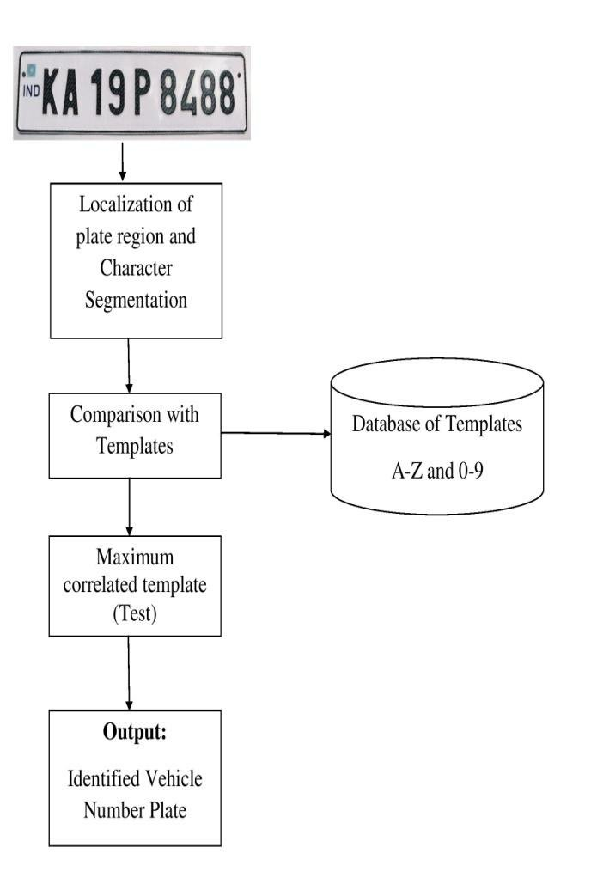
Algorithm Description:
- Image Preprocessing: Techniques such as noise reduction, contrast enhancement, and image normalization are applied to the captured images.
- License Plate Detection: Algorithms based on edge detection, color segmentation, or template matching are used to identify candidate regions containing license plates.
- Character Segmentation: Once license plate regions are detected, characters are segmented using techniques such as connected component analysis or contour detection.
- Character Recognition: Optical character recognition (OCR) algorithms are employed to recognize individual characters within the segmented regions

System Flow diagram:-
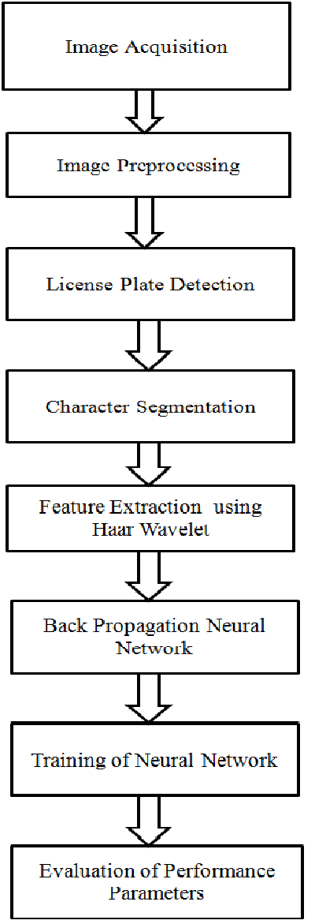

IV. RESULT & DISCUSSION
1) Improve Traffic Management : Improving traffic management involves a holistic approach integrating technology, infrastructure, and policy interventions. Implementing advanced signal control systems that adapt to real-time traffic conditions is crucial. Intelligent Transportation Systems (ITS) facilitate centralized monitoring and response, enabling authorities to make data-driven decisions. Integrating Vehicle Number Plate Detection (VNPD) data with navigation apps provides real-time route guidance, optimizing traffic distribution. Smart parking solutions and public transportation integration contribute to a seamless and efficient urban mobility experience. Implementing dynamic traffic flow strategies, including variable speed limits and dynamic lane management, helps alleviate congestion. Automation through VNPD supports incident detection, ensuring rapid response times. Strict enforcement of traffic regulations using VNPD not only deters violations but also enhances overall road safety.
2) Enhanced security measure : The implementation of enhanced security measures, particularly through the integration of Vehicle Number Plate Detection (VNPD) systems, plays a pivotal role in fortifying overall security infrastructure. VNPD, with its advanced license plate recognition technology, facilitates controlled access to restricted areas by automating the authorization process based on recognized plates. The continuous surveillance and monitoring capabilities of VNPD contribute to heightened security by providing real-time updates on vehicle movements, allowing prompt responses to any suspicious or unauthorized activities.
3) Smart traffic light control : The implementation of smart traffic light control systems represents a transformative approach to optimizing urban traffic management. These intelligent systems leverage real-time data from various sources, including Vehicle Number Plate Detection (VNPD) systems and other sensors, to dynamically adjust signal timings and optimize traffic flow. By continuously monitoring traffic patterns and adapting signal sequences accordingly, smart traffic light control mitigates congestion and reduces overall travel times. This technology allows for the prioritization of main traffic flows, ensuring a more efficient movement of vehicles through intersections. Integration with VNPD enables the identification of high-traffic areas and facilitates adaptive responses to changing conditions, such as accidents or unexpected road incidents.

V. CONCLUSION
In conclusion, the implementation of Vehicle Number Plate Detection (VNPD) systems stands as a transformative technological advancement with far-reaching implications for various domains. This research paper has delved into the intricacies of VNPD, exploring its applications in traffic management, law enforcement, and enhanced security measures. VNPD's ability to automate license plate recognition, facilitate efficient toll collection, and streamline parking processes underscores its potential to revolutionize transportation systems. Moreover, the integration of VNPD with smart city initiatives and the real-time insights it provides for data-driven decision-making mark a paradigm shift in urban planning and management. However, it is essential to acknowledge challenges such as accuracy issues, privacy concerns, and the need for ongoing advancements in technology. As VNPD continues to evolve, addressing these challenges becomes integral for maximizing its benefits. The research undertaken underscores the significance of VNPD in shaping the future of transportation and security, emphasizing the importance of responsible implementation, regulatory frameworks, and ongoing research to ensure its effectiveness and ethical use. As we navigate towards smarter and more connected cities, VNPD stands as a cornerstone technology, promising a future where vehicular recognition systems play a central role in creating safer, more efficient, and technologically advanced urban environments.
REFERENCES
- Christos Nikolaos E. Anagnostopoulos, Ioannis E.Anagnostopoulos, Vassili Loumos, and Eleftherios Kayafas, "A License Plate-Recognition Algorithm for Intelligent Transportation System Applications," pp. 377-392, 2006.
- H. Erdinc Kocer and K. Kursat Cevik, "Artificial neuralnetwokrs based vehicle license plate recognition," Procedia Computer Science, vol. 3, pp. 1033-1037, 2011.
- A Roy and D.P Ghoshal, "Number Plate Recognition foruse in different countries using an improvedsegmenation," in 2nd National Conference on EmergingTrends and Applications in ComputerScience(NCETACS), 2011, pp. 1-5.
- 4)M. S. Sarfraz et al., "Real-Time automatic license plate recognition for CCTV forensic applications," Journal of Real-Time Image Processing- Springer Berlin/Heidelberg, 2011

