Analysis of IEEE 5 Bus Power Quality By 48 Pulse STATCOM
¹Prof Rajendra Bhome ²Akanksha R Rodge ³Prof. Saurabh Bagde ⁴Dr. Kishor Porate
²Student Department of Electrical Engineering Gurunanak Institute of Engineering and Technology
^{1,3,4} Professor, Department of Electrical Engineering Gurunanak Institute of Engineering and Technology
Abstract— A Static Synchronous Compensator (STATCOM) is a type of shunt-connected device under the Flexible AC Transmission System (FACTS) umbrella, designed to manage reactive power in power systems. It operates through a Voltage Source Converter (VSC) equipped with Gate Turn-Off thyristors (GTOs). A primary use of the STATCOM is to stabilize voltage at the center of long transmission lines, thereby improving power transmission capacity and maintaining reactive power balance at the load end. While conventional Proportional-Integral (PI) controllers are commonly used for reactive current regulation, they can induce oscillations and instability, especially when the STATCOM functions in inductive mode. To overcome this limitation, nonlinear feedback control methods offer a more stable alternative. The overall dynamic performance of a STATCOM is highly sensitive to its control parameters, and is typically evaluated through transient simulation analysis. In this work, a STATCOM system based on a two-level inverter is modelled to generate both 18-pulse and 48-pulse waveforms. Of these, the 48-pulse variant yields a higher quality and more efficient output. The project explores the application of both configurations in mitigating different types of short-circuit faults on transmission lines, followed by a post-fault performance comparison to assess their relative effectiveness.
Keywords—FACTS devices; STATCOM; voltage source converter; multilevel converter; Fuzzy logic controller; power system stability; Power quality.

INTRODUCTION
In recent years, the rising demand for electricity has placed increasing pressure on power systems, complicating their operation and reducing overall system security. In the context of a deregulated electricity market, ensuring reliable and stable power delivery has become a significant challenge. To address these concerns, Flexible AC Transmission System (FACTS) devices have been introduced to improve grid performance and extend transmission capacity. These technologies play a vital role in controlling voltage profiles and regulating both active and reactive power flows. Of particular importance is reactive power, as it directly influences voltage stability and determines the extent to which transmission lines can be loaded efficiently.
FACTS technology offers several key advantages
i)Enhanced controllability
ii)Faster response times
iii)Reliable and adaptable operation
iv) Lower system stress and reduced power losses
As depicted in Figure 1, FACTS controllers are generally divided into three primary categories. Among the shunt-connected devices, the Static Synchronous Compensator (STATCOM) stands out due to its ability to inject or absorb reactive power regardless of the prevailing system voltage. Another widely used shunt device is the Static Var Compensator (SVC), which helps stabilize voltage at the Point of Common Coupling (PCC). Devices like Thyristor Switched Reactors (TSRs) and Thyristor Controlled Reactors (TCRs) are typically employed on underloaded transmission lines to keep voltage levels within the desired range. Additionally, Thyristor Switched Capacitors (TSCs) are used to supply reactive power in discrete steps by integrating power capacitors with thyristor-controlled switches [5], [6].
FACTS controllers also include series devices, which may incorporate capacitive or inductive components, variable impedances, or power-electronic-based voltage sources. These are inserted in series with the transmission line to control power flow. When the injected voltage is oriented at 90 degrees to the line current (i.e., in quadrature), the device either supplies or absorbs reactive power. An example of this is the Static Synchronous Series Compensator (SSSC), which offers full control over its injected voltage without requiring an external energy source, adjusting dynamically based on PCC voltage conditions.
Other series compensation devices include:
- Thyristor Controlled Series Capacitor (TCSC)
- Interline Power Flow Controller (IPFC)
- Thyristor Switched Series Capacitor (TSSC)
- Thyristor Switched Series Reactor (TSSR)
- Thyristor Controlled Series Reactor (TCSR)
These devices function by either supplying or absorbing reactive power to regulate voltage levels along transmission lines. In particular, the Thyristor Controlled Voltage Limiter (TCVL) incorporates a metal-oxide varistor combined with thyristor switching to protect the system from transient over-voltages. Similarly, the Thyristor Controlled Voltage Regulator (TCVR) utilizes thyristor-controlled transformers to provide a variable output voltage. Given the ever-changing nature of power systems, disturbances are inevitable and can threaten overall stability. Reactive power compensation is essential in maintaining both synchronous stability and voltage control. Devices such as the STATCOM are particularly crucial, as they dynamically support voltage regulation by modulating reactive power.
To ensure the continuous flow of active power, the transmission line voltage must be maintained within acceptable thresholds. Capacitors are commonly employed for reactive power compensation due to their ability to store energy as an electrostatic field. When energized, they generate a voltage differential that varies over time and resists rapid changes in system voltage, causing the voltage to lag behind the current.
Figure 1 represents the IEEE 14-bus test system integrated with a 138 kV, 100 MVA STATCOM. This model incorporates both a 2-level Voltage Source Converter (VSC) and a 3-level Diode-Clamped Multilevel Converter (DCMC). Based on economic considerations and system loss sensitivity, bus 14 is identified as the most suitable location for STATCOM deployment [15]–[17]. The entire system is developed using MATLAB/SIMULINK, leveraging the SimPower Systems toolbox. Sinusoidal Pulse Width Modulation (SVPWM) techniques are applied to control both VSC and DCMC converters. The study further evaluates and compares the voltage regulation capabilities of the 2-level and 3-level STATCOM designs under various loading scenarios, including both linear and nonlinear loads.

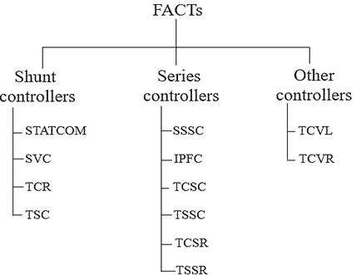
Fig. 1: Classification of FACTs devices
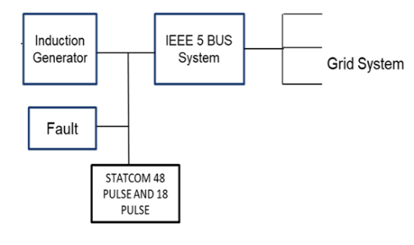
Figure 2 block diagram of proposed work
The main goals of reactive power compensation in power systems are:
i) to improve system stability,
ii) to maintain voltage levels within desired limits, and
iii) to reduce power losses across the network.
By addressing these areas, reactive power compensation significantly enhances transient response and boosts the overall reliability of the grid. To facilitate this, various FACTS devices are employed, with the Static Synchronous Compensator (STATCOM) being a central component.
As a solid-state member of the FACTS family, STATCOM can both absorb and inject reactive power as needed. It delivers real-time reactive power support to help stabilize voltage at the Point of Common Coupling (PCC). Through continuous adjustment of its output, STATCOM keeps system operation within stable bounds.
This study presents a STATCOM model that uses a 2-level, 12-pulse Voltage Source Converter (VSC) controlled by a Type-2 control strategy. The Type-2 controller modulates the phase angle of the converter’s output voltage in relation to the bus voltage, thereby regulating the STATCOM’s reactive current injection.
However, under inductive mode operation, using a conventional Proportional-Integral (PI) controller for reactive current feedback can introduce instability into the system. To overcome this issue, the study also examines an enhanced STATCOM design featuring a three-level, 18-pulse VSC in conjunction with a Type-3 controller. This advanced configuration offers higher precision in control and improved system stability across a wide range of operating conditions.
RESULT
Case 1:- 18 pulse 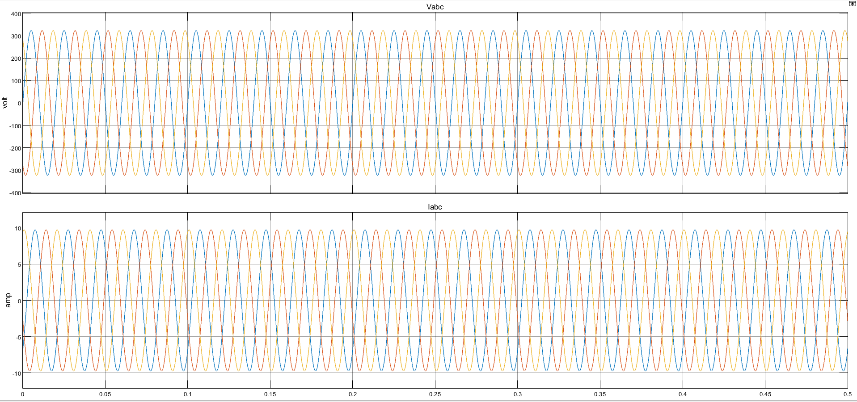
Figure 7:-Grid voltage and current waveform at LG fault condition with STATCOM
Figure 7 shows the waveform of BUS with the LG fault having little sag during the fault time. 3 level provide compensation the voltage magnitude. Fault time is 0.2 to 0.3 sec at that time STATCOM is applied with the breaker act as a switch.

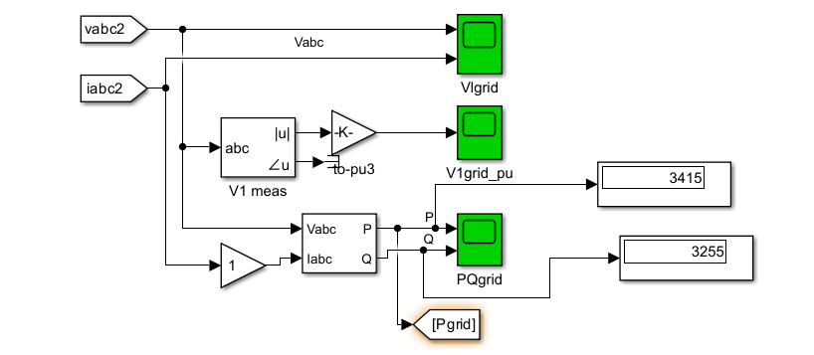
Figure 8 power display of LG FAULT ieee 5 bus condition

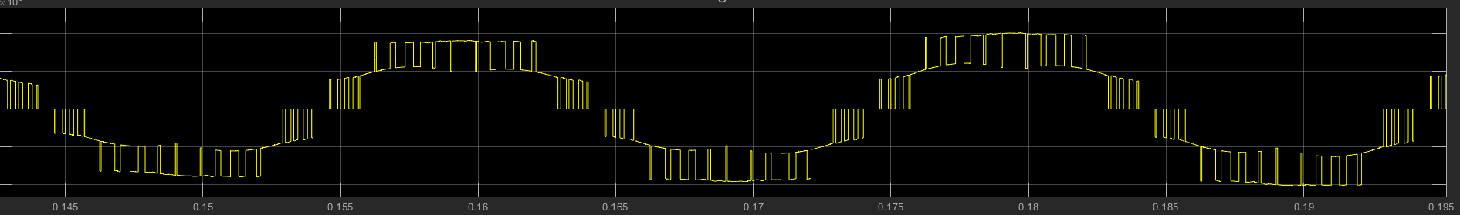

Figure 10 waveform of 18 pulse
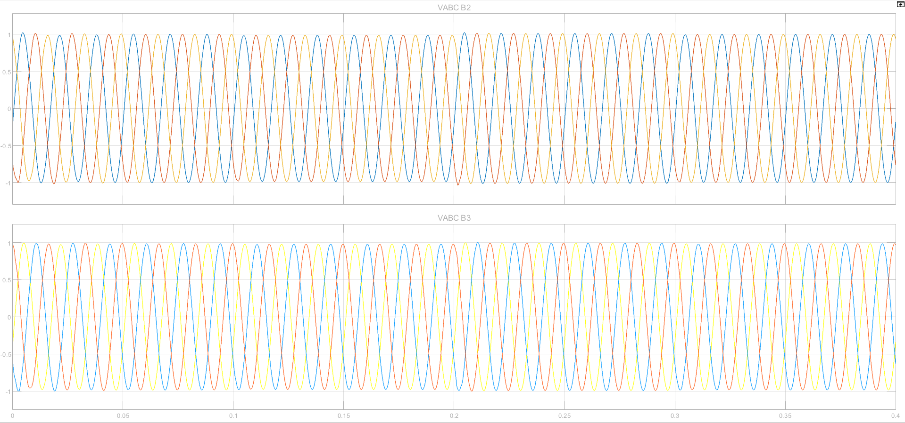
Fig.11 Vabc and Iabc of 2nd bus
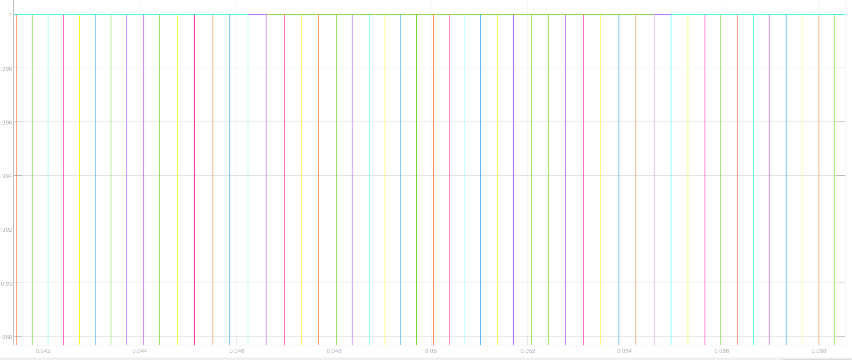
Fig.12 48 pulse of statcom i.e. 24 in half cycle

Figure 10 and figure 12 show the waveform of 18 and 48 pulse, in figure 9 from 0.2 sec to 0.4 sec 11 pulse is get and in figure 10 from 0.165 to 0.175 48 pulse is seen.
CONCLUSION

Parameter | 18-Pulse STATCOM | 48-Pulse STATCOM
Number of Converters | Typically consists of 3 six-pulse VSCs | Typically consists of 4 twelve-pulse VSCs
Transformer Configuration | Three-phase transformer with phase-shifting | Multi-winding transformer with finer phase-shifting
Harmonic Performance | Higher harmonic content compared to 48-pulse | Lower harmonic distortion, improved waveform quality
THD (Total Harmonic Distortion) | Moderate (~8-10%) | Lower (~3-5%)
Filtering Requirements | Requires larger filters to meet grid standards | Requires smaller filters due to reduced harmonics
Complexity | Less complex in design and control | More complex due to increased number of pulses
Efficiency | Slightly lower due to higher losses | Higher efficiency due to reduced harmonics and losses
Control Performance | Adequate for moderate dynamic compensation | Superior for fast and precise voltage regulation
Cost | Lower due to fewer components | Higher due to complex transformer and control requirements
Application | Suitable for medium voltage applications | Preferred for high-power, high-voltage applications

REFERENCES
- Alexander Z. Gamm, Irina I. Golub, Andrzej Bachry, Zbigniew A. Styczynski, “Solving Several Problems Using Spectral and Singular Analyses”, IEEE Trans. Power Syst., vol. 18, no. 1, February 2003.
- Daundkar, a. (2025). error rate estimation in cmos circuits: a tcad and spice-based approach with timing and frequency considerations. technology (ijecet), 16(1).
- Daundkar, A., Engineer, S. P., & Nvidia, S. C. Microprocessors for AI: Architectural Evolution, Challenges, and Future Prospects.
- Daundkar, A., Engineer, S. P., & Nvidia, S. C. Secure VLSI Architectures: Defense Against Hardware Trojans and Side-Channel Attacks.
- Gianfranco Chicco, George Gross, “Current Issues In Reactive Power Management: A Critical Overview” ©2008 IEEE.
- Heinz K. Tyll, SM, Dr. Frank Schettler1, “Historical overview on dynamic reactive power compensation solutions from the begin of AC power transmission towards present applications” 978-1-4244-3811-2/09/$25.00 ©2009 IEEE.
- Ying Xiao, Y. H. Song, Chen-Ching Liu, Fellow, Y. Z. Sun, “Available transfer capability enhancement using FACTS devices” IEEE Trans. on Power Syst., vol. 18, no. 1, february 2003.
- Kalyan K. Sen, Albert J.F.Keri, “Comparison of Field Results and Digital Simulation Results of Voltage – Source Conveter – Based FACTS Controllers.
- Jaya Laxmi, G. Tulasi Ram Das and K. Uma Rao, “Role of PI and fuzzy controllers in unified Power quality conditioner” vol. 2, no. 2, april 2007 issn 1819-6608arpn journal of engineering and applied sciences
- N. G. Hingorani and L. Gyugyi, “Understanding FACTS, Concepts, and Technology of Flexible AC Transmission Systems”, Piscataway, NJ: IEEE Press, 2000.
- M. S. ElMoursi, Prof. Dr. A. M. Sharaf, “Voltage stabilization and reactive compensation using a novel FACTS- STATCOM scheme” 0-7803-8886-0/05/$20.00 ©2005 IEEE CCECE/CCGEI, Saskatoon, May 2005
- Pranesh Rao, M. L. Crow, Zhiping Yang , “STATCOM Control for Power System Voltage Control Applications,” IEEE transactions on power delivery, Vol. 15, No. 4, October 2000.
- Peter W. Lehn, “ Direct Harmonic Analysis of the Voltage Source Converter” IEEE Transactions on power delivery, vol. 18, no. 3, July 2003
- J.Rodriguez, Lai,JihSheng,Fang Zheng eng, Multilevel inverters a survey of topologies, controls and applications, IEEE Trans. On Industrial Electronics, Vol.49, Aug. 22.
- D.Soto, T.C.Green, "A comparison of high-power converter topologies for the implementation of FACTS controllers," IEEE Transactions on Industrial Electronics, vol. 49, pp. 1072-1080, Oct. 2002.
- Berrezzek Farid, Omeiri Amar, “A Study of New Techniques of Controlled PWM Inverters”, European Journal of Scientific Research ISSN 1450-216X Vol.32 No.1 (2009).
- Amit kumar Gupta, Ashwin M.Khambadkone, “A Space vector PWM Scheme for Multilevel Inverters Based on two level space vector PWM” IEEE transactions on Industrial electronics, Vol,53, No.5 october 2006.
- Antonio J. Conejo, Francisco D. Galiana, Ivana Kockar, “ Z-Bus Loss Allocation”, IEEE transactions on power systems, vol.16, no.1, February 2001.
- Stephane Gerbex, Rachid Cherkaoui, Alain j. Germond, “Optimal Location of Multi- type FACTS devices in a Power system by means of genetic algorithms”IEEE Transactions on power Systems, vol. 16, No.3, August 2001.
- M.Arun Bhaskar, M.Mahesh, Dr.S.S.Dash, M.Jagadeesh Kumar, C.Subramani, “Modelling and Voltage Stability Enhancement of IEEE 14 Bus System Using “Sen” Transformer”, 2011 International Conference on Signal, Image Processing and Applications, With workshop of ICEEA 2011, IPCSIT vol.21 (2011) © IACSIT Press, Singapoor.
- Antonio Griffo and Davide Lauria , “ Two- leg three phase Inverter control for STATCOM and SSSC applications” IEEE transactions on power delivery, vol.23. No.1, January 2008.
- Dong Myung Lee, JinWoo Jung, SangShin Kwak “Simple space vector PWM scheme for 3level NPC Inverters including the overmodulation region”, Journal of power Electronics Vol.11, No.5, September 2011.
- Soumitra Das, G. Narayanan, “ Novel Switching Sequence for a Space Vector –Modulated Three Level Inverter”, IEEE transactions on Industrial Electronics, Vol.59, No.3, March 2012.
- Jin-Woo Jung, “Project 2 Space Vector PWM Inverter” Department of Electrical and Computer Engineering, The Ohio State University.
- Maryan Saeedifard, Hassan Nikkhjoei, Reza Iravani, “ A Space Vector Modulated STATCOM based on a Three-level Neutral point Clamped Converter” IEEE transactions on power Delivery,vol.22, No.2, April 2007.
- Josep Pou, Rafael Pindalo, Dushan Boroyevich, Pedro Rodriguez, “Evaluation of the low – Frequency neutral – Point Voltage oscillations in the three-level inverter” IEEE transactions on industrial Electronics, vol. 52, No.6, December 2005.
- Abd Almula G. M. Gebreel, “Simulation and implementation of two level and three-level inverters by Matlab and RT-lab”, thesis The Ohio State University 2011

