Design and Development of Caseete Fixture

Prof. M.C. Shinde¹, Assistant Professor
Rohan Awasare¹,Balchari Gudoji²,Nehal Arote³,Sagar Borade⁴ ,UG Student
Department of Mechanical Engineering
Suman Ramesh Tulsiani Technical Campus-Faculty of Engineering, Pune, India, 410405

Abstract – In this modern world of industrialization, rapid manufacturing is on its peak. Due to the increasing demand of customers, industries are trying to reduce the handling time for optimum manufacturing of their product.Thus designing of modular fixture is essential. This will not only reduce the handling time but also affect the quality of product and the optimum use of tools. The objective of this project was to design of fixture for 5412-120-02 shank and 5412-120-09 shank used on STAMA 531 machine.Fixture was designed to machine to shank at a time also in order to reduce the time. Also fixture is made modular in order to fit various sizes of shank. This reduces handling time and man-hours. Cost estimation and manufacturing of fixture was also carried out.
Keywords-Design and development of fixture to reduce human efforts and time.
INTRODUCTION
In this industrialization race, human beings are looking for there own luxurious and comfort life by consuming on all available resources at theie disposal. Hence with development of machines, there was a need to develop the work holding devices for machining as well. These work holding devices are known as “FIXTURE”.Function of fixture is to hold the work-piece in place. This improves the efficiency and method of doing work with repeatability and accuracy “SANDVIK ASIA “PVT. LTD.” Is No. 1 in world for manufacturing in tooling. Our project, in this renowned MNC, is on one such fixture used to hold tool shank family.
A fixture is a work-holding or support device used in manufacturing industry. Fixtures are used to securely locate position in a specific location or orientation and support the work, ensuring that all parts produced use in the fixture will maintain conformityand interchangeability. Using a fixture improves the economy of the production by allowing smooth operation and quick transition from part to part, reducing the requirement for skilled labor by simplifying how workpieces are mounted, and increasing conformity across a production run. A fixture differs from a jig in that when a fixture is used, the tool must move relative to the workpiece, a jig moves the piece while the tool remains stationary. A fixture’s primary purpose is to create a secure mounting point for a workpiece, allowing for support during operation and increased accuracy, Precision, reliability and interchangeability in the finished parts. It also serves to reduce working time by allowing quick set-up, and by smoothing the transition from part to part. It frequently reduces the complexity of a process, allowing for unskilled workers to perform it and effectively transferring the skill of the tool maker to the unskilled worker. Fixtures also allow for the higher degree of operator safety by reducing the concentration and effort required to hold a piece steady.Economically speaking the most valuable function of a fixture is to reduce labor costs. Without a fixture, operating a machine or process may require two or more operators; using a fixture can eliminate one of the operators by securing the workpiece.
METHODOLOGY
To plan out course of the project, we were made to understand the problem on which we were going to work. We had brainstorming session to discuss the pros and cons of every idea of team member. We were directed to find solutions to the problem raised, during every brainstorming session. With these session we planned out our method of working. [2] and the design was then analyzed in Ansys software. The analysis was done on Ansys v14.0 software to check the stresses and deformation in the system.

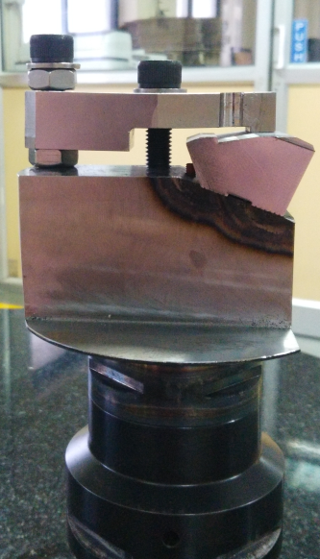

Fig. 1- fig shows the matter

DESIGN
Firstly, we targeted the design. We tried to improve the current design on the basis of company requirements. We were taught to be as optimum we could be. On preparation of our design, it was put for approval from the design engineer. After approval we would start the manufacturing of the fixture.
RAW MATERIAL:
For the production of fixture first of all raw material is required. The raw material required for the production of fixture is steel of type EN-47 Composition of EN47 steel:

  - Carbon – 0.48-0.53%

  - Silicon – 0.15-0.30%

  - Manganese – 0.70-0.90%

  - Chromium – 0.80-1.10%

  - Vanadium – 0.15% (Min)

  - Sulphur – 0.04 (Max)

  - Phosphors - 0.035%

MECANICAL PROPERTIES OF EN47
- Youngs Modulus = 200000 Mpa
2) Tensile Strength = 650-880 Mpa
    - Elongation = 8-25%

    - Fatigue = 275Mpa

    - Yield Strength = 350-550 Mpa

PHYSICAL PROPERTIES
    - Thermal Conductivity = 25 W/ m. K

    - Thermal Expansion = 10 e⁻⁶ /K

    - Specific Heat = 460 J/ Kg. K

    - Melting Temp. = 1450-1510 ºC

    - Density = 7700 Kg/ m³

    - Resistivity = 0.55 Ω.mm²/m

Procedure for ANSYS Analysis
Static analysis is used to determine the displacements stresses, stains and forces in
structures or components due to loads that act on the component. Steady loading in
response conditions are assumed. The kinds of loading that can be applied in a static
analysis include externally applied forces and pressures, steady state inertial forces
such as gravity or rotational velocity imposed (non-zero) displacements, temperatures
(for thermal strain). A static analysis can be either linear or non linear.
work we consider linear static analysis.
The procedure for static analysis consists of these main steps:

1. Building the model
2. Obtaining the solution
3. Reviewing the results.

Analysis of Fixture

The Fixture was designed in Catia V5R22. The material used for Fixture is EN47 as it possess the properties like high elasticity and higher fatigue strength.

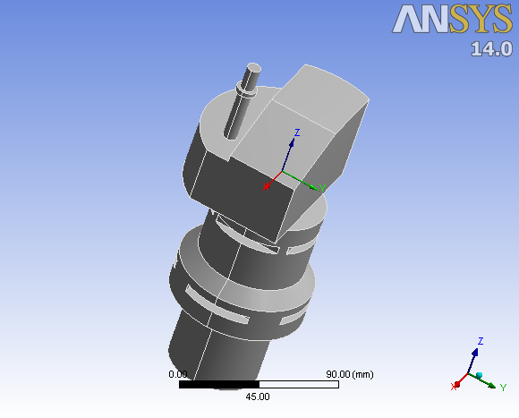

Figure 2: CAD model of Fixture

Static structural analysis is done to find the safety of the Fixture under impact.For analysis of Fixture it was assumed as a cantilever, the end which is attached to hub was constrained and the force due to impact was applied on the other end

Force Analysis
Steady state structural analysis is performed to check the safety of the design.While performing operation on the workpiece (cassete)for formation of tipseat on the blank a force of 30 KN is applied on it which is also taken by the fixture as the cassete is clamped on the fixture. The lower part of the fixture is fixed support as shown in the fig 3.And fig 4 shows the force on the fixture .
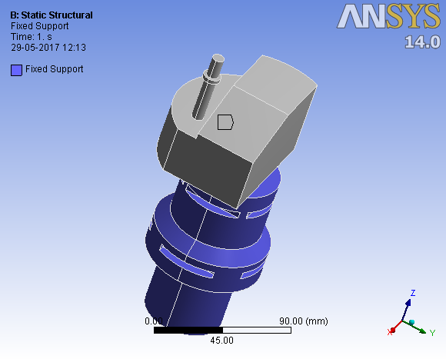

Fig 3 showing fixed support

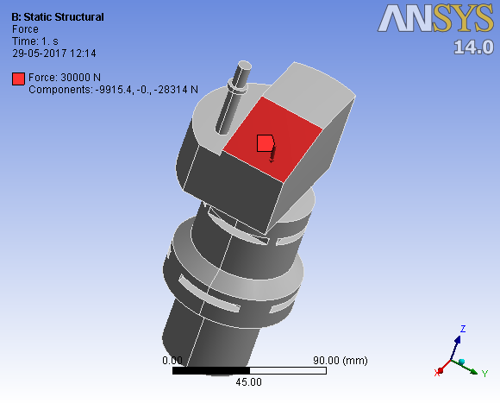
Fig 4 force on fixture
Maximum force on fixture is 30KN.

Stress Analysis
- Total Deformation
- Equivalent Stress
- Equivalent Strain

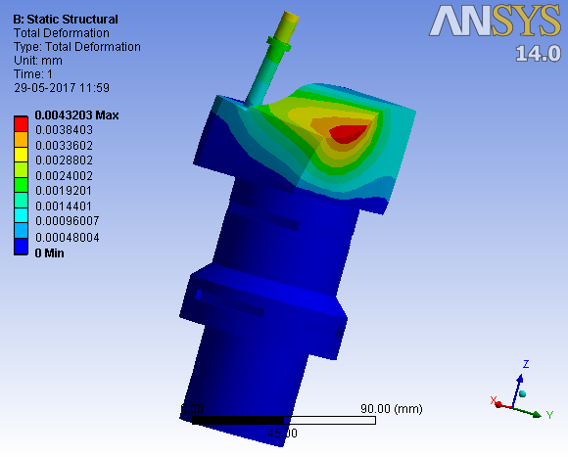
Fig 5 Total Deformation

Object Name | Total Deformation | Equivalent Stress
Minimum | 0. mm | 2.972e-009 MPa
Maximum | 4.3203e-003 mm | 15.612 MPa

Table 1: Result of analysis of force on fixture and its deformation

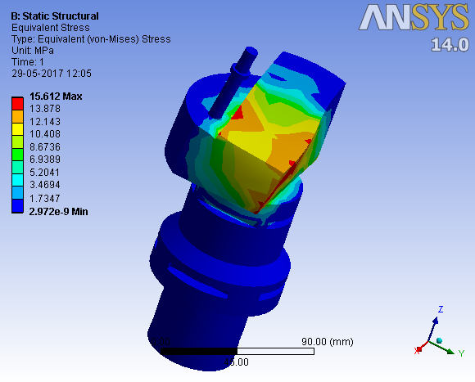
Fig 6 Stress Distribution
Object Name | Total Deformation | Equivalent Stress
Minimum | 0. mm | 2.972e-009 MPa
Maximum | 4.3203e-003 mm | 15.612 MPa
Table 2: Stress distribution in fixture
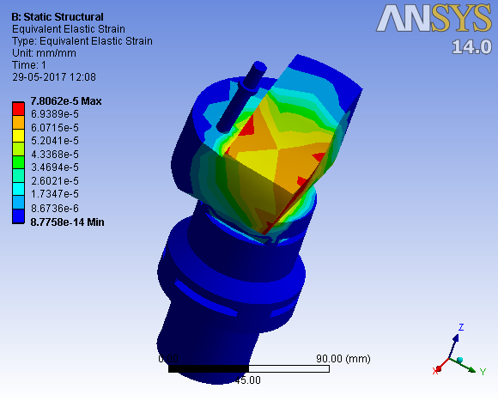
Figure 7: Strain distribution in fixture.
Object Name | Total Deformation | Equivalent Strain
Minimum | 0 mm | 8.7758e-014 mm/mm
Maximum | 4.3203e-003 mm | - 7.8062e-005 mm/mm

Table 3: Result of analysis in fixture due to strain

Selecting an optimum design

Before selecting an optimum design it is important to consider all the other parameters like weight of design, manufacturing feasibility, nature of deformation and cost. It is necessary that the weight should be less and the manufacturing should be simple and easy to reduce the overall cost of the product.

The nature of deformation should be in desired way so that whenever any impact comes the stability of the fixture is maintained at the same time the shock should be absorbed and it should regain its original shape as soon as the fixture crosses the disturbance.

Inspection
Types of quality checks done in company:
- Inside inspection: This is the inspection done on the inventory. This is done to pass no defective
piece ahead for manufacturing. Those helps in avoiding a wastage and loss in time.

- Spot inspection: This is the inspection done after the products is worked on in every stage.Consider if the product passes from one machine to another machine the inspection is done before it is passed to another machine. This saves time and money.
- Sampling:Sampling is choosing a specific amount of products from a lot to test them tovarious test conditions, to check for failure. If the samples are good then the lot is accepted, else they are rejected. Sampling is done on the basis of workers institutions.

Time study
Before the implementation of fixture the operations were carried itself by a single machine.due to which the critical dimension were out of the required tolerances.so we designed a fixture only for the tipset operation of workpiece cassete.So we carried out the time study with the help of stopwatch to verify the change in operation time.But we conclude that the time required was same as earlier.But the critical dimensions were within the tolerance limits.
CONCLUSIONS
Earlier the shank was manufactured on a single machine. The rejection rate was out of the range of company policy .So after designing and implementing of fixture for tipseat operation the rejection rate has consideriable reduced.This was concluded from the inspection carried out.
ACKNOWLEDGMENT
I express true sense of gratitude towards our project guide Prof. M.C. Shinde for his invaluable co-operation and the guidance that he gave me throughout the project preparation.
Prof. Mahesh Chandrabhan
Shinde
Assistant Professor
ME (Heat Power Engineering)
Mechanical Engineering Department
VIT Campus Kamshet Pune


Rohan Awasare
B.E. Student
Mechanical Engineering Department
VIT Campus Kamshet Pune


Balchari Gudoji
B.E. Student
Mechanical Engineering Department
VIT Campus Kamshet Pune


Nehal Arote
B.E. Student
Mechanical Engineering Department
VIT Campus Kamshet Pune


Sagar Borade
B.E. Student
Mechanical Engineering Department
VIT Campus Kamshet Pune

REFERENCES
Sheldon Levine [1], highlighted the importance of the rigidity of fixture. The paper of addresses the vibration response of the fixture, to get fixture as rigid as possible within the allowable weight limits & fixture should therefore have no resonances within the frequency range. That is, the first resonant frequency should be above the maximum specified tested frequencies.
Eiji Nabata & Yuji Terasaka[2], in his paper proposed that large vibration can occur in tools and workpiece during machining. This vibration causes problems in machining accuracy, efficiency, tool life and safety. One of the causes for vibration is lack of sufficient dynamic rigidity to stabilize parts in a dynamic cutting force. In this case, parts are reinforced by a jig to supplement inadequate rigidity. This report describes the development of vibration analysis technology for analyzing of an entire system including jigs achieved through the utilization of recent 3D-CAD.
Necmettin Kaya [3], in his paper proposed that clamping is very important in the fixture design to get rigidity of the fixture. In his paper he also concluded that use of ANSYS FOR THE finite element analysis of fixture.
Yi Zheng [4], establishes the finite element model of fixture unit stiffness and develops the experimental approaches to identify contact stiffness. Based on this study, the database of fixture stiffness can be built up, and further used in CAFD. Further in this report, he proposed mathematical calculation approach of finite element analysis.
J.E. Akin [5], proposed that fea is the most common tool for stress and structural analysis. Various fields of study are often related. Further he guided the steps involved in the finite element analysis. The basic concept behind the FEM is to replace any complex shape with the union (or summation) of a large number of very simple shapes (like triangles) that are combined to correctly model the original part. The smaller simpler shapes are called finite elements because each one occupies a small but finite sub-domain of the original part.
Xiumei Kang and Qingjin Peng [6], concludes with the research trend of computer aided fixture panning.
Finite element analysis (FEA) is a useful tool in modeling fixture workpiece interactions for the deformation analysis. The model can be parametrically built to optimize a fixture layout and clamping forces at a minimized workpiece deformation.
David Roylance [7], proposes the FEA is now the basis of multibillion dollar per year industry. Numerical solutions to even very complicated stress problem can now obtained using FEA.
Haiyan Deng [8], proposed that Fixturing stability is an important concern in machining fixture design and refers to the ability of a fixture to fully restrain a workpiece that is subjected to external forces generated by the machining operation. The majority of prior work on fixturing stability analysis is static or quasi-static. Early efforts in this area focused on the study of form closure and force closure & present a systematic mathematical procedure for modeling and analysis of the fixturing dynamic stability of an arbitrarily configured fixture-workpiece system

