Accident Prevention System

1. Mrs. M. A. Shaikh 2.Miss. Shrushti Patil 3.Miss. Shraddha Deore
Lecturer K.K.Wagh Polytechnic Student Student
mashaikh@kkwagh.edu.in shrushtipatil2545@gmail.com sdeore475@gmail.com

4. Miss. Samruddhi Kshatriya 5. Miss. Ashwini Dhikale
Student Student
samruddhikshatriya02@gmail.com kndhikale@gmail.com

Received on: xxxx,20xx, Revised on: xxxx,20xx, Published on: xxxx,20xx

Abstract Car accidents truly can be considered as one of the most disastrous phenomena. Through the reasons can be different for those accidents like the main reason can be driver’s unawareness as well as speed. With the help of IOT we can try to prevent as well as reduce the number of accidents. IOT (Things of Internet), is one of the most growing technology in IT industries, which is used to decrease burden of human beings. In this, the system will monitor and help to reduce those accidents. This paper discusses the process of developing accident prevention system. With the growing population the use of cars as becomes superfluous and this has led to increase in number of accidents at the alarm rate. In this project, we first applied Éclat algorithm to group the crime locations into 0 level, 1 level, 2 level accident location. Éclat algorithm takes accident level count as a factor to cluster the locations. Then we will use association rule mining to identify these locations. The rules show different factors associated with road Accident at different locations. For all this we will provide Accident data that are issue from Transport Ministry Officer. Safety driving suggestions will be marked based on Accident data. This idea is designed based on Arduino Microcontroller board and helps in controlling accidents. The system will also notify you if a driver has been that the speed limit has been exceeded then it is indicated through buzzer and displays on LCD. When accelerometer is triggered, it helps in detecting the accident and sending the signal to the Arduino of the system. The GPS technology is used to locate the position of the car in the form of latitude and longitude coordinates. So that police can trace the location through the GPS modem and necessary action will be taken. This idea is useful in preventing the accidents.
Keywords- Éclat algorithm, Clustering, Classification, GPS tracking, Accident.
INTRODUCTION
The number of deaths due to traffic accidents is very high. Looking at the number of deaths and injuries due to road traffic accidents shows the global crisis of road safety. Nearly 1.3 million people are killed every year and about 50 million injured worldwide due to road accidents, which averages to 3,287 lives lost every day. More than 50 percent of road traffic deaths affect young adults between the age of 15-44. Around 400,000 individuals under the age of 25 dies in road traffic accidents every year. Even in countries with very good road safety measures, the number of road accident deaths is getting higher every year. More than 90% of road traffic deaths occur in middle-income countries. In low-income countries the figure is even higher. In India, the World Health Organization (WHO) has revealed in its first ever Global Status Report on Road Safety that more people die in road accidents in India than anywhere else in the world, including the more populous China. Calling road fatalities an "epidemic" that will become the world's fifth biggest killer by 2030, the report said while rich nations had been able to lower their death rates, these were sharply on the rise in the third world. It said 90% of deaths on the world's roads occur in low and middle-income countries (21.5 and 19.5 per lakh of population, respectively) though they have just 48% of all registered vehicles. The statistics for India are chilling. At least 13 people die every hour in road accidents in the country, the latest report of the National Crime Records Bureau reveals. However, road safety experts say the real numbers could be higher since many of these accident cases are not even reported. "There is no estimate of how many injured in road accidents die a few hours or days after the accident," points out Rohit Baluja, member of the UN Road Safety Collaboration and Commission of Global Road Safety representing Asia. Based on the records, India will become the world number 1 in Road Deaths due to the poor record of average 13 die every hour, which is 1.14 lakh per year. This will make India to be the first place. This causative information about the accidents is the intent to develop the proposed technology as scientific traffic engineering wings to reduce the fatalities due to accidents. This proposed methodology is the automatic system which will provide the solution for identifying the accident location. Nowadays accidents are increasing at an alarming rate. Speed is the cause of most number of traffic accidents. In this project, we first applied Eclat algorithm to group the crime locations into 0 level, 1 level, 2 level accident location. Eclat algorithm takes accident level count as a factor to cluster the locations. Then we will use association rule mining to identify these locations. The rules show different factors associated with road Accident at different locations. For all this we will provide Accident data that are issue from Transport Ministry Officer. Safety driving suggestions will be marked based on Accident data. This idea is designed based on Arduino Microcontroller board and helps in controlling accidents. The system will also notify you if a driver has been that the speed limit has been exceeded then it is indicated through buzzer and displays on LCD. When accelerometer is triggered, it helps in detecting the accident and sending the signal to the Arduino of the system. The GPS technology is used to locate the position of the car in the form of latitude and longitude coordinates. So that police can trace the location through the GPS modem and necessary action will be taken. This idea is useful in preventing the accidents. This will help to reach the family members and friends service in time and save the valuable human life.

LITERATURE REVIEW
[1] Sadhana B have explained Smart helmet intelligent safety for motorcyclist using raspberry pi and open CV. The idea is obtained after knowing that there is increased number of fatal road accidents over the years. This project is designed to introduce safety systems for the motorcyclist to wear the helmet properly.

[2] Sarika R. Gujar explained advanced Embedded System of Vehicle Accident Detection and Tracking System. The main objective of this system is to first detect the accident location and call for the emergency services. Vehicle accident detection is possible with the help of sensors. A GPS and GSM module helps to trace the vehicle.

[3] Mohd Khairul Amri Kamarudin has established, “Smart Helmet with Sensors for Accident Prevention. This paper provides an intelligent system for two wheeler accident prevention and detection for human life safety. The prevention part involves, Smart Helmet, which automatically checks whether the person is wearing the helmet and has non-alcoholic breath while driving.
[4]Vijay J, Saritha B, Priyadharshini B,Deepeka S and Laxmi R (2011) has established, “Drunken Drive Protection System”. International Journal of Scientific & Engineering Research. This system efficiently checks the wearing of helmet and drunken driving. By implementing this system a safe two wheeler journey is possible which would decrease the head injuries during accidents and also reduce the accidents due to drunken driving. An intelligent system has been embedded in the helmet itself.
[5]Harish Chandra Mohanta, Rajat Kumar Mahapatra and Jyotirmayee Muduli(2014), “ Anti-Theft Mechanism System with Accidental Avoidance and Cabin Safety System for Automobiles”. An anti-theft system is any device or methid used to prevent or detect the unauthorized appropriation of items considered valuable. Theft is one of the most common and oldest criminal behaviours.
[6] Safety measures for “Two wheelers by Smart Helmet and Four wheelers by Vehicular Communication”, The small voltage of ignition of the two wheelers is grounded. In normal condition when the helmet is wearied the pressure is senses pressure and the RF transmitter radiates the FM modulated signal.
[7] Nitin Agarwal Anshul Kumar Singh, Pushpendra Pratap Singh, Rajesh Sahani, “SMART HELMET”, International Research Journal of Engineering and Technology, volume 2, issue 2, May 2015, “ Next generation motor cycle helmet with sound control and 360 degree vision that will transform your ride. The cross helmet X1 is a revolutionary motor cycle helmet that will transform your ride.

METHOLOGY
The proposed system aims to develop an efficient and accurate IOT model that can gives signals to drivers after entering in accident prone zone and informs driver to decrease speed of car.
The system architecture [Fig. 1] demonstrates the work flow of the model, an application will be created for interacting with the user and using the curated and preprocessed dataset a questionnaire will be generated which will gather the information about symptoms from the user. These inputs gathered from the user will be fed to the IOT model as an input which will predict speed of car.
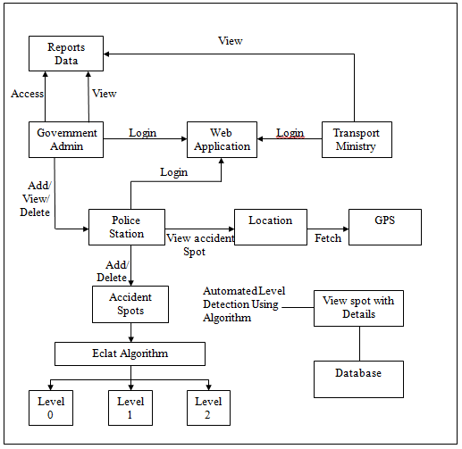
Fig. 1-System Flow Diagram
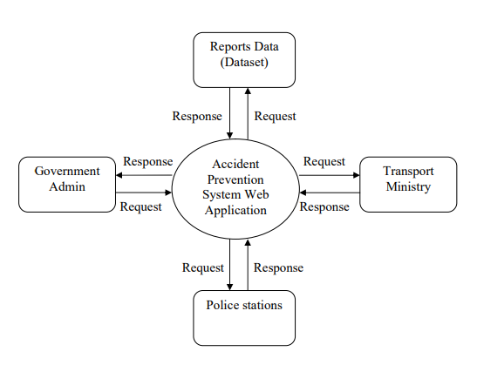
Fig. 2- DFD Level-0

Hardware Requirements:

You'll need the following hardware to install and set up the Accident Prevention System Using IoT for Car:

An Arduino board

An ultrasonic sensor

A GPS module

A buzzer

LCD

Accelerometer

Algorithm: Eclat
The basic idea is to use Transaction Id Sets (tidsets) intersections to compute the support value of a candidate and avoiding the generation of subsets which do not exist in the prefix tree. In the first call of the function, all single items are used along with their tidsets. Then the function is called recursively and in each recursive call, each item-tidset pair is verified and combined with other item-tidset pairs. This process is continued until no candidate item-tidset pairs can be combined.
Algorithm Steps:

- Get TidList for each item by scanning Database.
- TidList of set a is exactly the list of Transactions of containing set a.
- Intersect TidList of set a with the TidList of all other items, re- sulting in TidLists of set (a,b), (a,c), (a,d),ˆaS´. = (set of a)- conditional database (if (set a) is removed)
- Intersect TidList of set a with the TidList of all other items, re- sulting in TidLists of set (a,b), (a,c), (a,d),ˆaS´. = (set of a)- conditional database (if (set a) is removed)
- Repeat for all other items.

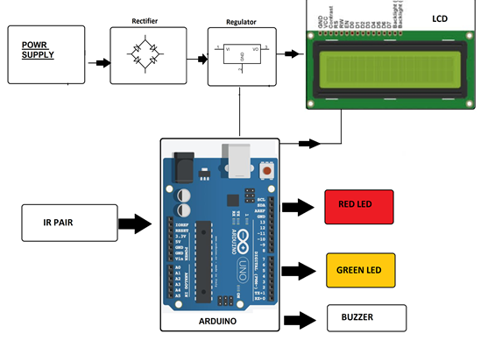
RESULT & DISCUSSION.

Fig.3 - IOT Device
In this project, we first applied Eclat algorithm to group the accident locations into 0 level, 1 level, 2 level accident location. Eclat algorithm takes accident level count as a factor to cluster the locations. Then we will use association rule mining to identify these locations. The rules show different factors associated with road Accident at different locations. For all this we will provide Accident data that are issue from Transport Ministry Officer. Safety driving suggestions will be marked based on Accident data. This idea is designed based on Arduino Microcontroller board and helps in controlling accidents. The system will also notify you if a driver has been that the speed limit has been exceeded then it is indicated through buzzer and displays on LCD. When accelerometer is triggered, it helps in detecting the accident and sending the signal to the Arduino of the system. The GPS technology is used to locate the position of the car in the form of latitude and longitude coordinates. So that police can trace the location through the GPS modem and necessary action will be taken.
Applications:
- Automotive and transport vehicles
- Security, remote monitoring and transportation and logistics
- This system also can be interfaced with vehicle alerting system
- This system can be used on highways
- Exchange messages wirelessly
- Distance measurement
- Automatic speed control
- Automobiles
- Security Guard Cabins
- Operators at nuclear power plants where continuous monitoring is necessary
- Pilots of airplane
- Military application where high intensity monitoring of soldier is needed

ACKNOWLEDGEMENT
I would like to show my sincere gratitude towards Mr. S. H, Sangale Lecturer, Department of Computer Technology, K. K. Wagh Polytechnic, Nashik and Mrs. M. A. Shaikh, Lecturer, Department of Computer Technology, K. K. Wagh Polytechnic, Nashik for their valuable guidance and encouragement.
CONCLUSION
We have proposed system for accident prevention and making the world a much better and safe place to live. The outcome of the project is basically having two applications. One is to prevent and control the vehicle from the accidental situations. Second is to detect the accident occurred area, which is helpful to track and rescue. The proposed system is developed to provide the information about the accident occur and the location of the accident. It helps to easily provide the assistant and help to the victim of the accident. This system uses GPS module to locate the vehicle. GSM is used to provide the information of accident. The results of the proposed systems are satisfactory. Main motto of the accident prevent system project is to decrease the chances of losing life in such accident which we can’t stop from occurring. Whenever accident is alerted, the paramedics are reached to the particular location to increase the chances of life. Thus this work ensures the reduction of death ratio and fatalities in the country like India and also which will have a greater importance in day to day life.
REFERENCES
[1]Sadhana B Shabrin, Bhagyashree Jagadish Nikharge, Maithri M Poojary and T Pooja, “Smart helmet-intelligent safety for motorcyclist using raspberry pi and open CV”, proc.IEEE,vol.03, no.03 pp.2395-0056 2016
[2] Sarika R. Gujar and Prof. A. R. Itkikar has focused on “Advanced Embedded System of Vehicle Accident Detection and Tracking System”, Proc-IEEE, vol.5, no.2, pp- 2277 128X 2015
[3]Smart Helmet with Sensors for Accident Prevention Mohd Khairul Afiq Mohd Rasli, Nina Korlina Madzhi, Juliana Johari Faculty of Electrical Engineering University Tecnology MARA40450 Shah Alam Selangor, MALAYSIAjulia893@salam.uitm.edu.my)
[4]Vijay J, Saritha B, Priyadharshini B,Deepeka S and Laxmi R (2011), “Drunken Drive Protection System”, International Journal of Scientific & Engineering Research, Vol. 2, No. 12, ISSN: 2229- 5518.
[5]Harish Chandra Mohanta, Rajat Kumar Mahapatra and Jyotirmayee Muduli(2014)”, Anti-Theft Mechanism System Accidental Avoidance and Cabin Safety System for Automobiles”, International Refereed Journal of Engineering and Science (IRJES), Vol. 3, No. 4, pp. 56.
[6]Safety measures for “Two wheelers by Smart Helmet and Four wheelers by Vehicular Communication” Manjesh N 1, Prof. Sudarshan raju C H 2 M Tech, ECEDSCE, JNTUA, Hindupur Email: manjesh405@gmail.com HOD & Asst. Prof. BIT-IT, Hindupur International
[7]Nitin Agarwal, Anshul Kumar Singh, Pushpendra Pratap Singh, Rajesh Sahani, “SMART HELMET”, International Research Journal of Engineering and Technology, volume 2, issue 2, May 2015

