Design and Static Analysis of CNC Milling Machine Bed using Composite Material
Mrs. Vibha¹, Mr. Chandrabhushan Tiwari², Mrs. Rinky Sahu³
¹M.Tech Student, Department of Mechanical Engineering, GDRCET Bhilai, Chhattisgarh, 490024
²Asst. Professor, Department of Mechanical Engineering, GDRCET Bhilai, Chhattisgarh, 490024
³Asst. Professor, Department of Mechanical Engineering, GDRCET Bhilai, Chhattisgarh, 490024

Abstract: Structural materials used in a machine tool have a decisive role in determining the productivity and accuracy of the part manufactured in it. The conventional structural materials used in precision machine tools such as cast iron and steel at high operating speeds develop positional errors due to the vibrations transferred into the structure. Faster cutting speeds can be acquired only by structure which has high stiffness and good damping characteristics. Clearly the life of a machine is inversely proportional to the levels of vibration that the machine is subjected. The further process is carried out to undergo the deformation. using Static analysis. Since the bed in machine tool plays a critical role in ensuring the precision and accuracy in components. It is one of the most important tool structures which tend to absorb the vibrations resulting from the cutting operation. To analyse the bed for possible material changes that could increase stiffness, reduce weight, improve damping characteristics and isolate natural frequency range from the operating. This was the main motivation behind the idea to go in for a composite model involving Al-SiC. In this work, a machine bed is selected for the analysis of static loads. Then investigation is carried out to reduce the weight of the machine bed without deteriorating its structural rigidity. The 3D CAD model of the bed has been created by using commercial 3D modelling software and analyses were carried out using ANSYS.

Key words: Machine Bed, Static analysis, ANSYS Benchwork
.
I. INTRODUCTION

CNC milling machines are used for precision and more productivity. This requires a transfer of high speed as well as the high cutting speed of machine tools. It ensures not only faster cutting rates but also lesser cutting force. Faster cutting speeds can be acquired only by structure which has high stiffness and good damping characteristics. The deformation of machine tool structure under cutting forces and loads which lead to the poor quality of products with less accuracy, both dimensional and also geometrical of the item.
So, the level of deformation and vibration that determines the components with high precision. Clearly the life of a machine is inversely proportional to the levels of vibration that the machine is subjected.
The additionally process is completed to hold up under the disfigurement, utilizing Static examination. To explore the bed for conceivable material changes that would expand firmness, diminish weight, enhance damping attributes and seclude regular recurrence from the operational range. At present most of the machine beds are made of grey cast iron material which has certain drawbacks. Like sudden burdens amid operation Cast Iron does not withstand at whatever point the heap achieves extreme burdens. In order to have high strength and high stiffness the weight of the machine bed should be high.

II. LITERATURE REVIEW

S. Syath Abuthakeer [1] proposed how to improve static and dynamic characteristics on a CNC machine. Simulation results show that the static and dynamic performances of vertical ribs with hollow bed have been improved. Structural vertical ribs with hollow offers a method to improve the conventional design of machine structure. Based on structural modifications, ribs parameters and distributions can be further optimized.
A. Merlo [2] analyzed the combination of hybrid materials (steel, CFRP, Al honeycomb) and an intensive use of gluing technology allows to increase damping and, at the same time, to get a consistent mass reduction (up to 40%) without reducing the overall stiffness.
A.Selvakumar, P.V. Mohanram [3] shows that Structure material plays a vital role in precision machine tools, which are expected to produce the parts within the specified accuracy of shape and dimensions together with the required surface finish. The shape of the work piece depends on the instantaneous relative position of the tool and the work piece and, therefore, of the machine parts which carry them. Hence, a structure which possesses high structural stiffness and high damping is to be selected. Composite materials such as, epoxy granite, exhibit good mechanical properties such as high stiffness and damping ratio at a lesser weight, compared to conventional materials. However, for the same stiffness, the basic dimensions of the structures vary.

III. MATERIAL

A composite is a material that is formed by two or more materials to achieve superior properties. Almost all the materials we see around are composites. Some of them like woods, bones, stones, etc. are natural composites, as they are grown in nature or produced by natural processes.
To analyse the bed for possible material changes that could increase stiffness, reduce weight, improve damping characteristics and isolate natural frequency from the operating range. This was the main motivation behind the idea to go in for a composite material which is Al-SiC Aluminium Silicon Carbide as metal matrix composite (MMC). Though carbide has good strength and stiffness properties but it lacks in damping requirements. On the other hand Aluminium, though it lacks in strength but it has good damping characteristics. This makes it ideal to combine these materials in a proper manner.

IV. METHODOLOGY

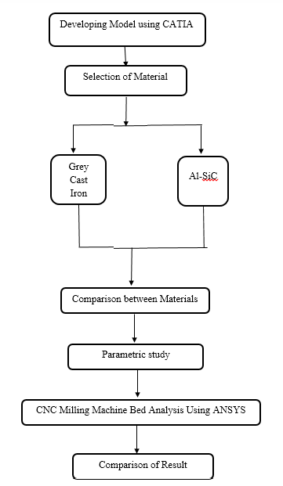
Fig.1:- Flow chart of dissertation execution
V. MACHINE BED

Machine Bed supports the all elements like column, work table and servo motors. Whatever the cutting force induced in the machining process is simply transformed to machine bed, and machine beds absorb the vibrations induced in the machining process. Machine bed contains hole for accommodating lead screw which drives the work table. So that work piece can be moved as per the user programming code. It also supports the column on the rear end of it with the help of lead screws. Machine beds withstand the various forces generated during the cutting. In order to produce the accurate products a machine bed should have high structural stiffness with good damping coefficient, these are the two major design factors considered while the design of machine bed. Whenever machining operation starts machine bed experiences cutting forces. These cutting forces can be divided into three types; they are tangential cutting force, feed force and radial force. The loads applied on the machine bed are calculated as.
Total weight of Machine = 170 Kg.
Load acting on rear end of Machine Bed = 73Kg.
Weight of the Work Table = 18Kg.
Total forces acting on guide ways = cutting force + weight of work table and work piece
= 95 + (18*9.81)
= 272N
Force due to other accessories = 73 * 9.81= 717N
All the above calculated loads are applied on the machine bed during the analysis of the machine bed.

VI. MODELING AND ANALYSIS

A 3D model of the CNC machine bed was created in the CATIA V5 R20 software and saved in the iges format and importing in to Ansys work bench. The analysis was carried out on three materials cast iron, stainless steel and HM CFRP. In this stage Force and displacement boundary condition were applied as follows forces, front end of the machine bed carries cutting force, weight of the work table and weight of the work piece, due to this a total load of 272 N is applied on the Guide ways of Machine bed. Rear end of the Machine bed carries vertical column, and other accessories (ie servo motors, spindles etc.), due to this a total load of 717N will be applied on two flat surfaces of rear end.

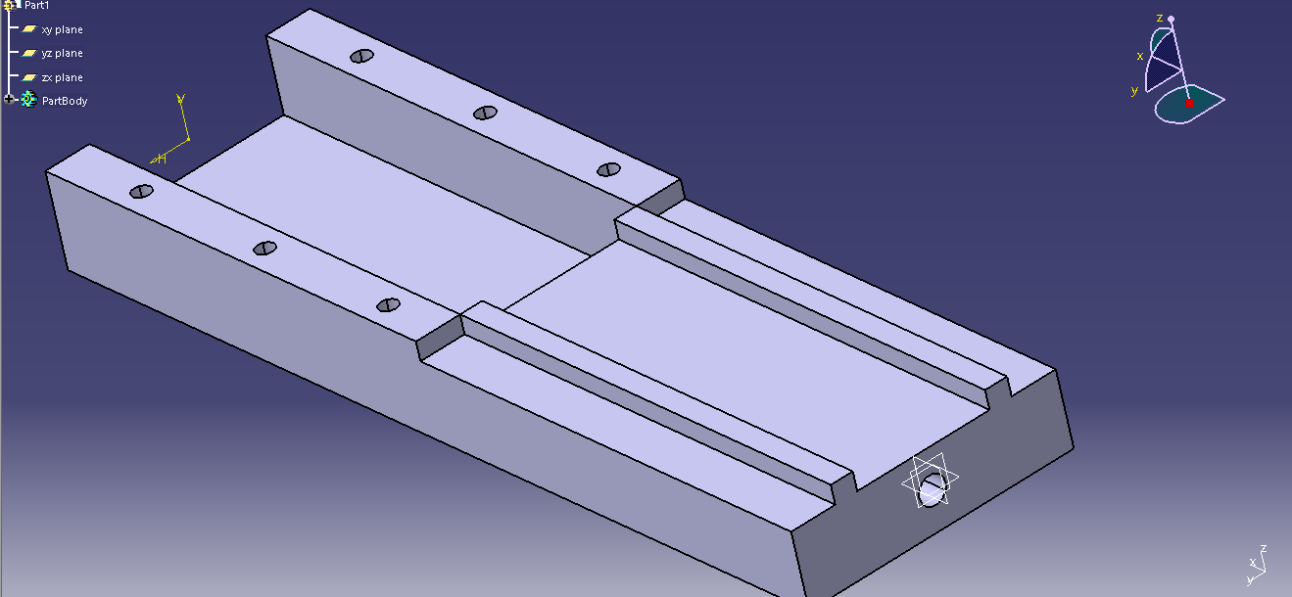
Fig.2:- Machine Bed Model in CATIA

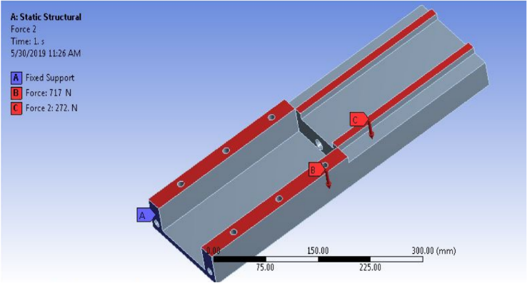
Fig.3:-. Forces applied on the machine bed

Static Analysis:

- Total Deformation:

- Grey Cast Iron:
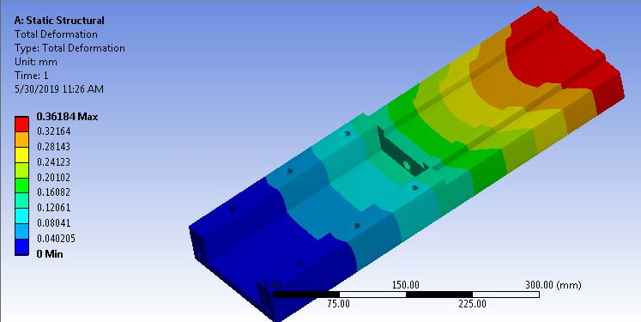
Fig.4:- Total Deformation of Grey Cast Iron

- Al-SiC
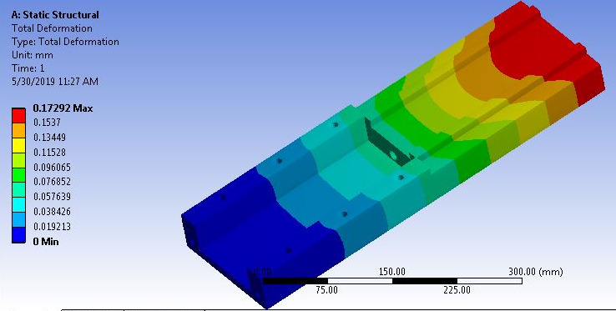
Fig.5:- Total Deformation of Al-SiC

- Equivalent (von-mises) Stress:

- Grey Cast Iron:
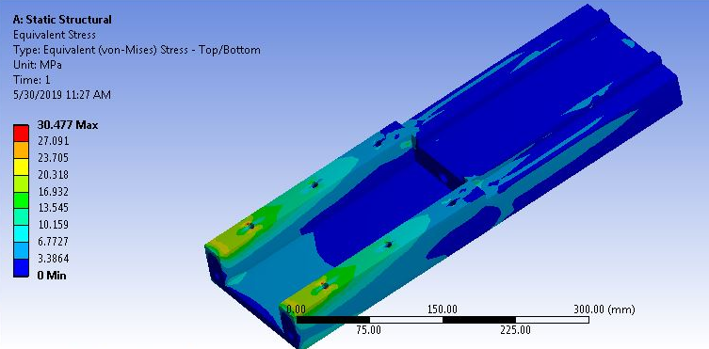
Fig.6:-Von-mises stress of Grey Cast Iron
- Al-SiC:
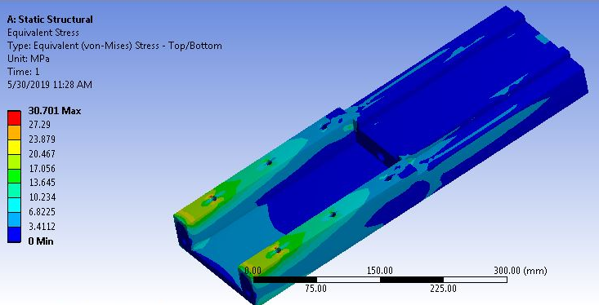
Fig.7:-Von-mises stress of Al-SiC

VII. RESULTS AND DISCUSSION

For comparison of the results obtained from the analysis under static load condition is given below tabular column:

Material | Total Deformation (mm) | Von-mises Stress (MPa)
Grey Cast Iron | 0.3618 | 30.47
Al-SiC | 0.17292 | 30.701
Table.1:- Comparison of Static Structural Results

Fig.8:- Comparison for Total Deformation

Fig.9:- Comparison for Von-mises Stress

From the above result we can conclude following points:
- We observe all 4 materials Grey Cast Iron, Al alloy, Al-SiC/graphite and Al-SiC, the Al-SiC has minimum deformation and stress is bigger as both the material is good enough to resist max load.
- The total deformation of the composite is less as compare to other three materials due to its high modulus of elasticity.
- Finally we can say using Al-SiC composite is very useful to industry which tends to longer life as deformation and stress is within the limits.

VIII. CONCLUSION
Based on the data related to the component, the existing bed was replaced by composite material for better strength and stiffness static analysis shows that there is improvement in the design life of the machine bed. By considering all the result data it can be seen that deformation is least in composite because of its high rigidity. The study suggests that Aluminium Silicon Carbide (Al-SiC) is best suited for CNC machine bed.

REFERENCE
1. S. Syath Abuthakeer, P.V. Mohanram, G. Mohan kumar, “Structural redesigning of a CNC lathe bed to improve its static and dynamic characteristics”, International journal of Engineering, 2011.
2. Merlo, D. Ricciardi, A. Cremona, F. Meo, F. Aggogeri, “Advanced composite materials in precision machine tools sector – Applications and perspectives”, 2013.
3. A.Selvakumar, P.V. Mohanram, “Analysis of alternative composite material for high speed precision machine tool structures” International journal of Engineering, 2012.
4. S. Kalpakjan, Manufacturing Engineering and Technology, 3rd Edition, Addison-Wesley, Reading, MA, 1995.
5. Anil Antony Sequeira, “Modified Approach for Cutting Force Measurement for Face in Milling”, Innovative Systems Design and Engineering, 2012.
6. Jung Do Suha, Seung Hwan Changa et.al, “Damping characteristics of composite hybrid spindle covers for high speed machine tools”, Journal of Materials Processing Technology, 2001.
7. K Karvanis, et.al, “Production and mechanical properties of Al-SiC metal matrix composites” 2016
8. M.Govindan, et.al, “Design and Analysis of Automobile Brake Disc by Using Al/SiC MMC”, 2017.

