Solar Tracking System

Prof. Arshi ansari,¹Mohsin Ahamed,²Shiva nand jha,³lalita segyem,⁴Firoz Alam,

Dept. of Electrical Engineering, PCE,Nagpur.

Abstract:-Solar panel has been used increasingly in recent years to convert solar energy to electrical energy. The solar panel can be used either as a stand-alone system or as a large solar system that is connected to the electricity grids . We are trying to consume more energy from the sun using solar Tracking panel. In order to maximize the conversion from solar to electrical energy . The tracking of the sun’s location and positioning of the solar panel are important. The tracking system will move the solar panel that its position perpendicular to the sun for maximum energy conversion. In our project output will give more energy then panels without tracking.

Keywords— Solar panel, Comparator IC, Motor Driver.
- INTRODUCTION
Renewable energy solutions are becoming popular. Maximizing output from solar system increases efficiency. Presently solar panels are of fixed type which lower the efficiency. Maintaining vertical direction between light and panel maximizes the efficiency. Solar tracking system has higher generating power than fixed.

- BLOCK DIAGRAM
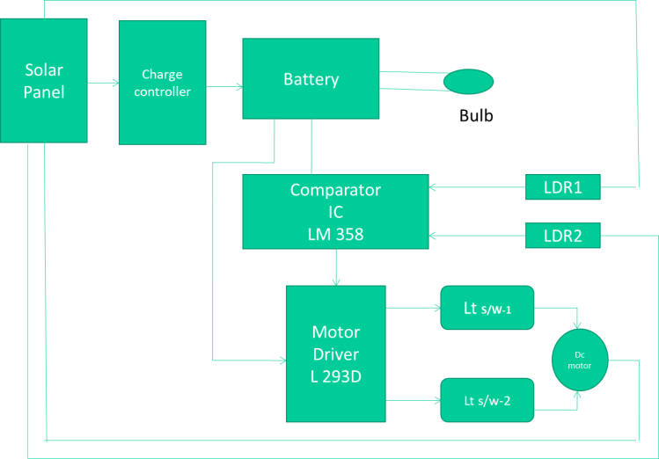Figure (1):- BlockDiagram Of solar tracking system

- CIRCUIT DIAGRAM

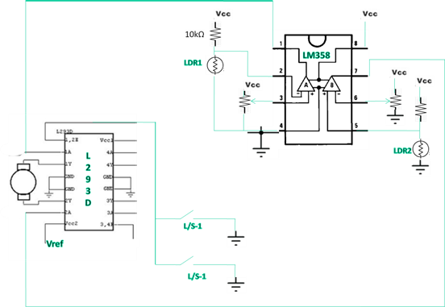
- COMPONENTS
A.- SOLAR PANEL
A solar panel works by allowing photons, or particles of light, to knock electrons free from atoms, generating a flow of electricity. Solar panels actually comprise many, smaller units called photovoltaic cells. (Photovoltaic simply means they convert sunlight into electricity.) Many cells linked together make up a solar panel
QUICK OVERVIEW
- Power Watt-20 W
- Dimension: 540 x 460 x 24 mm
- Poly-crystalline Solar Module
- Open circuit voltage (VOC) – 23.1
- Voltage maximum power (Vm(v)) -17.5
- Short cicuit current (ISC) (Amps) – 1.44
- Maximum power current (MP)(Amps) -1.03

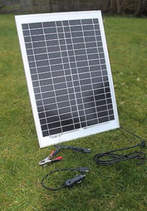

Figure (2):- solar panel

B Charge controller :-
A solar charge controller manages the power going into the battery bank from the solar array. It ensures that the deep cycle batteries are not overcharged during the day, and that the power doesn’t run backwards to the solar panels overnight and drain the batteries. Some charge controllers are available with additional capabilities, like lighting and load control, but managing the power is its primary job

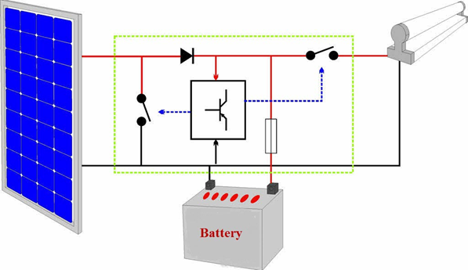

Figure(3):- Charge controller

c. Battery

The cathode and anode (the positive and negative sides at either end of a traditional battery) are hooked up to an electrical circuit. The chemical reactions in the battery causes a build up of electrons at the anode. This results in an electrical difference between the anode and the cathode

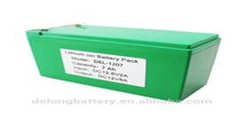
Figure (4) :- battery
D. Comparator IC LM358
The LM358 is operational amplifier ,and easy to use duel channel op-amp IC. It is designed and introduced by national semiconductor. It consist of two internally frequency compensated, high gain , independent op-amp. the IC is designed for specially to operate from a single power supply over a wide range of voltages. It is available in a chip sized package .it can handle 3-32v dc supply source up to 20mA per channel.it is available in an 8-pin
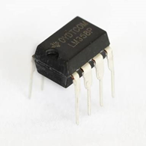
Figure (5):- IC LM358
Pin diagram
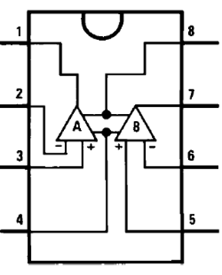
Working:
LM358 is an operational amplifier (Op-Amp) and in this circuit we are using it as a voltage comparator. The LM358 has two independent voltage comparators inside it, which can be powered by single PIN, so we can use the single IC to build two IR sensor modules. We have used only one comparator here, which have inputs at PIN 2 & 3 and output at PIN 1. Voltage comparator has two inputs, one is inverting input and second is non-inverting input (PIN 2 and 3 in LM358). When voltage at non-inverting input (+) is higher than the voltage at inverting input (-), then the output of comparator (PIN 1) is High. And if the voltage of inverting input (-) is Higher than non-inverting

E. Motor Driver L293D
Motor Driver IC- It means, by using a L293D IC we can control two DC motors. As well, this IC can drive small and quiet big motors. This L293D IC works on the basic principle of H-bridge, this motor control circuit allows the voltage to be flowing in any direction.
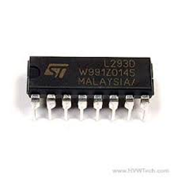
Figure (6) :- Motor driver L293D
Pin Diagram
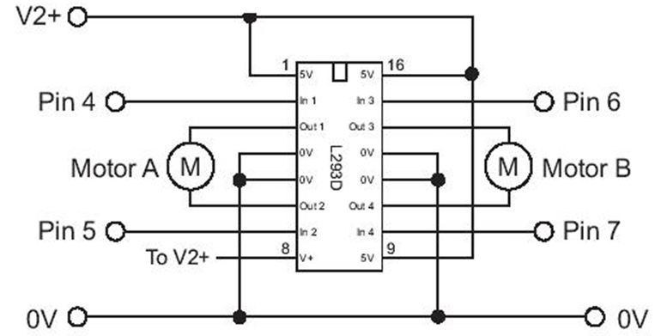
Working
There are 4 input pins for l293d, pin 2,7 on the left and pin 15 ,10 on the right as shown on the pin diagram. Left input pins will regulate the rotation of motor connected across left side and right input for motor on the right hand side. The motors are rotated on the basis of the inputs provided across the input pins as LOGIC 0 or LOGIC 1.In simple you need to provide Logic 0 or 1 across the input pins for rotating the motor.
• Pin 2 = Logic 1 and Pin 7 = Logic 0 | Clockwise Direction
• Pin 2 = Logic 0 and Pin 7 = Logic 1 | Anticlockwise Direction
• Pin 2 = Logic 0 and Pin 7 = Logic 0 | Idle [No rotation] [Hi-Impedance state]
• Pin 2 = Logic 1 and Pin 7 = Logic 1 | Idle [No rotation]
F: LDR
When it’s dark, the LDR has high resistance. This makes the voltage at the base of the transistor too low to turn the transistor ON.
Therefore, no current will go from the collector to the emitter of the transistor. All the current will instead pass through the LDR and the potentiometer.
When it’s light, the LDR has low resistance. This makes the voltage at the base of the transistor higher. High enough to turn the transistor ON.
Because the transistor is turned on, current flows through the transistor. It flows from the positive battery terminal, through R1, the LED, and the transistor down to the negative battery terminal.
This makes the LED light up.
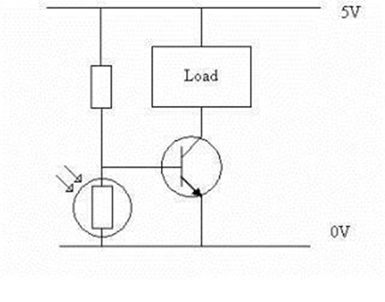
G : DC MOTOR
An Electric DC motor is a machine which converts electric energy into mechanical energy. The working of DC motor is based on the principle that when a current-carrying conductor is placed in a magnetic field, it experiences a mechanical force
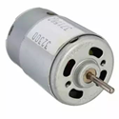

Figure(7):- DC MOTOR

H. LIMIT SWITCH :
A limit switch is an electromechanical device that consists of an actuator mechanically linked to a set of contacts. When an object comes into contact with the actuator, the device operates the contacts to make or break an electrical connection
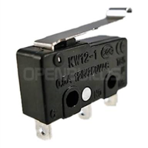
FLOW CHART:



Result
WITHOUT TRACKER
- Without charge controller
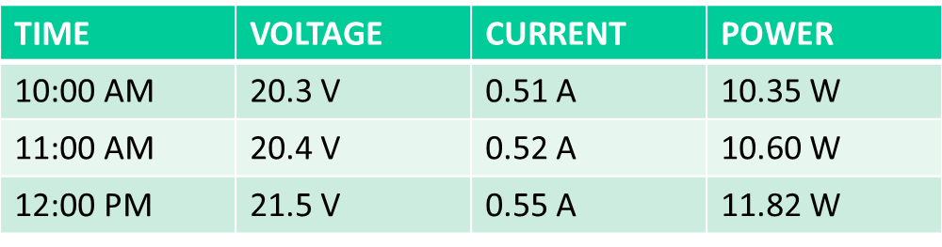

- With charge controller

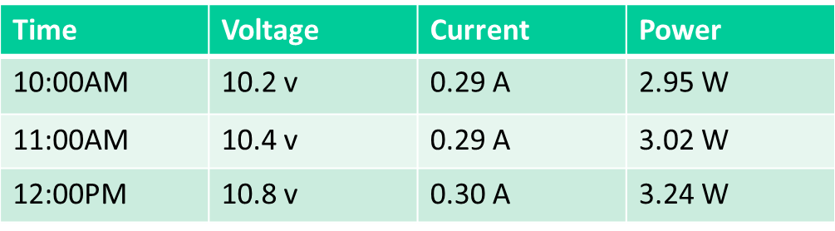
WITH TRACKER
- WITHOUT CONTROLLER

- WITH CONTROLLER

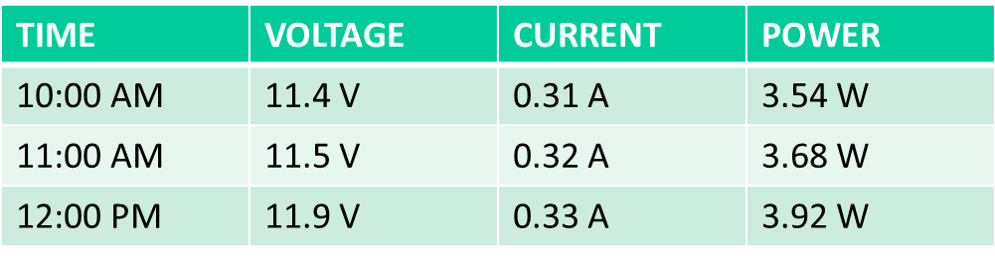
REFERENCES
[1] NikeshD.Watane,Rakesh.A.Dafde, “AUTOMATIC SOLARTRACKER SYSTEM’’, International journal of scientific & research,volume 4,Issue6, june-2013 ISSN 2229-551
[2] Jeng-nan,R.Radharamanan, “Design of a SolarTracking System forRenewable Energy”,conference of theamerican society for engineeringeducation(ASEE ZONE-1)
[3] Asst. prof. k. Sambasivarao, P. Harish, “TimeOperated Solar Tracking for optimum power generation” International Journal of Scientific & Engineering Research, volume 4, Issue5,May-2013 ISSN 2229-5518
[4] TiberiuTudorache, liviukreindler, “Design of a solar tracker system for PV Power plants”, Acta polytechnic hungarica , Volume 7 , November -2010
[5] Reshmi Banerjee, “Solar tracking system” , International journal of scientific & research publications , Volume 5 , Issue 3 , March -2015 ISSN 2250-3153
[6] AdarshAdeppa, “Solar Tracker with stepper motor control” Proceeding of NCRIET-2015 And Indian J. Sci. Res. 12(1) : 375-380,2015
[7] Shahriar bazyari, Reza keypour , shahrokh farhangin , amir ghaedi , khashayar bazyari “ A study on the effect of solar tracking systems on the performance of photovoltaic power plants” Journal of power and energy Engineering, 2014 ,2,718-728
[8] A. Kassem , M. Hamad “A microcontroller – based Multi-function solar tracking system” Conference paper May-2011. 5929048 IEEE xplore
[9] Sinan Kibrak , Mustafa Gunduzalp furkan Dincer “Theoretical and experimental performance investigation of a two axis solar tracker under the climatic condition of denizli , turkey” Przeglad elektrotechniczny, R.88 NR 2/2012, ISSN 0033-2097
[10] Syaffi, Refbinal Nazir, Kamshory, Mohammad Hadi “Improve Dual axis solar tracker algorithm based on sunrise and sunset position” J. Electrical systems 11-4(2015):397-406

