CONTENTS page no
Abstract i
Assumptions and notations ii-iii
Symbols iv-v
Chapter 1: Introduction 1-11
1.1 Early modern and the industrial age 2-3
1.1.1 Modern architecture 3
1.2 Statement of the project 4
1.3 Literature review 5
1.3.1 Method of flexibility coefficients 5
1.3.2 Slope displacement equations 5-6
1.3.3 Kani’s method 6-8
1.3.4 Approximate method 8-9
1.4 Design of multi-storeyed residential building 10
1.4.1 Limit state method 11
Chapter 2: Software’s 12-16
2.1 Staad 13
2.1 Alternatives for staad 14
2.2 Staad editor 14
2.3 Staad foundation 14-15
2.2 Auto cad 16

Chapter 3: Plan and Elevation 17-21
3.1 Plan 18
3.2 Elevation 19-21
Chapter 4 : Loadings 22-38
4.1 Load conditions and structural system response 23

4.2 Building loads categorized by orientation 23
4.2.1 Horizontal (lateral) loads 23
4.2.2 Vertical loads 23-24
4.2.3 Lateral loads 24-25
4.3 Structural systems 25-26
4.4 Design loads for residential buildings 27
4.4.1 Dead loads 28
4.4.2 Live loads 29-30
4.4.3 Wind loads 31-33
4.4.3.1 Basic wind speed at 10 m for height for some important cities/town 34-36
4.4.4 Floor load 37
4.4.5 Load combinations 38
Chapter 5: Beams 39-48
5.1 Beam Design: 39
5.1.1 Singly reinforced beams: 39
5.1.2 Doubly reinforced concrete beams 39
5.3 Check for the Design of a beam 46-48
Chapter 6 Columns 49-57
6.1 Positioning of columns 50
6.2 Axial loaded columns 50
6.2.1 Axial load and uniaxial bending 50
6.2.2 Axial load and biaxial bending 51-52
6.3 Column design 53-54 6.4 Outputs
6.5 Check the Design of a columns 55-57

Chapter 7- Slabs 58-67
7.1 Design of slab 58-63
7.2 Manual calculations 63-67
Chapter 8: Footings 68-92
8.1 Foundation design 69-71
8.2 Dimensions and reinforcement details of all the footings 72-92
Chapter 9 Results
9.1 Staad Editor 93-117
9.3 Estimation 117
9.2 Diagrams For Bending Moment and Shear Force 118
9.3 Reference and Conclusions 119 ANALYSIS AND DESIGN OF A (G + 6) MULTI STOREY RESIDENTIAL

BUILDING USING STAAD PRO

Abstract

In order to compete in the ever growing competent market it is very important for a structural engineer to save time. as a sequel to this an attempt is made to analyse and design a Multi-storeyed building by using a software package staad pro.
For analysing a multi storied building one has to consider all the possible loadings and see that the structure is safe against all possible loading conditions.
There are several methods for analysis of different frames like kani’s method, cantilever method, portal method, Matrix method.
The present project deals with the analysis of a multi storeyed residential building of G+6 consisting of 5 apartments in each floor. The dead load &live loads are applied and the design for beams, columns, footing is obtained
STAAD Pro with its new features surpassed its predecessors, and compotators with its data sharing capabilities with other major software like AutoCAD, and MS Excel.

We conclude that staad pro is a very powerful tool which can save much time and is very accurate in Designs.

Thus it is concluded that staad pro package is suitable for the design of a multi-storeyed building.

Assumptions and Notations used:
The notations adopted throughout the work is same IS-456-2000.
Assumptions in Design:
1.Using partial safety factor for loads in accordance with clause 36.4 of IS-456-2000 as ϒ_{t}=1.5
2.Partial safety factor for material in accordance with clause 36.4.2 is IS-456-2000 is taken as 1.5 for concrete and 1.15 for steel.
3.Using partial safety factors in accordance with clause 36.4 of IS-456-2000 combination of load.
D.L+L.L. 1.5
D.L+L.L+W.L 1.2
Density of materials used:
MATERIAL: DENSITY
- Plain concrete 24.0KN/m³
- Reinforced 25.0KN/m³
- Flooring material(c.m) 20.0KN/m³
- Brick masonry 19.0KN/m³
- Fly ash 5.0KN/m³
4.LIVE LOADS: In accordance with IS. 875-86
- Live load on slabs = 20.0KN/m²
- Live load on passage = 4.0KN/m²
iii)Live load on stairs = 4.0KN/m²

DESIGN CONSTANTS:
Using M₃₀ and Fe 415 grade of concrete and steel for beams, slabs, footings, columns. Therefore:-
f_{ck} = Characteristic strength for M30-30N/mm²
f_{y} = Characteristic strength of steel-415N/mm²

Assumptions Regarding Design:
- Slab is assumed to be continuous over interior support and partially fixed on edges, due to monolithic construction and due to construction of walls over it.
- Beams are assumed to be continuous over interior support and they frame in to the column at ends.
Assumptions on design:-
- M₂₀grade is used in designing unless specified.
- Tor steel Fe 415 is used for the main reinforcement.
- Tor steel Fe 415 and steel is used for the distribution reinforcement.
- Mild steel Fe 230 is used for shear reinforcement.

Symbols:
The following symbols has been used in our project and its meaning is clearly mentioned respective to it:
A |  | -Area
Ast |  | - Area of steel
b |  | - Breadth of beam or shorter dimension of rectangular column
D |  | -Overall depth of beam or slab
D_{L} |  | -Dead load
d1 |  | -effective depth of slab or beam
D |  | - overall depth of beam or slab
Mu,max |  | -moment of resistance factor
F_{ck} |  | -characters tic compressive strength
F_{y} |  | -characteristic strength of of steel
L_{d} |  | -development length
LL |  | -live load
L_{x} |  | -length of shorter side of slab
Ly |  | - length of longer side of slab
B.M. |  | -bending moment
Mu | -factored bending moment
M_{d} | -design moment
M_{f} | -modification factor
M_{x} | -mid span bending moment along short span
M_{y} ₋ mid span bending moment along longer span M’_{x} -support bending moment along short span M’_{y} - support bending moment along longer span p_{t} -percentage of steel W -total design load
W_{d} -factored load
T_{c max} -maximum shear stress in concrete with shear
T_{v} -shear stress in concrete T_{v} -nominal shear stress ɸ -diameter of bar
P_{u} -factored axial load
M_{u,lim} -limiting moment of resistance of a section with out compression
reinforcement
M_{ux,}M_{uy} -moment about X and Y axis due to design loads
M_{ux1,}M_{uy1} maximum uniaxial moment capacity for an axial load of p_{u},bending
moment x and Y axis respectively
A_{c} - area of concrete&
A_{sc} -area of longitudinal reinforcement for column

CHAPTER 1 INTRODUCTION

Building construction is the engineering deals with the construction of building such as residential houses. In a simple building can be define as an enclose space by walls with roof, food, cloth and the basic needs of human beings. In the early ancient times humans lived in caves, over trees or under trees, to protect themselves from wild animals, rain, sun, etc. as the times passed as humans being started living in huts made of timber branches. The shelters of those old have been developed nowadays into beautiful houses. Rich people live in sophisticated condition houses.
Buildings are the important indicator of social progress of the county. Every human has desire to own comfortable homes on an average generally one spends his two-third life times in the houses. The security civic sense of the responsibility. These are the few reasons which are responsible that the person do utmost effort and spend hard earned saving in owning houses.
Nowadays the house building is major work of the social progress of the county. Daily new techniques are being developed for the construction of houses economically, quickly and fulfilling the requirements of the community engineers and architects do the design work, planning and layout, etc., of the buildings. Draughtsman are responsible for doing the drawing works of building as for the direction of engineers and architects. The draughtsman must know his job and should be able to follow the instruction of the engineer and should be able to draw the required drawing of the building, site plans and layout plans etc., as for the requirements.
A building frame consists of number of bays and storey. A multi-storey, multi-paneled frame is a complicated statically intermediate structure. A design of R.C building of G+6 storey frame work is taken up. The building in plan (40*28) consists of columns built monolithically forming a network. The size of building is 40x28m. The number of columns are 85. it is residential complex.
The design is made using software on structural analysis design (staad-pro). The building subjected to both the vertical loads as well as horizontal loads. The vertical load consists of dead load of structural components such as beams, columns, slabs etc. and live loads. The horizontal load consists of the wind forces thus building is designed for dead load, live load and wind load as per IS 875. The building is designed as two dimensional vertical frame and analyzed for the maximum and minimum bending moments and shear forces by trial and error methods as per IS 456-2000. The help is taken by software available in institute and the computations of loads, moments and shear forces and obtained from this software.
1.1 Early modern and the industrial age:
With the emerging knowledge in scientific fields and the rise of new materials and technology, architecture engineering began to separate, and the architect began to concentrate on aesthetics and the humanist aspects, often at the expense of technical aspects of building design.
Meanwhile, the industrial revolution laid open the door for mass production and consumption. Aesthetics became a criterion for the middle class as ornamental products, once within the province of expensive craftsmanship, became cheaper under machine production.
Vernacular architecture became increasingly ornamental. House builders could use current architectural design in their work by combining features found in pattern books and architectural journals.
1.1.1 Modern architecture:
The Bauhaus Dessau architecture department from 1925 by Walter Gropius.
The dissatisfaction with such a general situation at the turn of the 20th century gave rise to many new lines of thought that served as precursors to modern architecture. Notable among these is detachers’ derkbund, formed in 1907 to produce better quality machine made objects. The rise of the profession of industrial design is usually placed here. Following this lead, the Bauhaus school, founded in Weimar, Germany in 1919, redefined the architectural bounds prior set throughout history viewing the creation of a building as the ultimate synthesis—the apex—of art, craft and technology.
When modern architecture was first practiced, it was an avant-garde moment with moral, philosophical, and aesthetic underpinning. Immediately after world war I, pioneering modernist architects sought to develop a completely new style appropriate for a new post-war social and economic order, focused on meeting the needs of the middle and working classes. They rejected the architectural practice of the academic refinement of historical styles which served the rapidly declining aristocratic order.

1.2 Statement of project
Salient features:
Utility of building : residential complex
No of stories : G+6
Shape of the building : 5 APARTMENTS
No of staircases : 5
No. of flats: 30
No of lifts : 4
Type of construction : R.C.C framed structure
Types of walls : brick wall Geometric details:
Ground floor : 3m
Floor to floor height : 3m.
Height of plinth : 0.6m Depth of foundation: 500mm Materials:
Concrete grade : M30 All steel grades: Fe415 grade
Bearing capacity of soil: 300KN/M²

1.3 Literature review:
Method of analysis of statistically indeterminate portal frames:
- Method of flexibility coefficients.
- Slope displacements methods(iterative methods)
- Moment distribution method
- Kane’s method
- cantilever method
- Portal method
- Matrix method
- STAAD Pro

1.3.1 Method of flexibility coefficients:
The method of analysis is comprises reducing the hyper static structure to a determinate structure form by:
Removing the redundant support (or) introducing adequate cuts (or) hinges.
Limitations:
It is not applicable for degree of redundancy>3

1.3.2 Slope displacement equations:
It is advantageous when kinematic indeterminacy <static indeterminacy. This procedure was first formulated by axle bender in 1914 based on the applications of compatibility and equilibrium conditions.
The method derives its name from the fact that support slopes and displacements are explicitly comported. Set up simultaneous equations is formed the solution of these parameters and the joint moment in each element or computed from these values.
Limitations:
A solution of simultaneous equations makes methods tedious for manual computations. this method is not recommended for frames larger than too bays and two storey’s. .
Iterative methods:
These methods involves distributing the known fixed and moments of the structural member to adjacent members at the joints in order satisfy the conditions of compatibility.
Limitations of hardy cross method:
It presents some difficulties when applied to rigid frame especially when the frame is susceptible to side sway. The method cannot be applied to structures with intermediate hinges.

1.3.3 Kani’s method:
This method over comes some of the disadvantages of hardy cross method. Kani’s approach is similar to H.C.M to that extent it also involves repeated distribution of moments at successive joints in frames and continues beams. However there is a major difference in distribution process of two methods. H.C.M distributes only the total joint moment at any stage of iteration.
The most significant feature of kani’s method is that process of iteration is self corrective.
Any error at any stage of iterations corrected in subsequent steps consequently skipping a few steps error at any stage of iteration is corrected in subsequent consequently skipping a few steps of iterations either by over sight of by intention does not lead to error in final end moments.

Advantages:
It is used for side way of frames.

Limitations:
The rotational of columns of any storey should be function a single rotation value of same storey.
The beams of storey should not undergo rotation when the column undergoes translation. That is the column should be parallel.
Frames with intermediate hinges cannot be analysis.

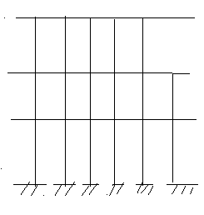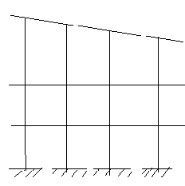
Applicable
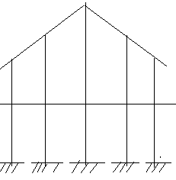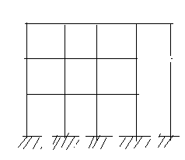
Not applicable

1.3.4 Approximate method:
Approximate analysis of hyper static structure provides a simple means of obtaining a quick
Solution for preliminary design. It makes Some simplifying assumptions regarding Structural behaviour so to obtain a rapid solution to complex structures.
The usual process comprises reducing the given indeterminate configuration to a determine structural system by introducing adequate no of hinges. it is possible to sketch the deflected profile of the structure for the given loading and hence by locate the print inflection

Since each point of inflection corresponds to the location of zero moment in the structures. The inflection points can be visualized as hinges for the purpose of analysis. The solution of structures is sundered simple once the inflection points are located. The loading cases are arising in multi-storeyed frames namely horizontal and vertical loading. The analysis carried out separately for these two cases.
Horizontal cases:
The behaviour of a structure subjected to horizontal forces depends upon its heights to width ratio among their factor. It is necessary to differentiate between low rise and high rise frames in this case.
Low rise structures:
Height < width
It is characterized predominately by shear deformation.
High rise buildings
Height > width
It is dominated by bending action Matrix analysis of frames:
The individual elements of frames are oriented in different directions unlike those of continues beams so their analysis is more complex .never the less the rudimentary flexibility and stiffness methods are applied to frames stiffness method is more useful because its adaptability to computer programming stiffness method is used when degree of redundancy is greater than degree of freedom. However stiffness method is used degree of freedom is greater than degree of redundancy especially for computers.

1.4 Design of multi storied residential building:
General:
A structure can be defined as a body which can resist the applied loads without appreciable deformations.
Civil engineering structures are created to serve some specific functions like human habitation ,transportation, bridges ,storage etc. in a safe and economical way. A structure is an assemblage of individual elements like pinned elements (truss elements),beam element ,column, shear wall slab cable or arch. Structural engineering is concerned with the planning, designing and thee construction of structures.
Structure analysis involves the determination of the forces and displacements of the structures or components of a structure. Design process involves the selection and detailing of the components that make up the structural system.
The main object of reinforced concrete design is to achieve a structure that will result in a safe economical solution.
The objective of the design is
- Foundation design
- Column design
- Beam design
- Slab design
These all are designed under limit state method
1.4.1 Limit state method:
The object of design based on the limit state concept is to achieve an acceptability that a structure will not become unserviceable in its life time for the use for which it is intended. I.e. it will not reach a limit state. In this limit state method all relevant states must be considered in design to ensure a degree of safety and serviceability.
Limit state:
The acceptable limit for the safety and serviceability requirements before failure occurs is called a limit state.

Limit state of collapse:
This is corresponds to the maximum load carrying capacity.
Violation of collapse limit state implies failures in the source that a clearly defined limit state of structural usefulness has been exceeded. However it does not mean complete collapse.
This limit state corresponds to :
- Flexural
- Compression
- Shear
- Torsion
Limit state of survivability:
this state corresponds to development of excessive deformation and is used for checking member in which magnitude of deformations may limit the rise of the structure of its components.
- Deflection
- Cracking
- Vibration

CHAPTER 2 SOFTWARES

This project is mostly based on software and it is essential to know the details about these software’s.
List of software’s used
- Staad pro(v8i)
- Staad foundations 5(v8i)
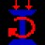
3
. Auto cad

Staad pro Staad Auto Cad Foundations
STAAD
Staad is powerful design software licensed by Bentley .Staad stands for structural analysis and design
Any object which is stable under a given loading can be considered as structure. So first find the outline of the structure, where as analysis is the estimation of what are the type of loads that acts on the beam and calculation of shear force and bending moment comes under analysis stage. Design phase is designing the type of materials and its dimensions to resist the load. this we do after the analysis.
To calculate s.f.d and b.m.d of a complex loading beam it takes about an hour. So when it comes into the building with several members it will take a week. Staad pro is a very powerful tool which does this job in just an hour’s staad is a best alternative for high rise buildings.
Now a days most of the high rise buildings are designed by staad which makes a compulsion for a civil engineer to know about this software.
These software can be used to carry rcc ,steel, bridge , truss etc. according to various country codes.
2.1 Alternatives for staad:
struts, robot, sap, adds pro which gives details very clearly regarding reinforcement and
manual calculations. But these software’s are restricted to some designs only where as staad can deal with several types of structure.
2.2 Staad Editor:
Staad has very great advantage to other software’s i.e., staad editor. staad editor is the programming
For the structure we created and loads we taken all details are presented in programming format in staad editor. This program can be used to analyze another structures also by just making some modifications, but this require some programming skills. So load cases created for a structure can be used for another structure using staad editor.
Limitations of Staad pro:
1.Huge output data
2.Even analysis of a small beam creates large output.
3.Unable to show plinth beams.
2.3 Staad foundation:
Staad foundation is a powerful tool used to calculate different types of foundations. It is also licensed by Bentley software’s. All Bentley software’s cost about 10 lakhs and so all engineers can’t use it due to heavy cost.
Analysis and design carried in Staad and post processing in staad gives the load at various supports. These supports are to be imported into these software to calculate the footing details i.e., regarding the geometry and reinforcement details.
This software can deal different types of foundations
SHALLOW (D<B)
- 1. Isolated (Spread) Footing
- 2.Combined (Strip) Footing
- 3.Mat (Raft) Foundation
DEEP (D>B)
- 1.Pile Cap
- 2. Driller Pier
- Isolated footing is spread footing which is common type of footing.
- Combined Footing or Strap footing is generally laid when two columns are very near to each other.
- Mat foundation is generally laid at places where soil has less soil bearing capacity.
- pile foundation is laid at places with very loose soils and where deep excavations are required.
So depending on the soil at type we has to decide the type of foundation required.
Also lot of input data is required regarding safety factors, soil, materials used should be given in respective units.
After input data is give software design the details for each and every footing and gives the details regarding
- Geometry of footing
- Reinforcement
- Column layout
- Graphs
- Manual calculations
These details will be given in detail for each and every column.
Another advantage of foundations is even after the design; properties of the members can be updated if required.
The following properties can be updated
  - Column Position
  - Column Shape
  - Column Size  Load Cases
  - Support List

It is very easy deal with this software and we don’t have any best alternative to this.

AutoCAD:
AutoCAD is powerful software licensed by auto desk. The word auto came from auto desk company and cad stands for computer aided design. AutoCAD is used for drawing different layouts, details, plans, elevations, sections and different sections can be shown in auto cad.
It is very useful software for civil, mechanical and also electrical engineer.
The importance of this software makes every engineer a compulsion to learn this software’s.
We used AutoCAD for drawing the plan, elevation of a residential building. We also used AutoCAD to show the reinforcement details and design details of a stair case.
AutoCAD is a very easy software to learn and much user friendly for anyone to handle and can be learn quickly
Learning of certain commands is required to draw in AutoCAD.

CHAPTER 3 PLAN AND ELEVATION

PLAN

The auto cad plotting no.1 represents the plan of a g+6 building. The plan clearly shows that it is a combination of five apartments. We can observe there is a combination between each and every apartments. .
In each block the entire floor consists of a three bed room house which occupies entire floor of a block. It represents a rich locality with huge areas for each house.
It is a g+6 proposed building, So for 5 blocks we have 5*6=30 flats.
The plan shows the details of dimensions of each and every room and the type of room and orientation of the different rooms like bed room, bathroom, kitchen, hall etc.. All the five apartments have similar room arrangement.
The entire plan area is about 1100 sq.m. There is some space left around the building for parking of cars. The plan gives details of arrangement of various furniture like sofa etc.
The plan also gives the details of location of stair cases in different blocks. we have 2 stair cases for each block and designing of stair case is shown in AutoCAD plot no.3
In the middle we have a small construction which consists of four lifts and those who want to fly through lift can use this facility and we know for a building with more than g+4 floors should compulsory have lift and the charges for the facilities is collected by all the members. At that junction we have a club for our enjoyment and charges are collected by all the building occupants every month.
So these represent the plan of our building and detailed explanation of remaining parts like elevations and designing is carried in the next sections.

Elevation:
AutoCAD plot no.2 represents the proposed elevation of building. It shows the elevation of a g+6 building representing the front view which gives the overview of a building block.
The figure represents the site picture of our structure which are taken at the site .the building is actually under constructions and all the analysis and design work is completed before the beginning of the project.
Each floor consists of height 3m which is taken as per GHMC rules for residential buildings.
The building is not designed for increasing the number of floors in future.so the number of floors is fixed for future also for this building due to unavailability of the permissions of respective authorities.
Also special materials like fly ash and self compacted concrete were also used in order to reduce the dead load and increase life of the structure and also improve economy. But these materials were not considered while designing in staad to reduce the complexity and necessary corrections are made for considering the economy and safety of the structure as it is a very huge building with 30 apartments.
The construction is going to complete in the month of June 2012 and ready for the occupancy.
This is regarding the plan and details of the site and next section deals with the design part of the building under various loads for which the building is designed.
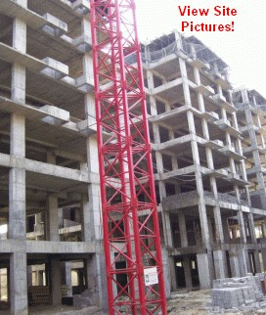

Figure 3.2a Elevation of the building

Center line plan
The above figure represents the center line diagram of our building in staad pro. Each support represents the location of different columns in the structure. This structure is used in generating the entire structure using a tool called transitional repeat and link steps. After using the tool the structure that is created can be analyzed in staad pro under various loading cases.
Below figure represents the skeletal structure of the building which is used to carry out the analysis of our building.
All the loadings are acted on this skeletal structure to carry out the analysis of our building.
This is not the actual structure but just represents the outline of the building in staad pro.
A mesh is automatically created for the analysis of these building.
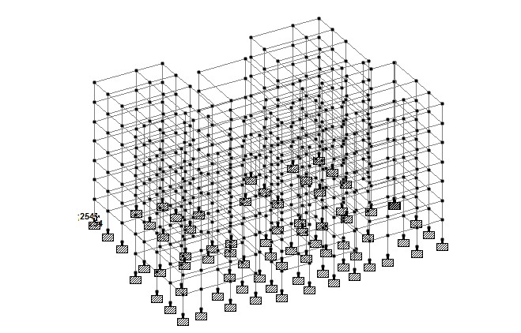

Figure 3.2b Skeletal structure of the building

CHAPTER 4 LOADINGS

4.1 Load Conditions and Structural System Response :
The concepts presented in this section provide an overview of building loads and their effect on the structural response of typical wood-framed homes. As shown in Table, building loads can be divided into types based on the orientation of the structural action or forces that they induce: vertical and horizontal (i.e., lateral) loads. Classification of loads are described in the following sections.
4.2 Building Loads Categorized by Orientation:
Types of loads on an hypothetical building are as follows.
- Vertical Loads
- Dead (gravity)
- Live (gravity)
- Snow(gravity)
- Wind(uplift on roof)
- Seismic and wind (overturning)  Seismic( vertical ground motion)
4.2.1 Horizontal (Lateral) Loads:
Direction of loads is horizontal w.r.t to the building.
- Wind
- Seismic(horizontal ground motion)
- Flood(static and dynamic hydraulic forces
- Soil(active lateral pressure)

4.2.2 Vertical Loads :
Gravity loads act in the same direction as gravity (i.e., downward or vertically) and include dead, live, and snow loads. They are generally static in nature and usually considered a uniformly distributed or concentrated load. Thus, determining a gravity load on a beam or column is a relatively simple exercise that uses the concept of tributary areas to assign loads to structural elements, including the dead load (i.e., weight of the construction) and any applied loads(i.e., live load). For example, the tributary gravity load on a floor joist would include the uniform floor load(dead and live) applied to the area of floor supported by the individual joist. The structural designer then selects a standard beam or column model to analyze bearing connection forces (i.e., reactions) internal stresses (i.e., bending stresses, shear stresses, and axial stresses) and stability of the structural member or system a for beam equations.
The selection of an appropriate analytic model is, however no trivial matter, especially if the structural system departs significantly from traditional engineering assumptions are particularly relevant to the structural systems that comprise many parts of a house, but to varying degrees. Wind uplift forces are generated by negative (suction) pressures acting in an outward direction from the surface of the roof in response to the aerodynamics of wind flowing over and around the building.
As with gravity loads, the influence of wind up lift pressures on a structure or assembly(i.e., roof) are analyzed by using the concept of tributary areas and uniformly distributed loads. The major difference is that wind pressures act perpendicular to the building surface (not in the direction of gravity) and that pressures vary according to the size of the tributary area and its location on the building, particularly proximity to changes in geometry (e.g., eaves, corners, and ridges).Even though the wind loads are dynamic and highly variable, the design approach is based on a maximum static load (i.e., pressure) equivalent. Vertical forces are also created by overturning reactions due to wind and seismic lateral loads acting on the overall building and its lateral force resisting systems, Earthquakes also produce vertical ground motions or accelerations which increase the effect of gravity loads. However, Vertical earthquake loads are usually considered to be implicitly addressed in the gravity load analysis of a light-frame building.
4.2.3 Lateral Loads:
The primary loads that produce lateral forces on buildings are attributable to forces associated with wind, seismic ground motion, floods, and soil. Wind and seismic lateral loads apply to the entire building. Lateral forces from wind are generated by positive wind pressures on the windward face of the building and by negative pressures on the leeward face of the building, creating a combined push and-pull effect. Seismic lateral forces are generated by a structure’s dynamic inertial response to cyclic ground movement.
The magnitude of the seismic shear (i.e., lateral)load depends on the magnitude of the ground motion, the buildings mass, and the dynamic structural response characteristics(i.e., dampening, ductility ,natural period of vibration ,etc.).for houses and other similar low rise structures, a simplified seismic load analysis employs equivalent static forces based on fundamental Newtonian mechanics(F=ma) with somewhat subjective(i.e., experience-based) adjustments to account for inelastic, ductile response characteristics of various building systems. Flood loads are generally minimized by elevating the structure on a properly designed foundation or avoided by not building in a flood plain.
Lateral loads from moving flood waters and static hydraulic pressure are substantial. Soil lateral loads apply specifically to foundation wall design, mainly as an “out-of-plane” bending load on the wall. Lateral loads also produce an overturning moment that must be offset by the dead load and connections of the building. Therefore, overturning forces on connections designed to restrain components from rotating or the building from overturning must be considered.
Since wind is capable of the generating simultaneous roof uplift and lateral loads, the uplift component of the wind load exacerbates the overturning tension forces due to the lateral component of the wind load. Conversely the dead load may be sufficient to offset the overturning and uplift forces as is the case in lower design wind conditions and in many seismic design conditions.
4.3 Structural systems :
As far back as 1948,it was determined that “conventions in general use for wood, steel and concrete structures are not very helpful for designing houses because few are applicable”(NBS,1948).More specifically, the NBS document encourages the use of more advanced methods of structural analysis for homes. Unfortunately. the study in question and all subsequent studies addressing the topic of system performance in housing have not led to the development or application of any significant improvement in the codified design practice as applied to housing systems.
This lack of application is partly due to conservative nature of the engineering process and partly due to difficulty of translating the results of narrowly focused structural systems studies to general design applications. Since this document is narrowly scoped to address residential construction, relevant system
Based studies and design information for housing are discussed, referenced, and applied as appropriate. If a structural member is part of system, as it typically the case in light frame residential construction, its response is altered by the strength and stiffness characteristics of the system as a whole.
In general, system performance includes two basic concepts known as load sharing and composite action. Load sharing is found in repetitive member systems(i.e., wood framing) and reflects the ability of the load on one member to be shared by another or, in the case of a uniform load, the ability of some of the load on a weaker member to be carried by adjacent members. Composite action is found in assemblies of components that, when connected to one another, from a “composite member” with greater capacity and stiffness than the sum of the component parts.
However, the amount of composite action in a system depends on the manner in which the various elements are connected. The aim is to achieve a higher effective section modulus than the component members are taken separately. For example, when floor sheathing is nailed and glued to floor joists, the floor system realizes a greater degree of composite action than a floor with sheathing that is merely nailed; the adhesive between components helps prevents shear slippage, particularly if a rigid adhesive is used. Slippage due to shear stresses transferred between the component parts necessitates consideration of partial composite action, which depends on the stiffness of an assembly’s connections. Therefore, consideration of the floor system of fully composite T-beams may lead to an un conservative solution.
Whereas the typical approach of only considering the floor joist member without composite system effect will lead to a conservative design. This guide addresses the strengthenhancing effect of sharing and partial composite action when information is available for practical design guidance. Establishment of repetitive member increase factors (also called system factors) for general design use is a difficult task because the amount of system effect can vary substantially depending on system assembly and materials.
Therefore, system factors for general design use are necessarily conservative to cover broad conditions. Those that more accurately depict system effects also require a more exact description of and compliance with specific assembly details and material specifications. It should be recognized however that system effects do no t only affect the strength and stiffness of light-frame assemblies(including walls, floors and roofs).They also alter the classical understanding of how loads are transferred among the various assemblies of a complex woodframed home. For example, floor joists are sometimes doubled under non load-bearing partition walls “because of the added dead load and resulting stresses” determined in accordance with accepted engineering practice.
Such practice is based on a conservative assumption regarding a load path and the structural response. That is, the partition wall does create an additional load, but the partition wall is relatively rigid and actually acts as a deep beam, particularly when the top and bottom are attached to the ceiling and floor framing, respectively. As the floor is loaded and deflects, the interior wall helps resist the load. Of course, the magnitude of effect depends on the wall configuration (i.e., amount of openings) and other factor. The above example of composite action due to the interaction of separate structural systems or subassemblies points to the improved structural response of the floor system such that it is able to carry more dead and live than if the partition wall were absent .on whole-house assembly test has demonstrated this effect (Hurst,1965).Hence ,a double joist should not be required under a typical non load-bearing partition; In fact, a single joist may not even be required directly below the partition, assuming that the floor sheeting is adequately specified to support the partition between the joists. While this condition cannot yet be duplicated in a standard analytic form conductive to simple engineering analysis, A designer should be aware of the concept when making design assumption regarding light frame residential constructions.
At this point, the readership should consider that the response of a structural system, Not just its individual elements, determines the manner in which a structure distributes and resists horizontal and vertical loads. For wood framed systems, the departure from calculations based are classical engineering mechanics (i.e., single members with standard tributary areas and assumed elastic behaviour)and simplistic assumptions regarding load path can be substantial
4.4 Design loads for residential buildings :
General
Loads are a primary consideration in any building design because they define the nature and magnitude of hazards are external forces that a building must resist to provide a reasonable performance(i.e., safety and serviceability )through out the structure’s useful life. The anticipated loads are influenced by a building’s intended use (occupancy and function),configuration(size and shape)and location(climate and site conditions).Ultimately, the type and magnitude of design loads affect critical decisions such as material collection, construction details and architectural configuration.
Thus, to optimize the value (i.e., performance versus economy) of the finished product, it is essential to apply design loads realistically. While the buildings considered in this guide are primarily single-family detached and and attached dwellings, the principles and concepts related to building loads also apply to other similar types of construction, such as low-rise apartment buildings. In general, the the design loads recommended in this guide are based on applicable provisions of the ASCE 7 standard-Minimum Design ;loads for buildings and other structures (ASCE,1999).the ASCE 7 standard represents an acceptable practice for building loads in the United states and is recognized in virtually all U.S. building codes. For this reason, the reader is encouraged to become familiar with the provisions, commentary, and technical references contained in the ASCE 7 standard. In general structural design of housing has not been treated as a unique engineering discipline or subjected to a special effort to develop better, more efficient design practices. Therefore, this part of the guide focuses on those aspects aspects of ASCE 7 and other technical resources that are particularly relevant to the determination of design loads for residential structures.
The guide provides supplemental design assistance to address aspects of residential construction where current practice is either silent or in need of improvement. Residential buildings methods for determining design loads are complete yet tailored to typical residential conditions. as with any design function, the designer must ultimately understand and approve the loads for a given project as well as the overall design methodology, including all its inherent strengths and weakness.
Since building codes tend to vary in their treatment of design loads the designer should, as a matter of due diligence, identify variances from both local accepted practice and the applicable code relative to design loads as presented in this guide, even though the variances may be considered technically sound. Complete design of a home typically requires the evaluation of several different types of materials. Some material specifications use the allowable stress design (ASD) approach while others use load and resistance factor design (LRFD).

4.4.1 Dead Loads:
Dead loads consist of the permanent construction material loads compressing the roof, floor, wall, and foundation systems, including claddings, finishes and fixed equipment. Dead load is the total load of all of the components of the components of the building that generally do not change over time, such as the steel columns, concrete floors, bricks, roofing material etc.
In staad pro assignment of dead load is automatically done by giving the property of the member.
In load case we have option called self weight which automatically calculates weights using the properties of material i.e., density and after assignment of dead load the skeletal structure looks red in color as shown in the figure.
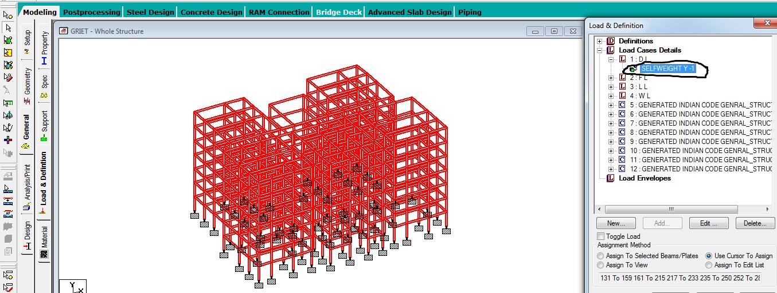

Fig 4.4.1a Example for calculation of dead load;

Dead load calculation
Weight=Volume x Density
Self weight floor finish=0.12*25+1=3kn/m^2
The above example shows a sample calculation of dead load.
Dead load is calculated as per IS 875 part 1

4.4.2 Live Loads:
Live loads are produced by the use and occupancy of a building. Loads include those from human occupants, furnishings, no fixed equipment, storage, and construction and maintenance activities. As required to adequately define the loading condition, loads are presented in terms of uniform area loads, concentrated loads, and uniform line loads. The uniform and concentrated live loads should not be applied simultaneously n a structural evaluation. Concentrated loads should be applied to a small area or surface consistent with the application and should b e located or directed to give the maximum load effect possible in enduse conditions. For example. The stair load of 300 pounds should be applied to the center of the stair tread between supports.
In staad we assign live load in terms of U.D.L .we has to create a load case for live load and select all the beams to carry such load. After the assignment of the live load the structure appears as shown below.
For our structure live load is taken as 25 N/mm for design.
Live loads are calculated as per IS 875 part 2
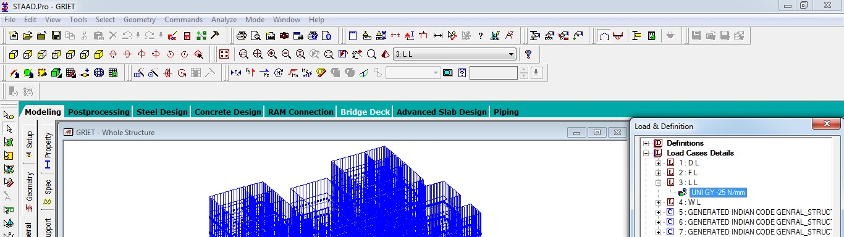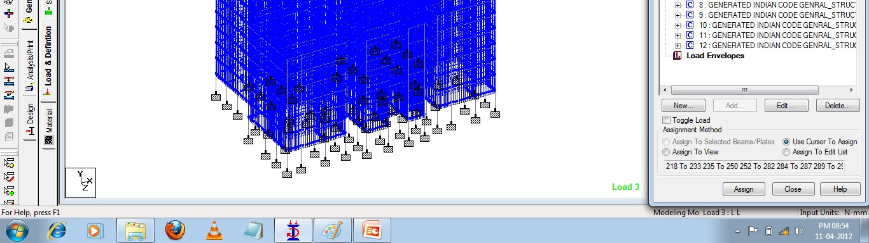
Fig 4.4.2a diagram of live load

4.4.3 Wind loads:
In the list of loads we can see wind load is present both in vertical and horizontal loads.
This is because wind load causes uplift of the roof by creating a negative(suction) pressure on the top of the roof
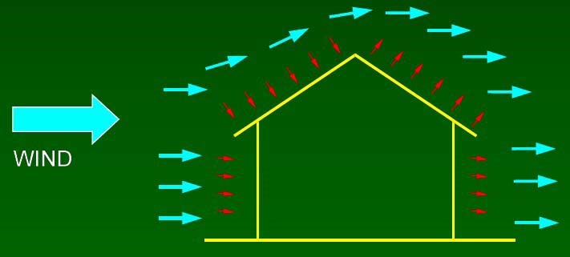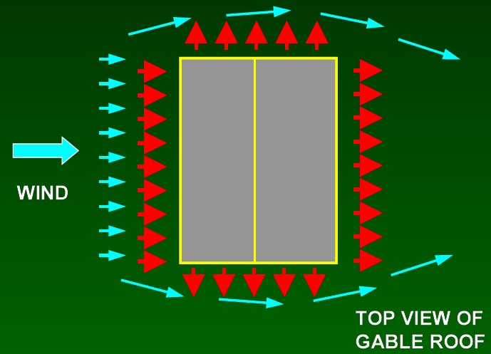

Fig 4.4.3a a diagram of wind load
wind produces non static loads on a structure at highly variable magnitudes. the variation in pressures at different locations on a building is complex to the point that pressures may become too analytically intensive for precise consideration in design. Therefore, wind load specifications attempt to amplify the design problem by considering basic static pressure zones on a building representative of peak loads that are likely to be experienced. The peak pressures in one zone for a given wind direction may not, However, occur simultaneously in other zones. For some pressure zones, The peak pressure depends on an arrow range of wind direction. Therefore, the wind directionality effect must also be factored into determining risk consistent wind loads on buildings.
In fact, most modern wind load specifications take account of wind load directionality and other effects in determining nominal design loads in some simplified form(sbcci,1999; ASCe,1999).this section further simplifies wind load design specifications to provide an easy yet effective approach for designing designing typical residential buildings. Because they vary substantially over the surface of a building. wind load star considered at two different scales. on large scale, the load produced on the overall building are on major structural systems that sustain wind loads from from more than one surface of building, are considered the main wind force resisting systems (MWFRS).the MWFRS of a home includes the shear walls, Diaphragms that create the lateral force resisting systems(LFRS).As well as the structural systems such as trusses that experience loads from two surfaces are regimes of the building.
The wind loads applied to the MWFRS account for the large affects of time varying wind pressures on the surface are surfaces of the building. On a Smaller scale, pressures are somewhat greater on localized surface area of the building, particularly near abrupt changes in building geometry (i.e., eaves, ridges, and corners). These higher wind pressures occur on smaller areas, particularly affecting the loads borne by components and cladding (e.g., sheathing, windows, doors, purling, studs).
The components and cladding (C&C) transfer localized time-varying loads to the MWFRS, at which point the loads average out both spatially and temporally since, at a given time, some components may beat near peak loads while others are at substantially less than peak.
The next section presents a simplified method for determining both MWFRS and C&C wind loads. Since the loads in the section 3.6.2 are determined for specific applications, the calculation of MWFRS and C&C wind loads is implication the values provided. Design example 3.2 in section 3.10 demonstrate the calculation of wind loads by applying the simplified method of the following section 3.6.2to several design conditions associated with wind loads and the load combinations.
Century, modernism morphed into the international style, an aesthetic epitomized in many ways by the Twin Towers of New York’s world trade center.
Many architects resisted modernism, finding it devoid of the decorative richness of ornamented styles. Yet as the of the movement lost influence in the late 1970s, postmodernism developed as a reaction against the austerity of Modernism. Robert ventures’ contention that a “decorated shed” (an ordinary building which is functionally designed inside and embellished on the outside) was better than a “Duck” (a building in which the whole form and its function are tied together) gives an idea of this approach.
Assignment of wind speed is quite different compared to remaining loads.
We have to define a load case prior to assignment.
After designing wind load can be assigned in two ways
- collecting the standard values of load intensities for a particular heights and assigning of the loads for respective height.
- calculation of wind load as per IS 875 part 3.
We designed our structure using second method which involves the calculation of wind load using wind speed.
In Hyderabad we have a wind speed of 45 kmph for 10 m height and this value is used in calculation.
After the assignment of wind load the structure looks as shown in figure

4.4.3.1 Basic wind speed:
Gives basic wind speed of India, as applicable to 1m height above means ground level for different zones of the country. Basic wind speed is based on peak just velocity averaged over a short time interval of about 3 seconds and corresponds to mean heights above ground level in an open terrain.
The wind speed for some important cities/towns is given table below.

4.4.3.2 Design wind speed:
The basic wind speed (Vb) for any site shall be obtained the following effects to get design wind velocity at any height (Vz) for the chosen structure.
- Risk level
- Terrain roughness, height and size of the structure and
- Local topography

It can be mathematically expressed as follows:
Vs.=Vb* K1* K2* K3
Where
Vz= design wind speed at any height Z in m/s
K1= probability factor (risk coefficient)
K2=terrain height and structure size factor and
K3=topography factor

Table 4.4.3.3
Basic wind speed at 10 m for hight for some important cities/town:

CITIES SPEED | BASIC WIND  (m/s) | CITIES SPEED | BASIC WIND  (m/s)
Cuttack | 50 | Pune | 39
Agra | 47 | Jhansi | 47
Durbhanga | 55 | Raipur | 39
Ahmadabad | 39 | Jodhpur | 47
Darjeeling | 47 | Rajkot | 39
Ajmer | 47 | Kanpur | 47
Dehra dun | 47 | Ranchi | 39
Alomar | 47 | Kohima | 44
Delhi | 47 | Roorkee | 39
Amritsar | 47 | Kurnool | 39
Alanson | 47 | Rourkela | 39

Gangtok | 47 | Lakshadweep | 39
Auragabad | 39 | Simla | 39
Gauhati | 50 | Srinagar | 39
Bahraich | 47 | Ludhina | 47
Gaya | 39 | Surat | 44
Bangalore | 33 | Madras | 50
Gorakhpur | 47 | Tiruchchirappalli | 47
Varanasi | 47 | Madurai | 39
Hyderabad | 44 | Trivandrum | 39
Bareilly | 47 | Mandi | 39
Impale | 47 | Udaipur | 47
Bhatinda | 47 | Mangalore | 39
Jabalpur | 47 | Vododara | 44
Bhalali | 39 | Moradabad | 47
Jaipur | 47 | Varanasi | 33
Bhopal | 39 | Mysore | 50
Jamshedpur | 47 | Vijayawada | 50
Bhuvaneshwar | 50 | Nagpur | 44

Bhuj | 50 | Vishakhapatnam | 50
Bikaner | 47 | Naimital | 47
Bikaro | 47 | Nasik | 39
Bokaro | 47 | Nellore | 50
Bombay | 44 | Panjim | 39
Calcutta | 50 | Patiala | 47
Calicut | 47 | Patna | 47
Chandigarh | 47 | Pondicherry | 50
Coimbatore | 39 | Por blair | 44

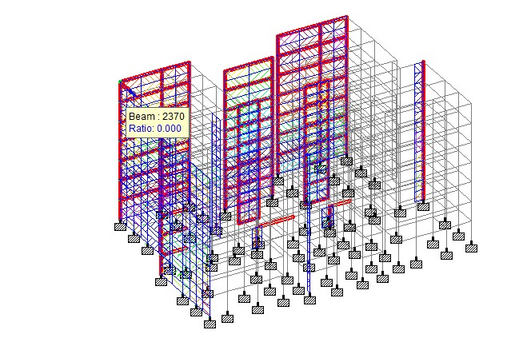

figure 4.4.3.3b Wind Load

4.4.4 Floor load:
Floor load is calculated based on the load on the slabs. Assignment of floor load is done by creating a load case for floor load. After the assignment of floor load our structure looks as shown in the below figure.
The intensity of the floor load taken is: 0.0035 N/mm² -ve sign indicates that floor load is acting downwards.
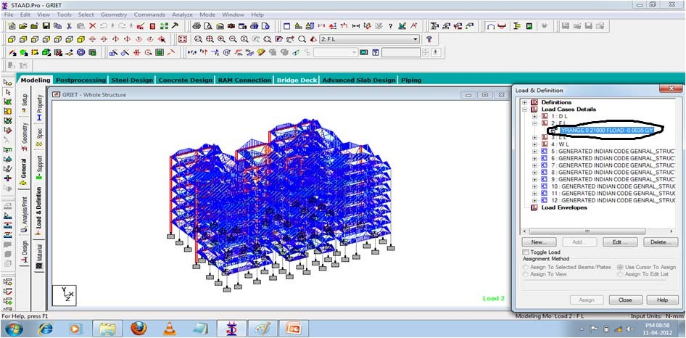

Fig 4.4.4.a Diagram of floor load

4.4.5 Load combinations:
All the load cases are tested by taking load factors and analysing the building in different load combination as per IS456 and analyzed the building for all the load combinations and results are taken and maximum load combination is selected for the design
Load factors as per IS456-2000
Live load | dead load | wind load
1.5 | 1.5 | 0
1.2 | 1.2 | 1.2
0.9 | 0.9 | 0.9

When the building is designed for both wind and seismic loads maximum of both is taken. Because wind and seismic do not come at same time as per code.
Structure is analyzed by taking all the above combinations.

CHAPTER 5 BEAMS

Beams transfer load from slabs to columns .beams are designed for bending.
In general we have two types of beam: single and double. Similar to columns geometry and perimeters of the beams are assigned. Design beam command is assigned and analysis is carried out, now reinforcement details are taken.
5.1 Beam design:
a reinforced concrete beam should be able to resist tensile, compressive and shear stress induced in it by loads on the beam.
There are three types of reinforeced concrete beams
- single reinforced beams
- double reinforced concrete
- flanged beams

5.1.1 Singly reinforced beams:
In singly reinforced simply supported beams steel bars are placed near the bottom of the beam where they are more effective in resisting in the tensile bending stress. I cantilever beams reinforcing bars placed near the top of the beam, for the same reason as in the case of simply supported beam.

5.1.2 Doubly reinforced concrete beams:
It is reinforced under compression tension regions. The necessity of steel of compression region arises due to two reasons. When depth of beam is restricted. The strength availability singly reinforced beam is in adequate. At a support of continuous beam where bending moment changes sign such as situation may also arise in design of a beam circular in plan.

Figure shows the bottom and top reinforcement details at three different sections.
These calculations are interpreted manually.
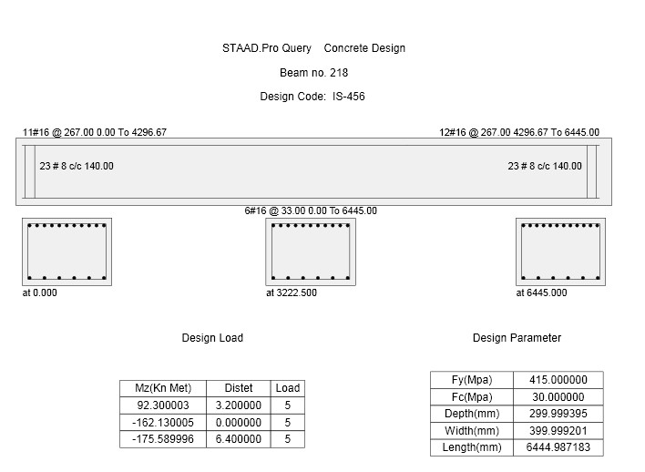

Fig 5.2a A diagram of the reinforcement details of beam

The following figure shows the deflection of a column.

Deflection:
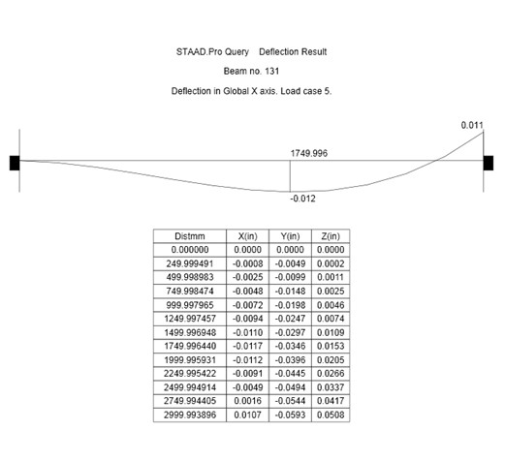

Fig 5.2b A diagram of the deflection of a column.

Due to huge output data, output of a sample beam is shown below.
Beam design
====================================================================== ======
B E A M N O. 218 D E S I G N R E S U L T S
M30 Fe415 (Main) Fe415
(Sec.)

LENGTH: 6445.0 mm SIZE: 400.0 mm X 300.0 mm COVER:
25.0 mm

DESIGN LOAD SUMMARY (KN MET)
-------------------------------------------------------------------
---------
SECTION |FLEXURE (Maxm. Sagging/Hogging moments)| SHEAR
(in mm) | P MZ MX Load Case | VY MX
Load Case
-------------------------------------------------------------------
---------
0.0 | 0.00 23.66 -1.39 4 | 154.56 0.78 5
| 0.00 -162.13 0.78 5 |
537.1 | 0.00 22.68 -1.98 9 | 131.59 0.78 5
| 0.00 -91.95 2.30 7 |
1074.2 | 0.00 22.24 -1.98 9 | 106.30 0.78 5
| 0.00 -36.08 2.30 7 |
1611.2 | 0.00 37.65 -1.05 6 | 80.61 0.78 5
| 0.00 -15.45 2.21 10 |
2148.3 | 0.00 64.93 0.78 5 | 51.11 2.30 7
| 0.00 -6.69 2.21 10 |
2685.4 | 0.00 86.02 0.78 5 | 29.06 2.30 7
| 0.00 0.00 0.00 1 |
3222.5 | 0.00 92.30 0.78 5 | 10.62 2.21 10
| 0.00 0.00 0.00 1 |
3759.6 | 0.00 83.77 0.78 5 | -32.40 -1.05 6
| 0.00 -3.53 -1.39 4 |
4296.7 | 0.00 60.45 0.78 5 | -57.22 0.78 5
| 0.00 -7.41 -1.39 4 |
4833.8 | 0.00 31.42 2.30 7 | -84.78 0.78 5
| 0.00 -15.12 -1.98 9 |
5370.8 | 0.00 20.20 2.21 10 | -110.48 0.78 5
| 0.00 -42.41 -1.05 6 |
5907.9 | 0.00 20.40 2.21 10 | -135.77 0.78 5
| 0.00 -100.07 -1.05 6 |
6445.0 | 0.00 19.37 2.21 10 | -158.73 0.78 5
| 0.00 -175.59 0.78 5 |
-------------------------------------------------------------------
---------

SUMMARY OF REINF. AREA (Sq.mm)

---------------------------------------------------------------------------
SECTION | TOP | BOTTOM | STIRRUPS
(in mm) | Reqd./Provided reinf. | Reqd./Provided reinf. | (2 legged)
-------------------------------------------------------------------
---------
0.0 | 2102.75/2211.68(11-16í )| 625.79/ 804.25( 4-16í )| 8í
@ 140 mm
537.1 | 1151.51/1206.37( 6-16í )| 265.73/ 603.19( 3-16í )| 8í
@ 140 mm
1074.2 | 422.27/ 603.19( 3-16í )| 260.79/ 603.19( 3-16í )| 8í
@ 140 mm
1611.2 | 218.75/ 603.19( 3-16í )| 425.58/ 603.19( 3-16í )| 8í
@ 140 mm
2148.3 | 218.75/ 603.19( 3-16í )| 756.82/ 804.25( 4-16í )| 8í
@ 140 mm
2685.4 | 0.00/ 402.12( 2-16í )| 1042.62/1206.37( 6-16í )| 8í
@ 140 mm
3222.5 | 0.00/ 402.12( 2-16í )| 1133.58/1206.37( 6-16í )| 8í
@ 140 mm
3759.6 | 218.75/ 603.19( 3-16í )| 1010.85/1206.37( 6-16í )| 8í
@ 140 mm
4296.7 | 218.75/ 603.19( 3-16í )| 699.37/ 804.25( 4-16í )| 8í
@ 140 mm
4833.8 | 218.75/ 603.19( 3-16í )| 368.27/ 603.19( 3-16í )| 8í
@ 140 mm
5370.8 | 481.59/ 603.19( 3-16í )| 240.74/ 603.19( 3-16í )| 8í
@ 140 mm
5907.9 | 1254.86/1407.43( 7-16í )| 242.95/ 603.19( 3-16í )| 8í @ 140 mm
6445.0 | 2284.09/2412.74(12-16í )| 826.67/1005.31( 5-16í )| 8í @ 140 mm
-------------------------------------------------------------------

SHEAR DESIGN RESULTS AT DISTANCE d (EFFECTIVE DEPTH) FROM FACE OF
THE SUPPORT

SHEAR DESIGN RESULTS AT 490.0 mm AWAY FROM START SUPPORT
VY = 133.60 MX = 0.78 LD= 5
Provide 2 Legged 8í @ 140 mm c/c

SHEAR DESIGN RESULTS AT 490.0 mm AWAY FROM END SUPPORT
VY = -137.98 MX = 0.78 LD= 5 Provide 2 Legged 8í @ 140 mm c/c

shear
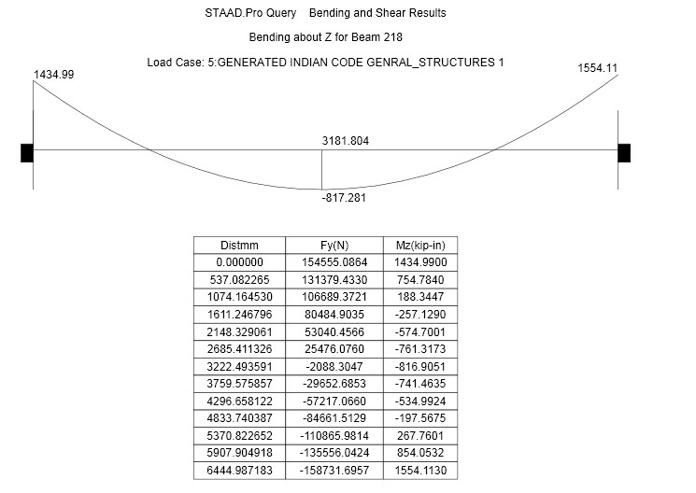
Fig 5.2c A diagram of the shear force of a column.
5.3 Check for the design of a beam (no. 230):
Given data:
Cross section of beam : b x d = 300mm x400 mm Vertical shear force = v_{u} =145.93 KN τ_{c} = 0.29 N/mm² (from table 19 of IS 456 200)
Minimum Shear Reinforcement:
When τ_{v} is less than τ_{c} , given in Table 19, minimum shear reinforcement shall -be provided

Design of Shear Reinforcement:
When τ_{v} exceeds τ_{c}, given in Table 19, shear reinforcement shall be provided in any of the following forms:
- Vertical stirrups,
- Bent-up bars along with stirrups, and
- Inclined stirrups, τ_{v} = v_{u}/(b x d) (As per clause 40.1 of IS 456-2000)
=145.93 x 10³/(400x300)
=1.216 N/mm²
τ_{v} ≥ τ_{c}
design reinforcement Vus = Vu- τ_{c}xbxd (As per clause 40.4 of IS 456-2000)

= 145.93 x10³ -0.29x400x300
= 111100 N

Shear reinforcement shall be provided to carry a shear equal to Vu - τ_{c} bd The strength of shear reinforcement Vus, shall be calculated as below:

For vertical stirrups:

Vus = 0.87 f_{y}Asvd/Sv (As per clause 40.4 of IS 456-2000)

Asv = total cross-sectional area of stirrup legs or bent-up bars within a distance Sv.

Sv = spacing of the stirrups or bent-up bars along the length of the member, τ_{v} = nominal shear stress
τ_{c =} design shear strength of the concrete,
b = breadth of the member which for flanged beams, shall be taken as the breadth of the web bw,
fy = characteristic strength of the stirrup or bent-up reinforcement which shall notbe taken greater than 415 N/mm², α = angle between the inclined stirrup or bent- up bar and the axis of the member, not less than
45”, and d = effective depth.

111130 N= 0.87x415x2xπx8²x400/Sv
Sv = 140 mm
Sv should not be more than the following
- 0.75xd = 0.75 x 400 = 300 mm
- 300 mm
- Minimum shear reinforcement spacing = Svmin

Minimum shear reinforcement:
Minimum shear reinforcement in the form of stirrups shall be provided such that:

Asv/bSv ≥ 0.4/ 0.87fy (As per clause 26.5.1.6 of IS 456-2000)

Asv = total cross-sectional area of stirrup legs effective in shear,
Sv = stirrup spacing along the length of the member, b = breadth of the beam or breadth of the web of flanged beam, and
fy = characteristic strength of the stirrup reinforcement in N/mm* which shall not be taken greater than 415 N/mn²

S_{v}=2x(π/4)x8²x0.87x415/(0.4x300)

=302 mm.

Provided 2 legged 8mm @ 140 mm stirrups.

Hence matched with staad output.

CHAPTER 6 COLUMNS

A column or strut is a compression member, which is used primary to support axial compressive loads and with a height of at least three it is least lateral dimension.
A reinforced concrete column is said to be subjected to axially loaded when line of the resultant thrust of loads supported by column is coincident with the line of C.G 0f the column I the longitudinal direction.
Depending upon the architectural requirements and loads to be supported,R.C columns may be cast in various shapes i.e square ,rectangle, and hexagonal ,octagonal,circular.Columns of L shaped or T shaped are also sometimes used in multi-storeyed buildings.
The longitudinal bars in columns help to bear the load in the combination with the concrete.The longitudinal bars are held in position by transverse reinforcement, or lateral binders.
The binders prevent displacement of longitudinal bars during concreting operation and also check the tendency of their buckling towards under loads.

6.1 Positioning of columns:
Some of the guiding principles which help the positioning of the columns are as follows:-
- Columns should be preferably located at or near the corners of the building and at the intersection of the wall, but for the columns on the property line as the following requirements some area beyond the column, the column can be shifted inside along a cross wall to provide the required area for the footing with in the property line.
alternatively a combined or a strap footing may be provided.
- The spacing between the column is governed by the lamination on spans of supported beams, as the spanning of the column decides the the span of the beam. As the span of the of the beam increases, the depth of the beam, and hence the self weight of the beam and the total.

Effective length:
The effective length of the column is defined as the length between the points of contraflexure of the buckled column. The code has given certain values of the effective length for normal usage assuming idealized and conditions shown in appendix D of IS 456(table 24)
A column may be classified based as follows based on the type of loading:
- Axially loaded column
- A column subjected to axial load and uneasily bending 3) A column subjected to axial load and biaxial bending.

6.2 Axially loaded columns:
All compression members are to be designed for a minimum eccentricity of load into principal directions. In practice, a truly axially loaded column is rare ,if not nonexistent.
Therefore, every column should be designed for a minimum eccentricity .clause 22.4 of IS code
E _{min}=(L/500)+(D/300) ,subjected to a minimum of 200 mm.

Where L is the unsupported length of the column (see 24.1.3 of the code for definition unsupported length) and D is the lateral dimension of the column in the direction under the consideration.

6.2.1 Axial load and uniaxial bending:
A member subjected to axial force and bending shall be designed on the basis of
- The maximum compressive strength in concrete in axial compression is taken as 0.002
- The maximum compressive strength at the highly compressed extreme fiber in concrete subjected to highly compression and when there is no tension on the section shall be
0.0035-0.75 times the strain at least compressed extreme fiber.

Design charts for combined axial compression and bending are in the form of intersection diagram in which curves for P_{u}/f_{ck} bD verses M_{u}/f_{ck} bD² are plotted for different values of p/f_{ck} where p is reinforcement percentage.

6.2.2 Axial load and biaxial bending:
The resistance of a member subjected to axial force and biaxial bending shall be obtained on the basis of assumptions given in 38.1 and 38.2 with neutral axis so chosen as to satisfy the equilibrium of load and moment about two weeks.
Alternatively such members may be designed by the following equation:
(Mux/ Muy)αn +(Muy/ Muy1)αn<=1.0
M_{ux}&M_{uy}=moment about x and Y axis due to design loads
M_{ux1}&M_{uy1}=maximum uniaxial moment capacity for an axial load of P_{u} bending about x and y axis respectively.
αn is related to P_{u}/p_{uz} p_{uz}=0.45*f_{ck}*A_{c}+0.75*f_{y}*A_{sc}
For values of p_{u}/P_{uz}=0.2 to 0.8, the values of αn vary linearly from 1.0 to 2.0 for values less than
0.2, αn is values greater than 0.8 , α_{n} is 2.0
The main duty of column is to transfer the load to the soil safely.columns are designed for compression and moment. The cross section of the column generally increase from one floor to another floor due to the addition of both live and dead load from the top floors. Also the amount if load depends on number of beams the columns is connected to. As beam transfer half of the load to each column it is connected.
6.3 Column design:
A column may be defined as an element used primary to support axial compressive loads and with a height of a least three times its lateral dimension. The strength of column depends upon the strength of materials, shape and size of cross section, length and degree of proportional and dedicational restrains at its ends.
A column may be classify based on deferent criteria such as
- shape of the section
- slenderness ratio(A=L+D)
- type of loading, land
- pattern of lateral reinforcement.

The ratio of effective column length to least lateral dimension is released to as slenderness ratio.
In our structure we have 3 types of columns.
- Column with beams on two sides
- Columns with beams on three sides
- Columns with beams on four sides
So we require three types of column sections. So create three types of column sections and assign to the respective columns depending on the connection. But in these structure we adopted same cross section throughout the structure with a rectangular cross section .In foundations we generally do not have circular columns if circular column is given it makes a circle by creating many lines to increase accuracy.
The column design is done by selecting the column and from geometry page assigns the dimensions of the columns. Now analyze the column for loads to see the reactions and total loads on the column by seeing the loads design column by giving appropriate parameters like
- Minimum reinforcement, max, bar sizes, maximum and minimum spicing.
- Select the appropriate design code and input design column command to all the column.
- Now run analysis and select any column to collect the reinforcement details

The following figure shows the reinforcement details of a beam in staad.
The figure represents details regarding
- Transverse reinforcement
- Longitudinal reinforcement
The type of bars to be used, amount of steel and loading on the column is represented in the below figure.
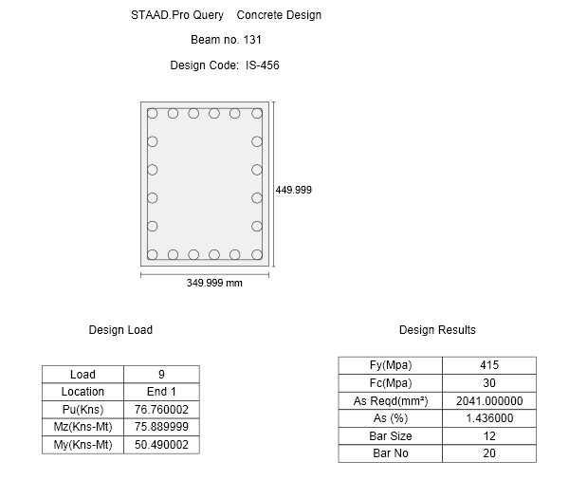
Fig 6.3a reinforcement details of a column
Output:
Due to very huge and detailed explanation of staad output for each and every coloumn we have shown a column design results below showing the amount of load,moments,amount of steel required,section adopted etc.

The main problem with staad is it takes all coloumns also as beams initially before design and continue the same.so here output of column 1 which os actually 131st beam as most of beams are used in drawing the plan.

Out put for coloumn 1(beam 131):

C O L U M N N O. 131 D E S I G N R E S U L T S
M30 Fe415 (Main) Fe415
(Sec.)

LENGTH: 3000.0 mm CROSS SECTION: 350.0 mm X 450.0 mm COVER:
40.0 mm

** GUIDING LOAD CASE: 9 END JOINT: 1 SHORT COLUMN

DESIGN FORCES (KNS-MET)
-----------------------
DESIGN AXIAL FORCE (Pu) : 76.8

About Z About Y
INITIAL MOMENTS : 75.89 50.49
MOMENTS DUE TO MINIMUM ECC. : 1.61 1.54

SLENDERNESS RATIOS : - -
MOMENTS DUE TO SLENDERNESS EFFECT : - -
MOMENT REDUCTION FACTORS : - -
ADDITION MOMENTS (Maz and May) : - -

TOTAL DESIGN MOMENTS : 75.89 50.49

REQD. STEEL AREA : 2041.15 Sq.mm.
REQD. CONCRETE AREA: 155458.86 Sq.mm.
MAIN REINFORCEMENT : Provide 20 - 12 dia. (1.44%, 2261.95 Sq.mm.)
(Equally distributed)
TIE REINFORCEMENT : Provide 8 mm dia. rectangular ties @ 190 mm c/c

SECTION CAPACITY BASED ON REINFORCEMENT REQUIRED (KNS-MET)
----------------------------------------------------------
Puz : 2734.00 Muz1 : 144.59 Muy1 : 107.38

INTERACTION RATIO: 1.00 (as per Cl. 39.6, IS456:2000)
SECTION CAPACITY BASED ON REINFORCEMENT PROVIDED (KNS-MET)
----------------------------------------------------------
WORST LOAD CASE: 9
END JOINT: 1 Puz : 2799.74 Muz : 157.05 Muy : 116.44 IR: 0.92

The following figure shows the deflection of same column.

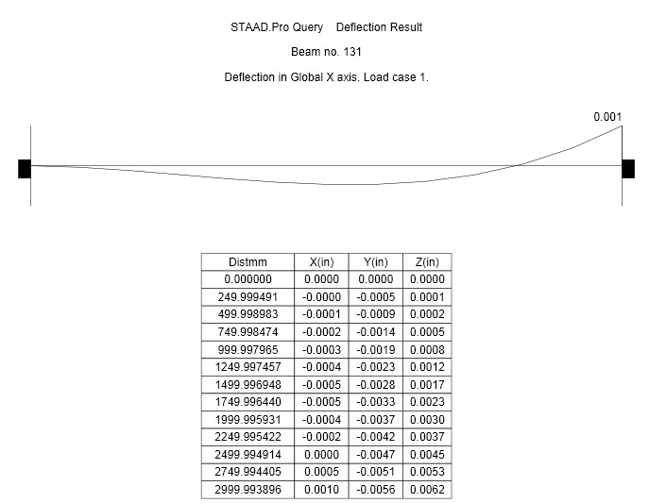
Fig 6.3 b deflection of column
Check for Column design :
Short axially loaded columns: Given data
fck =30 N/mm²
fy =415N/mm² puz=2734 N b=350 d=450
Design of reinforcement Area:
(As per clause 39.6 of IS 456 2000)
Puz=0.45f_{ck}A_{c}+0.75f_{y}A_{sc}
2734=0.45*30*(350*450-Asc) +0.75*415*A_{sc}
On solving the above equation we get
Asc=2041.15 Sq.mm.((Matched with Output)
Design of Main(Longitudinal) reinforcement:
(As per clause 26.5.3.1 of IS 456-2000 )
- The cross sectional area of longitudinal reinforcement shall not be less 0.8% , not more than 6% of the gross cross sectional area of the column.
- The bars shall not be less than 12 mm in diameter.
- Spacing of longitudinal bars measured along the periphery of the column shall not exceed 300 mm.

Provided main reinforcement: 20 - 12 dia
(1.44%, 2261.95 Sq.mm.)
Check for Transverse reinforcement :
(As per clause 26.5.3.2 of IS 456-2000)
A) Pitch:
Shall not be more than the least of the following
1) Least lateral dimension of the compression member (350mm). 2) 16 x diameter of longitudinal reinforcement bar
= 16x 12 = 192 mm
3) 300 mm

B) Diameter:
    - Shall not be less than one fourth of the diameter of main reinforcement.
    - Not less than 6 mm.

PROVIDED TIE REINFORCEMENT: Provide 8 mm dia. rectangular ties @ 190 mm c/c

CHAPTER 7
SLABS

7.1 Slab design:
Slab is plate elements forming floor and roofs of buildings carrying distributed loads primarily by flexure.

One way slab:
One way slab are those in which the length is more than twice the breadth it can be simply supported beam or continuous beam.

Two way slab:
When slabs are supported to four sides two ways spanning action occurs.Such as slab are simply supported on any or continuous or all sides the deflections and bending moments are considerably reduces as compared to those in one way slab.

Checks:
There is no need to check serviceability conditions, because design satisfying the span for depth ratio.
- Simply supported slab
- Continuous beam
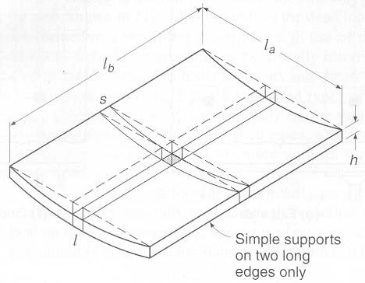
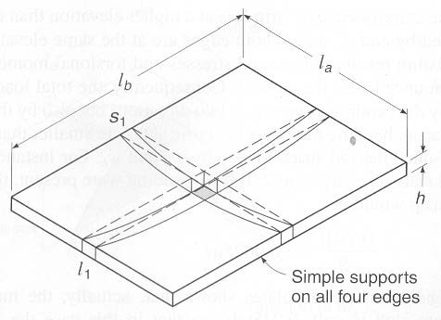

Fig 7.1. a Diagrams of slab deflection in one way and two way slabs
Following figures shows the load distributions in two slabs.
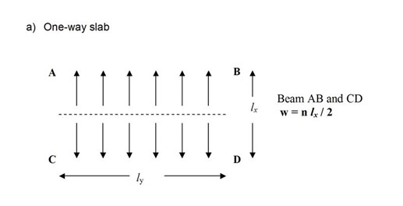
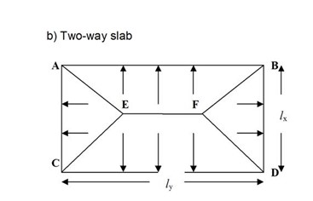
Fig 7.1.b A Diagram of load distribution of one way and two way slabs

Slabs are designed for deflection. Slabs are designed based on yield theory
This diagram shows the distribution of loads in two slabs.

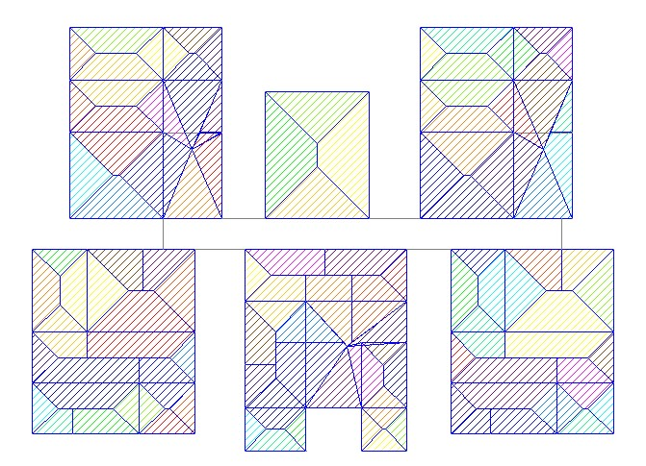
Figure 7.1.c Distribution of loads in two slabs.

order to design a slab we has to create a plate by selecting a plate cursor. Now select the
members to form slab and use form slab button. Now give the thickness of plate as 0.12 m. Now similar to the above designs give the parameters based on code and assign design slab command and select the plates and assign commands to it. After analysis is carried out go to advanced slab design page and collect the reinforcement details of the slab.
Slabs are also designed as per IS456-2000

The following figure shows the monolithic connection between beam, column and slab
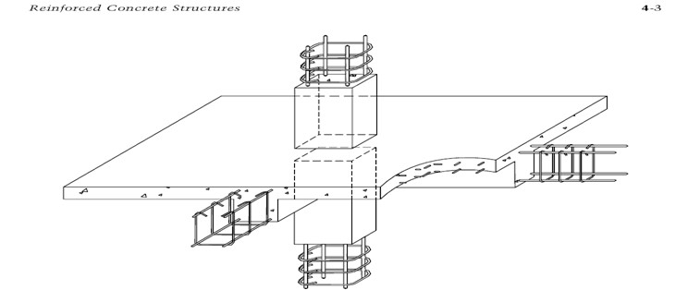
Figure 7.1.d monolithic connection between beam, column and slab

Design of slabs :

Size: 3.88m x 3.53m
End conditions for slab:
Adjacent long and short sides are continuous and other edges discontinuous.
Assuming the thickness of slab as 120 mm.

Calculation of loads:
Live load:
For residential building live load is usually taken as 2 kN/sq.m. (in accordance with 875 part II)
Dead load :
Self-weight of slab = 1x1x0.12x25 = 3.0 KN/m²
Weight of flooring (75mm thick) = 1x1x0.005x20 = 1.0 KN/m²
Accidental loads | = 1.0 KN/m² = 1.0 KN/m²
Live load: | 5.0 KN/m²
Live load is taken | = 2.0 KN/m²
Total load | = 2 + 5.0 KN/m²
Factored load | = 1.5x7.0 KN/m²
Design load | = 10.5 KN/m²

Calculation of moments:
(As per Table 12 of IS 456-2000)
Bending moment coefficients for slab:
Dead load and super imposed load
Near the middle
End of span  At support next to |  |  | +1/12
End support |  |  | -1/10
Positive bending moment at mid span |  | = | wl²/12
Mu |  | = | 10.5x(3.88)²/12
 |  | = | 13.17KNm
Negative bending moment at support | = -10.5x(3.88)²/10
 | = 15.8KNm
Design bending moment  Calculation of effective depth:  Adopting M30 concrete and Fe 415 steel  As per IS 456-2000(Annexure G) | = 15.8KNm
Mu,limit | =0.36xXumax/d(1-0.42Xumax/d)bd²f_{ck}
 | =0.36x0.46(1-0.42x0.48)bd²x30
Xumax/d | =0.48
Mulimit | =4.13bd²
Assuming b | =1000mm
Mu | =Mulimit
d | =√15.8x10⁶/(4.13x1000)
Adopting 8-mm dia bars as reinforcement | =61.852mm
Effective cover | = 15+10/2 =20mm
Over all depth | = D =61.852+20=81.852
Therefore providing overall depth D | = 120mm
Effective depth d | = 120-20=100mm

Calculation of steel: (MAIN REINFORCEMENT)

Form IS 456-2000(Annexure G)
Mu =0.87xf_{y}xAstxd (1-f_{y}xAst/bdf_{ck})
15.8 =0.87x415x100xAst (1-415xAst/(1000x100x30)
Ast =437.6mm²
Providing minimum steel of =0.12%xbxD=144mm²
Spacing of 10mm dia bars = (astx1000)/Ast
= (∏x10²x1000)/(4x437.6)
=179.47mm c/c
As per IS 456 2000, clause 26.3.3b,the spacing of Reinforcement should be not more than least of following
- 3xeffective depth =3x100 =300mm
- 300mm
Provide 10 mm Ф bars @ 175 mm.

Distribution reinforcement:

As per IS 456-2000(clause: 26.5.2.1)
Providing 0.12% of gross area as distribution reinforcement
Area of steel = (0.12x120x1000)/100 =144mm²

Adopting 6mm Ф bars as distribution reinforcement
Spacing = (astx1000)/Ast
= (∏/4x6²x1000)/144
=196.35mm c/c
Provide 6mm Ф bars @ 180mm c/c
Check for development length:

As per IS 456-2000(clause 26.2.1)
The development length Ld is given by
Ld | = Фσst/4 ᵗbd
 | = (10x0.87x415)/(4x1.2x1.6)
 | = 470.11 mm (req.)
Ld(available) | = MI/V+L₀
M1 | = 0.87xf_{y}xAstxd(1-f_{y}xAst/bdf_{ck})
 | = 0.87x415x437x100(1-437x415/(1000x100x30)
 | = 14.82x10⁶N-mm
Shear force at the section due to design loads
V | = W1/2 = 10.5x3.88/2
 | = 20.37
M1/V+L₀ | = 14.82/20.37 +L₀
 | = 0.727m + L₀
 | =727mm +L₀
Ld(available)>Ld(req’d) safe

CHAPTER 8

FOOTINGS

Foundations are structural elements that transfer loads from the building or individual column to the earth .If these loads are to be properly transmitted, foundations must be designed to prevent excessive settlement or rotation, to minimize differential settlement and to provide adequate safety against sliding and overturning.
GENERAL:
- Footing shall be designed to sustain the applied loads, moments and forces and the induced reactions and to assure that any settlements which may occur will be as nearly uniform as possible and the safe bearing capacity of soil is not exceeded.
- Thickness at the edge of the footing: in reinforced and plain concrete footing at the edge shall be not less than 150 mm for footing on the soil nor less than 300mm above the tops of the pile for footing on piles.
BEARING CAPACITY OF SOIL:
The size foundation depends on permissible bearing capacity of soil. The total load per unit area under the footing must be less than the permissible bearing capacity of soil to the excessive settlements.

8.1 Foundation design:
Foundations are structure elements that transfer loads from building or individual column to earth this loads are to be properly transmitted foundations must be designed to prevent excessive settlement are rotation to minimize differential settlements and to provide adequate safety isolated footings for multi storey buildings. These may be square rectangle are circular in plan that the choice of type of foundation to be used in a given situation depends on a number of factors.
- Bearing capacity of soil
- Type of structure
- Type of loads
- Permissible differential settlements
- economy
A footing is the bottom most part of the structure and last member to transfer the load. In order to design footings we used staad foundation software.
These are the types of foundations the software can deal.
Shallow (D<B)
- 1. Isolated (Spread) Footing
- 2.Combined (Strip) Footing
- 3.Mat (Raft) Foundation
Deep (D>B)
- 1.Pile Cap
- 2. Driller Pier
The advantage of this software is even after the analysis of staad we can update the following properities if required.
The following Parameters can be updated:
- Column Position
- Column Shape
- Column Size  Load Cases
- Support List
After the analysis of structure at first we has to import the reactions of the columns from staad pro using import button.
After we import the loads the placement of columns is indicated in the figure.

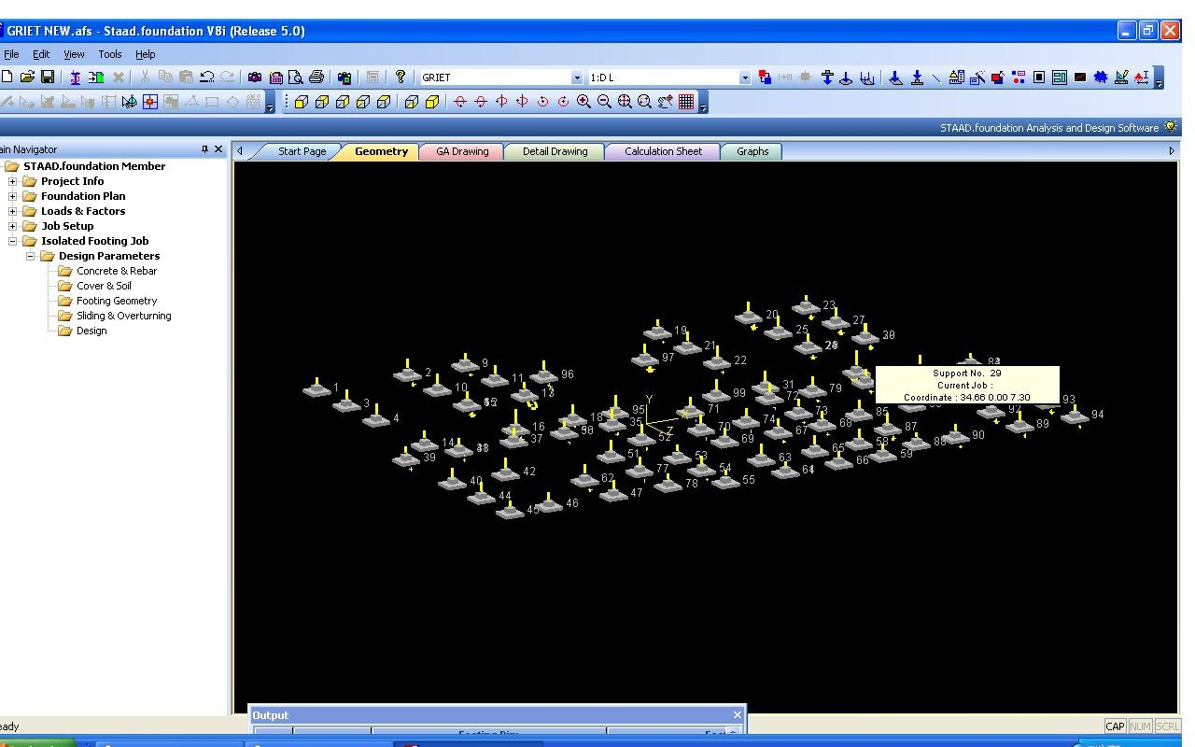
Fig 8.1a placement of columns

After importing the reactions in the staad foundation the following input data is required regarding materials, Soil type, Type of foundation, safety factors.
- Type of foundation: ISOLATED.
- Unit weight of concrete:25kn/m^3
- Minimum bar spacing:50mm
- Maximum bar spacing:500mm
- Strength of concrete:30 N/mm^2
- Yield strength of steel:415 n/mm^2
- Minimum bar size:6mm
- Maximum bar size:40mm
- Bottom clear cover:50mm
- Unit weight of soil:22 kn/m^3
- Soil bearing capacity:300 kn/m^3
- Minimumlength:1000mm
- Minimum width:1000mm
- Minimum thichness:500mm
- Maximum length:12000mm
- Maximum width:12000mm
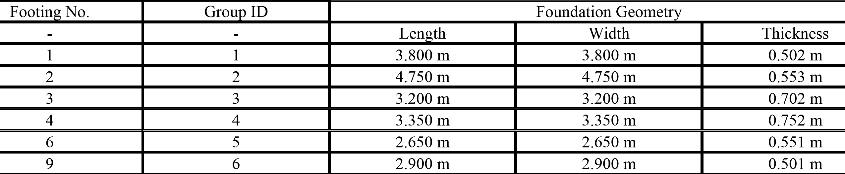
- Maximum thickness:1500mm
- Plan dimension:50mm
- Aspect ratio:1
- Safety against friction,overturning,sliding:0.5,1.5,1.5
After this input various properties of the structure and click on design.
After the analysis detailed calculation of each and every footing is given with plan and elevation of footing including the manual calculation.
The following tables show the dimensions and reinforcement details of all the footings.

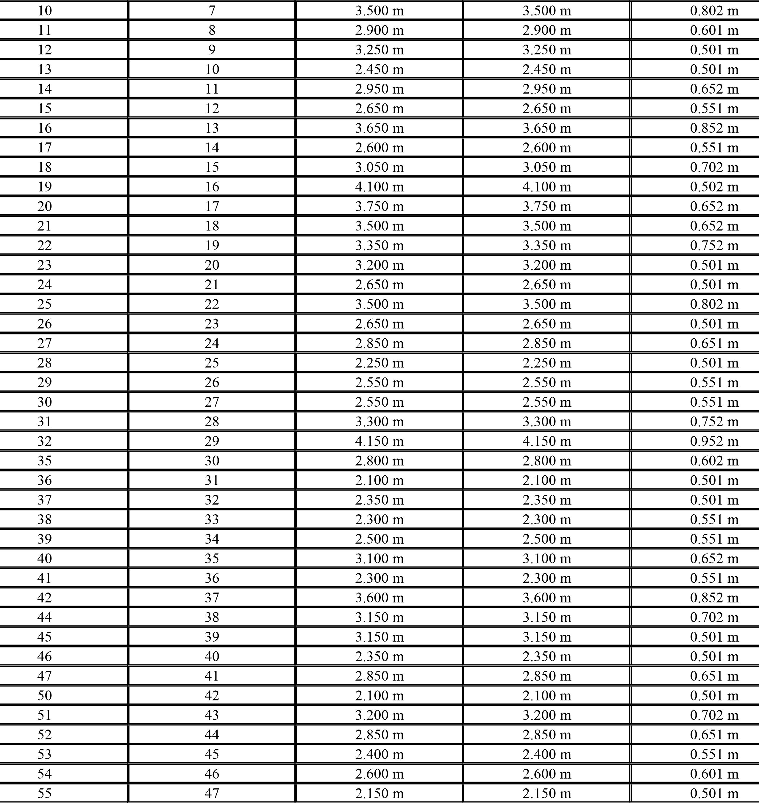
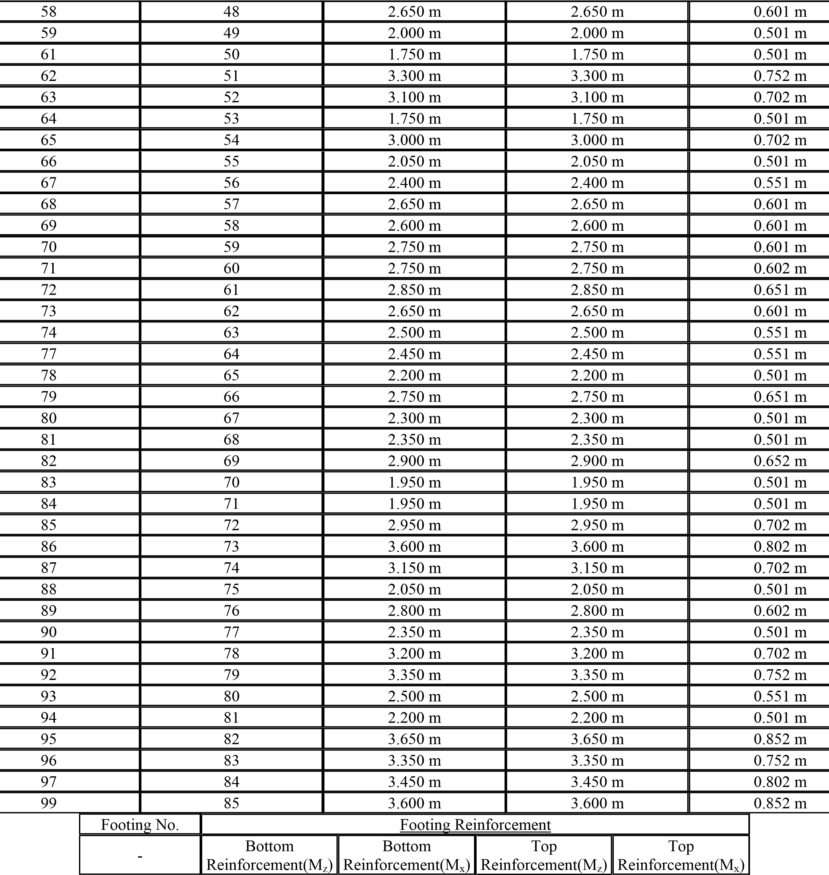

1 | #10 @ 65 mm c/c | #10 @ 65 mm c/c | #8 @ 80 mm c/c | #8 @ 80 mm c/c
2 | #12 @ 70 mm c/c | #12 @ 70 mm c/c | #8 @ 80 mm c/c | #8 @ 80 mm c/c
3 | #10 @ 70 mm c/c | #10 @ 70 mm c/c | #8 @ 80 mm c/c | #8 @ 80 mm c/c
4 | #10 @ 60 mm c/c | #10 @ 60 mm c/c | #8 @ 80 mm c/c | #8 @ 80 mm c/c
6 | #8 @ 65 mm c/c | #8 @ 50 mm c/c | #8 @ 80 mm c/c | #8 @ 80 mm c/c
9 | #8 @ 60 mm c/c | #8 @ 55 mm c/c | #8 @ 80 mm c/c | #8 @ 80 mm c/c
10 | #10 @ 65 mm c/c | #10 @ 55 mm c/c | #8 @ 80 mm c/c | #8 @ 80 mm c/c
11 | #8 @ 50 mm c/c | #8 @ 50 mm c/c | #8 @ 80 mm c/c | #8 @ 80 mm c/c
12 | #8 @ 80 mm c/c | #8 @ 80 mm c/c | #8 @ 80 mm c/c | #8 @ 80 mm c/c
13 | #8 @ 65 mm c/c | #8 @ 65 mm c/c | #8 @ 80 mm c/c | #8 @ 80 mm c/c
14 | #10 @ 75 mm c/c | #10 @ 70 mm c/c | #8 @ 80 mm c/c | #8 @ 80 mm c/c
15 | #8 @ 65 mm c/c | #8 @ 50 mm c/c | #8 @ 80 mm c/c | #8 @ 80 mm c/c
16 | #10 @ 65 mm c/c | #10 @ 50 mm c/c | #8 @ 80 mm c/c | #8 @ 80 mm c/c
17 | #8 @ 65 mm c/c | #8 @ 55 mm c/c | #8 @ 80 mm c/c | #8 @ 80 mm c/c
18 | #8 @ 50 mm c/c | #10 @ 70 mm c/c | #8 @ 80 mm c/c | #8 @ 80 mm c/c
19 | #10 @ 70 mm c/c | #10 @ 65 mm c/c | #8 @ 80 mm c/c | #8 @ 80 mm c/c
20 | #10 @ 60 mm c/c | #10 @ 65 mm c/c | #8 @ 80 mm c/c | #8 @ 80 mm c/c
21 | #10 @ 65 mm c/c | #10 @ 65 mm c/c | #8 @ 80 mm c/c | #8 @ 80 mm c/c
22 | #10 @ 60 mm c/c | #10 @ 60 mm c/c | #8 @ 80 mm c/c | #8 @ 80 mm c/c
23 | #8 @ 55 mm c/c | #8 @ 55 mm c/c | #8 @ 80 mm c/c | #8 @ 80 mm c/c
24 | #8 @ 55 mm c/c | #8 @ 55 mm c/c | #8 @ 80 mm c/c | #8 @ 80 mm c/c
25 | #10 @ 65 mm c/c | #10 @ 55 mm c/c | #8 @ 80 mm c/c | #8 @ 80 mm c/c
26 | #8 @ 55 mm c/c | #8 @ 55 mm c/c | #8 @ 80 mm c/c | #8 @ 80 mm c/c
27 | #8 @ 50 mm c/c | #8 @ 50 mm c/c | #8 @ 80 mm c/c | #8 @ 80 mm c/c
28 | #8 @ 80 mm c/c | #8 @ 80 mm c/c | #8 @ 80 mm c/c | #8 @ 80 mm c/c
29 | #8 @ 55 mm c/c | #8 @ 55 mm c/c | #8 @ 80 mm c/c | #8 @ 80 mm c/c
30 | #8 @ 55 mm c/c | #8 @ 55 mm c/c | #8 @ 80 mm c/c | #8 @ 80 mm c/c
31 | #10 @ 65 mm c/c | #10 @ 60 mm c/c | #8 @ 80 mm c/c | #8 @ 80 mm c/c
32 | #10 @ 50 mm c/c | #10 @ 50 mm c/c | #8 @ 80 mm c/c | #8 @ 80 mm c/c
35 | #10 @ 75 mm c/c | #10 @ 75 mm c/c | #8 @ 80 mm c/c | #8 @ 80 mm c/c
36 | #8 @ 75 mm c/c | #8 @ 70 mm c/c | #8 @ 75 mm c/c | #8 @ 75 mm c/c
37 | #8 @ 55 mm c/c | #8 @ 55 mm c/c | #8 @ 80 mm c/c | #8 @ 80 mm c/c
38 | #8 @ 70 mm c/c | #8 @ 60 mm c/c | #8 @ 80 mm c/c | #8 @ 80 mm c/c
39 | #8 @ 55 mm c/c | #8 @ 50 mm c/c | #8 @ 80 mm c/c | #8 @ 80 mm c/c
40 | #10 @ 70 mm c/c | #10 @ 70 mm c/c | #8 @ 80 mm c/c | #8 @ 80 mm c/c
41 | #8 @ 70 mm c/c | #8 @ 60 mm c/c | #8 @ 80 mm c/c | #8 @ 80 mm c/c
42 | #10 @ 65 mm c/c | #10 @ 55 mm c/c | #8 @ 80 mm c/c | #8 @ 80 mm c/c
44 | #10 @ 65 mm c/c | #10 @ 70 mm c/c | #8 @ 80 mm c/c | #8 @ 80 mm c/c
45 | #8 @ 70 mm c/c | #8 @ 65 mm c/c | #8 @ 80 mm c/c | #8 @ 80 mm c/c
46 | #8 @ 60 mm c/c | #8 @ 60 mm c/c | #8 @ 80 mm c/c | #8 @ 80 mm c/c
47 | #8 @ 50 mm c/c | #8 @ 50 mm c/c | #8 @ 80 mm c/c | #8 @ 80 mm c/c

50 | #8 @ 75 mm c/c | #8 @ 70 mm c/c | #8 @ 75 mm c/c | #8 @ 75 mm c/c
51 | #10 @ 65 mm c/c | #10 @ 65 mm c/c | #8 @ 80 mm c/c | #8 @ 80 mm c/c
52 | #8 @ 50 mm c/c | #8 @ 50 mm c/c | #8 @ 80 mm c/c | #8 @ 80 mm c/c
53 | #8 @ 65 mm c/c | #8 @ 65 mm c/c | #8 @ 80 mm c/c | #8 @ 80 mm c/c
54 | #8 @ 55 mm c/c | #8 @ 55 mm c/c | #8 @ 80 mm c/c | #8 @ 80 mm c/c
55 | #8 @ 75 mm c/c | #8 @ 70 mm c/c | #8 @ 80 mm c/c | #8 @ 80 mm c/c
58 | #8 @ 55 mm c/c | #8 @ 55 mm c/c | #8 @ 80 mm c/c | #8 @ 80 mm c/c
59 | #8 @ 80 mm c/c | #8 @ 80 mm c/c | #8 @ 80 mm c/c | #8 @ 80 mm c/c
61 | #8 @ 80 mm c/c | #8 @ 80 mm c/c | #8 @ 80 mm c/c | #8 @ 80 mm c/c
62 | #10 @ 75 mm c/c | #10 @ 60 mm c/c | #8 @ 80 mm c/c | #8 @ 80 mm c/c
63 | #10 @ 70 mm c/c | #10 @ 65 mm c/c | #8 @ 80 mm c/c | #8 @ 80 mm c/c
64 | #8 @ 80 mm c/c | #8 @ 80 mm c/c | #8 @ 80 mm c/c | #8 @ 80 mm c/c
65 | #10 @ 75 mm c/c | #10 @ 75 mm c/c | #8 @ 80 mm c/c | #8 @ 80 mm c/c
66 | #8 @ 80 mm c/c | #8 @ 75 mm c/c | #8 @ 80 mm c/c | #8 @ 80 mm c/c
67 | #8 @ 65 mm c/c | #8 @ 65 mm c/c | #8 @ 80 mm c/c | #8 @ 80 mm c/c
68 | #8 @ 55 mm c/c | #8 @ 55 mm c/c | #8 @ 80 mm c/c | #8 @ 80 mm c/c
69 | #8 @ 55 mm c/c | #8 @ 55 mm c/c | #8 @ 80 mm c/c | #8 @ 80 mm c/c
70 | #8 @ 50 mm c/c | #8 @ 50 mm c/c | #8 @ 80 mm c/c | #8 @ 80 mm c/c
71 | #10 @ 75 mm c/c | #10 @ 75 mm c/c | #8 @ 80 mm c/c | #8 @ 80 mm c/c
72 | #8 @ 50 mm c/c | #8 @ 50 mm c/c | #8 @ 80 mm c/c | #8 @ 80 mm c/c
73 | #8 @ 55 mm c/c | #8 @ 55 mm c/c | #8 @ 80 mm c/c | #8 @ 80 mm c/c
74 | #8 @ 55 mm c/c | #8 @ 55 mm c/c | #8 @ 80 mm c/c | #8 @ 80 mm c/c
77 | #8 @ 60 mm c/c | #8 @ 60 mm c/c | #8 @ 80 mm c/c | #8 @ 80 mm c/c
78 | #8 @ 70 mm c/c | #8 @ 65 mm c/c | #8 @ 80 mm c/c | #8 @ 80 mm c/c
79 | #8 @ 55 mm c/c | #8 @ 50 mm c/c | #8 @ 80 mm c/c | #8 @ 80 mm c/c
80 | #8 @ 65 mm c/c | #8 @ 60 mm c/c | #8 @ 80 mm c/c | #8 @ 80 mm c/c
81 | #8 @ 65 mm c/c | #8 @ 60 mm c/c | #8 @ 80 mm c/c | #8 @ 80 mm c/c
82 | #8 @ 50 mm c/c | #10 @ 75 mm c/c | #8 @ 80 mm c/c | #8 @ 80 mm c/c
83 | #8 @ 80 mm c/c | #8 @ 80 mm c/c | #8 @ 80 mm c/c | #8 @ 80 mm c/c
84 | #8 @ 80 mm c/c | #8 @ 80 mm c/c | #8 @ 80 mm c/c | #8 @ 80 mm c/c
85 | #8 @ 55 mm c/c | #10 @ 70 mm c/c | #8 @ 80 mm c/c | #8 @ 80 mm c/c
86 | #10 @ 55 mm c/c | #10 @ 55 mm c/c | #8 @ 80 mm c/c | #8 @ 80 mm c/c
87 | #10 @ 65 mm c/c | #10 @ 70 mm c/c | #8 @ 80 mm c/c | #8 @ 80 mm c/c
88 | #8 @ 80 mm c/c | #8 @ 75 mm c/c | #8 @ 80 mm c/c | #8 @ 80 mm c/c
89 | #10 @ 75 mm c/c | #10 @ 75 mm c/c | #8 @ 80 mm c/c | #8 @ 80 mm c/c
90 | #8 @ 60 mm c/c | #8 @ 60 mm c/c | #8 @ 80 mm c/c | #8 @ 80 mm c/c
91 | #10 @ 65 mm c/c | #10 @ 65 mm c/c | #8 @ 80 mm c/c | #8 @ 80 mm c/c
92 | #10 @ 60 mm c/c | #10 @ 65 mm c/c | #8 @ 80 mm c/c | #8 @ 80 mm c/c
93 | #8 @ 60 mm c/c | #8 @ 60 mm c/c | #8 @ 80 mm c/c | #8 @ 80 mm c/c
94 | #8 @ 70 mm c/c | #8 @ 65 mm c/c | #8 @ 80 mm c/c | #8 @ 80 mm c/c
95 | #10 @ 60 mm c/c | #10 @ 55 mm c/c | #8 @ 80 mm c/c | #8 @ 80 mm c/c
96 | #10 @ 65 mm c/c | #10 @ 60 mm c/c | #8 @ 80 mm c/c | #8 @ 80 mm c/c
97 | #10 @ 65 mm c/c | #10 @ 60 mm c/c | #8 @ 80 mm c/c | #8 @ 80 mm c/c
99 | #10 @ 65 mm c/c | #10 @ 60 mm c/c | #8 @ 80 mm c/c | #8 @ 80 mm c/c

After the design is complete the calculations is obtained for each and every column and a sample column calculations is shown below.

Isolated Footing 1
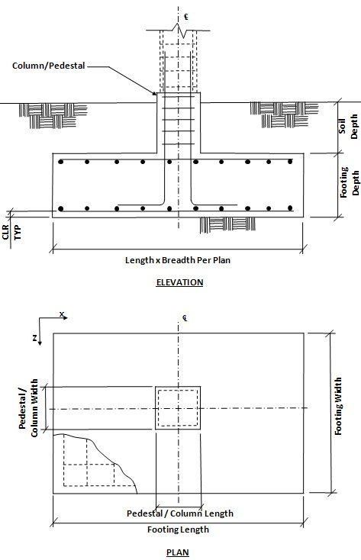

Fig 8.1.a Elevation and Plan of Isolated Footing

Footing Geometry
Footing Thickness (Ft) : 500.00 mm
Footing Length – X (Fl) : 1000.00 mm
Footing Width – Z (Fw) : 1000.00 mm

Column Dimensions
Column Shape : | Rectangular
Column Length – X  (Pl) : | 0.45 m
Column  Width – Z (Pw) : | 0.35 m

Pedestal
Pedestal Length – X : N/A
Pedestal Width – Z : N/A
Design Parameters
Concrete and Rebar Properties
Unit Weight of Concrete : 25.000 kN/m3
Strength of Concrete : 30.000 N/mm2
Yield Strength of Steel : 415.000 N/mm2
Minimum Bar Size : # 6
Maximum Bar Size : # 40
Minimum Bar Spacing : 50.00 mm
Maximum Bar Spacing : 500.00 mm Footing Clear Cover (F, CL) : 50.00 mm
Soil Properties :
Soil Type : Un Drained
Unit Weight : 22.00 kN/m3
Soil Bearing Capacity : 300.00 kN/m2
Soil Surcharge : 0.00 kN/m2
Depth of Soil above Footing : 0.00 mm
Untrained Shear Strength : 0.00 N/mm2

Sliding and Overturning :
Coefficient of Friction : 0.50
Factor of Safety Against Sliding : 1.50
Factor of Safety Against Overturning : 1.50
 | Applied Loads – Allowable Stress Level
LC | Axial (kN) | Shear X (kN) | Shear Z (kN) |  | Moment X (kNm) | Moment Z (kNm)
1 | 168.123 | -1.837 | 0.275 |  | 1.491 | 1.441
2 | 140.638 | -3.797 | -0.289 |  | 0.593 | 3.370
3 | 842.201 | -16.764 | -1.784 |  | 2.831 | 14.560
4 | -116.948 | 20.364 | 19.053 |  | 32.167 | -52.030
5 | 1726.443 | -33.597 | -2.696 |  | 7.373 | 29.057
6 | 1240.817 | -2.441 | 20.708 |  | 44.499 | -39.191
7 | 1521.493 | -51.314 | -25.020 |  | -32.702 | 85.682
8 | 1381.155 | -26.878 | -2.156 |  | 5.898 | 23.245
9 | 76.762 | 27.790 | 28.993 |  | 50.487 | -75.884
10 | 427.606 | -33.301 | -28.168 |  | -46.014 | 80.207
11 | 252.184 | -2.755 | 0.413 |  | 2.237 | 2.162
12 | 151.310 | -1.653 | 0.248 |  | 1.342 | 1.297
 |  | Applied Loads – Strength Level
LC | Axial (kN) | Shear X (kN) | Shear Z (kN) |  | Moment X (kNm) | Moment Z (kNm)
- 168.123 -1.837 0.275 1.491 1.441
- 140.638 -3.797 -0.289 0.593 3.370
- 842.201 -16.764 -1.784 2.831 14.560
- -116.948 20.364 19.053 32.167 -52.030
- 1726.443 -33.597 -2.696 7.373 29.057
- 1240.817 -2.441 20.708 44.499 -39.191
- 1521.493 -51.314 -25.020 -32.702 85.682
- 1381.155 -26.878 -2.156 5.898 23.245
- 76.762 27.790 28.993 50.487 -75.884
- 427.606 -33.301 -28.168 -46.014 80.207
- 252.184 -2.755 0.413 2.237 2.162 12 151.310 -1.653 0.248 1.342 1.297

Design Calculations :

Footing Size
Initial Length (L_{o}) = 1.00 m
Initial Width (W_{o}) = 1.00 m
Uplift force due to buoyancy = -0.00 kN Effect due to adhesion = 0.00 kN
Min. footing area required from bearing pressure, A_{min} = P / q_{max} = 5.796 m ²
Footing area from initial length and ₂
L_{o} x W_{o} = 1.00 m
width, A_{o} =

Final Footing Size
Length (L₂) = 3.80 M Governing Load Case : # 4
Width (W₂) = 3.80 M Governing Load Case : # 4
Depth (D₂) = 0.50 m Governing Load Case : # 4
Area (A₂) = 14.44 m²

Pressures at Four Corner
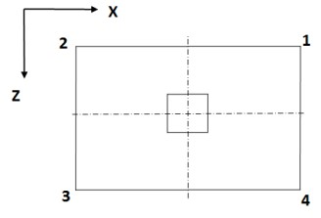
Load Case | Pressure at corner 1 (q₁)  (kN/m^2) | Pressure at corner 2 (q₂)  (kN/m^2) | Pressure at corner 3 (q₃)  (kN/m^2) | Pressure at corner 4 (q₄)  (kN/m^2) | Area of footing in  uplift (A_{u})  (m²)
5 | 136.4151 | 126.3869 | 127.7045 | 137.7327 | 0.00
5 | 136.4151 | 126.3869 | 127.7045 | 137.7327 | 0.00
5 | 136.4151 | 126.3869 | 127.7045 | 137.7327 | 0.00
5 | 136.4151 | 126.3869 | 127.7045 | 137.7327 | 0.00
If A_{u} is zero, there is no uplift and no pressure adjustment is necessary. Otherwise, to account for uplift, areas of negative pressure will be set to zero and the pressure will be redistributed to remaining corners.

Summary of adjusted Pressures at Four Corner
Load Case | Pressure at corner 1 (q₁)  (kN/m^2) | Pressure at corner 2 (q₂)  (kN/m^2) | Pressure at corner 3 (q₃)  (kN/m^2) | Pressure at corner 4 (q₄)  (kN/m^2)
5 | 136.4151 | 126.3869 | 127.7045 | 137.7327
5 | 136.4151 | 126.3869 | 127.7045 | 137.7327
5 | 136.4151 | 126.3869 | 127.7045 | 137.7327
5 | 136.4151 | 126.3869 | 127.7045 | 137.7327
Adjust footing size if necessary.

Details of Out-of-Contact Area (If Any)
Governing load case = N/A
Plan area of footing = 14.44 sq.m
Area not in contact with soil = 0.00 sq.m % of total area not in contact = 0.00%

Check For Stability Against Overturning And Sliding

- | Factor of safety against sliding |  | Factor of safety against overturning
Load Case No. | Along X-  Direction | Along Z-  Direction | About X-  Direction | About Z-  Direction
1 | 94.894 | 633.851 | 406.729 | 280.722
2 | 42.284 | 556.554 | 1358.999 | 115.812
3 | 30.503 | 286.709 | 1001.994 | 84.696
4 | 1.560 | 1.668 | 2.896 | 1.941
5 | 28.379 | 353.724 | 601.339 | 79.013
6 | 291.089 | 34.319 | 49.231 | 71.120
7 | 16.584 | 34.012 | 71.523 | 29.044
8 | 29.051 | 362.094 | 615.569 | 80.883
9 | 4.629 | 4.437 | 7.522 | 5.444
10 | 9.130 | 10.794 | 19.225 | 11.929
11 | 78.517 | 524.459 | 336.534 | 232.274
12 | 100.353 | 670.316 | 430.128 | 296.871

Critical Load Case And The Governing Factor Of Safety For Overturning and Sliding X Direction
Critical Load Case for Sliding along X-Direction : 4
Governing Disturbing Force : 20.364 kN
Governing Restoring Force : 31.776 kN
Minimum Sliding Ratio for the Critical Load Case : 1.560
Critical Load Case for Overturning about X-Direction : 4
Governing Overturning Moment : 41.693 kNm
Governing Resisting Moment : 120.746 kNm
Minimum Overturning Ratio for the Critical Load Case 2.896 :
Critical Load Case And The Governing Factor Of Safety For Overturning and Sliding Z Direction
Critical Load Case for Sliding along Z-Direction : 4
Governing Disturbing Force : 19.053 kN
Governing Restoring Force : 31.776 kN
Minimum Sliding Ratio for the Critical Load Case : 1.668
Critical Load Case for Overturning about Z-Direction : 4
Governing Overturning Moment : -62.212 kNm
Governing Resisting Moment : 120.746 kNm Minimum Overturning Ratio for the Critical Load Case : 1.941

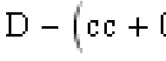
Momen
t
Calculati
Cri
o
n :

Check T
t
ical Load
Effe
r
ial Depth a
C
ase = #5
c
tive Depth
Gove

g
ainst mom

=
r
ning mome
e

nt (w.r.t. X
=

nt (M
u
)=

Axis)

0
.45
m
6
78.540753

k
Nm
As Per IS 456 2000 ANNEX G G-1.1C
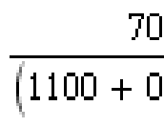
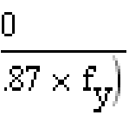
= 0.479107
Limiting Factor1 (K_{umax}) =
Limiting Factor2 (R_{umax}) =
= 4133.149375 kN/m^2
= 3138.136379 kNm Limit Moment Of Resistance (M
uma
x
)
=
M_{u} <= M_{umax} hence, safe

Check Trial Depth against moment (w.r.t. Z Axis)
Critical Load Case = #5


Effective Depth = = 0.45 m
Governing moment (M_{u}) = 656.192207 kNm
As Per IS 456 2000 ANNEX G G-1.1C
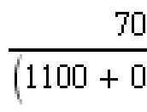
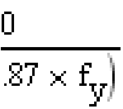
= 0.479107
Limiting Factor1 (K_{umax}) =
Limiting Factor2 (R_{umax}) =
= 4133.149375 kN/m^2
= 3138.136379 kNm
Limit Moment Of Resistance (M
uma
x
)
=
M_{u} <= M_{umax} hence, safe
------------------------------------------------------

Check Tri
Crit
She
a
l Depth for
i
cal Load
a
r Calculatio

one way sh
C
ase
=
#
5
n

e
ar (Along
X
Axis)

Shear Force(S) = 582.75 kN
Shear Stress(T_{v}) = 343.078914 kN/m^2
Percentage Of Steel(P_{t}) = 0.2566
As Per IS 456 2000 Clause 40 Table 19
Shear Strength Of Concrete(T_{c}) = 1005.98 kN/m^2

T_{v}< T_{c} hence, safe

Check Trial Depth for one way shear (Along Z Axis)
Critical Load Case = #5
Shear Force(S) = 573.75 kN
Shear Stress(T_{v}) = 337.778591 kN/m^2
Percentage Of Steel(P_{t}) = 0.2479
As Per IS 456 2000 Clause 40 Table 19
Shear Strength Of Concrete(T_{c}) = 1005.98 kN/m^2
T_{v}< T_{c} hence, safe

Check Trial Depth for two way shear
Critical Load Case = #5
Shear Force(S) = 1640.97 kN
Shear Stress(T_{v}) = 1083.55 kN/m^2
As Per IS 456 2000 Clause 31.6.3.1
K_{s} = = 1.00
Shear Strength(T_{c})= = 1369.3064 kN/m^2
K_{s} x T_{c} = 1369.3064 kN/m^2
T_{v}<= K_{s} x T_{c} hence, safe
Reinforc
C
alculation
Al
e
ment Calc

o
f Maximu

o

ng X Axis
u

lation

m
Bar Size

Bar diameter corresponding to max bar size (d_{b}) = 25.000 mm
As Per IS 456 2000 Clause 26.2.1
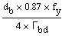
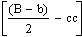
Development Length(l_{d}) = = 1.47 m
Allowable Length(l_{db}) = = 1.63 m
l_{db} >l_{d} hence, safe
Along Z Axis
Bar diameter corresponding to max bar size(d_{b}) = 25.000 mm
As Per IS 456 2000 Clause 26.2.1
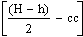
Development Length(l_{d}) = = 1.47 m
Allowable Length(l_{db}) = = 1.68 m
l_{db} >l_{d} hence, safe

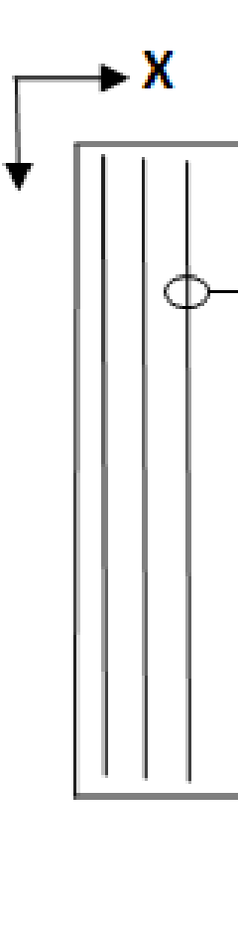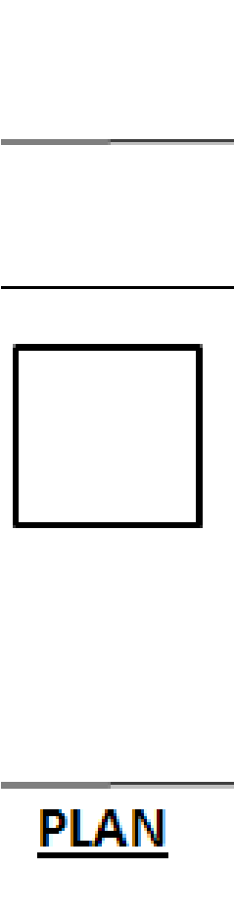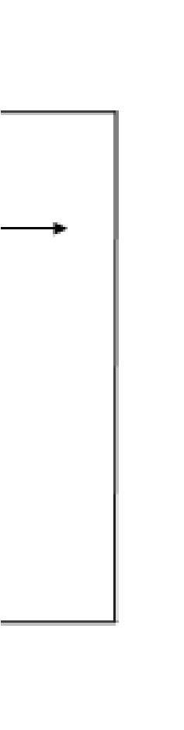

Bottom Re
Al

i
nforcemen

o
ng Z Axis

t
Desi
g
n

For moment w.r.t. X Axis (M_{x})
As Per IS 456 2000 Clause 26.5.2.1
Critical Load Case = #5
Minimum Area of Steel (A_{stmin}) = 2289.12 mm2
Calculated Area of Steel (A_{st}) = 4359.21 mm2
Provided Area of Steel (A_{st,Provided}) = 4359.205 mm2
Astmin<= Ast,Provided Steel area is accepted

Selected bar Dia = 10.000
Minimum spacing allowed (S_{min}) = 50.000 mm
Selected spacing (S) = 67.091 mm
S_{min} <= S <= S_{max} and selected bar size < selected maximum bar size...
The reinforcement is accepted.
Based on spacing reinforcement increment; provided reinforcement is
#10 @ 65.000 mm o.c.

Along X Axis
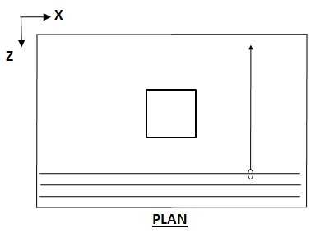

For moment w.r.t. Z Axis (M_{z})
As Per IS 456 2000 Clause 26.5.2.1
Critical Load Case = #5
Minimum Area of Steel (A_{stmin}) = 2289.12 mm2
Calculated Area of Steel (A_{st}) = 4210.337 mm2
Provided Area of Steel (A_{st,Provided}) = 4210.337 mm2
Astmin<= Ast,Provided Steel area is accepted

Selected bar Dia = 10.000
Minimum spacing allowed (S_{min}) = = 50.000 mm
Selected spacing (S) = 69.62 mm
S_{min} <= S <= S_{max} and selected bar size < selected maximum bar size...
The reinforcement is accepted.
Based on spacing reinforcement increment; provided reinforcement is
#10 @ 65.000 mm o.c.

Top Reinforcement Design

Along Z Axis
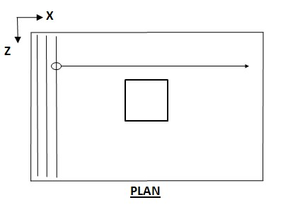

Minimum Area of Steel (A_{stmin}) = 2289.120 mm2
Calculated Area of Steel (A_{st}) = 2284.560 mm2
Provided Area of Steel (A_{st,Provided}) = 2289.120 mm2
Astmin<= Ast,Provided Steel area is accepted Governing Moment = 0.000 kNm

Selected Bar Dia = 8.000
Minimum spacing allowed (S_{min}) = 50.000 mm
Selected spacing (S) = 82.044 mm
S_{min} <= S <= S_{max} and selected bar size < selected maximum bar size... The reinforcement is accepted.
Based on spacing reinforcement increment; provided reinforcement is
#8 @ 80.000 mm o.c.

Along X Axis

Minimum Area of Steel (A_{stmin}) = 2289.120 mm2
Calculated Area of Steel (A_{st}) = 2284.560 mm2
Provided Area of Steel (A_{st,Provided}) = 2289.120 mm2
Astmin<= Ast,Provided Steel area is accepted Governing Moment = 0.000 kNm

Selected Bar Dia = 8.000
Minimum spacing allowed (S_{min}) = = 50.000 mm
Selected spacing (S) = 82.044 mm
S_{min} <= S <= S_{max} and selected bar size < selected maximum bar size... The reinforcement is accepted. Based on spacing reinforcement increment; provided reinforcement is
#8 @ 80.000 mm o.c.

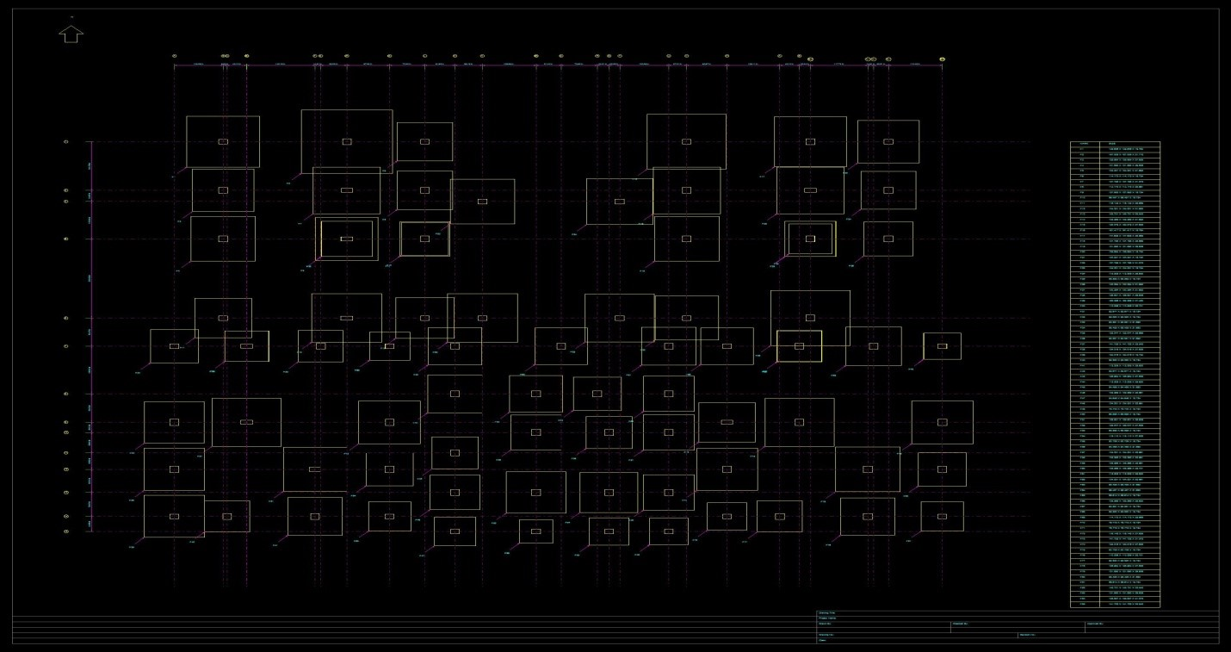
The figure shows layout of foundations for each and every column.
Here we can observe that some of the footings coincide as they are very near, in such situations combined(strap or cantilever) is laid.
Reinforcement details of column is shown below
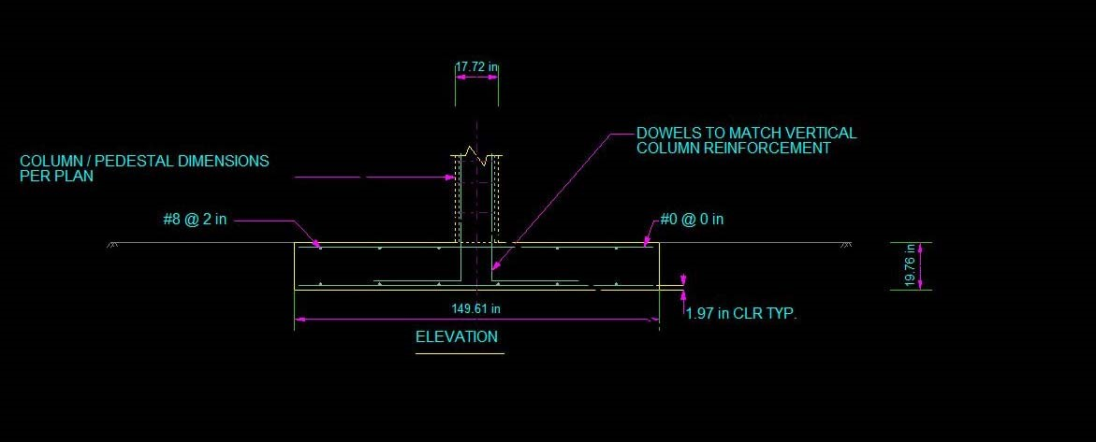

Fig 8.2.1 elevation of reinforcements
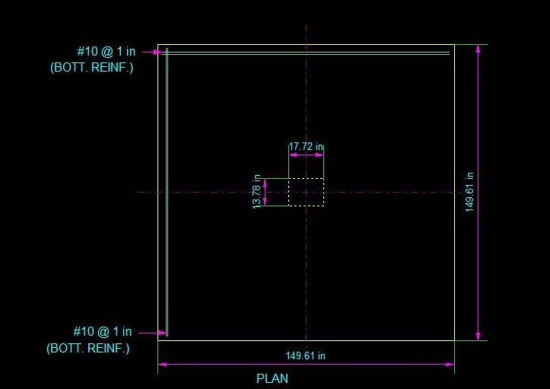

Fig 8.2.b plan of reinforcement

Staad Editor:
STAAD SPACE
START JOB INFORMATION
ENGINEER DATE 14-Apr-08
END JOB INFORMATION
INPUT WIDTH 79
UNIT METER KN
JOINT COORDINATES
1 0 0 0; 2 6.445 0 0; 3 0 0 3.65; 4 0 0 7.29; 6 6.445 0 7.29; 9 10.51 0 0;
10 6.445 0 3.65; 11 10.51 0 3.65; 12 6.445 0 7.3; 13 10.51 0 7.3;
14 0 0 13.235; 15 6.44 0 7.29; 16 6.44 0 13.235; 17 10.51 0 7.29;
18 10.51 0 13.235; 19 24.153 0 0; 20 30.598 0 0; 21 24.153 0 3.65;
22 24.153 0 7.29; 23 34.663 0 0; 24 30.593 0 7.29; 25 30.598 0 3.65;
26 30.598 0 7.29; 27 34.663 0 3.65; 28 30.598 0 7.3; 29 34.663 0 7.3;
30 34.663 0 7.29; 31 24.153 0 13.235; 32 30.593 0 13.235; 35 12.083 0 15.35;
36 8.668 0 15.35; 37 5.088 0 15.35; 38 1.223 0 15.35; 39 -2.542 0 15.35;
40 -2.542 0 21.06; 41 1.228 0 15.35; 42 1.228 0 21.06; 44 -2.542 0 24.59;
45 -2.542 0 28.12; 46 0.204 0 28.12; 47 4.788 0 28.12; 50 8.673 0 15.35;
51 8.673 0 21.06; 52 12.083 0 18.92; 53 12.083 0 23.35; 54 12.083 0 26.325;
55 12.083 0 29.255; 58 23.213 0 26.325; 59 23.213 0 29.255; 61 16.307 0 29.255;
62 4.788 0 24.59; 63 16.303 0 26.325; 64 16.303 0 29.255; 65 20.103 0 26.325;
66 20.103 0 29.255; 67 20.103 0 21.825; 68 23.213 0 21.825; 69 16.303 0 21.825;
70 16.303 0 18.92; 71 17.613 0 15.35; 72 23.213 0 15.35; 73 23.213 0 18.92;
74 19.488 0 18.92; 77 8.668 0 24.59; 78 8.668 0 28.12; 79 26.258 0 15.35;
80 30.023 0 15.35; 81 30.028 0 15.35; 82 33.888 0 15.35; 83 37.468 0 15.35;
84 37.473 0 15.35; 85 26.258 0 21.06; 86 30.028 0 21.06; 87 26.258 0 24.59;
88 26.258 0 28.12; 89 33.588 0 28.12; 90 29.004 0 28.12; 91 37.473 0 21.06;
92 33.588 0 24.59; 93 37.468 0 24.59; 94 37.468 0 28.12; 95 13.51 0 13.235;
96 13.51 0 4.49; 97 20.663 0 4.49; 99 20.663 0 13.235; 100 0 3 0;
101 6.445 3 0; 102 0 3 3.65; 103 0 3 7.29; 104 6.445 3 7.29; 105 10.51 3 0;
106 6.445 3 3.65; 107 10.51 3 3.65; 108 6.445 3 7.3; 109 10.51 3 7.3;
110 0 3 13.235; 111 6.44 3 7.29; 112 6.44 3 13.235; 113 10.51 3 7.29;
114 10.51 3 13.235; 115 24.153 3 0; 116 30.598 3 0; 117 24.153 3 3.65;
118 24.153 3 7.29; 119 34.663 3 0; 120 30.593 3 7.29; 121 30.598 3 3.65;
122 30.598 3 7.29; 123 34.663 3 3.65; 124 30.598 3 7.3; 125 34.663 3 7.3;
126 34.663 3 7.29; 127 24.153 3 13.235; 128 30.593 3 13.235;
129 34.663 3 13.235; 130 12.083 3 15.35; 131 8.668 3 15.35; 132 5.088 3 15.35;
133 1.223 3 15.35; 134 -2.542 3 15.35; 135 -2.542 3 21.06; 136 1.228 3 15.35;
137 1.228 3 21.06; 138 -2.542 3 24.59; 139 -2.542 3 28.12; 140 0.204 3 28.12;
141 4.788 3 28.12; 142 8.673 3 15.35; 143 8.673 3 21.06; 144 12.083 3 18.92;
145 12.083 3 23.35; 146 12.083 3 26.325; 147 12.083 3 29.255;
148 23.213 3 26.325; 149 23.213 3 29.255; 150 16.307 3 29.255;
151 4.788 3 24.59; 152 16.303 3 26.325; 153 16.303 3 29.255;
154 20.103 3 26.325; 155 20.103 3 29.255; 156 20.103 3 21.825;
157 23.213 3 21.825; 158 16.303 3 21.825; 159 16.303 3 18.92;
160 17.613 3 15.35; 161 23.213 3 15.35; 162 23.213 3 18.92; 163 19.488 3 18.92;
164 8.668 3 24.59; 165 8.668 3 28.12; 166 26.258 3 15.35; 167 30.023 3 15.35;
168 30.028 3 15.35; 169 33.888 3 15.35; 170 37.468 3 15.35; 171 37.473 3 15.35;
172 26.258 3 21.06; 173 30.028 3 21.06; 174 26.258 3 24.59; 175 26.258 3 28.12;
176 33.588 3 28.12; 177 29.004 3 28.12; 178 37.473 3 21.06; 179 33.588 3 24.59; 180 37.468 3 24.59; 181 37.468 3 28.12; 182 13.51 3 13.235; 183 13.51 3 4.49;
184 20.663 3 4.49; 186 20.663 3 13.235; 189 33.888 3 13.25; 190 6.44 3 15.335;
191 0 6 0; 192 6.445 6 0; 193 0 6 3.65; 194 0 6 7.29; 195 6.445 6 7.29;
196 10.51 6 0; 197 6.445 6 3.65; 198 10.51 6 3.65; 199 6.445 6 7.3;
200 10.51 6 7.3; 201 0 6 13.235; 202 6.44 6 7.29; 203 6.44 6 13.235;
204 10.51 6 7.29; 205 10.51 6 13.235; 206 24.153 6 0; 207 30.598 6 0;
208 24.153 6 3.65; 209 24.153 6 7.29; 210 34.663 6 0; 211 30.593 6 7.29;
212 30.598 6 3.65; 213 30.598 6 7.29; 214 34.663 6 3.65; 215 30.598 6 7.3;
216 34.663 6 7.3; 217 34.663 6 7.29; 218 24.153 6 13.235; 219 30.593 6 13.235;
220 34.663 6 13.235; 221 12.083 6 15.35; 222 8.668 6 15.35; 223 5.088 6 15.35;
224 1.223 6 15.35; 225 -2.542 6 15.35; 226 -2.542 6 21.06; 227 1.228 6 15.35;
228 1.228 6 21.06; 229 -2.542 6 24.59; 230 -2.542 6 28.12; 231 0.204 6 28.12;
232 4.788 6 28.12; 233 8.673 6 15.35; 234 8.673 6 21.06; 235 12.083 6 18.92;
236 12.083 6 23.35; 237 12.083 6 26.325; 238 12.083 6 29.255;
239 23.213 6 26.325; 240 23.213 6 29.255; 241 16.307 6 29.255;
242 4.788 6 24.59; 243 16.303 6 26.325; 244 16.303 6 29.255;
245 20.103 6 26.325; 246 20.103 6 29.255; 247 20.103 6 21.825;
248 23.213 6 21.825; 249 16.303 6 21.825; 250 16.303 6 18.92;
251 17.613 6 15.35; 252 23.213 6 15.35; 253 23.213 6 18.92; 254 19.488 6 18.92;
255 8.668 6 24.59; 256 8.668 6 28.12; 257 26.258 6 15.35; 258 30.023 6 15.35;
259 30.028 6 15.35; 260 33.888 6 15.35; 261 37.468 6 15.35; 262 37.473 6 15.35;
263 26.258 6 21.06; 264 30.028 6 21.06; 265 26.258 6 24.59; 266 26.258 6 28.12;
267 33.588 6 28.12; 268 29.004 6 28.12; 269 37.473 6 21.06; 270 33.588 6 24.59;
271 37.468 6 24.59; 272 37.468 6 28.12; 273 13.51 6 13.235; 274 13.51 6 4.49;
275 20.663 6 4.49; 276 20.663 6 13.235; 277 33.888 6 13.25; 278 6.44 6 15.335; 279 0 9 0; 280 6.445 9 0; 281 0 9 3.65; 282 0 9 7.29; 283 6.445 9 7.29;
284 10.51 9 0; 285 6.445 9 3.65; 286 10.51 9 3.65; 287 6.445 9 7.3;
288 10.51 9 7.3; 289 0 9 13.235; 290 6.44 9 7.29; 291 6.44 9 13.235;
292 10.51 9 7.29; 293 10.51 9 13.235; 294 24.153 9 0; 295 30.598 9 0;
296 24.153 9 3.65; 297 24.153 9 7.29; 298 34.663 9 0; 299 30.593 9 7.29;
300 30.598 9 3.65; 301 30.598 9 7.29; 302 34.663 9 3.65; 303 30.598 9 7.3;
304 34.663 9 7.3; 305 34.663 9 7.29; 306 24.153 9 13.235; 307 30.593 9 13.235;
308 34.663 9 13.235; 309 12.083 9 15.35; 310 8.668 9 15.35; 311 5.088 9 15.35;
312 1.223 9 15.35; 313 -2.542 9 15.35; 314 -2.542 9 21.06; 315 1.228 9 15.35;
316 1.228 9 21.06; 317 -2.542 9 24.59; 318 -2.542 9 28.12; 319 0.204 9 28.12;
320 4.788 9 28.12; 321 8.673 9 15.35; 322 8.673 9 21.06; 323 12.083 9 18.92;
324 12.083 9 23.35; 325 12.083 9 26.325; 326 12.083 9 29.255;
327 23.213 9 26.325; 328 23.213 9 29.255; 329 16.307 9 29.255;
330 4.788 9 24.59; 331 16.303 9 26.325; 332 16.303 9 29.255;
333 20.103 9 26.325; 334 20.103 9 29.255; 335 20.103 9 21.825;
336 23.213 9 21.825; 337 16.303 9 21.825; 338 16.303 9 18.92;
339 17.613 9 15.35; 340 23.213 9 15.35; 341 23.213 9 18.92; 342 19.488 9 18.92;
343 8.668 9 24.59; 344 8.668 9 28.12; 345 26.258 9 15.35; 346 30.023 9 15.35;
347 30.028 9 15.35; 348 33.888 9 15.35; 349 37.468 9 15.35; 350 37.473 9 15.35;
351 26.258 9 21.06; 352 30.028 9 21.06; 353 26.258 9 24.59; 354 26.258 9 28.12;
355 33.588 9 28.12; 356 29.004 9 28.12; 357 37.473 9 21.06; 358 33.588 9 24.59;
359 37.468 9 24.59; 360 37.468 9 28.12; 361 13.51 9 13.235; 362 13.51 9 4.49;
363 20.663 9 4.49; 364 20.663 9 13.235; 365 33.888 9 13.25; 366 6.44 9 15.335;
367 0 12 0; 368 6.445 12 0; 369 0 12 3.65; 370 0 12 7.29; 371 6.445 12 7.29;
372 10.51 12 0; 373 6.445 12 3.65; 374 10.51 12 3.65; 375 6.445 12 7.3;
376 10.51 12 7.3; 377 0 12 13.235; 378 6.44 12 7.29; 379 6.44 12 13.235;
380 10.51 12 7.29; 381 10.51 12 13.235; 382 24.153 12 0; 383 30.598 12 0;
384 24.153 12 3.65; 385 24.153 12 7.29; 386 34.663 12 0; 387 30.593 12 7.29;
388 30.598 12 3.65; 389 30.598 12 7.29; 390 34.663 12 3.65; 391 30.598 12 7.3;
392 34.663 12 7.3; 393 34.663 12 7.29; 394 24.153 12 13.235;
395 30.593 12 13.235; 396 34.663 12 13.235; 397 12.083 12 15.35;
398 8.668 12 15.35; 399 5.088 12 15.35; 400 1.223 12 15.35;
401 -2.542 12 15.35; 402 -2.542 12 21.06; 403 1.228 12 15.35;
404 1.228 12 21.06; 405 -2.542 12 24.59; 406 -2.542 12 28.12;
407 0.204 12 28.12; 408 4.788 12 28.12; 409 8.673 12 15.35; 410 8.673 12 21.06;
411 12.083 12 18.92; 412 12.083 12 23.35; 413 12.083 12 26.325;
414 12.083 12 29.255; 415 23.213 12 26.325; 416 23.213 12 29.255;
417 16.307 12 29.255; 418 4.788 12 24.59; 419 16.303 12 26.325;
420 16.303 12 29.255; 421 20.103 12 26.325; 422 20.103 12 29.255;
423 20.103 12 21.825; 424 23.213 12 21.825; 425 16.303 12 21.825;
426 16.303 12 18.92; 427 17.613 12 15.35; 428 23.213 12 15.35;
429 23.213 12 18.92; 430 19.488 12 18.92; 431 8.668 12 24.59;
432 8.668 12 28.12; 433 26.258 12 15.35; 434 30.023 12 15.35;
435 30.028 12 15.35; 436 33.888 12 15.35; 437 37.468 12 15.35;
438 37.473 12 15.35; 439 26.258 12 21.06; 440 30.028 12 21.06;
441 26.258 12 24.59; 442 26.258 12 28.12; 443 33.588 12 28.12;
444 29.004 12 28.12; 445 37.473 12 21.06; 446 33.588 12 24.59;
447 37.468 12 24.59; 448 37.468 12 28.12; 449 13.51 12 13.235;
450 13.51 12 4.49; 451 20.663 12 4.49; 452 20.663 12 13.235;
453 33.888 12 13.25; 454 6.44 12 15.335; 455 0 15 0; 456 6.445 15 0;
457 0 15 3.65; 458 0 15 7.29; 459 6.445 15 7.29; 460 10.51 15 0;
461 6.445 15 3.65; 462 10.51 15 3.65; 463 6.445 15 7.3; 464 10.51 15 7.3;
465 0 15 13.235; 466 6.44 15 7.29; 467 6.44 15 13.235; 468 10.51 15 7.29;
469 10.51 15 13.235; 470 24.153 15 0; 471 30.598 15 0; 472 24.153 15 3.65;
473 24.153 15 7.29; 474 34.663 15 0; 475 30.593 15 7.29; 476 30.598 15 3.65;
477 30.598 15 7.29; 478 34.663 15 3.65; 479 30.598 15 7.3; 480 34.663 15 7.3;
481 34.663 15 7.29; 482 24.153 15 13.235; 483 30.593 15 13.235;
484 34.663 15 13.235; 485 12.083 15 15.35; 486 8.668 15 15.35;
487 5.088 15 15.35; 488 1.223 15 15.35; 489 -2.542 15 15.35;
490 -2.542 15 21.06; 491 1.228 15 15.35; 492 1.228 15 21.06;
493 -2.542 15 24.59; 494 -2.542 15 28.12; 495 0.204 15 28.12;
496 4.788 15 28.12; 497 8.673 15 15.35; 498 8.673 15 21.06;
499 12.083 15 18.92; 500 12.083 15 23.35; 501 12.083 15 26.325;
502 12.083 15 29.255; 503 23.213 15 26.325; 504 23.213 15 29.255;
505 16.307 15 29.255; 506 4.788 15 24.59; 507 16.303 15 26.325;
508 16.303 15 29.255; 509 20.103 15 26.325; 510 20.103 15 29.255;
511 20.103 15 21.825; 512 23.213 15 21.825; 513 16.303 15 21.825;
514 16.303 15 18.92; 515 17.613 15 15.35; 516 23.213 15 15.35;
517 23.213 15 18.92; 518 19.488 15 18.92; 519 8.668 15 24.59;
520 8.668 15 28.12; 521 26.258 15 15.35; 522 30.023 15 15.35;
523 30.028 15 15.35; 524 33.888 15 15.35; 525 37.468 15 15.35;
526 37.473 15 15.35; 527 26.258 15 21.06; 528 30.028 15 21.06;
529 26.258 15 24.59; 530 26.258 15 28.12; 531 33.588 15 28.12;
532 29.004 15 28.12; 533 37.473 15 21.06; 534 33.588 15 24.59;
535 37.468 15 24.59; 536 37.468 15 28.12; 537 13.51 15 13.235;
538 13.51 15 4.49; 539 20.663 15 4.49; 540 20.663 15 13.235;
541 33.888 15 13.25; 542 6.44 15 15.335; 543 0 18 0; 544 6.445 18 0;
545 0 18 3.65; 546 0 18 7.29; 547 6.445 18 7.29; 548 10.51 18 0;
549 6.445 18 3.65; 550 10.51 18 3.65; 551 6.445 18 7.3; 552 10.51 18 7.3;
553 0 18 13.235; 554 6.44 18 7.29; 555 6.44 18 13.235; 556 10.51 18 7.29;
557 10.51 18 13.235; 558 24.153 18 0; 559 30.598 18 0; 560 24.153 18 3.65;
561 24.153 18 7.29; 562 34.663 18 0; 563 30.593 18 7.29; 564 30.598 18 3.65;
565 30.598 18 7.29; 566 34.663 18 3.65; 567 30.598 18 7.3; 568 34.663 18 7.3;
569 34.663 18 7.29; 570 24.153 18 13.235; 571 30.593 18 13.235;
572 34.663 18 13.235; 573 12.083 18 15.35; 574 8.668 18 15.35;
575 5.088 18 15.35; 576 1.223 18 15.35; 577 -2.542 18 15.35;
578 -2.542 18 21.06; 579 1.228 18 15.35; 580 1.228 18 21.06;
581 -2.542 18 24.59; 582 -2.542 18 28.12; 583 0.204 18 28.12;
584 4.788 18 28.12; 585 8.673 18 15.35; 586 8.673 18 21.06;
587 12.083 18 18.92; 588 12.083 18 23.35; 589 12.083 18 26.325;
590 12.083 18 29.255; 591 23.213 18 26.325; 592 23.213 18 29.255;
593 16.307 18 29.255; 594 4.788 18 24.59; 595 16.303 18 26.325;
596 16.303 18 29.255; 597 20.103 18 26.325; 598 20.103 18 29.255;
599 20.103 18 21.825; 600 23.213 18 21.825; 601 16.303 18 21.825;
602 16.303 18 18.92; 603 17.613 18 15.35; 604 23.213 18 15.35;
605 23.213 18 18.92; 606 19.488 18 18.92; 607 8.668 18 24.59;
608 8.668 18 28.12; 609 26.258 18 15.35; 610 30.023 18 15.35;
611 30.028 18 15.35; 612 33.888 18 15.35; 613 37.468 18 15.35;
614 37.473 18 15.35; 615 26.258 18 21.06; 616 30.028 18 21.06;
617 26.258 18 24.59; 618 26.258 18 28.12; 619 33.588 18 28.12;
620 29.004 18 28.12; 621 37.473 18 21.06; 622 33.588 18 24.59;
623 37.468 18 24.59; 624 37.468 18 28.12; 625 13.51 18 13.235;
626 13.51 18 4.49; 627 20.663 18 4.49; 628 20.663 18 13.235;
629 33.888 18 13.25; 630 6.44 18 15.335; 631 0 21 0; 632 6.445 21 0;
633 0 21 3.65; 634 0 21 7.29; 635 6.445 21 7.29; 636 10.51 21 0;
637 6.445 21 3.65; 638 10.51 21 3.65; 639 6.445 21 7.3; 640 10.51 21 7.3;
641 0 21 13.235; 642 6.44 21 7.29; 643 6.44 21 13.235; 644 10.51 21 7.29;
645 10.51 21 13.235; 646 24.153 21 0; 647 30.598 21 0; 648 24.153 21 3.65;
649 24.153 21 7.29; 650 34.663 21 0; 651 30.593 21 7.29; 652 30.598 21 3.65;
653 30.598 21 7.29; 654 34.663 21 3.65; 655 30.598 21 7.3; 656 34.663 21 7.3;
657 34.663 21 7.29; 658 24.153 21 13.235; 659 30.593 21 13.235;
660 34.663 21 13.235; 661 12.083 21 15.35; 662 8.668 21 15.35;
663 5.088 21 15.35; 664 1.223 21 15.35; 665 -2.542 21 15.35;
666 -2.542 21 21.06; 667 1.228 21 15.35; 668 1.228 21 21.06;
669 -2.542 21 24.59; 670 -2.542 21 28.12; 671 0.204 21 28.12;
672 4.788 21 28.12; 673 8.673 21 15.35; 674 8.673 21 21.06;
675 12.083 21 18.92; 676 12.083 21 23.35; 677 12.083 21 26.325;
678 12.083 21 29.255; 679 23.213 21 26.325; 680 23.213 21 29.255;
681 16.307 21 29.255; 682 4.788 21 24.59; 683 16.303 21 26.325;
684 16.303 21 29.255; 685 20.103 21 26.325; 686 20.103 21 29.255;
687 20.103 21 21.825; 688 23.213 21 21.825; 689 16.303 21 21.825;
690 16.303 21 18.92; 691 17.613 21 15.35; 692 23.213 21 15.35;
693 23.213 21 18.92; 694 19.488 21 18.92; 695 8.668 21 24.59;
696 8.668 21 28.12; 697 26.258 21 15.35; 698 30.023 21 15.35;
699 30.028 21 15.35; 700 33.888 21 15.35; 701 37.468 21 15.35;
702 37.473 21 15.35; 703 26.258 21 21.06; 704 30.028 21 21.06;
705 26.258 21 24.59; 706 26.258 21 28.12; 707 33.588 21 28.12;
708 29.004 21 28.12; 709 37.473 21 21.06; 710 33.588 21 24.59;
711 37.468 21 24.59; 712 37.468 21 28.12; 713 13.51 21 13.235;
714 13.51 21 4.49; 715 20.663 21 4.49; 716 20.663 21 13.235;
717 33.888 21 13.25; 718 6.44 21 15.335;
MEMBER INCIDENCES
131 1 100; 132 2 101; 133 3 102; 134 4 103; 135 6 104; 136 9 105; 137 10 106;
138 11 107; 139 12 108; 140 13 109; 141 14 110; 142 15 111; 143 16 112;
144 17 113; 145 18 114; 146 19 115; 147 20 116; 148 21 117; 149 22 118;
150 23 119; 151 24 120; 152 25 121; 153 26 122; 154 27 123; 155 28 124;
156 29 125; 157 30 126; 158 31 127; 159 32 128; 161 35 130; 162 36 131;
163 37 132; 164 38 133; 165 39 134; 166 40 135; 167 41 136; 168 42 137;
169 44 138; 170 45 139; 171 46 140; 172 47 141; 173 50 142; 174 51 143;
175 52 144; 176 53 145; 177 54 146; 178 55 147; 179 58 148; 180 59 149;
181 61 150; 182 62 151; 183 63 152; 184 64 153; 185 65 154; 186 66 155;
187 67 156; 188 68 157; 189 69 158; 190 70 159; 191 71 160; 192 72 161;
193 73 162; 194 74 163; 195 77 164; 196 78 165; 197 79 166; 198 80 167;
199 81 168; 200 82 169; 201 83 170; 202 84 171; 203 85 172; 204 86 173;
205 87 174; 206 88 175; 207 89 176; 208 90 177; 209 91 178; 210 92 179;
211 93 180; 212 94 181; 213 95 182; 214 96 183; 215 97 184; 217 99 186;
218 100 101; 219 100 102; 220 102 103; 221 101 105; 222 103 111; 223 102 106;
224 101 106; 225 106 104; 226 106 107; 227 108 109; 228 105 107; 229 107 113;
230 103 110; 231 111 104; 232 111 112; 233 113 109; 235 115 116; 236 115 117;
237 117 118; 238 116 119; 239 118 120; 240 117 121; 241 116 121; 242 121 122; 243 121 123; 244 124 125; 245 119 123; 246 123 126; 247 118 127; 248 120 122;
249 120 128; 250 126 125; 252 110 112; 253 112 114; 254 127 128; 255 128 129;
256 134 133; 257 133 136; 258 132 131; 259 131 142; 260 134 135; 261 136 132;
262 136 137; 263 135 138; 264 138 139; 265 141 140; 266 140 139; 267 142 130;
268 142 143; 269 130 144; 270 144 145; 271 145 146; 272 146 147; 273 135 137;
274 150 153; 275 148 149; 276 141 151; 277 151 138; 278 153 147; 279 152 153;
280 146 152; 281 154 155; 282 152 154; 284 154 148; 285 155 149; 286 156 154;
287 157 148; 289 144 159; 290 130 160; 291 160 161; 292 161 162; 293 162 157;
294 162 163; 297 157 156; 298 137 143; 299 164 165; 300 141 165; 301 164 143;
302 151 164; 303 166 167; 304 167 168; 305 169 170; 306 170 171; 307 166 172;
308 168 169; 309 168 173; 310 172 174; 311 174 175; 312 176 177; 313 177 175;
314 171 178; 315 172 173; 316 176 179; 317 179 174; 318 173 178; 319 180 181;
320 176 181; 321 180 178; 322 179 180; 323 114 182; 324 161 166; 325 182 183;
326 183 184; 327 184 186; 328 182 186; 1263 186 127; 1264 112 190;
1265 189 169; 1269 18 17; 1271 129 126; 1272 159 158; 1273 158 152;
1274 163 159; 1275 109 114; 1276 100 191; 1277 101 192; 1278 102 193;
1279 103 194; 1280 104 195; 1281 105 196; 1282 106 197; 1283 107 198;
1284 108 199; 1285 109 200; 1286 110 201; 1287 111 202; 1288 112 203;
1289 113 204; 1290 114 205; 1291 115 206; 1292 116 207; 1293 117 208;
1294 118 209; 1295 119 210; 1296 120 211; 1297 121 212; 1298 122 213;
1299 123 214; 1300 124 215; 1301 125 216; 1302 126 217; 1303 127 218;
1304 128 219; 1305 129 220; 1306 130 221; 1307 131 222; 1308 132 223;
1309 133 224; 1310 134 225; 1311 135 226; 1312 136 227; 1313 137 228;
1314 138 229; 1315 139 230; 1316 140 231; 1317 141 232; 1318 142 233;
1319 143 234; 1320 144 235; 1321 145 236; 1322 146 237; 1323 147 238;
1324 148 239; 1325 149 240; 1326 150 241; 1327 151 242; 1328 152 243;
1329 153 244; 1330 154 245; 1331 155 246; 1332 156 247; 1333 157 248;
1334 158 249; 1335 159 250; 1336 160 251; 1337 161 252; 1338 162 253;
1339 163 254; 1340 164 255; 1341 165 256; 1342 166 257; 1343 167 258;
1344 168 259; 1345 169 260; 1346 170 261; 1347 171 262; 1348 172 263;
1349 173 264; 1350 174 265; 1351 175 266; 1352 176 267; 1353 177 268;
1354 178 269; 1355 179 270; 1356 180 271; 1357 181 272; 1358 182 273;
1359 183 274; 1360 184 275; 1361 186 276; 1362 189 277; 1363 190 278;
1364 191 192; 1365 191 193; 1366 193 194; 1367 192 196; 1368 194 202;
1369 193 197; 1370 192 197; 1371 197 195; 1372 197 198; 1373 199 200;
1374 196 198; 1375 198 204; 1376 194 201; 1377 202 195; 1378 202 203;
1379 204 200; 1380 206 207; 1381 206 208; 1382 208 209; 1383 207 210;
1384 209 211; 1385 208 212; 1386 207 212; 1387 212 213; 1388 212 214;
1389 215 216; 1390 210 214; 1391 214 217; 1392 209 218; 1393 211 213;
1394 211 219; 1395 217 216; 1396 201 203; 1397 203 205; 1398 218 219;
1399 219 220; 1400 225 224; 1401 224 227; 1402 223 222; 1403 222 233;
1404 225 226; 1405 227 223; 1406 227 228; 1407 226 229; 1408 229 230;
1409 232 231; 1410 231 230; 1411 233 221; 1412 233 234; 1413 221 235;
1414 235 236; 1415 236 237; 1416 237 238; 1417 226 228; 1418 241 244;
1419 239 240; 1420 232 242; 1421 242 229; 1422 244 238; 1423 243 244;
1424 237 243; 1425 245 246; 1426 243 245; 1427 245 239; 1428 246 240;
1429 247 245; 1430 248 239; 1431 235 250; 1432 221 251; 1433 251 252;
1434 252 253; 1435 253 248; 1436 253 254; 1437 248 247; 1438 228 234;
1439 255 256; 1440 232 256; 1441 255 234; 1442 242 255; 1443 257 258;
1444 258 259; 1445 260 261; 1446 261 262; 1447 257 263; 1448 259 260; 1449 259 264; 1450 263 265; 1451 265 266; 1452 267 268; 1453 268 266;
1454 262 269; 1455 263 264; 1456 267 270; 1457 270 265; 1458 264 269;
1459 271 272; 1460 267 272; 1461 271 269; 1462 270 271; 1463 205 273;
1464 252 257; 1465 273 274; 1466 274 275; 1467 275 276; 1468 273 276;
1469 276 218; 1470 203 278; 1471 277 260; 1472 220 217; 1473 250 249;
1474 249 243; 1475 254 250; 1476 200 205; 1477 191 279; 1478 192 280;
1479 193 281; 1480 194 282; 1481 195 283; 1482 196 284; 1483 197 285;
1484 198 286; 1485 199 287; 1486 200 288; 1487 201 289; 1488 202 290;
1489 203 291; 1490 204 292; 1491 205 293; 1492 206 294; 1493 207 295;
1494 208 296; 1495 209 297; 1496 210 298; 1497 211 299; 1498 212 300;
1499 213 301; 1500 214 302; 1501 215 303; 1502 216 304; 1503 217 305;
1504 218 306; 1505 219 307; 1506 220 308; 1507 221 309; 1508 222 310;
1509 223 311; 1510 224 312; 1511 225 313; 1512 226 314; 1513 227 315;
1514 228 316; 1515 229 317; 1516 230 318; 1517 231 319; 1518 232 320;
1519 233 321; 1520 234 322; 1521 235 323; 1522 236 324; 1523 237 325;
1524 238 326; 1525 239 327; 1526 240 328; 1527 241 329; 1528 242 330;
1529 243 331; 1530 244 332; 1531 245 333; 1532 246 334; 1533 247 335;
1534 248 336; 1535 249 337; 1536 250 338; 1537 251 339; 1538 252 340;
1539 253 341; 1540 254 342; 1541 255 343; 1542 256 344; 1543 257 345;
1544 258 346; 1545 259 347; 1546 260 348; 1547 261 349; 1548 262 350;
1549 263 351; 1550 264 352; 1551 265 353; 1552 266 354; 1553 267 355;
1554 268 356; 1555 269 357; 1556 270 358; 1557 271 359; 1558 272 360;
1559 273 361; 1560 274 362; 1561 275 363; 1562 276 364; 1563 277 365;
1564 278 366; 1565 279 280; 1566 279 281; 1567 281 282; 1568 280 284;
1569 282 290; 1570 281 285; 1571 280 285; 1572 285 283; 1573 285 286; 1574 287 288; 1575 284 286; 1576 286 292; 1577 282 289; 1578 290 283;
1579 290 291; 1580 292 288; 1581 294 295; 1582 294 296; 1583 296 297;
1584 295 298; 1585 297 299; 1586 296 300; 1587 295 300; 1588 300 301;
1589 300 302; 1590 303 304; 1591 298 302; 1592 302 305; 1593 297 306;
1594 299 301; 1595 299 307; 1596 305 304; 1597 289 291; 1598 291 293;
1599 306 307; 1600 307 308; 1601 313 312; 1602 312 315; 1603 311 310;
1604 310 321; 1605 313 314; 1606 315 311; 1607 315 316; 1608 314 317;
1609 317 318; 1610 320 319; 1611 319 318; 1612 321 309; 1613 321 322;
1614 309 323; 1615 323 324; 1616 324 325; 1617 325 326; 1618 314 316;
1619 329 332; 1620 327 328; 1621 320 330; 1622 330 317; 1623 332 326;
1624 331 332; 1625 325 331; 1626 333 334; 1627 331 333; 1628 333 327;
1629 334 328; 1630 335 333; 1631 336 327; 1632 323 338; 1633 309 339;
1634 339 340; 1635 340 341; 1636 341 336; 1637 341 342; 1638 336 335;
1639 316 322; 1640 343 344; 1641 320 344; 1642 343 322; 1643 330 343;
1644 345 346; 1645 346 347; 1646 348 349; 1647 349 350; 1648 345 351;
1649 347 348; 1650 347 352; 1651 351 353; 1652 353 354; 1653 355 356;
1654 356 354; 1655 350 357; 1656 351 352; 1657 355 358; 1658 358 353;
1659 352 357; 1660 359 360; 1661 355 360; 1662 359 357; 1663 358 359;
1664 293 361; 1665 340 345; 1666 361 362; 1667 362 363; 1668 363 364;
1669 361 364; 1670 364 306; 1671 291 366; 1672 365 348; 1673 308 305;
1674 338 337; 1675 337 331; 1676 342 338; 1677 288 293; 1678 279 367;
1679 280 368; 1680 281 369; 1681 282 370; 1682 283 371; 1683 284 372;
1684 285 373; 1685 286 374; 1686 287 375; 1687 288 376; 1688 289 377;
1689 290 378; 1690 291 379; 1691 292 380; 1692 293 381; 1693 294 382;
1694 295 383; 1695 296 384; 1696 297 385; 1697 298 386; 1698 299 387; 1699 300 388; 1700 301 389; 1701 302 390; 1702 303 391; 1703 304 392;
1704 305 393; 1705 306 394; 1706 307 395; 1707 308 396; 1708 309 397;
1709 310 398; 1710 311 399; 1711 312 400; 1712 313 401; 1713 314 402;
1714 315 403; 1715 316 404; 1716 317 405; 1717 318 406; 1718 319 407;
1719 320 408; 1720 321 409; 1721 322 410; 1722 323 411; 1723 324 412;
1724 325 413; 1725 326 414; 1726 327 415; 1727 328 416; 1728 329 417;
1729 330 418; 1730 331 419; 1731 332 420; 1732 333 421; 1733 334 422;
1734 335 423; 1735 336 424; 1736 337 425; 1737 338 426; 1738 339 427;
1739 340 428; 1740 341 429; 1741 342 430; 1742 343 431; 1743 344 432;
1744 345 433; 1745 346 434; 1746 347 435; 1747 348 436; 1748 349 437;
1749 350 438; 1750 351 439; 1751 352 440; 1752 353 441; 1753 354 442;
1754 355 443; 1755 356 444; 1756 357 445; 1757 358 446; 1758 359 447;
1759 360 448; 1760 361 449; 1761 362 450; 1762 363 451; 1763 364 452;
1764 365 453; 1765 366 454; 1766 367 368; 1767 367 369; 1768 369 370;
1769 368 372; 1770 370 378; 1771 369 373; 1772 368 373; 1773 373 371;
1774 373 374; 1775 375 376; 1776 372 374; 1777 374 380; 1778 370 377;
1779 378 371; 1780 378 379; 1781 380 376; 1782 382 383; 1783 382 384;
1784 384 385; 1785 383 386; 1786 385 387; 1787 384 388; 1788 383 388;
1789 388 389; 1790 388 390; 1791 391 392; 1792 386 390; 1793 390 393;
1794 385 394; 1795 387 389; 1796 387 395; 1797 393 392; 1798 377 379;
1799 379 381; 1800 394 395; 1801 395 396; 1802 401 400; 1803 400 403;
1804 399 398; 1805 398 409; 1806 401 402; 1807 403 399; 1808 403 404;
1809 402 405; 1810 405 406; 1811 408 407; 1812 407 406; 1813 409 397;
1814 409 410; 1815 397 411; 1816 411 412; 1817 412 413; 1818 413 414;
1819 402 404; 1820 417 420; 1821 415 416; 1822 408 418; 1823 418 405; 1824 420 414; 1825 419 420; 1826 413 419; 1827 421 422; 1828 419 421;
1829 421 415; 1830 422 416; 1831 423 421; 1832 424 415; 1833 411 426;
1834 397 427; 1835 427 428; 1836 428 429; 1837 429 424; 1838 429 430;
1839 424 423; 1840 404 410; 1841 431 432; 1842 408 432; 1843 431 410;
1844 418 431; 1845 433 434; 1846 434 435; 1847 436 437; 1848 437 438;
1849 433 439; 1850 435 436; 1851 435 440; 1852 439 441; 1853 441 442;
1854 443 444; 1855 444 442; 1856 438 445; 1857 439 440; 1858 443 446;
1859 446 441; 1860 440 445; 1861 447 448; 1862 443 448; 1863 447 445;
1864 446 447; 1865 381 449; 1866 428 433; 1867 449 450; 1868 450 451;
1869 451 452; 1870 449 452; 1871 452 394; 1872 379 454; 1873 453 436;
1874 396 393; 1875 426 425; 1876 425 419; 1877 430 426; 1878 376 381;
1879 367 455; 1880 368 456; 1881 369 457; 1882 370 458; 1883 371 459;
1884 372 460; 1885 373 461; 1886 374 462; 1887 375 463; 1888 376 464;
1889 377 465; 1890 378 466; 1891 379 467; 1892 380 468; 1893 381 469;
1894 382 470; 1895 383 471; 1896 384 472; 1897 385 473; 1898 386 474;
1899 387 475; 1900 388 476; 1901 389 477; 1902 390 478; 1903 391 479;
1904 392 480; 1905 393 481; 1906 394 482; 1907 395 483; 1908 396 484;
1909 397 485; 1910 398 486; 1911 399 487; 1912 400 488; 1913 401 489;
1914 402 490; 1915 403 491; 1916 404 492; 1917 405 493; 1918 406 494;
1919 407 495; 1920 408 496; 1921 409 497; 1922 410 498; 1923 411 499;
1924 412 500; 1925 413 501; 1926 414 502; 1927 415 503; 1928 416 504;
1929 417 505; 1930 418 506; 1931 419 507; 1932 420 508; 1933 421 509;
1934 422 510; 1935 423 511; 1936 424 512; 1937 425 513; 1938 426 514;
1939 427 515; 1940 428 516; 1941 429 517; 1942 430 518; 1943 431 519;
1944 432 520; 1945 433 521; 1946 434 522; 1947 435 523; 1948 436 524; 1949 437 525; 1950 438 526; 1951 439 527; 1952 440 528; 1953 441 529;
1954 442 530; 1955 443 531; 1956 444 532; 1957 445 533; 1958 446 534;
1959 447 535; 1960 448 536; 1961 449 537; 1962 450 538; 1963 451 539;
1964 452 540; 1965 453 541; 1966 454 542; 1967 455 456; 1968 455 457;
1969 457 458; 1970 456 460; 1971 458 466; 1972 457 461; 1973 456 461;
1974 461 459; 1975 461 462; 1976 463 464; 1977 460 462; 1978 462 468;
1979 458 465; 1980 466 459; 1981 466 467; 1982 468 464; 1983 470 471;
1984 470 472; 1985 472 473; 1986 471 474; 1987 473 475; 1988 472 476;
1989 471 476; 1990 476 477; 1991 476 478; 1992 479 480; 1993 474 478;
1994 478 481; 1995 473 482; 1996 475 477; 1997 475 483; 1998 481 480;
1999 465 467; 2000 467 469; 2001 482 483; 2002 483 484; 2003 489 488;
2004 488 491; 2005 487 486; 2006 486 497; 2007 489 490; 2008 491 487;
2009 491 492; 2010 490 493; 2011 493 494; 2012 496 495; 2013 495 494;
2014 497 485; 2015 497 498; 2016 485 499; 2017 499 500; 2018 500 501;
2019 501 502; 2020 490 492; 2021 505 508; 2022 503 504; 2023 496 506;
2024 506 493; 2025 508 502; 2026 507 508; 2027 501 507; 2028 509 510;
2029 507 509; 2030 509 503; 2031 510 504; 2032 511 509; 2033 512 503;
2034 499 514; 2035 485 515; 2036 515 516; 2037 516 517; 2038 517 512;
2039 517 518; 2040 512 511; 2041 492 498; 2042 519 520; 2043 496 520;
2044 519 498; 2045 506 519; 2046 521 522; 2047 522 523; 2048 524 525;
2049 525 526; 2050 521 527; 2051 523 524; 2052 523 528; 2053 527 529;
2054 529 530; 2055 531 532; 2056 532 530; 2057 526 533; 2058 527 528;
2059 531 534; 2060 534 529; 2061 528 533; 2062 535 536; 2063 531 536;
2064 535 533; 2065 534 535; 2066 469 537; 2067 516 521; 2068 537 538;
2069 538 539; 2070 539 540; 2071 537 540; 2072 540 482; 2073 467 542; 2074 541 524; 2075 484 481; 2076 514 513; 2077 513 507; 2078 518 514;
2079 464 469; 2080 455 543; 2081 456 544; 2082 457 545; 2083 458 546;
2084 459 547; 2085 460 548; 2086 461 549; 2087 462 550; 2088 463 551;
2089 464 552; 2090 465 553; 2091 466 554; 2092 467 555; 2093 468 556;
2094 469 557; 2095 470 558; 2096 471 559; 2097 472 560; 2098 473 561;
2099 474 562; 2100 475 563; 2101 476 564; 2102 477 565; 2103 478 566;
2104 479 567; 2105 480 568; 2106 481 569; 2107 482 570; 2108 483 571;
2109 484 572; 2110 485 573; 2111 486 574; 2112 487 575; 2113 488 576;
2114 489 577; 2115 490 578; 2116 491 579; 2117 492 580; 2118 493 581;
2119 494 582; 2120 495 583; 2121 496 584; 2122 497 585; 2123 498 586;
2124 499 587; 2125 500 588; 2126 501 589; 2127 502 590; 2128 503 591;
2129 504 592; 2130 505 593; 2131 506 594; 2132 507 595; 2133 508 596;
2134 509 597; 2135 510 598; 2136 511 599; 2137 512 600; 2138 513 601;
2139 514 602; 2140 515 603; 2141 516 604; 2142 517 605; 2143 518 606;
2144 519 607; 2145 520 608; 2146 521 609; 2147 522 610; 2148 523 611;
2149 524 612; 2150 525 613; 2151 526 614; 2152 527 615; 2153 528 616;
2154 529 617; 2155 530 618; 2156 531 619; 2157 532 620; 2158 533 621;
2159 534 622; 2160 535 623; 2161 536 624; 2162 537 625; 2163 538 626;
2164 539 627; 2165 540 628; 2166 541 629; 2167 542 630; 2168 543 544;
2169 543 545; 2170 545 546; 2171 544 548; 2172 546 554; 2173 545 549;
2174 544 549; 2175 549 547; 2176 549 550; 2177 551 552; 2178 548 550;
2179 550 556; 2180 546 553; 2181 554 547; 2182 554 555; 2183 556 552;
2184 558 559; 2185 558 560; 2186 560 561; 2187 559 562; 2188 561 563;
2189 560 564; 2190 559 564; 2191 564 565; 2192 564 566; 2193 567 568;
2194 562 566; 2195 566 569; 2196 561 570; 2197 563 565; 2198 563 571; 2199 569 568; 2200 553 555; 2201 555 557; 2202 570 571; 2203 571 572;
2204 577 576; 2205 576 579; 2206 575 574; 2207 574 585; 2208 577 578;
2209 579 575; 2210 579 580; 2211 578 581; 2212 581 582; 2213 584 583;
2214 583 582; 2215 585 573; 2216 585 586; 2217 573 587; 2218 587 588;
2219 588 589; 2220 589 590; 2221 578 580; 2222 593 596; 2223 591 592;
2224 584 594; 2225 594 581; 2226 596 590; 2227 595 596; 2228 589 595;
2229 597 598; 2230 595 597; 2231 597 591; 2232 598 592; 2233 599 597;
2234 600 591; 2235 587 602; 2236 573 603; 2237 603 604; 2238 604 605;
2239 605 600; 2240 605 606; 2241 600 599; 2242 580 586; 2243 607 608;
2244 584 608; 2245 607 586; 2246 594 607; 2247 609 610; 2248 610 611;
2249 612 613; 2250 613 614; 2251 609 615; 2252 611 612; 2253 611 616;
2254 615 617; 2255 617 618; 2256 619 620; 2257 620 618; 2258 614 621;
2259 615 616; 2260 619 622; 2261 622 617; 2262 616 621; 2263 623 624;
2264 619 624; 2265 623 621; 2266 622 623; 2267 557 625; 2268 604 609;
2269 625 626; 2270 626 627; 2271 627 628; 2272 625 628; 2273 628 570;
2274 555 630; 2275 629 612; 2276 572 569; 2277 602 601; 2278 601 595;
2279 606 602; 2280 552 557; 2281 543 631; 2282 544 632; 2283 545 633;
2284 546 634; 2285 547 635; 2286 548 636; 2287 549 637; 2288 550 638;
2289 551 639; 2290 552 640; 2291 553 641; 2292 554 642; 2293 555 643;
2294 556 644; 2295 557 645; 2296 558 646; 2297 559 647; 2298 560 648;
2299 561 649; 2300 562 650; 2301 563 651; 2302 564 652; 2303 565 653;
2304 566 654; 2305 567 655; 2306 568 656; 2307 569 657; 2308 570 658;
2309 571 659; 2310 572 660; 2311 573 661; 2312 574 662; 2313 575 663;
2314 576 664; 2315 577 665; 2316 578 666; 2317 579 667; 2318 580 668;
2319 581 669; 2320 582 670; 2321 583 671; 2322 584 672; 2323 585 673; 2324 586 674; 2325 587 675; 2326 588 676; 2327 589 677; 2328 590 678;
2329 591 679; 2330 592 680; 2331 593 681; 2332 594 682; 2333 595 683;
2334 596 684; 2335 597 685; 2336 598 686; 2337 599 687; 2338 600 688;
2339 601 689; 2340 602 690; 2341 603 691; 2342 604 692; 2343 605 693;
2344 606 694; 2345 607 695; 2346 608 696; 2347 609 697; 2348 610 698;
2349 611 699; 2350 612 700; 2351 613 701; 2352 614 702; 2353 615 703;
2354 616 704; 2355 617 705; 2356 618 706; 2357 619 707; 2358 620 708;
2359 621 709; 2360 622 710; 2361 623 711; 2362 624 712; 2363 625 713;
2364 626 714; 2365 627 715; 2366 628 716; 2367 629 717; 2368 630 718;
2369 631 632; 2370 631 633; 2371 633 634; 2372 632 636; 2373 634 642;
2374 633 637; 2375 632 637; 2376 637 635; 2377 637 638; 2378 639 640;
2379 636 638; 2380 638 644; 2381 634 641; 2382 642 635; 2383 642 643;
2384 644 640; 2385 646 647; 2386 646 648; 2387 648 649; 2388 647 650;
2389 649 651; 2390 648 652; 2391 647 652; 2392 652 653; 2393 652 654;
2394 655 656; 2395 650 654; 2396 654 657; 2397 649 658; 2398 651 653;
2399 651 659; 2400 657 656; 2401 641 643; 2402 643 645; 2403 658 659;
2404 659 660; 2405 665 664; 2406 664 667; 2407 663 662; 2408 662 673;
2409 665 666; 2410 667 663; 2411 667 668; 2412 666 669; 2413 669 670;
2414 672 671; 2415 671 670; 2416 673 661; 2417 673 674; 2418 661 675;
2419 675 676; 2420 676 677; 2421 677 678; 2422 666 668; 2423 681 684;
2424 679 680; 2425 672 682; 2426 682 669; 2427 684 678; 2428 683 684;
2429 677 683; 2430 685 686; 2431 683 685; 2432 685 679; 2433 686 680;
2434 687 685; 2435 688 679; 2436 675 690; 2437 661 691; 2438 691 692;
2439 692 693; 2440 693 688; 2441 693 694; 2442 688 687; 2443 668 674;
2444 695 696; 2445 672 696; 2446 695 674; 2447 682 695; 2448 697 698; 2449 698 699; 2450 700 701; 2451 701 702; 2452 697 703; 2453 699 700;
2454 699 704; 2455 703 705; 2456 705 706; 2457 707 708; 2458 708 706;
2459 702 709; 2460 703 704; 2461 707 710; 2462 710 705; 2463 704 709;
2464 711 712; 2465 707 712; 2466 711 709; 2467 710 711; 2468 645 713;
2469 692 697; 2470 713 714; 2471 714 715; 2472 715 716; 2473 713 716; 2474 716 658; 2475 643 718; 2476 717 700; 2477 660 657; 2478 690 689;
2479 689 683; 2480 694 690; 2481 640 645;
DEFINE MATERIAL START
ISOTROPIC CONCRETE
E 2.17185e+007
POISSON 0.17
DENSITY 23.5616
ALPHA 1e-005
DAMP 0.05
END DEFINE MATERIAL
MEMBER PROPERTY
132 TO 134 138 140 144 147 TO 149 151 153 TO 157 159 161 163 166 169 171 172 - 174 TO 177 179 183 185 187 TO 195 198 TO 200 204 205 207 TO 211 1277 TO 1279 -
1283 1285 1289 1292 TO 1294 1296 1298 TO 1302 1304 1306 1308 1311 1314 1316 -
1317 1319 TO 1322 1324 1328 1330 1332 TO 1340 1343 TO 1345 1349 1350 1352 - 1353 TO 1356 1362 1478 TO 1480 1484 1486 1490 1493 TO 1495 1497 1499 TO 1503 -
1505 1507 1509 1512 1515 1517 1518 1520 TO 1523 1525 1529 1531 1533 TO 1541 -
1544 TO 1546 1550 1551 1553 TO 1557 1563 1679 TO 1681 1685 1687 1691 1694 -
1695 TO 1696 1698 1700 TO 1704 1706 1708 1710 1713 1716 1718 1719 -
1721 TO 1724 1726 1730 1732 1734 TO 1742 1745 TO 1747 1751 1752 1754 TO 1758 - 1764 1880 TO 1882 1886 1888 1892 1895 TO 1897 1899 1901 TO 1905 1907 1909 - 1911 1914 1917 1919 1920 1922 TO 1925 1927 1931 1933 1935 TO 1943 - 1946 TO 1948 1952 1953 1955 TO 1959 1965 2081 TO 2083 2087 2089 2093 2096 -
2097 TO 2098 2100 2102 TO 2106 2108 2110 2112 2115 2118 2120 2121 -
2123 TO 2126 2128 2132 2134 2136 TO 2144 2147 TO 2149 2153 2154 2156 TO 2160 -
2166 2282 TO 2284 2288 2290 2294 2297 TO 2299 2301 2303 TO 2307 2309 2311 -
2313 2316 2319 2321 2322 2324 TO 2327 2329 2333 2335 2337 TO 2345 -
2348 TO 2350 2354 2355 2357 TO 2361 2367 PRIS YD 0.45 ZD 0.45
135 137 139 142 143 152 164 167 168 182 203 1280 1282 1284 1287 1288 1297 - 1309 1312 1313 1327 1348 1481 1483 1485 1488 1489 1498 1510 1513 1514 1528 -
1549 1682 1684 1686 1689 1690 1699 1711 1714 1715 1729 1750 1883 1885 1887 -
1890 1891 1900 1912 1915 1916 1930 1951 2084 2086 2088 2091 2092 2101 2113 -
2116 2117 2131 2152 2285 2287 2289 2292 2293 2302 2314 2317 2318 2332 -
2353 PRIS YD 0.6 ZD 0.3
131 136 141 145 146 150 158 162 165 170 173 178 180 181 184 186 196 197 201 -
202 206 212 TO 215 217 1276 1281 1286 1290 1291 1295 1303 1305 1307 1310 - 1315 1318 1323 1325 1326 1329 1331 1341 1342 1346 1347 1351 1357 TO 1361 - 1363 1477 1482 1487 1491 1492 1496 1504 1506 1508 1511 1516 1519 1524 1526 -
1527 1530 1532 1542 1543 1547 1548 1552 1558 TO 1562 1564 1678 1683 1688 - 1692 1693 1697 1705 1707 1709 1712 1717 1720 1725 1727 1728 1731 1733 1743 -
1744 1748 1749 1753 1759 TO 1763 1765 1879 1884 1889 1893 1894 1898 1906 - 1908 1910 1913 1918 1921 1926 1928 1929 1932 1934 1944 1945 1949 1950 1954 -
1960 TO 1964 1966 2080 2085 2090 2094 2095 2099 2107 2109 2111 2114 2119 -
2122 2127 2129 2130 2133 2135 2145 2146 2150 2151 2155 2161 TO 2165 2167 - 2281 2286 2291 2295 2296 2300 2308 2310 2312 2315 2320 2323 2328 2330 2331 - 2334 2336 2346 2347 2351 2352 2356 2362 TO 2366 2368 PRIS YD 0.45 ZD 0.35
218 TO 233 235 TO 250 252 TO 282 284 TO 287 289 TO 294 297 TO 328 - 1263 TO 1265 1269 1271 TO 1275 1364 TO 1476 1565 TO 1677 1766 TO 1878 1967 -
1968 TO 2079 2168 TO 2280 2369 TO 2481 PRIS YD 0.3 ZD 0.4
CONSTANTS
MATERIAL CONCRETE ALL
SUPPORTS
1 TO 4 6 9 TO 32 35 TO 42 44 TO 47 50 TO 55 58 59 61 TO 74 77 TO 97 99 FIXED
DEFINE WIND LOAD
TYPE 1
<! STAAD PRO GENERATED DATA DO NOT MODIFY !!!
ASCE-7-2002: PARAMS 50.000 kmph 0 1 1 0 0.000 ft 0.000 ft 0.000 ft 1 -
1 21.000 ft 40.000 ft 29.000 ft 2.000 0.010 0 -
0 0 0 0 0.633 1.000 1.000 0.850 0 -
0 0 0 0.874 0.800 0.550
!> END GENERATED DATA BLOCK
INT 0.478803 0.478803 0.478803 0.478803 0.478803 0.478803 0.478803 0.478803 - 0.478803 0.478803 0.478803 0.478803 0.478803 0.478803 0.478803 HEIG 0 4.572 -
4.71268 4.85335 4.99403 5.13471 5.27538 5.41606 5.55674 5.69742 -
5.83809 5.97877 6.11945 6.26012 6.4008
EXP 1.5 JOINT 1 TO 4 6 9 TO 32 35 TO 42 44 TO 47 50 TO 55 58 59 61 TO 74 77 -
78 TO 97 99 TO 184 186 189 TO 718
LOAD 1 LOADTYPE Dead TITLE D L
SELFWEIGHT Y -1 LIST 131 TO 159 161 TO 215 217 TO 233 235 TO 250 252 TO 282 -
284 TO 287 289 TO 294 297 TO 328 1263 TO 1265 1269 1271 TO 2481
LOAD 2 LOADTYPE Live TITLE F L
FLOOR LOAD
YRANGE 0 21 FLOAD -3.5 GY
LOAD 3 LOADTYPE Live TITLE L L
MEMBER LOAD
218 TO 233 235 TO 250 252 TO 282 284 TO 287 289 TO 294 297 TO 300 302 TO 320 -
322 TO 328 1263 TO 1265 1269 1271 TO 1275 1364 TO 1440 1442 TO 1460 1462 - 1463 TO 1476 1565 TO 1641 1643 TO 1661 1663 TO 1677 1766 TO 1842 1844 TO 1862 -
1864 TO 1878 1967 TO 2043 2045 TO 2063 2065 TO 2079 2168 TO 2244 - 2246 TO 2264 2266 TO 2280 2369 TO 2445 2447 TO 2465 2467 TO 2480 -
2481 UNI GY -25
LOAD 4 LOADTYPE Wind TITLE W L
WIND LOAD X 1.5 TYPE 1 YR 0 21
WIND LOAD Z 1.5 TYPE 1 YR 0 21
LOAD COMB 5 Generated Indian Code Genral_Structures 1
1 1.5 2 1.5 3 1.5
LOAD COMB 6 Generated Indian Code Genral_Structures 2
1 1.2 2 1.2 3 1.2 4 1.2
LOAD COMB 7 Generated Indian Code Genral_Structures 3
1 1.2 2 1.2 3 1.2 4 -1.2
LOAD COMB 8 Generated Indian Code Genral_Structures 4
1 1.2 2 1.2 3 1.2
LOAD COMB 9 Generated Indian Code Genral_Structures 5
1 1.5 4 1.5
LOAD COMB 10 Generated Indian Code Genral_Structures 6
1 1.5 4 -1.5
LOAD COMB 11 Generated Indian Code Genral_Structures 7
1 1.5
LOAD COMB 12 Generated Indian Code Genral_Structures 8
1 0.9
PERFORM ANALYSIS PRINT ALL
START CONCRETE DESIGN
CODE INDIAN
UNIT MMS NEWTON
CLEAR 25 MEMB 218 TO 233 235 TO 250 252 TO 282 284 TO 287 289 TO 294 - 297 TO 300 302 TO 320 322 TO 328 1263 TO 1265 1269 1271 TO 1275 1364 TO 1440 -
1442 TO 1460 1462 TO 1476 1565 TO 1641 1643 TO 1661 1663 TO 1677 -
1766 TO 1842 1844 TO 1862 1864 TO 1878 1967 TO 2043 2045 TO 2063 - 2065 TO 2079 2168 TO 2244 2246 TO 2264 2266 TO 2280 2369 TO 2445 -
2447 TO 2465 2467 TO 2481
CLEAR 40 MEMB 131 TO 159 161 TO 215 217 1276 TO 1363 1477 TO 1564 -
1678 TO 1765 1879 TO 1966 2080 TO 2167 2281 TO 2368
FC 30 ALL
FYMAIN 415 ALL
FYSEC 415 ALL
MAXMAIN 16 ALL
MAXSEC 10 ALL
MINMAIN 12 ALL
MINSEC 8 ALL
TRACK 2 ALL
DESIGN BEAM 218 TO 233 235 TO 250 252 TO 282 284 TO 287 289 TO 294 - 297 TO 328 1263 TO 1265 1269 1271 TO 1275 1364 TO 1476 1565 TO 1677 1766 -
1767 TO 1878 1967 TO 2079 2168 TO 2280 2369 TO 2481
DESIGN COLUMN 131 TO 159 161 TO 215 217 1276 TO 1363 1477 TO 1564 -
1678 TO 1765 1879 TO 1966 2080 TO 2167 2281 TO 2368
CONCRETE TAKE
END CONCRETE DESIGN
FINISH

Estimation:
Total volume of concrete = 661.74 CU.METER
BAR DIA  (in mm) | WEIGHT  (in Staad)
-  8 | 142796.00
10 | 340.00
12 | 289856.00
16 | 172675.47
TOTAL= 605667.50

Bending Moment:
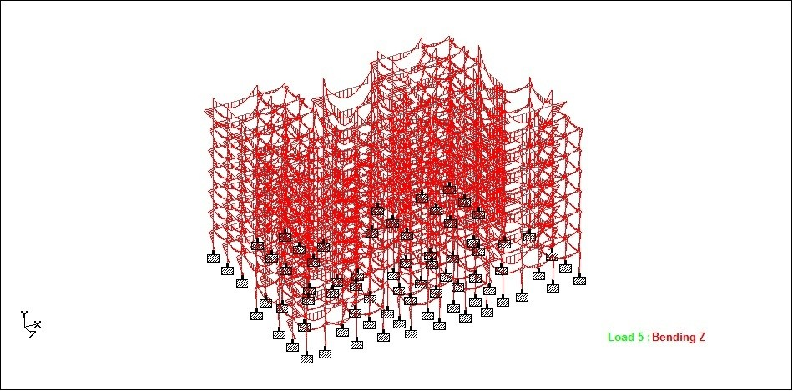
Fig 9.2 a showing bending moments of all the beams
Shear:
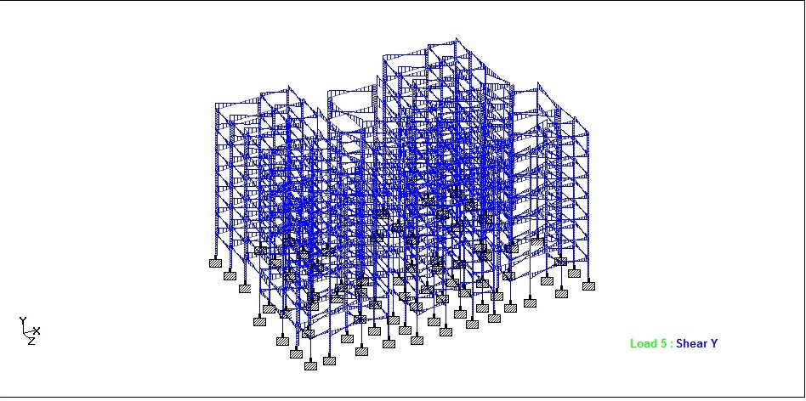
Fig 9.2 b Showing Shear Force of all the beams

Conclusions:

1. Designing using Software’s like Staad reduces lot of time in design work.
2. Details of each and every member can be obtained using staad pro.
3. All the List of failed beams can be obtained and also Better Section is given by the software.
4. Accuracy is improved by using software.

References:
1. Theory of Structures by ramamrutham for literature review on kani,s method
2. Theory of structures by B.C.punmia for literature on moment distribution method.
3. Reinforced concrete Structures by a.k. Jain and B.C. punmia for design of beams, columns and slab.

Code Books
1. IS 456-2000 code book for design of beams, columns and slabs
2.SP-16 for design of columns.

