Performance Analysis of Three Phase Sinusoidal Pulse Width Modulation Inverter

Dr.Dinesh Wankhede , Dr. Chaitanya Jibhkate, Apurva Yesankar, Sahil Sable,
Diksha Bhagat
St.Vincent Pallotti College of Engineering & Technology Nagpur, RTMNU Nagpur University
Nagpur, Maharashtra, India

dwankhede@stvincentngp.edu.in

Received on: 5 May,2024 Revised on: 10 July,2024 Published on: 12 July ,2024

Abstract- Sinusoidal pulse width modulation (SPWM) is a technique in power electronics for generating high-quality sinusoidal waveforms with reduced harmonic content. This paper presents an extensive review and performance analysis of SPWM inverters, focusing on their characteristics and challenges across various applications. The review begins with an overview of principles of SPWM, highlighting its ability to generate sinusoidal waveforms by modulating the width of the pulses in the PWM waveform. The advantages of SPWM which includes low harmonic distortion, high efficiency, and improved voltage regulation, are discussed in detail, highlighting its suitability for the use of motor drives, renewable energy systems, and grid- connected inverters. Performance metrics such as Total Harmonic Distortion (THD), modulation index, output voltage regulation, and efficiency are analysed to assess the effectiveness of SPWM inverters. In conclusion, this comprehensive review and performance analysis provide valuable insights into the design, implementation, and optimization of SPWM inverters, facilitating their widespread adoption and deployment in various power electronics applications.

Keywords- Inverter, sinusoidal pulse width modulation, total harmonic distortion.

INTRODUCTION
Inverter
Inverters are useful devices in modern power electronics systems, easing the conversion of DC direct current into AC alternating current. Their resilience and efficiency make them integral components in various applications, starting from renewable energy systems and motor drives, uninterruptible power supplies (UPS) system and grid tied inverters.
The basic principle of the inverters involves transforming the steady dc voltage input into an ac output waveform, typically sinusoidal, square, or modified sine wave, depending on the application requirements. This transformation enables the use of dc power sources, such as batteries or photovoltaic panels, to power ac loads or feed ac power into the grid.
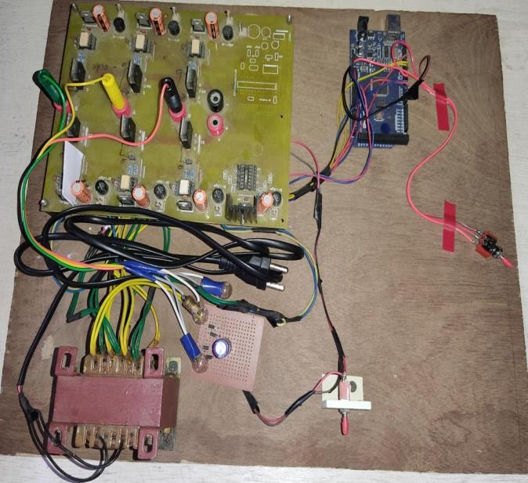


Arduino
Transformer

Figure 1: Hardware

Inverter with Sinusoidal Pulse Width Modulation
The SPWM in the inverter circuits is more complex than the PWM used in DC-DC converters. It has a sinusoidal waveform at the output of the inverter, with magnitude and frequency.

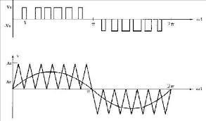

Figure 2: Sinusoidal pulse width modulation single phase inverter

Source: https://www.researchgate.net/figure/Sinusoidal-pulse-width-modulation-III-SINGLE- PHASE-SPWM-INVERTER_fig1_316432567

The foundation of Inverters with Sinusoidal Pulse Width Modulation rests upon the principle of modulating the width of the pulses within a Pulse Width Modulated (PWM) waveform to approximate a sinusoidal output waveform. By precisely controlling the width of these pulses in response to the instantaneous values of a reference sinusoidal waveform, SPWM achieves the objective of generating AC waveforms with minimal harmonic distortion and high fidelity to the desired sinusoidal waveform.

Modulation Index: The modulation index is defined as the ratio of change in the amplitude of carrier waveform to the amplitude of carrier waveform.

µ = change in amplitude of carrier waveform Amplitude of carrier waveform

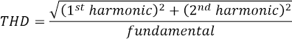
Total Harmonics Distortions (THD): It is the ratio of the total harmonic component to the fundamental component. The formula of the THD is xpressed as, the numerator is the sum of the RMS values of each order starting from the second order and the denominator is the RMS value of the fundamental waveform.

LITERATURE REVIEW
Pulse Width Modulation (PWM)
Pulse width modulation is abbreviated as PWM. It is a method which is used in electronics and digital communication to manage the amount of power delivered to the device by changing the width of pulses in a pulse train. In the pulse width modulation signal, the ratio of the duration of the high signal to the duration of the total period is changed to manage the power delivered.

PWM is commonly used in various operations which includes, speed control of the motors, regulating the intensity of LEDs, producing an analog signals, and controlling the power supplies. By modifying the duty cycle the average power which is delivered to the load can be controlled/managed efficiently. This allows for precise control of devices without dissipating much power as heat, making it an efficient method for controlling power.

Types of PWM Techniques

- Single-Pulse Width Modulation:- In SPWM, a series of pulses with variable widths are generated to approximate a sinusoidal waveform. This method is often used in motor control and power inverters for applications like variable-frequency drives (VFDs).
- Multiple-Pulse Width Modulation:- ‘MPWM’ is an extension of SPWM, where multiple pulses are used in each half-cycle to further approximate a sinusoidal waveform. This technique improves the quality of the output waveform compared to SPWM.
- Sinusoidal Pulse Width Modulation (SPWM):- ‘SPWM’ is abbreviated as Sinusoidal Pulse Width Modulation, which is a method used in inverters to control an output voltage and frequency of three-phase inverter. SPWM compares a sinusoidal ac voltage is a reference with a high-frequency triangular carrier waveform, which also determines the switching conditions for each pole in the inverter.
- Selective Harmonic Elimination (SHE):- ‘SHE’ is abbreviated as Selective Harmonics Elimination. It is method which eliminates the lower-order harmonics from a voltage or current waveform. SHE is also used in multilevel inverters (MLIs) to calculate switching angles that obtain the desired fundamental output voltage while eliminating the dominant low order harmonics.

SINUSOIDAL PULSE WIDTH MODULATION (SPWM) :-
Sinusoidal pulse width modulation is used for several reasons in the various applications, particularly in power electronics and motor control:

- Improved Output Quality: SPWM generates a PWM waveform that closely resembles a sinusoidal waveform. This results in a cleaner output signal with reduced harmonic distortion compared to simpler PWM techniques like Square Wave PWM or Single Pulse Width Modulation (SPWM). The reduced harmonic content leads to smoother operation and better performance of the controlled system.

- Reduced Electromagnetic Interference (EMI): The sinusoidal nature of the output waveform produced by SPWM helps to reduce electromagnetic interference generated by the system. This is particularly important sensitive applications where EMI can interfere with other electronic devices or communication systems.

- Higher Efficiency: SPWM can result in higher efficiency compared to simpler PWM techniques. By generating a waveform that closely matches the desired output signal, SPWM minimizes energy losses and improves the overall efficiency of the system, especially in applications such as motor drives and power inverters.

- Improved Motor Control: SPWM is widely used in motor control applications, particularly in the variable frequency drives, where accurate control of speed of the motor and torque is required. The smooth, sinusoidal output waveform generated by SPWM helps to minimize torque ripple and improve the overall performance of the motor.

- Flexibility: SPWM can be easily adjusted to meet specific requirements of different applications. By changing parameters such as modulation index, frequency, and phase angle, SPWM can accommodate a wide range of operating conditions and control objectives.

- Compatibility: SPWM is compatible with a variety of power electronic devices, including MOSFETs, IGBTs, and power diodes. This compatibility makes it suitable for integration into existing systems and for use with a wide range of power conversion and control applications.

Overall, Sinusoidal Pulse Width Modulation offers improved output quality, reduced EMI, higher efficiency, and better motor control compared to simpler PWM techniques, making it a preferred choice in many power electronics and motor control applications.

REFERENCES

- Sharmila Devi , J.S. Deepika , K. Darshini , G. Divyashree “User Interactive Hospital Management System by using Web Technology” August 2021
- S. Mathyvathana , R. Priyanthi , K. Nishanthan “Hospital Management System using Web Technology”, International Journal of Engineering and Management and Research , Oct 2022
- Rupak Chakraborty, Bishan Paul , Moloy Dhar “Implementation of Hospital Management System”, International Journal of reseach in Medical Science, Feb 2021
- Ari Yulianti, Muhardi N., “HMS efforts to improve hospital service quality” , Dec 2020
- Addanki Chardrahas Babu, Vavilala Naga Chandra Sai Teja, “Web based hospital management system”, International Conference on Advanced Computing and Communication Systems (ICACCS), March 2023
- Visvesaran C, Swetha K, Shri Yazhini, “Resource Allocation for Web based hospital appointment management system”, International Conference on System, Automation and Networking (ICSCAN), Novemeber 2023
- George Suciu, Stefen stefanescu, Cristian Beceanu, Marian Ceaparu, “WebRTC role in real-time communication and hospital management conferencing”, June 2020.
- WebRTC Website, https://webrtc.org
- Brazilian Journal of Hospital Pharmacy and Health Services, 6(3), 27-33. [7] Schriek, M., Türetken, O. & Kaymak, U. (2016)
- Areda, C.A., Galato, D. & Federal, D. (2015). Mapping of processes in a hospital pharmacy: tool forquality management and improvement, Brazilian Journal of Hospital Pharmacy and Health Services

