Enhancing Patient Care and Operational Efficiency

Prof. Shubhangi Chaware , Sameer Thakre, Darshan Zade, Anjali Chaje, Sejal Ganvir

Department of Info. Tech SVPCET, Nagpur, Maharashtra

schaware@stvincentnpg.edu.in

Received on: 5 May,2024 Revised on: 10 July,2024 Published on: 12 July ,2024

Abstract- The Hospital Management System (HMS) is a comprehensive solution designed to streamline the operations and management of healthcare facilities. It offers a range of functionalities to improve efficiency, enhance patient care, and ensure regulatory compliaorkshops, and meetings. A virtual event is an online gathering that takes place online and involves participants engaging virtually rather than in person. Virtual events are online gatherings that last for several sessions and frequently include webcasts and webinars. Because they offer more flexibility, better security, and lower costs-not to mention the safety and sustainability advantages of skipping long- distance travel-digital or virtual events are growing in popularity. Healthcare systems worldwide face numerous challenges in delivering efficient, cost-effective, and high- quality care to patients. In this context, the implementation of Hospital Management Systems (HMS) has emerged as a critical strategy to streamline operations, enhance patient care, and improve overall healthcare delivery. An HMS is a comprehensive software solution designed to automate and manage the day-to-day administrative and clinical operations of a hospital or healthcare facility.
Keywords- Virtuality, Web Application, Design, User Interface, appointment booking, admin.

INTRODUCTION
Healthcare systems worldwide face numerous challenges in delivering efficient, cost-effective, and high-quality care to patients. In this context, the implementation of Hospital Management Systems (HMS) has emerged as a critical strategy to streamline opekers. Healthcare systems worldwide face numerous challenges in delivering efficient, cost-effective, and high-quality care to patients. In this context, the implementation of Hospital Management Systems (HMS) has emerged as a critical strategy to streamline operations, enhance patient care, and improve overall healthcare delivery. An HMS is a comprehensive software solution designed to automate and manage the day- to-day administrative and clinical operations of a hospital or healthcare facility. The significance of an HMS lies in its ability to centralize and integrate various aspects of hospital management, including patient information management, appointment scheduling, billing, inventory management, and reporting. By digitizing these processes, an HMS can help healthcare providers improve efficiency, reduce errors, and enhance the quality of care.

Through this research, we hope to provide valuable insights into the role of HMS in transforming healthcare delivery and improving patient outcomes. By understanding the benefits and challenges of implementing an HMS, healthcare providers can make informed decisions about adopting this technology to enhance their operations and provide better care to their patients. An HMS integrates various departments and functions within a healthcare facility, such as admissions, billing, pharmacy, laboratory, and imaging. It also facilitates interoperability with external systems, such as electronic health records (EHRs) and health information exchanges (HIEs), ensuring seamless exchange of information between different healthcare providers and systems. An HMS provides advanced data analytics and reporting capabilities, allowing healthcare providers to analyze trends, track performance indicators, and make data-driven decisions. This can lead to improved resource allocation, better financial management, and enhancement of patient outcomes. An HMS is scalable and customizable to meet the unique needs of different healthcare settings, from small clinics to large hospitals. It can adapt to changing requirements and technologies, ensuring long-term sustainability and effectiveness. An HMS facilitates better communication and collaboration among healthcare providers, patients, and other stakeholders. It enables secure messaging, care coordination, and shared decision-making.

II -LITERATURE REVIEW

Our main goal in creating our virtual platform is to make users happy when they participate in virtual events. We are studying what attracts users, with an emphasis on hedonic motivation (enhancement of enjoyment) and easing any concerns. We're upgrading our hospital management conferencing at the same time with WebRTC to enable faster, more secure, and seamless online meetings. Our user- friendly software guarantees satisfaction with its intuitive navigation, excellent hospital management assistance, and insightful suggestions. Envision a comprehensive solution wherein virtual conferences are optimized for customer satisfaction in addition to efficiency. In addition, a peer-to-peer hospital management system is introduced, ensuring safe and joyful connections in real time for users.

In research paper titled [1] A User Interactive Hospital Management System (HMS) built using web technology offers a modern and accessible solution for managing hospital operations. This system can be accessed through a web browser, making it easy to use across different devices without the need for installation. Users, including hospital staff, administrators, and patients, can interact with the system to perform various tasks such as appointment scheduling, accessing medical records, managing inventory, and billing. In research paper titled [2] A Hospital Management System (HMS) using web technology is a comprehensive software solution designed to digitize and streamline the operations of a healthcare facility. This system leverages web technologies such as HTML, CSS, JavaScript, and backend frameworks like Django, Node.js, or Ruby on Rails to create a user-friendly interface accessible through web browsers. In proposed paper [3] The implementation of hospital management system includes conducting a thorough analysis of the hospital's requirements, including its size, specialties, patient demographics, and existing workflows, to determine the scope and features of the HMS. Developing a system architecture and user interface design that aligns with the hospital's needs and objectives, ensuring usability and efficiency. In research paper [4] An HMS streamlines patient registration, appointment scheduling, and admission processes, reducing waiting times and improving patient satisfaction. The system facilitates better communication among healthcare providers, ensuring timely access to patient information and coordinated care. By providing access to comprehensive patient records and decision support tools, an HMS helps healthcare providers make informed and timely clinical decisions, leading to better outcomes. An HMS automates billing processes, ensuring accurate and timely invoicing, reducing billing errors, and enhancing revenue management. The paper [5] A web-based Hospital Management System (HMS) is a software solution that allows healthcare facilities to manage their operations, processes, and patient data through a web browser. This system provides several advantages over traditional, on-premise HMS. Web- based HMS can easily scale to accommodate the needs of growing healthcare facilities, without the need for significant hardware upgrades or investments. In proposed paper [6] Resource allocation in a Hospital Management System (HMS) refers to the process of efficiently distributing and utilizing resources such as staff, equipment, facilities, and finances to meet the healthcare needs of patients and improve overall hospital performance. The system helps hospitals manage their equipment inventory and allocate resources based on demand. This ensures that equipment is utilized efficiently, reducing downtime and improving patient access to necessary equipment.
In research paper [7] WebRTC role in real-time communication and hospital management conferencing by George Suciu, Stefen stefanescu, Cristian Beceanu, Marian Ceaparu, the study entitled “WebRTC role in realtime communication and hospital management conferencing” Introduce the P2P hospital management conferencing system based on Web Real-Time Communication (WebRTC). In application [8] WebRTC Real-time voice, text, and hospital management conversations between web browsers and devices are made possible by the open-source WebRTC (Web Real- Time conversations) project. JavaScript application programming interfaces (APIs) are made available to software developers using WebRTC. These APIs allow developers to build peer-to-peer (P2P) connections between mobile applications and internet web browsers without having to worry about supporting text, hospital management, or audio-based content compatibility. Real-time data communication is possible with WebRTC; no additional plugins, special software, or customized interfaces are required for browser integration. With just a webpage opened, WebRTC facilitates real- time voice and hospital management communication.

III -OBJECTIVE

The objectives of a hospital management system (HMS) are multifaceted, aiming to streamline operations, enhance patient care, improve efficiency, and ensure regulatory compliance. The Hospital Management System (HMS) aims to streamline administrative and clinical processes, such as patient registration, appointment scheduling, billing, and inventory management, to improve overall efficiency. By providing quick access to patient information, treatment plans, and medical histories, the HMS helps healthcare providers deliver more personalized and effective care to patients. The system facilitates communication and collaboration among healthcare providers, patients, and other stakeholders, leading to better coordination of care and patient outcomes. Additionally, the HMS helps hospitals optimize resource utilization, reduce wastage, and improve revenue management, leading to cost savings and financial sustainability. It ensures the accurate and secure storage, retrieval, and sharing of patient data, helping hospitals maintain compliance with regulatory requirements and standards. Here are the primary objectives of an HMS:

- Efficient Patient Management: The HMS aims to streamline the process of patient registration, admission, and discharge, ensuring smooth transitions between different stages of care. The HMS stores and manages patient records electronically, making it easier for healthcare providers to access and update information. This includes medical history, test results, allergies, and medications. Having this information readily available allows healthcare providers to make informed decisions quickly.

- Appointment Scheduling: By providing a centralized system for scheduling appointments, the HMS helps optimize the allocation of resources and reduce patient wait times. Automating appointment scheduling reduces manual work for hospital staff, allowing them to focus on patient care. It also helps in optimizing the allocation of resources such as doctors, nurses, and rooms.

- Interactive Features: To keep participants interested and encourage participation, including features like feedback form and contact us patients can schedule, reschedule, or cancel appointments online, reducing the need for phone calls and improving accessibility.Interactive messaging features allow for real-time communication between healthcare providers, staff, and patients, facilitating quick decision-making and improving patient care.

- Billing and Invoicing: An HMS automates the billing process, reducing errors and ensuring timely and accurate invoicing for services rendered. The system generates bills for services rendered to patients, including consultations, procedures, medications, and other healthcare services. It calculates charges based on predefined rates or fee schedules. An HMS automates billing processes, ensuring accurate and timely invoicing, reducing billing errors, and enhancing revenue management.

- Reporting and Analytics: By generating reports and providing data analytics, the HMS helps hospital administrators make informed decisions about resource allocation, performance improvement, and strategic planning.The system generates customizable reports based on specific parameters, such as patient demographics, medical conditions, services provided, and financial transactions. Users can create ad- hoc reports or use predefined templates.

- Patient Engagement: Through features such as patient portals and telemedicine, the HMS helps hospitals engage with patients, empowering them to take an active role in their healthcare. Patient engagement is a critical aspect of a Hospital Management System (HMS) as it involves empowering patients to take an active role in their healthcare journey. Here are key features that facilitate patient engagement. Facilitate communication between patients and healthcare providers through secure messaging, allowing patients to ask questions, request prescription refills, and receive timely responses.

IV-PROPOSED METHODOLOGY
The proposed methodology for developing and implementing a hospital management system (HMS) begins with a comprehensive analysis of the hospital's requirements, including its size, specialties, patient demographics, and workflows.Agile development methodologies, such as scrum are employed to facilitate flexibility and responsiveness during the development and testing phases, which include unit testing, integration testing, and user acceptance testing to meet quality standards and operational needs. Here's an explanation of the methodology behind the Patient Module, Doctor Module, and Admin Module in a Hospital Management System (HMS):-

In the Patient Module, patients can register themselves by providing basic information such as name, contact details, and address, which is securely stored in the system. They can book appointments with doctors based on availability and specialty through a user-friendly interface. Patients can also update their medical history, including previous illnesses, surgeries, allergies, and current medications, aiding doctors in making informed decisions. Additionally, the module allows patients to view and pay bills online, with support for insurance claims processing. Patients can also provide feedback and reviews about their experience with the hospital and its staff, contributing to the improvement of service quality.

In the Doctor Module, doctors have comprehensive profile management capabilities, allowing them to update personal information, qualifications, specialties, and availability for appointments. They can efficiently manage their appointment schedules, viewing, accepting, rescheduling, or canceling appointments based on their availability and patient needs. Access to patient records is facilitated, enabling doctors to review medical history, test results, and prescriptions, and to update these records after each consultation. The module includes prescription management features, allowing doctors to create and print prescriptions for patients while also tracking medication usage and providing alerts for potential drug interactions.

In the Admin Module, administrators have a range of critical functions to manage the hospital's operations effectively. They can oversee user management, including creating, modifying, or deactivating user accounts and managing permissions within the system. Resource management is also a key aspect, allowing admins to efficiently allocate hospital resources such as rooms, equipment, and facilities based on availability and demand. The module provides comprehensive reporting and analytics capabilities, enabling admins to generate reports on various aspects of the hospital's operations, including patient demographics, revenue, and resource utilization. This data-driven approach helps in making the informed decisions and optimizing of the hospital's performance. Administrators can also configure system settings according to the hospital's requirements, such as appointment slots, billing rates, and insurance policies. By providing a centralized system for scheduling appointments, the HMS helps optimize the allocation of resources and reduce patient wait times. Automating appointment scheduling reduces manual work for hospital staff, allowing them to focus on patient care. It also helps in optimizing the allocation of resources such as doctors, nurses, and rooms. The Hospital Management System (HMS) aims to streamline administrative and clinical processes, such as patient registration, appointment scheduling, billing, and inventory management, to improve overall efficiency. By providing quick access to patient information, treatment plans, and medical histories, the HMS helps healthcare providers deliver more personalized and effective care to patients. The system facilitates communication and collaboration among healthcare providers, patients, and other stakeholders, leading to better coordination of care and patient outcomes. Additionally, the HMS helps hospitals optimize resource utilization, reduce wastage, and improve revenue management, leading to cost savings and financial sustainability. It ensures the accurate and secure storage, retrieval, and sharing of patient data, helping hospitals maintain compliance with regulatory requirements and standards.
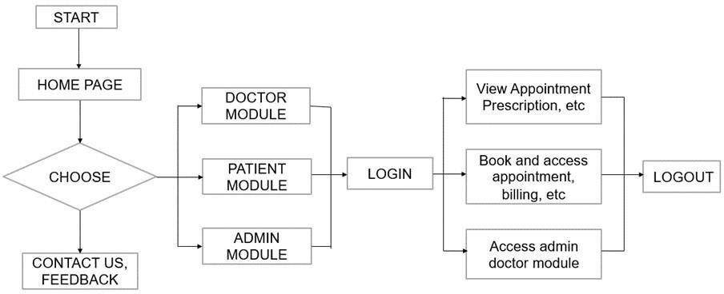

Fig. Flowchart of Proposed System

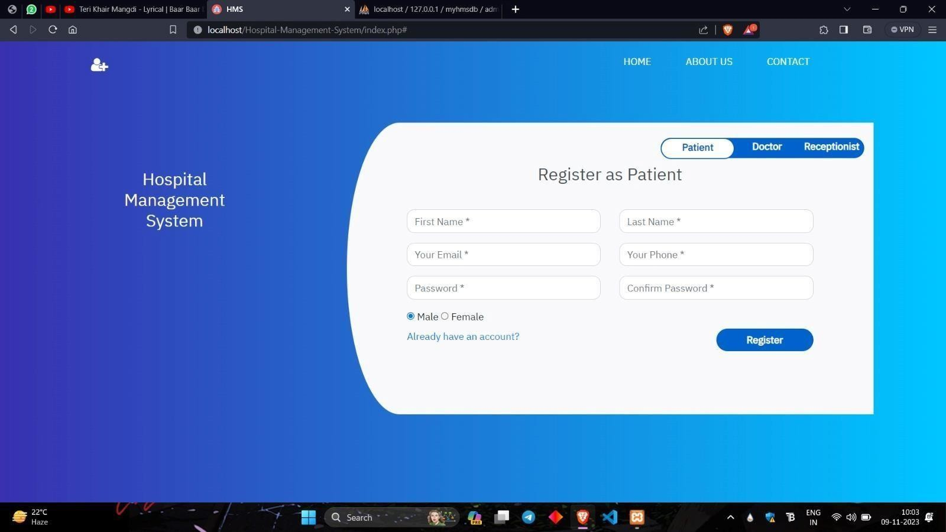

Fig: Login Page

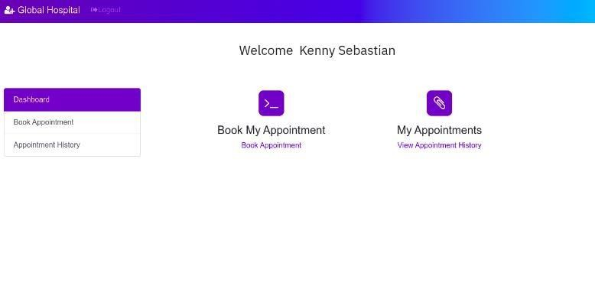

Fig. Patient Page

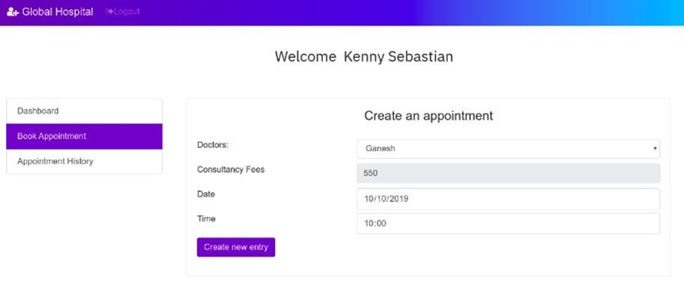

Fig. Appointment Page

EXPERIMENTAL ANALYSIS
In this section we will discuss about the flow of our project. The section is divided into three modules patients, doctor and admin module. Patients can register themselves by providing basic information such as name, contact details, and address, which is securely stored in the system. They can book appointments with doctors based on availability and specialty through a user-friendly interface. Patients can also update their medical history, including previous illnesses, surgeries, allergies, and current medications, aiding doctors in making informed decisions. Additionally, the module allows patients to view and pay bills online, with support for insurance claims processing. Patients can also provide feedback and reviews about their experience with the hospital and its staff, contributing to the improvement of service quality. Doctors have comprehensive profile management capabilities, allowing them to update personal information, qualifications, specialties, and availability for appointments. They can efficiently manage their appointment schedules, viewing, accepting, rescheduling, or canceling appointments based on their availability and patient needs. Access to patient records is facilitated, enabling doctors to review medical history, test results, and prescriptions, and to update these records after each consultation. The module includes prescription management features, allowing doctors to create and print prescriptions for patients while also tracking medication usage and roviding alerts for potential drug interactions. administrators have a range of critical functions to manage the hospital's operations effectively. They can oversee user management, including creating, modifying, or deactivating user accounts and managing permissions within the system. Resource management is also a key aspect, allowing admins to efficiently allocate hospital resources such as rooms, equipment, and facilities based on availability and demand. The module provides comprehensive reporting and analytics capabilities, enabling admins to generate reports on various aspects of the hospital's operations, including patient
demographics, revenue, and resource utilization. This data-driven approach helps in making the informed decisions and optimizing of the hospital's performance.

CONCLUSION

In conclusion, the implementation of a hospital management system (HMS) represents a significant step towards enhancing the efficiency, quality, and effectiveness of healthcare delivery. Through the systematic analysis of hospital requirements, thoughtful design and development, and meticulous testing and implementation, an HMS can streamline workflows, improve communication and collaboration among healthcare providers, and enhance patient care experiences. The system's ability to provide quick access to patient information and facilitate communication among healthcare providers leads to better coordination of care and improved patient outcomes. Additionally, the HMS helps hospitals optimize resource utilization, reduce costs, and improve revenue management, contributing to financial sustainability. Furthermore, by ensuring the accurate and secure storage of patient data, the HMS helps hospitals maintain compliance with regulatory requirements and standards. Overall, the HMS enhances the quality of healthcare services, empowers patients to take an active role in managing their health, and contributes to the overall efficiency and effectiveness of healthcare delivery.

FUTURE SCOPE

The future scope of Hospital Management Systems (HMS) is promising, driven by rapid technological advancements and evolving healthcare needs. Artificial Intelligence (AI) and Machine Learning are poised to revolutionize HMS by enabling predictive analytics for patient outcomes, optimizing resource allocation, and enhancing clinical decision-making. Integration of Internet of Things (IoT) devices will enable remote monitoring of patient health and tracking of medical equipment, enhancing operational efficiency. Telemedicine and Remote Monitoring will be key focuses, with HMS integrating features to facilitate remote consultations and patient monitoring. Blockchain technology will ensure secure sharing of health records among healthcare providers, ensuring data privacy and interoperability. Mobile Health (mHealth) integration will empower patients to monitor their health and share data with providers, promoting engagement and personalized care. Advanced data analytics will derive insights from large datasets, improving operational efficiency and patient outcomes.

REFERENCES

- Sharmila Devi , J.S. Deepika , K. Darshini , G. Divyashree “User Interactive Hospital Management System by using Web Technology” August 2021
- S. Mathyvathana , R. Priyanthi , K. Nishanthan “Hospital Management System using Web Technology”, International Journal of Engineering and Management and Research , Oct 2022
- Rupak Chakraborty, Bishan Paul , Moloy Dhar “Implementation of Hospital Management System”, International Journal of reseach in Medical Science, Feb 2021
- Ari Yulianti, Muhardi N., “HMS efforts to improve hospital service quality” , Dec 2020
- Addanki Chardrahas Babu, Vavilala Naga Chandra Sai Teja, “Web based hospital management system”, International Conference on Advanced Computing and Communication Systems (ICACCS), March 2023
- Visvesaran C, Swetha K, Shri Yazhini, “Resource Allocation for Web based hospital appointment management system”, International Conference on System, Automation and Networking (ICSCAN), Novemeber 2023
- George Suciu, Stefen stefanescu, Cristian Beceanu, Marian Ceaparu, “WebRTC role in real-time communication and hospital management conferencing”, June 2020.
- WebRTC Website, https://webrtc.org
- Brazilian Journal of Hospital Pharmacy and Health Services, 6(3), 27-33. [7] Schriek, M., Türetken, O. & Kaymak, U. (2016)
- Areda, C.A., Galato, D. & Federal, D. (2015). Mapping of processes in a hospital pharmacy: tool forquality management and improvement, Brazilian Journal of Hospital Pharmacy and Health Services

