Streamlined Data Export to CSV

Sahil Gupta, Sunil M. Wanjari, Brijesh Kanaujiya, Sanmesha Bhagat, Sahil Pancham,
Tushar Magare

Dept. of Computer Engineering, SVPCET, Nagpur, MH, India

Received on: 5 May,2024 Revised on: 10 July,2024 Published on: 12 July ,2024

Abstract- Fluctuations in weather patterns pose numerous challenges for various sectors, including agriculture, aviation, and infrastructure. Given the unpredictable nature of climatic conditions, accurate weather forecasting has become increasingly crucial. Experts closely monitor technological advancements and evolving atmospheric trends to enhance forecasting accuracy. Weather forecasting plays a vital role in mitigating disasters, facilitating efficient aviation operations, supporting agricultural practices, and meeting diverse business needs. The integration of artificial intelligence (AI) and machine learning (ML) has expanded the scope of weather research by enabling the development of sophisticated models. However, before delving into analysis and model training, meticulous data extraction is paramount.
In our study, we aimed to identify crucial parameters within radar data sourced from multiple raw files, essential for making precise weather predictions. These parameters include the reflectivity factor, velocity factor, spectrum width, as well as latitude and longitude coordinates. Accurately extracting these radar elements is pivotal for selecting appropriate models, thereby ensuring a system of high accuracy and optimal efficiency.

Keywords- Weather forecasting, AI and Weather Parameters

- INTRODUCTION
Weather forecasting is the process of estimating future atmospheric conditions by utilizing scientific models and methodologies to analyze present weather data. Planning daily activities, agriculture, aviation, emergency preparedness, and other things all depend on it. By giving individuals advance notice of dangerous weather conditions like storms, hurricanes, and heatwaves, accurate predictions save lives by enabling them to take the appropriate safety measures. Forecasts are also necessary for sectors like

transportation, energy, and agriculture to reduce risks and make well-informed decisions.
Regional meteorological centers use radar technology to detect, measure, and track precipitation, which helps in weather forecasting. Meteorologists are able to predict and issue warnings for severe weather phenomena such as storms, hurricanes, and tornadoes in a timely manner because Doppler radar devices provide vital information on wind patterns and storm development.
Radar technology, especially Doppler radar, is commonly used for data extraction utilizing parameters including longitude, latitude, reflectance, spectrum breadth, power and velocity.
Doppler radar is a type of specialized radar that uses the frequency shift of the radar waves reflected off objects to determine their velocity. Doppler radar is essential for detecting the velocity and intensity of precipitation, such as rain, snow, and hail, in weather forecasting. Meteorologists can spot the creation and movement of severe weather phenomena, such as thunderstorms and tornadoes, by analyzing Doppler radar data. This allows for better preparedness and timely warnings, which ultimately improves public safety and reduces damage from hazardous weather occurrences.
Meteorologists can learn more about the composition, intensity, and movement of weather systems by integrating and evaluating various data elements. This data is essential for is using monitoring severe weather occurrences and providing reliable weather forecasts.

- LITERATURE REVIEW
Radar systems are essential for meteorology, providing critical data for weather forecasting. Parameters extracted from radar data, including reflectivity, velocity, power, and geographical coordinates (longitude and latitude), play key roles in understanding atmospheric phenomena. Here's a concise summary of their significance

- Reflectivity (Z):
Reflectivity measures the intensity of radar signals reflected by precipitation particles. It helps identify precipitation types, estimate rainfall rates, and track storm movement and intensity. Reflectivity is crucial for rainfall estimation, storm tracking, and issuing timely weather warnings.
- Velocity (Doppler):
Doppler velocity data indicates the speed and direction of precipitation particles relative to the radar site. It provides insights into wind patterns within storms, aiding in the detection and analysis of severe weather phenomena like tornadoes and mesocyclones.
- Power (P):
Radar power represents the strength of transmitted radar signals, reflecting system sensitivity. Accurate power measurements are essential for calibrating radar systems and ensuring reliable data collection, especially in regions with low signal strength.
- Longitude and Latitude:
Geographical coordinates specify the location of radar measurements. Longitude indicates east-west position relative to the Prime Meridian, while latitude indicates north-south position relative to the equator. Georeferencing radar data with coordinates enables spatial analysis, storm tracking, and integration with geographical information systems (GIS) for improved weather forecasting accuracy.
These parameters collectively enable meteorologists to analyze weather patterns, detect severe weather events, and issue forecasts and warnings crucial for public safety and disaster preparedness. Integrating radar data with geographic information enhances spatial analysis and visualization, aiding in the interpretation and communication of meteorological information.

- METHODOLOGY
The web application retrieves radar data elements based on current weather conditions. The reflectivity, power, spectrum width, and velocity values, along with the longitude and latitude obtained from each raw file, are used to estimate the correlation between these radar elements. Longitude and latitude are essential for spatial analysis, which will be used to investigate patterns and correlations between radar data elements across various locations.

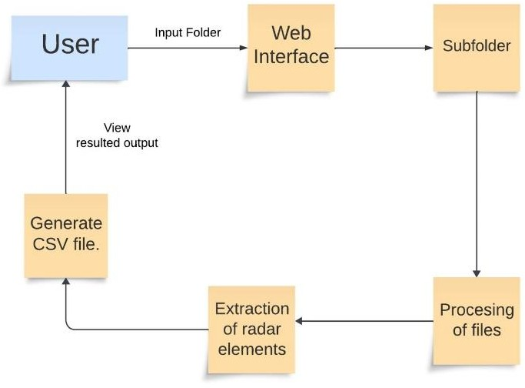

Fig 1. Diagram for Demonstrating Extraction Process
Creating a web application simplifies the process of generating datasets from raw files in batches. Metreologists have option to download files and use radar data which is present in CSV (Comma-Separated Values) format. This CSV file containing mode values for each parameter will be utilized as input for meteorological analysis. It turned out that the data in the raw file was quite enormous, and the size differed from file to file. This was due to the numbers being dependent on the cloud cover that existed at the time the radar data was collected. For instance, the radar element values for a raw radar file were found in a matrix of size 3600x998. As a result, the data collected for each radar element had to be normalized. NULL values were deleted, superfluous values were filtered out, and the mode value (the most recurring value) of each data file was considered. This analysis considered 289 raw files in a folder.
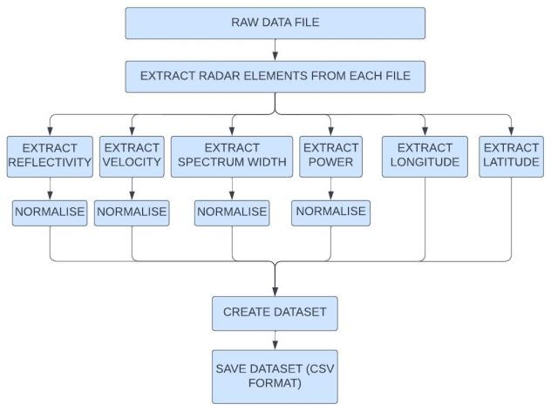

Fig 2. Data Flow Diagram for Parameters Extraction

We used the raw data from a certain day acquired by radar at various intervals. The raw files are a certain kind of file format that contains data in multidimensional array format, which we utilized to extract a specific field using the PY- ART library and then converted to a single CSV to be imported for meteorological analysis.

- RESEARCH ANALYSIS
The research project introduces an innovative approach to revolutionize weather forecasting by directly extracting radar parameters from raw data provided by the Indian Meteorological Department (IMD) and structuring them into a user-friendly CSV format. Unlike traditional methods that often involve converting radar data into images, this approach prioritizes simplicity and accessibility. It focuses on extracting crucial parameters like reflectivity factor, velocity factor, spectrum width, and total power, while paying close attention to capturing Min, Max, and MODE values for each parameter. By honing in on MODE values, which represent the most common occurrences within the dataset, the research aims to streamline model training processes and elevate predictive accuracy. The outcomes highlight the effectiveness of this approach in not only improving the efficiency of weather forecasting models but also making them more intuitive and adaptable for users. This breakthrough lays a strong foundation for future advancements in meteorological prediction methodologies, promising enhanced accuracy and reliability in weather forecasts for communities worldwide.
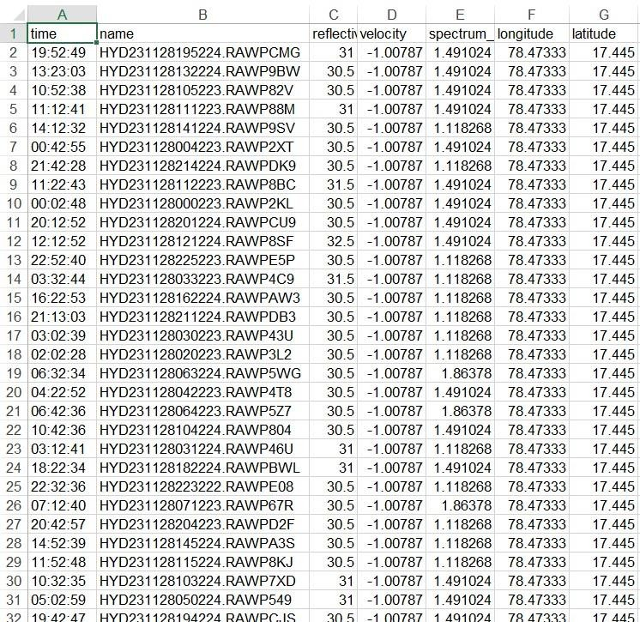
Fig 3. Output CSV file

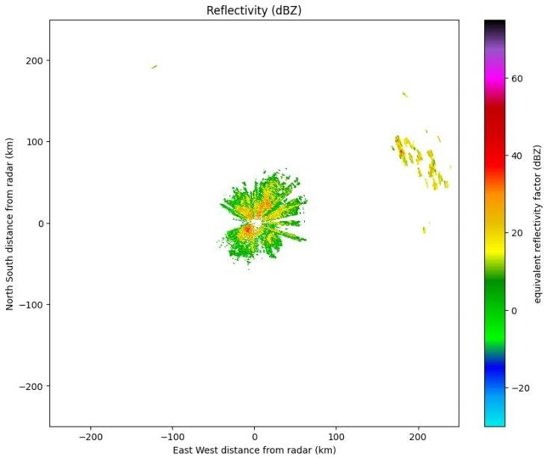
Fig 4. Reflectivity Graph for a radar file

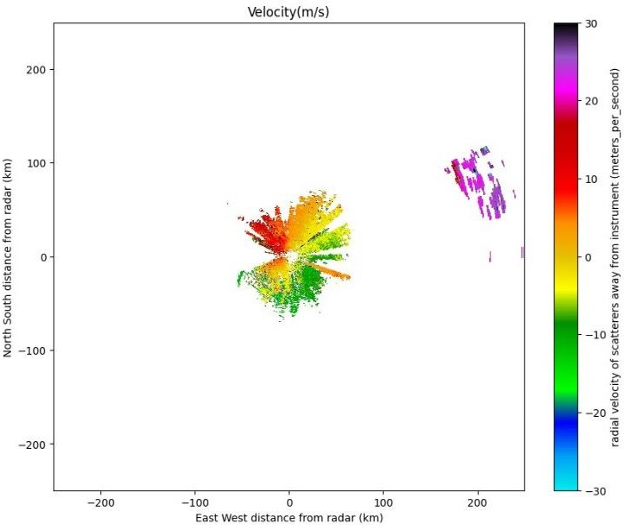
Fig 5. Velocity Graph for a radar file

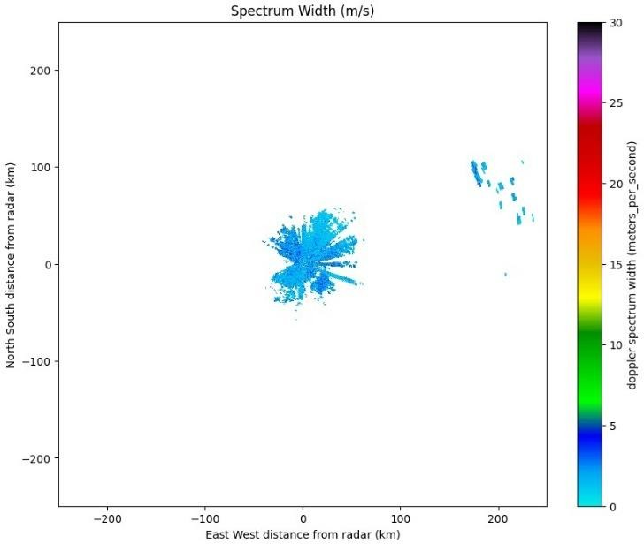
Fig 6. Spectrum Width graph for a radar file
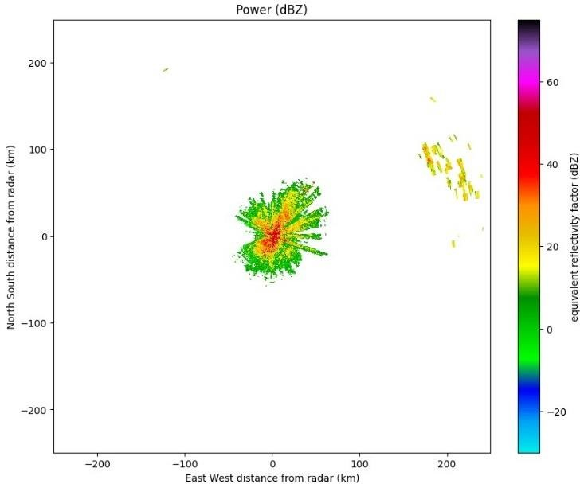

Fig 7. Power Graph for a radar file

- FINAL REPORT AND ANALYSIS
In summary, there exists a robust correlation between radar power and reflectivity, where higher power yields a more intense reflected signal and heightened sensitivity to targets. To accurately identify and measure targets using radar technology, however, it is imperative to meticulously manage and account for a multitude of complex factors.
Thorough examination of velocity and spectrum width measurements is essential for accurate radar data interpretation. In conclusion, radar velocity and spectrum width are interrelated quantities; however, their correlation is contingent upon various factors and necessitates thorough analysis for proper radar data interpretation.
- CONCLUSION
In conclusion, our project successfully tackles the formidable challenge of extracting vital radar data parameters, including reflectivity, velocity, spectrum width, power, longitude, and latitude, from an extensive collection of raw files. By efficiently processing these large datasets into a concise CSV format containing mode values for each parameter, we've achieved a significant milestone in streamlining data preparation for our model. Despite the inherent complexity and size constraints of radar files, our approach ensures that the extracted CSV data remains manageable and conducive to efficient model training

ACKNOWLEDGEMENT

We are profoundly thankful to the Indian Meteorological Department (IMD), Delhi, for graciously providing the resources essential for our research. Additionally, we express our deep gratitude to our industry mentor and esteemed college department for their invaluable guidance and unwavering support throughout the challenges encountered during our research journey. Their constructive feedback has played a pivotal role in refining and shaping our study, ensuring its quality and relevance.

REFERENCES
- Nayan Agrawal, Jasneet Kaur Saini, Aditya Sharma, Moin Sheikh, Dr. Sunil M. Wanjari “Weather Forecasting: Era of Artificial Intelligence” IRJET2020: Technology, vol. 07, Issue 04, April,2020
- Sarvesh Landge, Brijesh Kanaujiya, Dr. Sunil M. Wanjari, Aditya Taksande, Rachit Khandelwal, Shienell Amair, “Radar Vision - Weather Forecasting Using CNN-LSTM” ICCAE2021:International Conference on Computing and Applied Engineering Grand Inn,2021. GOA-INDIA GOA, India, July 23- 24,pp. 354–364, 2015.
- Radar Data Analysis Using Linear Regression - Anjali Banerjee Dr. Sunil M. Wanjari Mr. Brijesh Kanaujiya, Ashwin George, Harshali Hood, Ryan Chettiar, INTERNATIONAL JOURNAL FOR RESEARCH PUBLICATION & SEMINAR ISSN:2278-6848,2023.
- EXTRACTION OF RADAR ELEMENTS - Rahul Deshmukh, Sebi James, Shreyas Kumar, Akhil Benny, Dr. Sunil Wanjari, Brijesh Kanaujiya, © INTERNATIONAL JOURNAL FOR RESEARCH PUBLICATION & SEMINAR ISSN: 2278-6848,2023.

- https://training.weather.gov/nwstc/NEXR AD/RADAR/3-1.html
- Tage Andersson and Karl-Ivar Ivarsson, “A model for probability nowcasts of accumulated precipitation using radar,” Journal of Applied Meteorology, vol. 30, no. 1, pp. 135–141, 1991.
- W Schmid, S Mecklenburg, and J Joss, “Short-term risk forecasts of severe weather,” Physics and Chemistry of the Earth, Part B: Hydrology, Oceans and Atmosphere, vol. 25, no. 10-12, pp. 1335– 1338, 2000.
- Alan W Seed, Clive E Pierce, and Katie Norman, “Formulation and evaluation of a scale decomposition- based stochastic precipitation nowcast scheme,” Water Resources Research, vol. 49, no. 10, pp. 6624–6641, 2013.
- Aitor Atencia and Isztar Zawadzki, “A comparison of two techniques for generating nowcasting ensembles. part i: Lagrangian ensemble technique,” Monthly Weather Review, vol. 142, no. 11, pp. 4036–4052, 2014.
- Raw radar images dataset retrieved from website http://www.imdnagpur.gov.in/

