Institute Information System Using Salesforce
Dr. Vishal Tiwari ¹, Renuka Sumbh², Sakshi Patil³, Parth Pande ⁴, Devyani Makde⁵
¹Assistant Professor, ^{2,3,4,5}UG Engineering Students
Department of Information Technology, St. Vincent Pallotti College of Engineering & Technology, Nagpur, India, 441108
renukarss08@gmail.com

Received on: 05May, 2024 Revised on: 10 July, 2024 Published on: 12 July, 2024

Abstract - In the IT industry, salesforce is considered the hottest cloud computing technology that is available on the cloud. And we are doing our project on salesforce which institute information system. This paper aims to develop an Online Intranet Institute Information System (IIS) that is of importance to either an educational institution or a college. In the early existing system, all the activities are done manually. It is costly and time-consuming. Like automating course scheduling, facilitating online registration processes, and providing students with real-time access to course availability and prerequisites. The Education Edge integrated information management system connects daily operations in the College environment such as Admissions and Registration, Accounts, Faculty, Students, and other curriculum activities. All the data will be stored in Salesforce Cloud. The Institute Information System (IIS) built in Salesforce is a comprehensive solution designed to streamline and optimize various administrative processes within educational institutions. The system offers functionalities such as student enrolment, course registration, academic advising, and grade management, all within a secure and scalable environment.  Keywords: Salesforce.com, CRM, cloud computing,  - INTRODUCTION  Salesforce uses cloud computing by providing customer relationship management (CRM) and other application software solutions in the form of software as a service leased over the Internet, as opposed to software believed and installed on machines locally. Salesforce is a customer relationship management solution that helps the organization to manage their relationship and interactions with new customers as well as existing customers, it helps in storing the data for customers. | To build and distribute custom software, salesforce provides users with excessive customizability to fit their CRM and needs and for developers. This is the foremost reason why we selected Salesforce for creating our application, as applications are more portable and user-friendly. Being salesforce developers, we can able to help them by automating a few tasks and tracking system, so they can take benefit of that and use ahead to this. Salesforce is the primary initiative offering within the Salesforce platform. It provides companies with a result using Android phones. The data will be stored in the college server interface for case management and task management; and a system for automatically directing and mounting important events. It's one integrated CRM platform that gives all your departments including marketing, sales, commerce, and service — a single, shared view of every customer and information measures.  In today's fast-paced educational landscape, managing and organizing information within institutes has become increasingly complex. Salesforce, renowned for its flexibility and scalability, offers a robust platform for developing comprehensive Institute Information Systems (IIS). This introduction serves to outline the significance of such a system and provide an overview of its construction within the Salesforce ecosystem. Automating a few tasks and tracking system, so they can take benefit of that and use ahead to this. Salesforce is the primary initiative offering within the Salesforce platform. It provides companies with a result using Android phones. The data will be stored in the college server interface for case management and task management; and a system for automatically directing and mounting important events. It's one integrated CRM platform that gives all your departments including marketing, sales, commerce, and service — a single, shared view of every customer and information measures.
- LITERATURE SURVEY  [1] The author said that College is a place where students can learn methods of developing their minds in right direction and build their future goals and research on them from college time onward, they have to find the solutions to the problems they are getting from the real world and work on it. In our work, we have made cloud-based college management system where student can see their marks, assignments, and events and faculty can add marks, assignments, and lecture report we use the technologies PHP, HTML, JavaScript, MySQL, Ajax, and CSS.  [2] The author said that the College Management system is Salesforce CRM based application which is the new technical way to manage all department related jobs. The College management system is helpful for students as well as the colleges. In the existing system, all the activities are done manually. It is very costly and time-consuming. In our proposed system, students can view results using phones. The data will be stored in the Salesforce. The application will check user authentications. Admin module maintains the student’s marks of internal college exams. Other than this the advanced features are: In case of natural calamities such as floods, etc.  [3] This author has discussed Cloud computing is a technique that accesses and stores data through the internet rather than in a computer hard drive. Cloud is a metaphor to the internet, which provides more efficient computing by centralizing data processing and information measures. This cloud model is composed of some special functionality like Self-service, Resource pooling, and Board access network. There is a service models Software as Services (SAS), Platform as Service (PAAS), and Infrastructure as Service (IAS). Salesforce provides different platforms, that platforms used for developing software, and applications.  [4] The primary goal of the paper is to offer a thorough overview of information systems (IS) using a clear and concise method, detailing their definition, dimensions, infrastructure, and primary types. The study aims to highlight the understanding and future development of IS to improve overall system performance. It underscores the importance of effectively managing IS through a series of procedures and functions, which are essential for the success and performance of an organization. | [5] The paper focuses on developing an Online Intranet College Management System (CMS) for educational institutions or colleges. This intranet-based application is accessible throughout the institution or within specific departments and is designed for monitoring attendance and maintaining records of students and staff. Key features include the ability to monitor attendance, allow students and staff to access and search for college-related information, and enable staff to update student attendance and marks. Registered users can access and modify data based on their permissions, facilitating easy information access across all management levels within the organization. The CMS also serves as a knowledge/information management system, allowing both technical and non-technical staff to upload or download information from the database. Specifically developed for an engineering college, the system aims to streamline information management processes.  [6] The author describes the development and functionality of an Online College Management System (OCMS), which provides a basic interface for maintaining student data. This system is designed for educational institutions to efficiently manage and update records related to students' academic careers. The OCMS handles various student-related details, academic reports, school information, course details, curricula, batch information, placement details, and other resources. It includes faculty details, batch performance, student information in all aspects, and academic notifications for staff and students updated by the school administration. The system also allows for the analysis of school activities and generates reports and queries on students, batches, courses, faculty, exams, semesters, admissions, and the entire school.  [7] The project aims to enhance the management of student information in an institute by adding mobility and automation through an Android-based Mobile Campus application. This application addresses the inefficiencies of traditional communication methods, like notices and verbal messages, by providing a faster and easier means of communication among students, teachers, and parents. The app streamlines information access, making it more efficient, secure, and less error-prone compared to the previous system of hard files and cumbersome website searches. It ensures secure storage and transmission of sensitive data using encryption and cryptographic algorithms, leveraging the Secure Random class for added security.
METHODOLOGY  A Salesforce application is a logical vessel of all the objects, tabs, processes, and services linked with a given business function. Custom app and service cloud console are the two types of salesforce applications. To create an app in Salesforce, you can use the following steps which are as follows:  - Enter App in the Quick Find box from the Setup in the home tab then select App Manager. Then Click the New Lightning App Now Walkthrough the Lighting App Wizard. Click Save and Finish  In Salesforce we have a variety of options for selecting images for an App. You simply click on ‘Insert an Image’ and take from the document. If required you can add more tabs to the App, click on `Add` selected tabs will be moved to the selected Tabs selection. After creating the app in Salesforce, you can add objects, fields, and records to that app. There are 2 types of objects in Salesforce: Standard objects Those objects that are provided by the salesforce are called standard objects. Custom Object are those objects which are created by the user are called a custom object.  For creating a custom object-  - Direct to Setup-> Build-> Create-> Object  - Click on New Custom Objects.  - Fill in the object Name and Description.  - Click on Save  For creating a custom field-  - Direct to Setup -> Build -> Create -> Object  - Select the object that you want to Add.  - Scroll down to the custom field and Relationships for the objects and click on new.  - Click Next  - Select the page layout that should include this field.  - Click Save  Steps for adding the records-  - Click on the object for which you want to create a record.  - Click New.  - Select a record type.  - Enter values in the fields.  - Click Save  Techniques used for the development of the Salesforce app are as follows- | - Reports and Dashboards  Salesforce provides a sole technique to generate the reports and dashboards. We can easily generate reports in different styles. For generating a report user has to drag and drop the field that is required in reports. The date arranged in the report is usually in the form of rows and columns. Clicking on a run button the report will be run. The dashboard is a graphical representation of data generated by a report. The relationship between a dashboard component (such as charts, or tables) and a report is 1:1. Like reports, dashboards are stored in folders. Clicking on a run button the dashboard will be seen.  - Rules  Validation Rule: Validation Rules help the user to impose data integrity conditions against the data. Validation rules in Salesforce are verified if the data is “True”, and the records are saved. If the data is invalid it displays an error message and the condition is “False”. Assignment rules automate your organization’s lead generation and support processes. Irrespective of whether leads are created manually or generated from Web-To-Case lead assignment rules can be assigned further for case assignment rules whether created manually or automatically using Web-To-Case, case assignment rules can be assigned.  - Apex Integration Services  Apex code is the concept of understanding how the code properly handles more than one record at a time. Apex code enables to integrate external services tightly. Apex could also be an object-oriented linguistic communication that allows developers to start flow and transaction control statements on Salesforce servers. Apex is a language developed by Salesforce.com. In this service, the user will integrate salesforce.com with the third-party website. Salesforce.com is providing APIs to make this integration possible. These APIs will be organized properly and at the successful configuration, salesforce.com users will get access to the third-party limited resources. Apex is acquainted with defined programmed functions during many processes in the world including custom buttons and links, event handlers on record insertion, update, or deletion, scheduling, or the custom controllers of Visualforce pages.
- SYSTEM DESIGN  An Institute Information System is cloud-based education management software, meticulously crafted to streamline academic and administrative operations for colleges and higher education institutions. Its functionalities encompass a wide array of tasks, including admissions, student enrollment, attendance tracking, online fee management, grade management, assignment submission, examination scheduling, and other related activities.  The proposed Institute Information System (IIS) comprises several interconnected components aimed at efficiently managing various aspects of college operations. The integration with Salesforce.com expands the capabilities of the IIS, particularly in areas related to alumni relations, fundraising, and recruitment. Salesforce.com facilitates alumni management by tracking engagement, organizing events, and fostering communication.  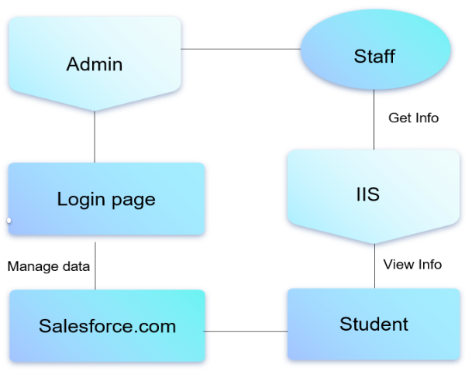  Fig 1. System Architecture  DATA FLOW DIAGRAM  A data flow diagram for an Institute Information System built in Salesforce would illustrate the flow of data within the Salesforce platform. The Data Flow Diagram (DFD) for the Institute Information System in Salesforce illustrates the flow of information between key entities (Students, Instructors, Administration, and Prospective Students) and the core processes (Manage Student Information, Course Management, Admissions Process, and Administration Management). It shows how data moves through the system, interacting with various databases (Student, Course, Admissions, Administration), to support the institute's operations. | 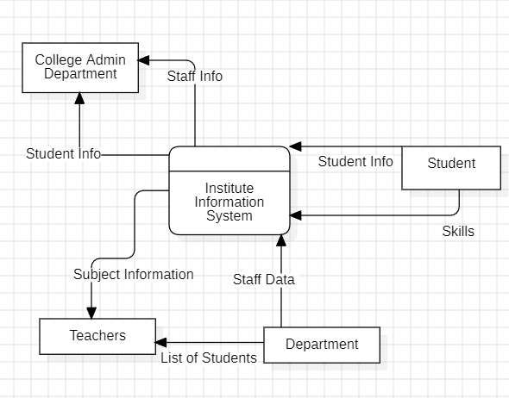  Fig. 2. Data Flow Diagram  USE CASE DIAGRAM  The use case diagram for the Institute Information System built in Salesforce depicts the interactions between actors (Students, Instructors, Administrators, and Prospective Students) and the system. Key use cases include enrolling in courses, viewing grades, updating personal information, creating and updating courses, receiving and processing applications, admitting students, managing faculty and financials, and generating reports. The diagram highlights the roles and actions performed by each actor within the system.  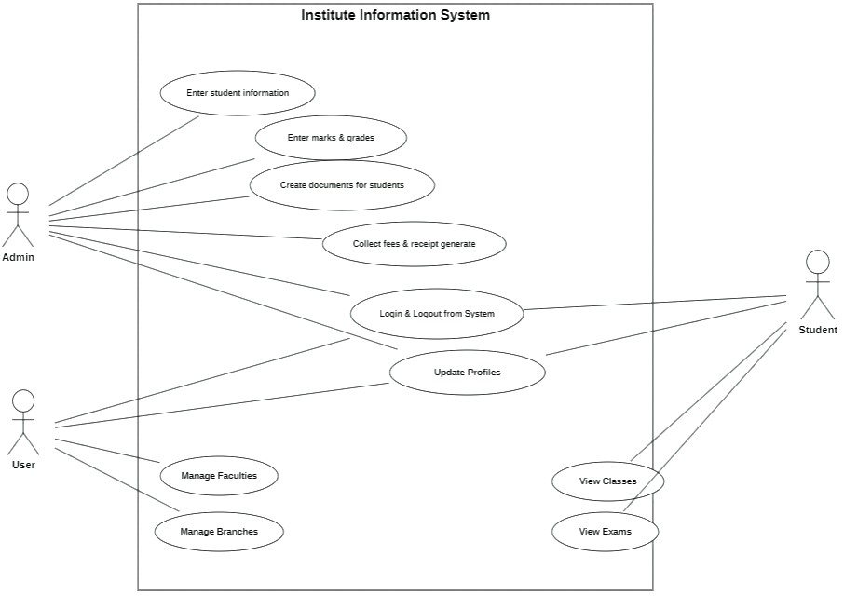  Fig. 3 Use Case Diagram
- CONCLUSION  The conclusion on a college management system built in Salesforce would depend on various factors including its Success in Meeting, like it enhances efficiency, data management, and communication among stakeholders, then the conclusion would likely be positive. User Satisfaction, if users find the system intuitive, easy to use, and beneficial in their day-to-day tasks, then the conclusion would be favourable and the cost-effectiveness of the Salesforce solution would also be a crucial factor. If the system delivers significant benefits in terms of efficiency gains, productivity improvements, and reduced. The development and implementation of the Institute Information System (IIS) using Salesforce marks a significant milestone in enhancing the operational efficiency and data management capabilities of our institution. This project has successfully integrated various functionalities into a cohesive platform, providing seamless access to crucial information for administrators, faculty, and students. By centralizing data and automating processes, IIS has significantly reduced manual administrative tasks, allowing staff to focus on more strategic initiatives. Real-time access to information has empowered stakeholders with accurate and timely data, facilitating better decision-making. The intuitive interface and user-friendly features of Salesforce have improved user satisfaction and engagement with the system.  - FUTURE SCOPE  To further enhance its functionality and utility, there are several avenues you could explore. Firstly, consider integrating your system with Learning Management Systems (LMS) to seamlessly manage course content, assignments, and assessments. By providing advanced analytics and reporting features, you can offer valuable insights into student performance, course effectiveness, and resource utilization. Developing a mobile application would extend accessibility, allowing students, faculty, and administrators to access the system on the go, receive notifications, and access course materials easily. Integrating AI and machine learning algorithms can help personalize the learning experience, predict student performance, and recommend courses tailored to individual interests and capabilities. | REFERENCES  - Rohit Jain, Aman Modi, Ishan Kashyap, Prof. Vandana Kate and Prof. Rachana Bahrawat: College Management System, Vol-4, April 2023.  - Prof. Anup Bhange: College Management System using Salesforce, Vol. 11, Issue 1, January 2022.  - Ghanshyam Singh Rathore: Cloud Based College Management System, May 2020.  - Suman Chatterjee, Manish Kumar Thakur: Smart Collage Management System, Vol-7, Issue-9, June 2019.  - Pawan Kumar, Shristi Soy, Sunayana Alda, Saroj Kumar Rout: Android Application for College Management System, Vol-9, Issue-4, No.01, April 2019.  - ManiKantha, Vasireddy Venkatadri, Mr. K. Mohana Krishna, Vasireddy Venkatadri: Design and Development of Online College Management System, Volume 6, Issue 2 April 2018  - Ms. Shabnam S. Mahat, Dr. S. D. Mundhe: Proposed Framework: College Attendance Management System with Mobile Phone Detector, Volume 5, Issue 11, November 2015.  - A. J. Kadam, Aradhana Singh, Komal Jagtap, Srujana Tankala: Mobile Web Based Android Application for College Management System, Volume 6, Issue 2, Feb. 2017.  - Kartiki Datarkar, Neha Hajare, Nidhi Fulzele, Sonali Kawle, Vaibhav Suryavanshi, Dipeeka Radke: Online College Management System, Vol. 5, Issue. 4, April 2016.  - Lalit Mohan Joshi: College Management System, Volume 122, No.11, July 2015.

