Review Paper On Design and Fabrication of Spiral Binding Machine

Sanika Bhusari, Sapna Yadav, Vinayak Naik, Varun Parmar, Prof. Ramanuj N. Chakraborty
Department of Mechanical Engineering, St. Vincent Pallotti College of Engineering and Technology, Nagpur

Sapnaryadav693@gmail.com

Received on: 05May, 2024 Revised on: 03 July, 2024 Published on: 06 July, 2024

Abstract- This paper presents the development of a cutting-edge mechatronic punch and bind office machine aimed at revolutionizing traditional business processes. By integrating smart technologies into conventional systems, this innovation promises enhanced productivity and efficiency. The paper outlines the creation of an experimental platform crucial for further advancements in servitization. Efforts have been focused on increasing the binding rate of office documents while minimizing errors. A novel measuring system has been devised to accurately measure documents and specify the appropriate binding spine simultaneously, thereby reducing errors and enhancing efficiency. Additionally, A technique for validating the implanted spine has been devised to supplement this process. The article also introduces an automated document binding system that integrates with a communication platform to smoothly connect all components. The new system's hardware design and sensor technologies provide various advantages over prior alternatives, including improved performance and scalability. Furthermore, the device can pierce a variety of materials, including paper, plastic, and other substrates, giving versatility in document handling. This study describes a significant advancement in office automation, which promises significant benefits for firms looking to optimize their document processing procedures.

Keywords: spiral binding, paper binding, comb binding.

INTRODUCTION
Spiral binding machines are indispensable tools for creating professional-grade spiral-bound documents, including notebooks, journals, calendars, and manuals. Our comprehensive range of spiral coil binding machines caters to diverse needs and budgets, offering options such as coil crimping pliers, manual punches with inserting tables, and electric punches with rollers. Spiral binding, also known as coil binding, involves threading a continuous plastic coil through punched holes along the document's edge. This method provides durability and customization options, with coils available in various sizes and colors.
Spiral-bound documents lay flat when open, facilitating readability, writing, and photocopying. Additionally, our offerings include eco-friendly options like recycled coils and pre-punched paper and covers for time-saving convenience. Binding, a critical aspect of document assembly, aims to organize content cohesively for easy handling and visual appeal. Various binding methods such as perfect binding, wire-o binding, comb binding, tape binding, and hardcover binding offer unique characteristics and applications.
This paper underscores the importance of spiral binding machines in enhancing document presentation and functionality. By leveraging these machines, businesses and individuals can
produce professional-looking documents that meet diverse requirements efficiently and effectively.

OBJECTIVES
- Design of Machine to reduce manual Work.
- Design of an automated Spiral Binding Machine.
- Fabrication of economical spiral binding machine.
- Testing and analysis of spiral binding machine.
- Design of Machine to reduce manual Work.

PROBLEMS IDENTIFICATION

In order to decrease the amount of manual work involved in document binding, this paper describes the design and development of an automated spiral binding machine. Conventional spiral binding requires labor-and time-intensive manual insertion and rolling of the coil through punched holes in the page. An integrated strategy integrating mechanical, electrical, and electronic components is suggested as a solution to this problem.
The goal of the mechanical design is to provide a sturdy and dependable method for perforating documents and inserting the spiral coil through them. To provide precise and reliable binding, this includes designing alignment systems, coil feeding mechanisms, and precision punching mechanisms.
sensors make sure that the binding process is properly aligned and controlled during paper feeding, coil insertion, and crimping.
Intelligent control and user-friendly operation are achieved by the integration of electronic components, including interface circuits and microcontrollers. This comprises creating logic in programming to automate sequential operations, keep an eye on system parameters, and give the user feedback.
To maximize the machine's performance and dependability, testing, prototyping, and iterative design iterations are all part of the development process. We assess important performance parameters including binding speed, accuracy, and user-friendliness to make sure the machine satisfies user needs.
By automating the document binding process, the suggested spiral binding machine provides a workable way to cut down on human labor and boost productivity.

PROBLEMS FORMULATION

A high-quality spiral binding machine is one of the most effective instruments for binding booklets fast. It makes booklet binding simple and straightforward. Nowadays, books and papers can be bound together to appear nice utilizing a variety of binding machines. A spiral-binding mechanism for stacks of paper. The device includes a coil cutter mechanism, a pin extension and retraction mechanism, a spiral binding unit for inserting spiral coils into holes in a stack of papers, and a paper thickness measurement and sizing mechanism.
LITERATURE SURVEY

Binding machines are versatile tools that offer a wide range of benefits for both business professionals and students. While they are commonly used in the business arena for creating presentations, client proposals, brochures, and annual reports, their utility extends to various other applications. Students, for instance, can utilize a document binder to create study guides, reports, art projects, calendars, and personalized presentations. Moreover, binding machines have found a place in recreational activities, enabling individuals to effortlessly and accurately create attractive scrapbooks, recipe books, sports rosters or schedules, and even travel literature. The possibilities are truly endless, limited only by one’s imagination..Investing in a high-quality binding machine ensures that your projects are completed with precision and professionalism. Gone are the days of struggling to bind documents together accurately. Thanks to the affordability of these devices, seeing your creative vision come to life has never been simpler.
In the Indian market, various types of document paper binders are available to cater to different binding needs. Mechanical binding options include plastic comb binding, ring-wire binding, wire-stitching, Velo-sure, and thermal-binding, among others..Once you’ve selected the desired document paper binder or binding machine, simply add it to your cart and proceed to checkout. Our secure payment gateway ensures that your personal and financial information is protected.
LITERATURE REVIEW

1). US5695308A, United States patent, Creator: Mark E. Hastings, Randy C. Peterson, Kevin L. Engelbert, and John H. Mar.
An instrument for spirally attaching a stack of papers into a unit. The equipment contains a spiral binding device that inserts a spiral coil into the holes in the stack of papers, a pin extension and retraction mechanism, a coil cutter mechanism, and a paper thickness measurement and sizing mechanism. The spiral binding device has a channel through which a spiral coil can be placed between a feed shaft and a rotatably mounted roller. As the coil is introduced, the roller forces the spiral coil to come into contact with the feed shaft. As the roller turns, a series of spiral guides lead the coil into the perforations in the stack of paper. The pin extension and retraction mechanism contains.
In their enlarged posture, the pins poke through the gaps in the stack of sheets.
The locating pins are connected to pivotal levers. A cam shaft rotates each lever in turn. The paper thickness and size mechanism measures the thickness and width of a stack of papers. This information is used to educate the operator on the proper coil size to use. The coil cutter uses this information to cut the coil to the desired length.

2) Sachin Thorat, https://learnmech.com/spiral-binding-punching-machine-diploma-mechanical-projects.
A spiral binding punching machine is a moveable multi-punch machine that punches holes in a stack of papers with a manually operated lever. This machine punches holes for spiral binding A4-sized documents (sheets). The punching machine consists of a series of narrow punches that pierce the die holes. A stack of papers is placed between the fixed remover plate and die, and the hole is punched at the predetermined location by manually exerting force with a lever. The punches are controlled by connecting connections, providing a mechanical advantage over manually applied loads. This machine's main advantages are its mobility, ease of maintenance and use, and low cost. The schematic, working drawing with specifications, and simulation of machine assembly are evaluated and tested in SOLIDWORKS drafting and design software to increase design efficiency, post-design fabrication, and final testing of the actual operation of all completed parts. As a diploma engineering student, working on this project gives us the opportunity to gain technical knowledge, design and manufacturing skills, cost estimation, and create a cost-effective, durable, and easily maintainable product for the competitive market.

3) Sensors (Basel). 2022 Feb; 22(3): 741. Published online 2022 Jan 19. doi: 10.3390/s22030741,Development of an Innovative Mechatronic Binder Machine,João Sousa,¹ Luis Figueiredo,¹ Carlos Ventura,² João Pedro Mendonça,¹ and José Machado^{1,*},Biswanath Samanta, Academic Editor.

This paper describes the development of a mechatronic punch-and-bind office machine. Integrating smart technology into existing traditional corporate machinery will speed up the development of these systems, resulting in enhanced productivity and efficiency. The development of an innovation platform that allows for additional advancements in servitization is required.
To increase the rate of binding of the office document while also lowering the danger of errors, efforts have been made to develop a measuring system that allows the paper item to be precisely measured. Specifies the appropriate binding helix at the same time. In furthermore, research has been done on a mechanism to verify the inserted spine. In addition, an automatic document binding system and a combined communication platform for all systems are shown.
The new system offers various advantages over prior systems, both in terms of hardware design and underlying sensors, including significant performance increases and upgradeability. This alternative includes a mechanism for punching various sheets of paper, plastic, or other materials.

METHODOLOGY

During the first week of the project, a discussion with the guide is held to coordinate the weekly meeting schedule. The purpose is to keep the guide informed about the project's development and to collaborate with the guide to resolve challenges. Guide gives an overview based on this project's description and the next job. Conduct a literature review using the web, books, published research, and other materials related to the title.
The planning stage starts with a few design models outlined on A4 paper. Perform a comparison to select the best concept. Applications for software are obtained from the web to build models based on sketches. Creo parametric 2.0 software enables the construction of more precise dimensions.
.
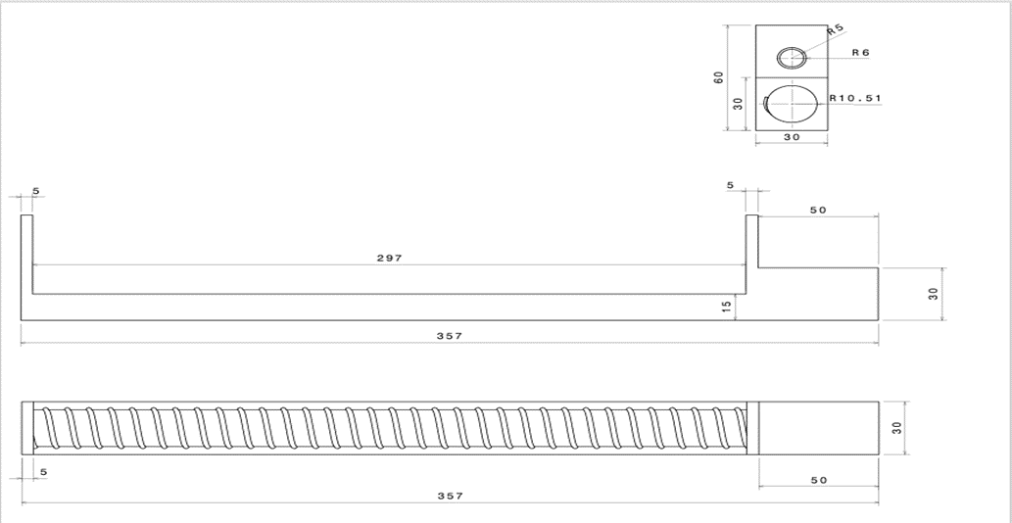

Fig1.1: CAD Design of guide

The next step is to create a mid-project presentation. Before introducing, the guide will check the slide demonstrations and make any necessary changes. The knowledge collected and ingrained during the designing phase is then presented to a panel of three judges. The next step is to devise a strategy for this undertaking. Choose a material and create a list of its dimensions. We are currently creating the fabrication procedure for this project. After that, start the fabrication process.
It would take seven weeks to complete the development and manufacturing process modifications. Conduct some testing and analysis for the project. Make corrections to the errors in this tasks. Painting is the final step in the fabrication process. The last duties will include writing the conclusive report and delivering the final presentation. The guide will review the final presentation and highlight any issues that need to be rectified.
The final presentation will be delivered to three panels. A preliminary report would then be submitted to the guide to point out any errors. the Corrections System are made, and the real final report is turned in as part of the final year's project.

COMPONENTS

List of components
  - A DC motors
  - A sliding tray
  - Paper stopers
  - A spiral element
  - Rollers
  - Guide
  - A spiral coil Cassette

CONCEPTUAL DESIGN

  - Firstly the set of paper will be arranged properly and then it will be subjected for punching.
  - And then by the sliding tray the set of paper will shift for spiral binding.
  - For initiating the binding process the coil needs to be fed in 1st hole then it will carry forward its path by the guide.
  - Then the set of paper will be binded by roller mechanism.
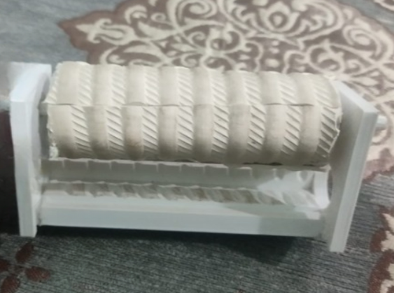
  - Finally when spiral binding is done then the coil will be cut by coil cutting mechanism.

Fig 1.2: Spiral Binding Prototype

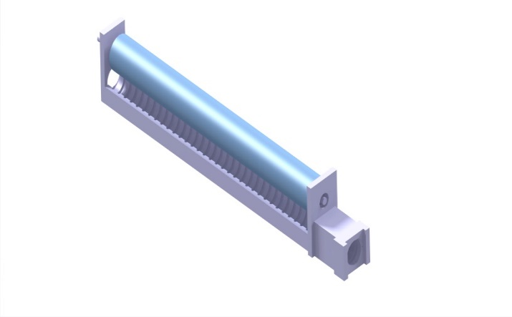
Fig 1.3: Spiral Coil feeder arrangement

BENEFITS

- Paper punches and drills are machines used to punch holes in big stacks of paper or small stacks of sheets.
- The key difference is the procedure used to attain the desired result.
- Powered by a motor, paper drills can handle massive stacks of paper.
- A paper punch is a manual device that creates holes in smaller quantities of paper.
- Custom hole punches can be made to meet your individual needs.
RESULT

The key advantage of the spiral binding machine project, which is currently under work, is that it can punch 39 holes for up to 15 pages without requiring electricity .The main lesson from the project's conclusion is that relatively little human work is required. We made every effort to develop the binding machine, but it might still be improved by adding an automated binding machine that is easy to use and can be programmed. Understanding the concept of design, tooling, producing charts, using tools like Creo, estimating and costing, manufacturing, and so on are the main lessons we learned from this project.

Conclusions
Binding machines are multipurpose instruments with several advantages for students and business people. Although they have many uses outside of the business sector, they are commonly employed in the creation of reports, proposals, brochures, and presentations. Binding machines can be used by students to make individualized presentations, art projects, study aids, reports, and calendars. Additionally, binding machines have found a use in leisure activities where they make it simple for people to produce beautiful scrapbooks, recipe books, trip literature, sports rosters, and more.
References

1). US5695308A, United States patent ,Inventor
- Mark E. Hastings,Randy C. Peterson,Kevin L. Engelbert,John H. Mar
- 2)Mark E. Hastings; Randy C. Peterson; Kevin L. Engelbert
- United States Patent Office,Patent no.5,695,308 Patented on Dec. 9, 1997.
- 3)Sachin Thorat,https://learnmech.com/spiral-binding-punching-machine-diploma-mechanical-projects/

