EV Wireless Pro

Nikita Nandapure¹, Pooja Talwekar², Khushi Rahangdale³, Mansi Rahangdale ⁴,
Nandini Chawhan⁵

¹Assistant Professor, Nikita Nandapure, Department of Computer Science and Engineering
Wainganga College of Engineering & Management, RTMNU University Nagpur, Maharashtra, India 441108
²Assistant Professor, Alsaba Naaz, Department of Computer Science and Engineering
Wainganga College of Engineering & Management, RTMNU University Nagpur, Maharashtra, India 441108

tanmaytalwekar8@gmail.com
Received on: 08 October, 2024 Revised on: 13 November. 2024 Published on: 15 November, 2024

Abstract – The EV Wireless Pro project aims to revolutionize the electric vehicle (EV) charging experience by developing an advanced wireless charging system that enhances the convenience, efficiency, and scalability of EV infrastructure. Traditional wired charging solutions are limited by physical connectors, wear-and-tear issues, and the need for precise alignment between the vehicle and the charging station. The EV Wireless Pro seeks to overcome these challenges by utilizing inductive charging technology, enabling seamless, contactless power transfer between the charging pad embedded in the ground and a receiver installed in the vehicle.
The EV Wireless Pro aims to pave the way for a future where wireless EV charging is as ubiquitous and user-friendly as refueling at a gas station. It promises to accelerate the adoption of electric vehicles by addressing current charging pain points and contributing to the broader goal of reducing the carbon footprint of the transportation sector.

Keywords- Electric Vehicle (EV), Wireless Charging, Inductive Charging, Contactless Power Transfer, Wireless Power Systems

INTRODUCTION

The adoption of Electric Vehicles (EVs) is rapidly increasing worldwide, driven by the need for sustainable transportation solutions to reduce carbon emissions and

dependence on fossil fuels. As EVs become more mainstream, one of the most critical challenges to address
is the efficiency, convenience, and accessibility of charging infrastructure. Traditional wired charging systems, though functional, come with several limitations, including the need for physical connectors,
alignment issues, and wear-and-tear concerns that can affect long-term usability and reliability.

To overcome these challenges, the EV Wireless Pro project seeks to revolutionize the EV charging experience through the development of an inductive wireless charging system. This technology uses electromagnetic fields to transmit energy from a transmitter coil embedded in the ground to a receiver coil in the vehicle, enabling a contactless and seamless charging experience.
The core aim of the EV Wireless Pro system is to eliminate the physical connection between the vehicle and the charging station, simplifying the process of charging while enhancing the user experience. By integrating advanced components such as an Arduino Uno microcontroller, IR sensors for vehicle alignment detection, relay modules for power management, and LCD displays for real-time feedback, this project delivers a smart, efficient, and user-friendly wireless charging solution for electric vehicles.

The EV Wireless Pro system operates in the following way:

Vehicle Alignment: When an EV approaches the charging station, the IR sensor detects its position. If the vehicle is properly aligned with the charging pad, the sensor sends a signal to the Arduino, indicating that the system is ready to begin charging.

Power Control: If the vehicle is aligned, the Arduino sends a signal to activate the relay. The relay closes the circuit, allowing power from the transmitter coil to flow to the receiver coil in the vehicle, enabling the charging process.

Charging Process: The transmitter coil generates an electromagnetic field, which is captured by the receiver coil inside the vehicle. The receiver coil converts this field back into electrical energy to charge the vehicle’s battery. The Arduino monitors the charging status and controls the relay to ensure that the charging process operates smoothly.

Safety Features: If the system detects any issues, such as misalignment or faults in the relay, the Arduino stops the power transfer to prevent damage. The system can also implement additional safety checks, such as temperature monitoring or overload protection, to safeguard both the vehicle and the charging station.

METHOLOGY
The methodology for implementing a Wireless Charging System for Electric Vehicles (EVs) using components like transmitter coils, receiver coils, IR sensors, relays, and Arduino will be divided into key phases. These phases will encompass planning, design, construction, testing, and refinement to ensure the system operates efficiently and safely.

System Design and Planning
The first step in the methodology is to plan the overall system architecture, including the functions of each component and how they will interact. Key considerations during this phase include:
a. Wireless Power Transfer Design
Transmitter Coil (Primary Coil): The transmitter coil will generate the magnetic field necessary for energy transfer. Its design will be based on resonant inductive coupling principles, where both the transmitter and receiver coils are tuned to the same frequency to ensure efficient energy transfer.
Receiver Coil (Secondary Coil): The receiver coil is placed on the EV and will capture the energy from the magnetic field and convert it into electrical energy. The design of the receiver coil will need to ensure that it can handle the power levels required for EV charging.
b. Control System Design (Arduino-based)
The Arduino will be used to manage the operation of the wireless charging system. The Arduino will monitor alignment, control the relay for power switching, and drive the display to show charging information.
c. Sensor Design
The IR Sensor will be used to detect the alignment of the transmitter and receiver coils. Proper coil alignment is essential for efficient energy transfer, and the IR sensor will monitor this and provide feedback to the Arduino.
d. Display and Feedback System
The LCD/LED Display will show key information, such as charging status, alignment status, and real-time feedback on the charging process.
Software & Hardware Used:
Software:
Arduino IDE
Embedded C programming language
Hardware:
Arduino nano
Transmitter receiver charging coil
RFID Reader module
IR sensor
Relay module
Wireless charging module
Nano cable
Adaptor
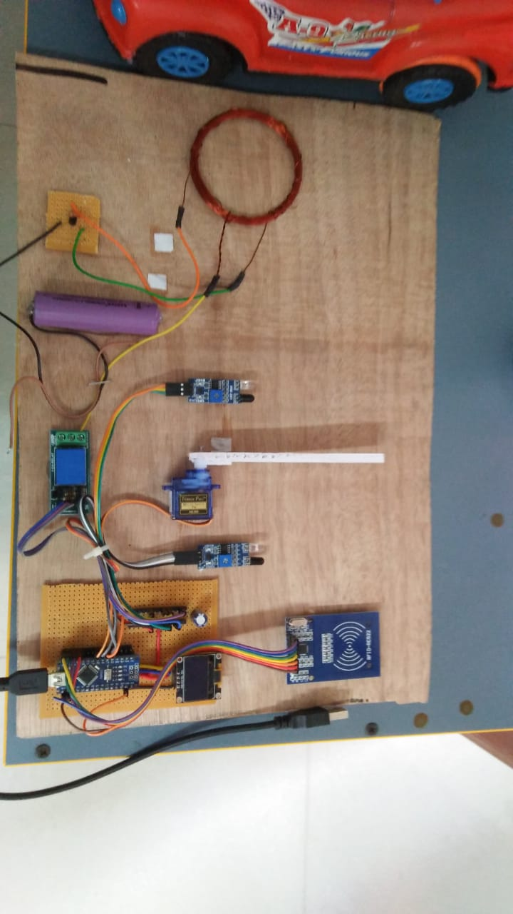
Fig. 1- Model
CONCLUSION
Smart wireless battery charging with IOT integration and charge monitoring presents a promising solution for efficient and convenient device charging. By combining wireless charging technology with IoT capabilities, users can remotely monitor and control the charging process while ensuring safety and efficiency. This technology has the potential to revolutionize the way we charge and interact with our devices.
This project successfully demonstrates the potential of combining Arduino-based control systems with wireless charging technology to create a more efficient, user-friendly, and safer charging solution for electric vehicles. It serves as a solid foundation for further development in the area of wireless energy transfer and smart charging systems. With additional refinements, this technology could help pave the way for more convenient and accessible charging solutions for the growing number of electric vehicles worldwide.
The project effectively utilized inductive charging coils to transfer energy from the charging pad (transmitter coil) to the vehicle (receiver coil) without the need for physical connections. This wireless technology reduces wear and tear on physical connectors and simplifies the charging process.
The IR sensors played a crucial role in ensuring the vehicle was properly aligned with the charging pad. When the vehicle was in position, the sensors communicated with the Arduino to trigger the relay, enabling the transfer of power. This prevents charging when the vehicle is not properly aligned, avoiding inefficiencies or safety hazards.

ACKNOWLEDGMENT
Pursuit of the course of Bachelor of Technology (Computer Science and Engineering) is challenging task. At the threshold of its completion, the contentment one experiences, after putting in hours of hard work, is quite fulfilling. We would like to express our gratitude and respect to all those who have directly or indirectly, aided us in our work and research.
We extend our sincerest gratitude to Prof. Nikita Nandapure Asst. Professor, Department of Computer Science and Engineering, WCEM, Nagpur, under whose guidance. We carried out this research. Without Head of department of Computer Science and Engineering advice and supervision our research would never have reached its conclusion.
We are thankful to Dr. Bharat Chede, Principal of Wainganga college of Engineering and Management, Nagpur for providing excellent facilities and access to required technology and research material for our study. We also thank all respected teachers, colleagues and friends for all their support
REFERENCES
- Lee, Y. J., Kim, D. L, & Park, J. H. (2020). IoT-based smart wireless charging system for electric vehicles. Energies.

- Chen, L., Xu, L., Sun, Z., & Zhang, X. (2018). An IoT-based battery charging system forelectric vehicles. IEEE Transactions on Industrial Informatics.

- Ahmed, M., & Kim, Y. S. (2020). A review of wireless charging systems for electric • vehicles: Topologies, operating principles, and technical challenges. Energies.

- Hamadache, M., Berrached, F., & Bendiabdellah, A. (2019). Design andimplementation of a wireless charging system for electric vehicles based oninductive resonant technology. International Journal of Electrical Power & EnergySystems.

